**Container Deployment Using Docker Swarm**

**docker version**

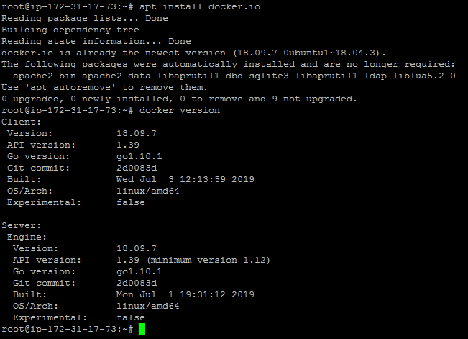

* Once the image is built, check if it is built properly or not. You can see a Docker image entry using Docker images command

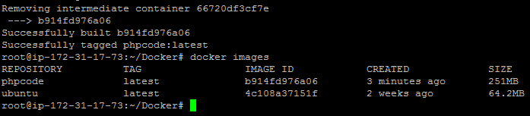

**docker swarm init**

**docker node ls**

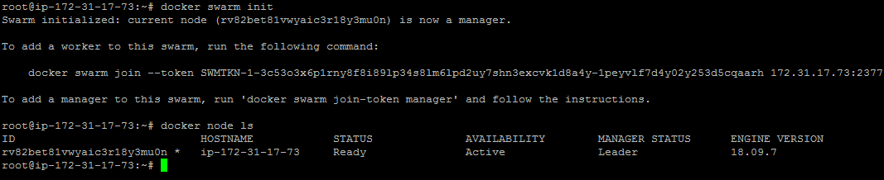

**docker service create -p 80:80 --name webserver phpcode**

**docker service ls**

**curl localhost**

