**Container Scaling with Docker Swarm**

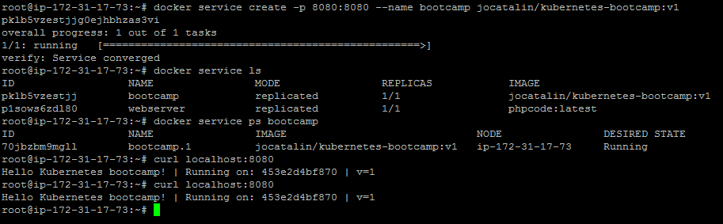

**docker service scale bootcamp=3**

**docker service psbootcamp**

**curl localhost:8080**

