**Deploy your Application**

**./kubectl**

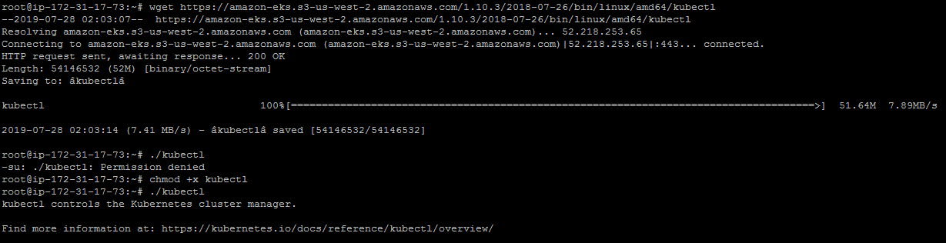

**mkdir bin**

**cp ./kubectl $HOME/bin/kubectl && export PATH=$HOME/bin:$PATH**

**kubectl version**

**kubectl version --short --client**

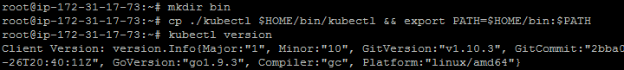

**wget https://amazon-eks.s3-us-west-2.amazonaws.com/1.10.3/2018-07-26/bin/linux/amd64/aws-iam-authenticator**

**chmod +x ./aws-iam-authenticator**

**cp ./aws-iam-authenticator $HOME/bin/aws-iam-authenticator && export PATH=$HOME/bin:$PATH**

**aws-iam-authenticator help**

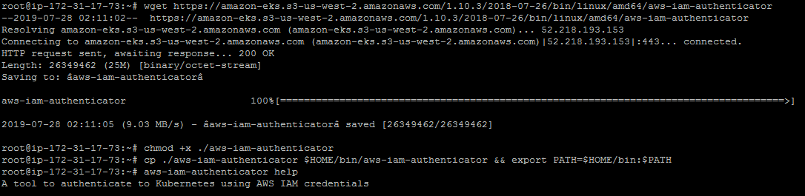

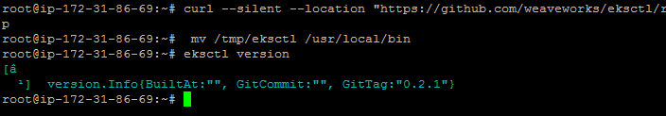

**apt install python-pip**

**pip install awscli**

**aws --version**

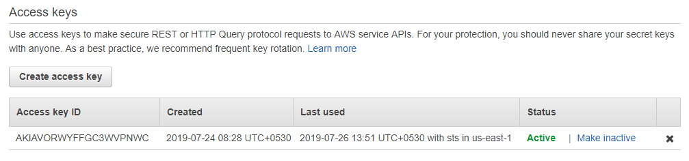

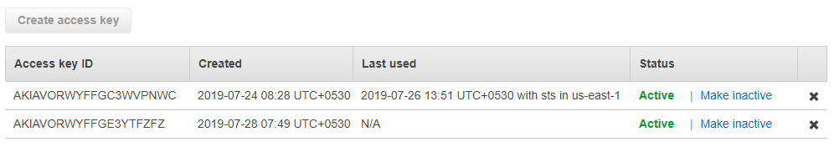

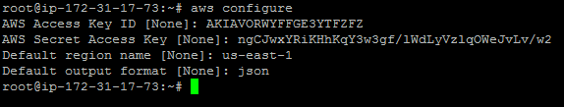

**eksctl create cluster --name=EKSCluster --nodes=2 --region=us-west-2**

