**Format and Mount an EBS Volume**

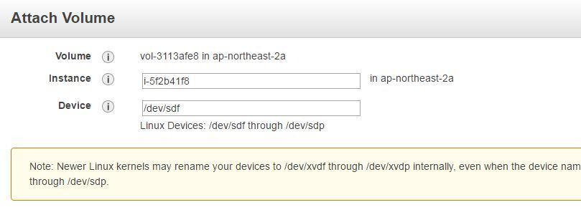

Mounting the EBS volume

* Login to your EC2 instance and list the available disks using the following command:

*ldblk*

* Use the following command to check if the volume has any data:

*sudo file -s /dev/xvdf*

* Use the following command to format the volume to ext4 filesystem:

*sudo mkfs -t ext4 /dev/xvdf*

* Use the following command to create a directory to mount the volume:

*sudo mkdir /newvolume*

* Use the following command to mount the volume:

*sudo mount /dev/xvdf /newvolume/*

* Check the disk space using the following command:

*cd /newvolume*