**Install Kubernetes**

**docker version**

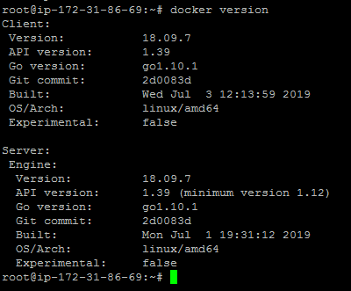

Configure Kubernetes using the procedure below.

**curl -s https://packages.cloud.google.com/apt/doc/apt-key.gpg | apt-key add -**

**echo "deb http://apt.kubernetes.io/ kubernetes-xenial main" >/etc/apt/sources.list.d/kubernetes.list**

**apt-get update**

**apt-get install -y kubelet kubeadm kubectl**

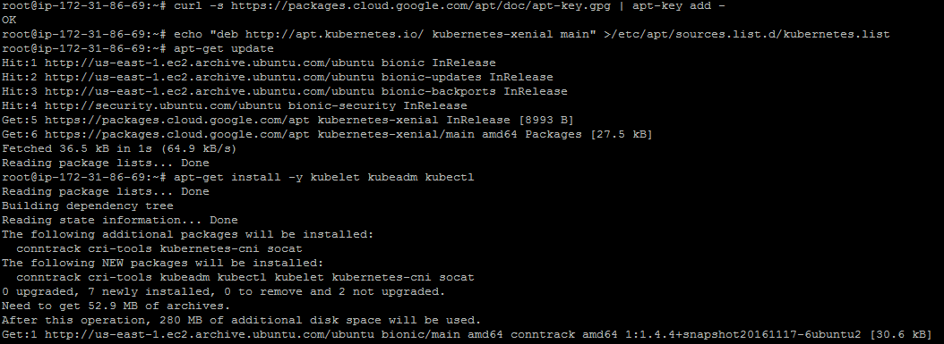

**kubeadm init**

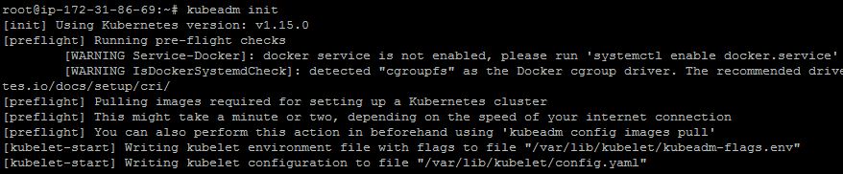

**mkdir -p $HOME/.kube**

**sudo cp -i /etc/kubernetes/admin.conf $HOME/.kube/config**

**sudo chown $(id -u):$(id -g) $HOME/.kube/config**

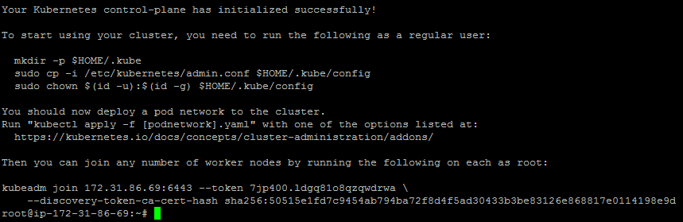

**export kubever=$(kubectl version | base64 | tr -d '\n')**

**kubectl apply -f "https://cloud.weave.works/k8s/net?k8s-version=$kubever"**

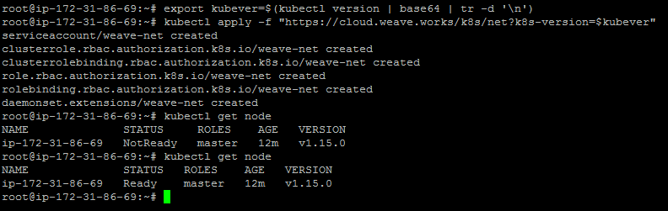

**kubectl get node**

**kubectl get pods --all-namespaces**

