**Install Kubernetes on Cloud**

AWS console and navigate to EKS service to create an EKS cluster.

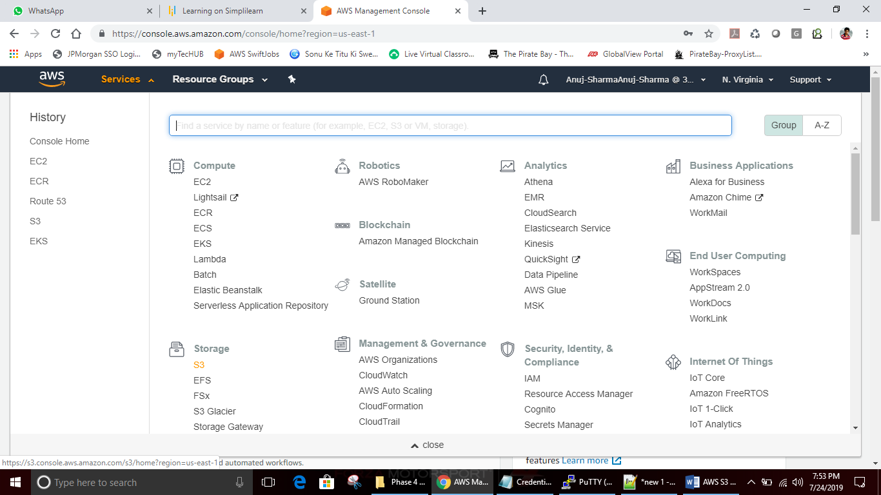

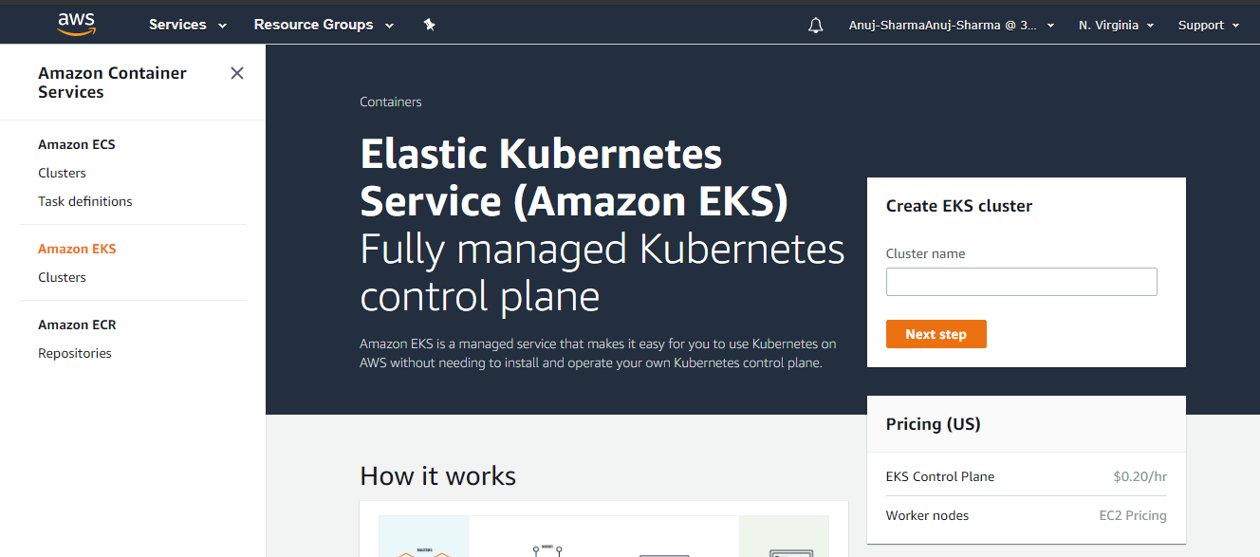

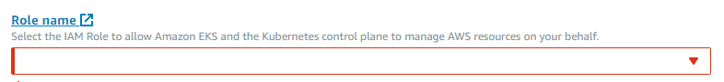

* Click on **Create Role** and provide the policy details. Select **EKS** from the service list.

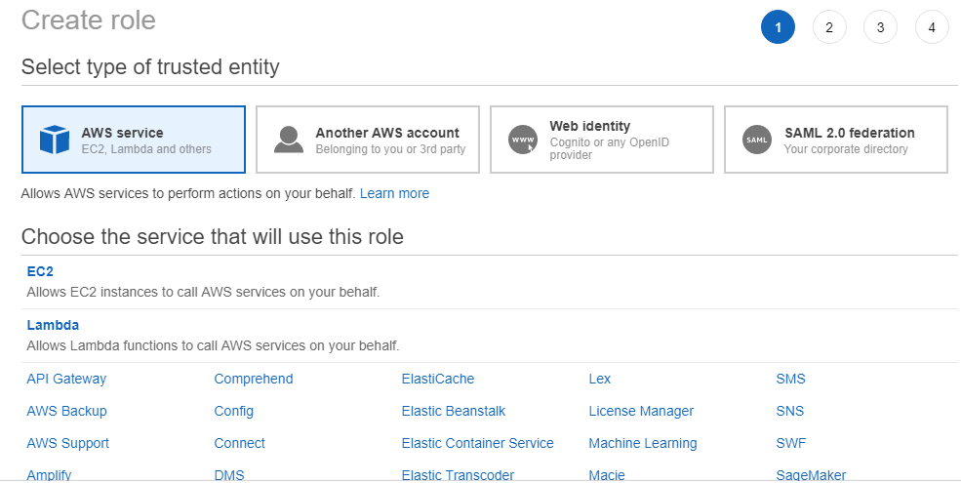

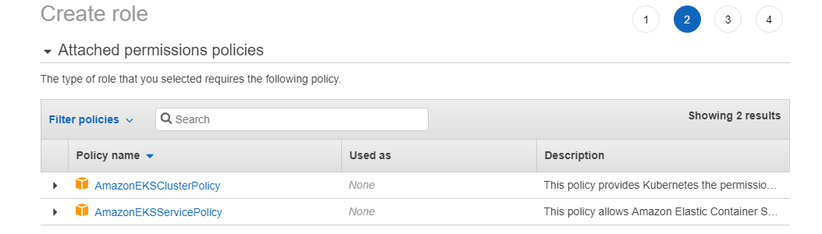

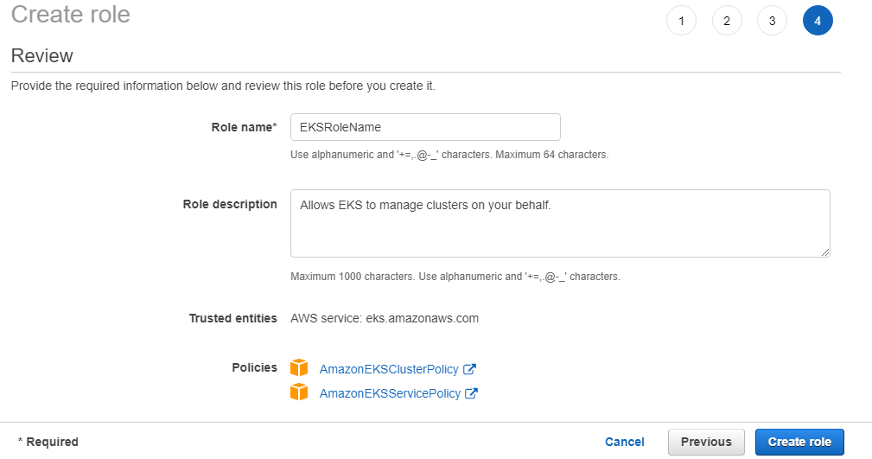

* Select the newly created role name from the list while creating the EKS cluster.

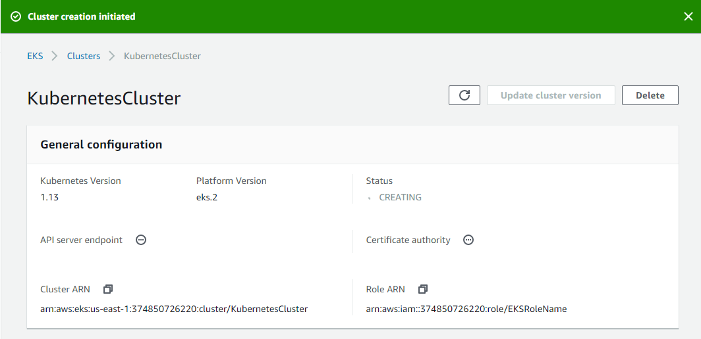

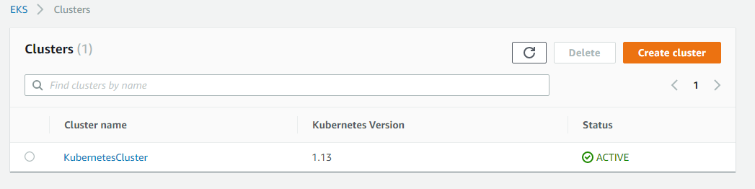

**wget https://amazon-eks.s3-us-west-2.amazonaws.com/1.10.3/2018-07-26/bin/linux/amd64/kubectl**

**chmod +x kubectl**

**./kubectl**

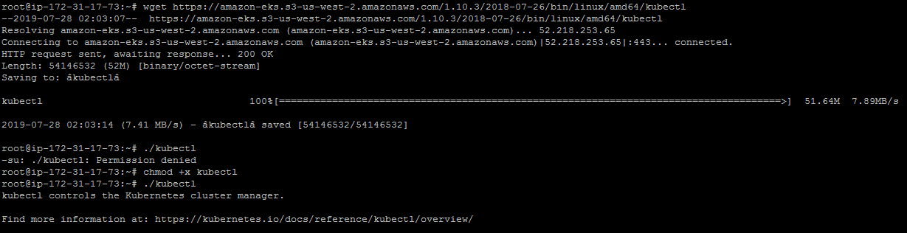

**mkdir bin**

**cp ./kubectl $HOME/bin/kubectl && export PATH=$HOME/bin:$PATH**

**kubectl version**

**kubectl version --short --client**

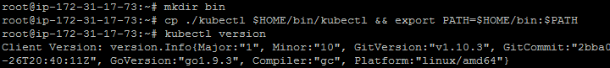

Linux: <https://amazon-eks.s3-us-west-2.amazonaws.com/1.10.3/2018-07-26/bin/linux/amd64/aws-iam-authenticator>

**wget https://amazon-eks.s3-us-west-2.amazonaws.com/1.10.3/2018-07-26/bin/linux/amd64/aws-iam-authenticator**

**chmod +x ./aws-iam-authenticator**

**cp ./aws-iam-authenticator $HOME/bin/aws-iam-authenticator && export PATH=$HOME/bin:$PATH**

**aws-iam-authenticator help**

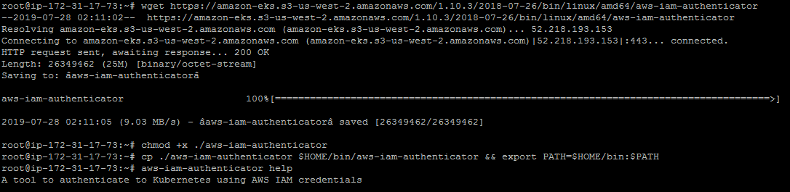

* Install AWS CLI using the sequence of commands mentioned below.

**apt install python-pip**

**pip install awscli**

**aws --version**

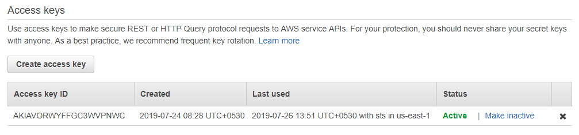

**Please Note:** Create Access keys and keep them saved in a document.

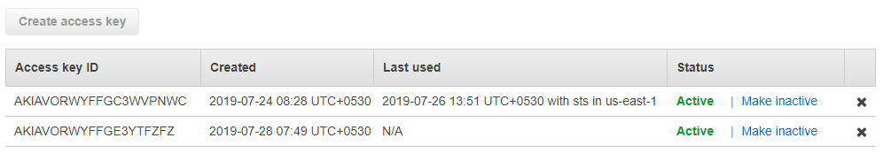

* Configure AWS CLI and provide **Access Keys** and **Secret Access Keys** while configuring it.

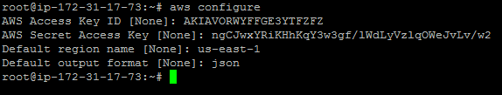**awseks --region us-east-1 update-kubeconfig --name KubernetesCluster**

**kubectl get svc**

