**Setting Up Jenkins Pipeline**

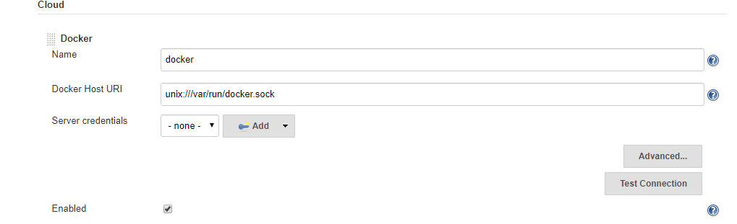

chmod 777 /var/run/docker.sock



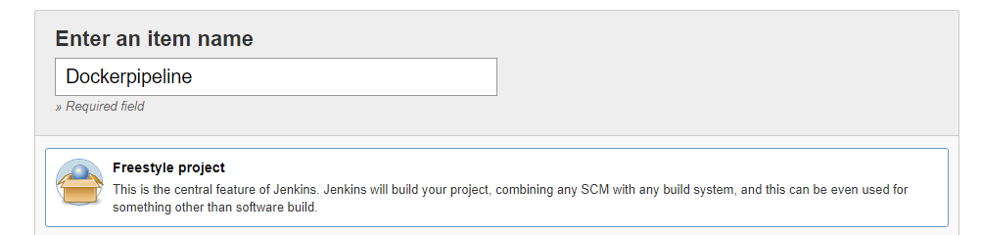

https://github.com/Anuj1990/Docker.git

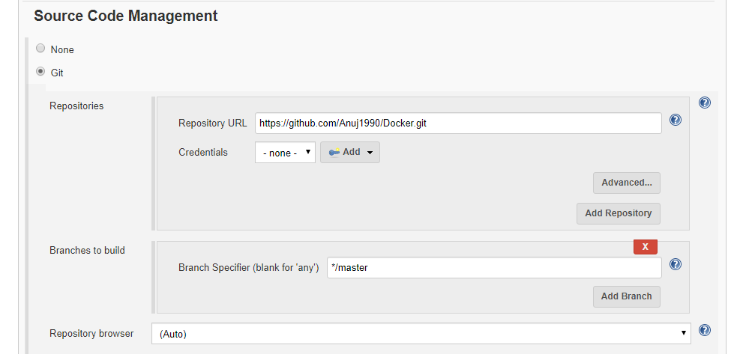

* Configure build triggers to enable Poll SCM feature so that once any push is detected

