Handling File Uploads



//Locating 'browse' button

WebElement browse =driver.findElement(By.id("uploadfile"));

//pass the path of the file to be uploaded using Sendkeys method

browse.sendKeys("D:\\SoftwareTestingMaterial\\UploadFile.txt");

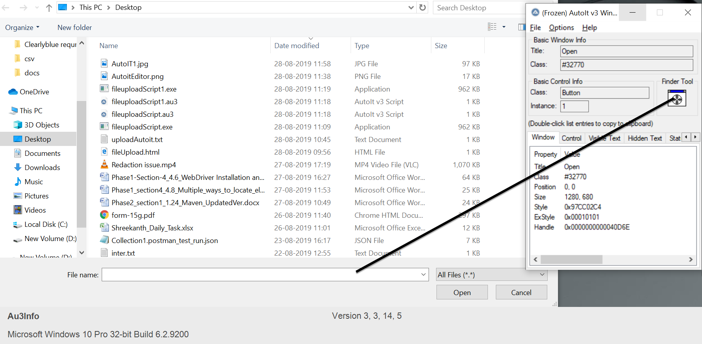

**import** java.io.IOException;

**import** java.util.concurrent.TimeUnit;

**import** org.openqa.selenium.By;

**import** org.openqa.selenium.WebDriver;

**import** org.openqa.selenium.firefox.FirefoxDriver;

**public** **class** AutoIt {

**private** **static** WebDriver driver = **null**;

**public** **static** void main(**String**[] args) **throws** **IOException**, **InterruptedException** {

driver = **new** FirefoxDriver();

driver.manage().timeouts().implicitlyWait(10, **TimeUnit**.SECONDS);

driver.get("http://toolsqa.com/automation-practice-form");

driver.findElement(By.id("photo")).click();

**Runtime**.getRuntime().exec("D:\AutoIt\AutoItTest.exe");

**Thread**.sleep(5000);

driver.close();