LiveCareer Resume Search Devops Engineer
Search for resumes by industry, job title or keyword.
Dev OPS Engineer e
Love this resume?
BUILD voua XOVV
By clicking Build Your Own Now, you agree to our Terms of Use and Privacy Policy.
JESSICA CLAIRE
100 Montgomery St. 10th Floor (555) 432-1000 resumesample@example.com
Professional Summary
- Experience working on Monolithic and Microservices oriented architecture.
- Experience in creating, configuring and maintaining Amazon EC2 instances.
- Experience working with version control systems like Subversion, GIT, Bitbucket.
- Implemented a CI/CD pipeline involving Git, Jenkins, Chef, Docker, Nexus and Ansible for complete automation from commit to deployment.
- Experience in using Chef as a configuration management tool to automate infrastructure provisioning by writing various chef recipes and cookbooks. • Hands-on experience using Maven as build tool for building of deployable artifacts from source code.
- Experience working with Load balancers to route incoming traffic to number of downstream servers.
- Experience working with microservices by using Docker.
- Deployed various web-based applications using Git and Jenkins to Apache Tomcat and JBoss servers.
- Experience in Bug/lssue tracking tools like HP Quality Center, Jira.
Skills
- DevOps Tools: Jenkins, Ant, Maven, • Configuration Management Tools:
Docker, Kubernetes, Grafana Chef, Ansible
- Scripting Languages: Python, Shell Cloud Platforms: Amazon Web
Bash Services, Google Cloud Platform

- Version Control Tools: GitHub,
BitBucket, Gitlab
- Artifactory: Nexus, JFrog
- Methodologies: Agile, Waterfall
Linkedln ID
- Databases: MySQL
- Operating Systems: Red Hat Enterprise Linux, CentOS, Ubuntu,
MacOS

- https://www.linkedin.com/in/jayadev-chitturi-12b769107/
Work History
DevOps Engineer, 10/2020 to Current
Bae Systems — Fort Gordon, GA
- Managed Chef cookbooks implemented rules and templates in Chef for better environment management.
- Experience using Bash and Python scripts for day-to-day activities and automated various tasks.
- Responsible for automating CI/CD build pipelines via GitHub and Jenkins and setting up master and worker node by following DevOps practices.
- Developed Chef cookbooks for automatic provisioning and installation of various packages in SBX/Prod servers.
- Experience in writing various Docker files and built container images to create Docker containers for each environment and further pushed them to Amazon ECR for storage.
- Experienced in setting up Kubernetes dashboard and worked on creating pods, replica sets, services, deployments, health checks and ingress by writing YAML manifests.
- Involved in maintaining, managing and improving cloud infrastructure on AWS by creating EC2 instances, Auto Scaling Groups, IAM, VPC's, CloudFront.
- Experience in preparing and maintaining documentation for changes build and release management process and also sharing the Root cause analysis with the team in case of PI issues.
- Technologies Used: AWS, GitHub, Maven, Jenkins, Docker, Kubernetes, Chef.
Release Engineer, 02/2018 to 10/2020
Zoom - AZ, State
' Planned and executed the SAAS releases to all the SBX and PROD customer instances hosted across multiple regions.
- Used Jenkins as the build server and integrated it with GitHub for daily CI activities.
- Experience in using RightScale as a Cloud Management service and created various deployments and Linux servers where the customer instances are hosted. Used Grafana dashboard actively as a monitoring tool to check the load on deployments for an efficient unerring release.
, Experience in using AWS services like EC2, S3, SES, IAM, CloudFront, CloudWatch, RDS for instance managements, backup storages, email service, access management, CDN and logging respectively.
- Responsible for troubleshooting various issues in the Linux systems for various deployments.
' Experience in using Docker in a Linux environment for delivering the application into various environments.
- Worked on supporting the SRE related activities for troubleshooting server/deployment issues across multiple regions.
- Managed all the releases using an internal tool Control-Next which acts as a dashboard to track the progress on the releases.
- Worked in migrating the customer instances to updated MySql deployments upon the dependency of ES stack.
- Experience in using Application Load balancers with a good knowledge of traffic patterns, usage of dependency services, security, load, responsiveness and durability in the event of failure and route them to downstream servers.
' Experience is writing documentation for runbooks on new release strategies and various major incidents occurred as part of releases.
- Experience in using Rundeck for upgrading microservices as part of on-going SAAS releases.
- Primary contact for all standard and off cycle enterprise releases throughout the entire organization.
- Communicated and collaborated with the CVM team and the customer support for release related queries and rollbacked the SBX/PROD instances to the previous version in case of any issue.
- Worked closely with the development team to integrate new deployment processes and strategies to meet our feature requirements.
- Directly reports all the daily release activities to the Senior Manager in the Release Management and further discusses the root cause of the escalation failures with the SRE team.
- Technologies Used: AWS, Github, Maven, Jenkins, RightScale, Rundeck, Docker,
Chef.
DevOps Engineer, 06/2017 to 02/2018
Bae Systems — Manassas, VA
- Implemented the CI/CD pipeline cycle for multiple teams from scratch in all environments.
- Experience on using Bitbucket with Admin privileges and created various repositories to integrate them with Jenkins.
- Experience in setting up Jenkins jobs for the respective projects and completely involved in the build process.
- Experience in using pipeline jobs in Jenkins for various projects.
- Monitored the overall build process and responsible for maintaining the code coverage results in SonarQube dashboard.
- Experience in using Jfrog and Nexus repository in CI pipeline for pushing the build artifacts for future process.
- Experience in pushing the Docker images from Jenkins to Nexus and maintaining the various versions of it.
- Worked closely with the development team for resolving the issues occurred due to the build process.
- Experience in using Docker compose files for the communication between multiple containers.
- Knowledge on implementing the blue/green deployment techniques using Docker and Kubernetes for zero down time achievement.
- Written Ansible scripts for picking up the Docker images and deploying them onto the target server.

- Experience in using SQL server for maintaining, pulling or inserts records into the database.
- Technologies Used: Stash/Bitbucket, Maven, Jenkins, Docker, Kubernetes, Ansible, MYSQL Workbench.
Education
Master's: Computer Science
University of Central Missouri - Kansas City, Missouri GPA: 3.4/4.0
Bachelors: Electronics and Communication Engineering
JNTU - Hyderabad
GPA: 3.0/4.0
By clicking Build Your Own Now, you agree to our Terms of Use and Privacy Policy
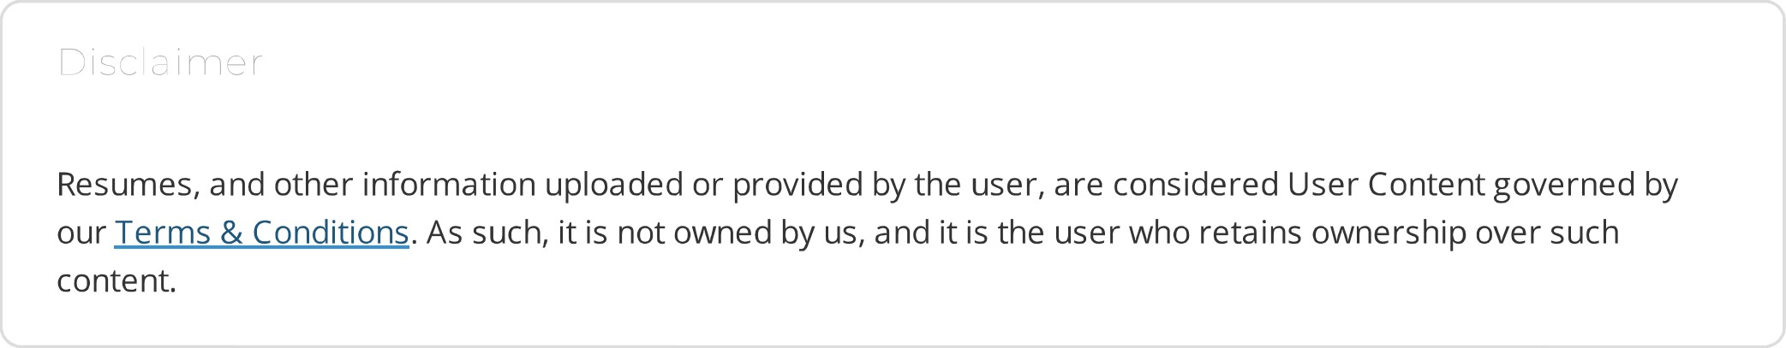
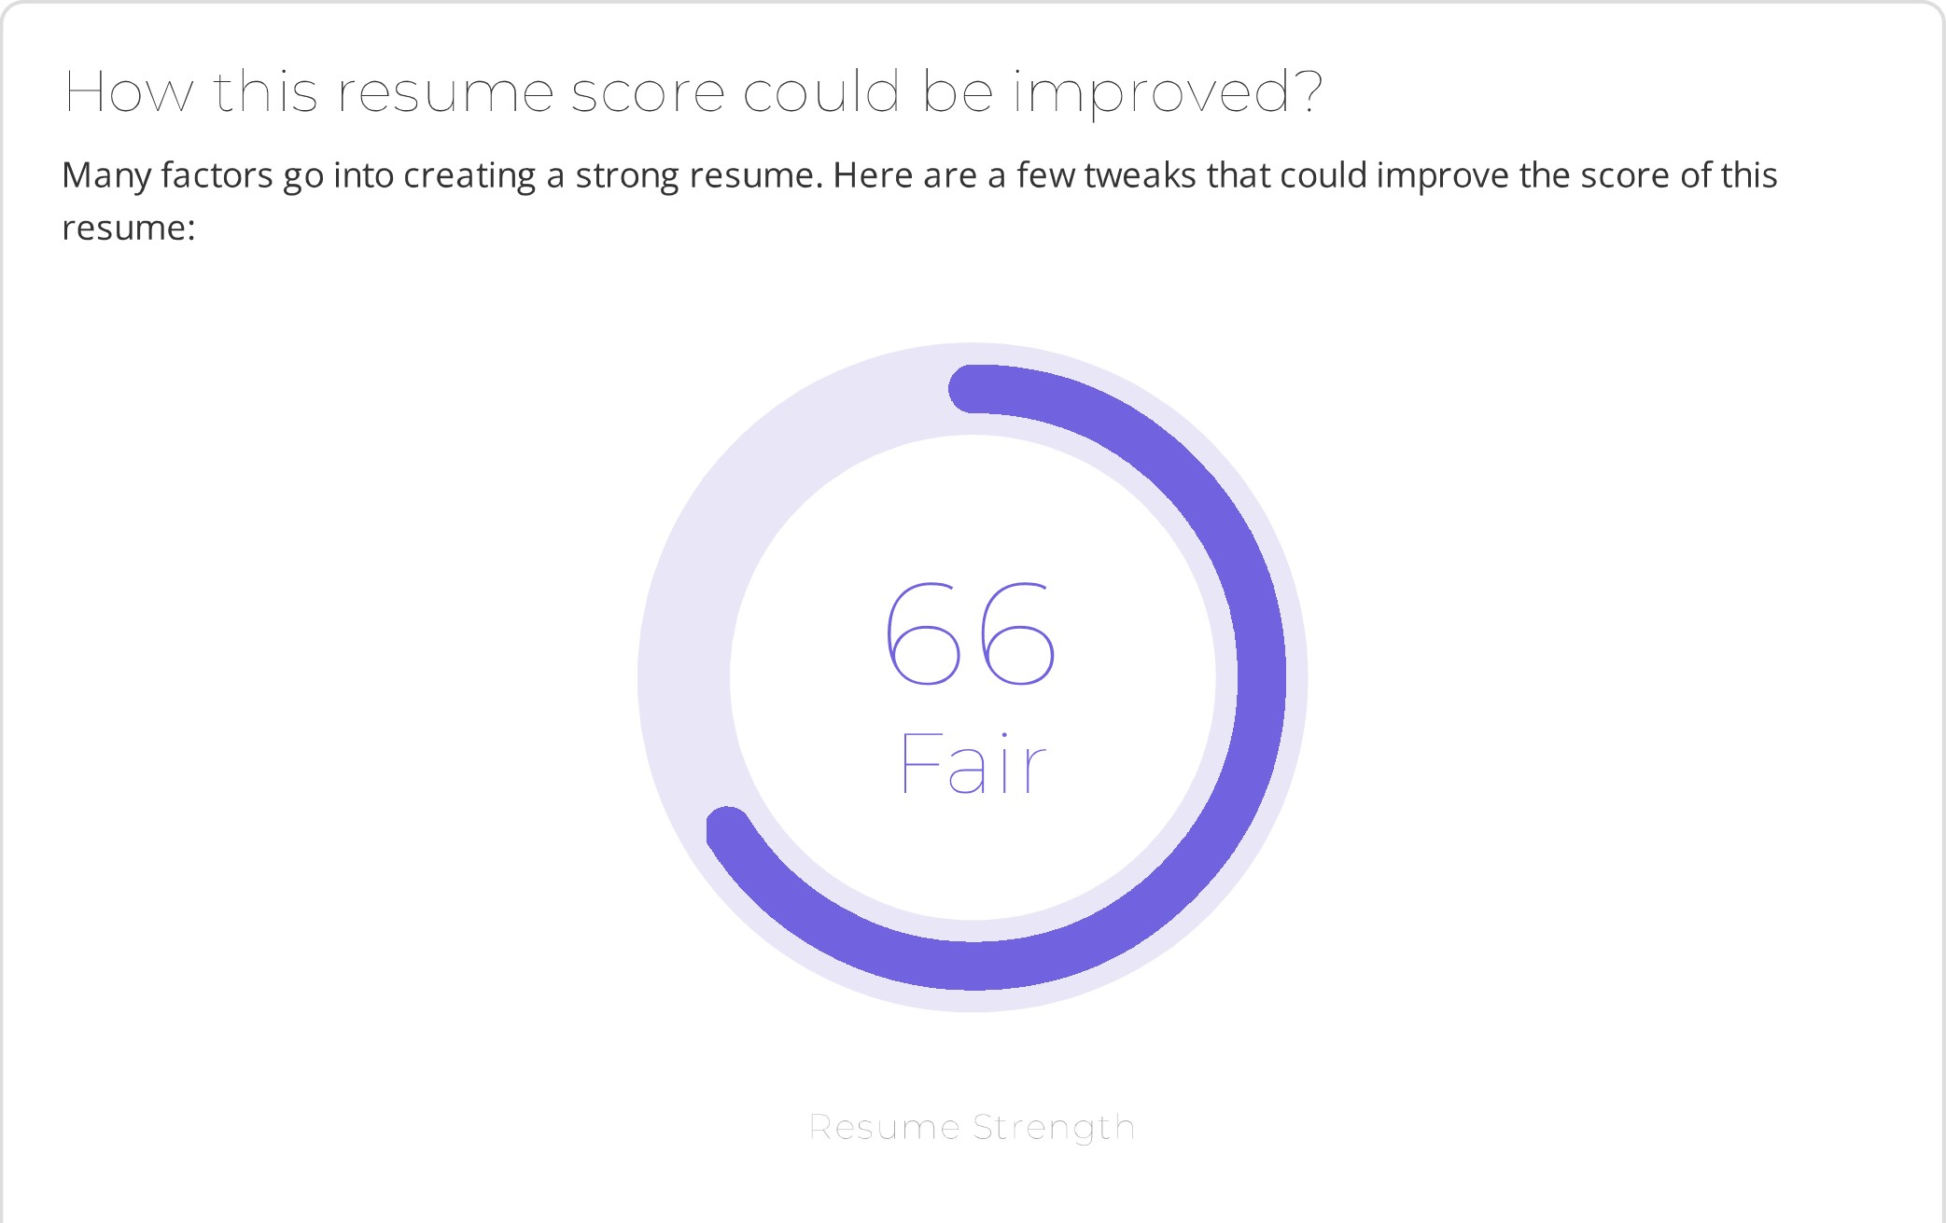
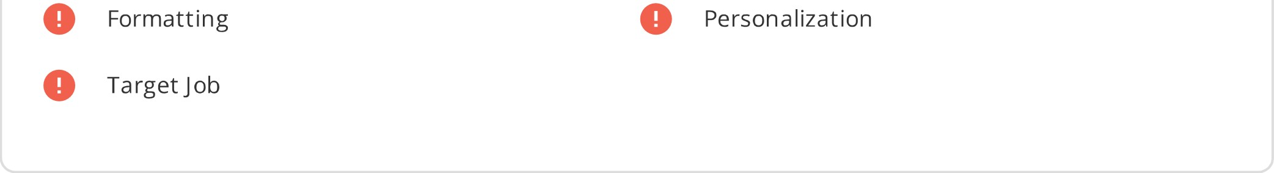
O
O
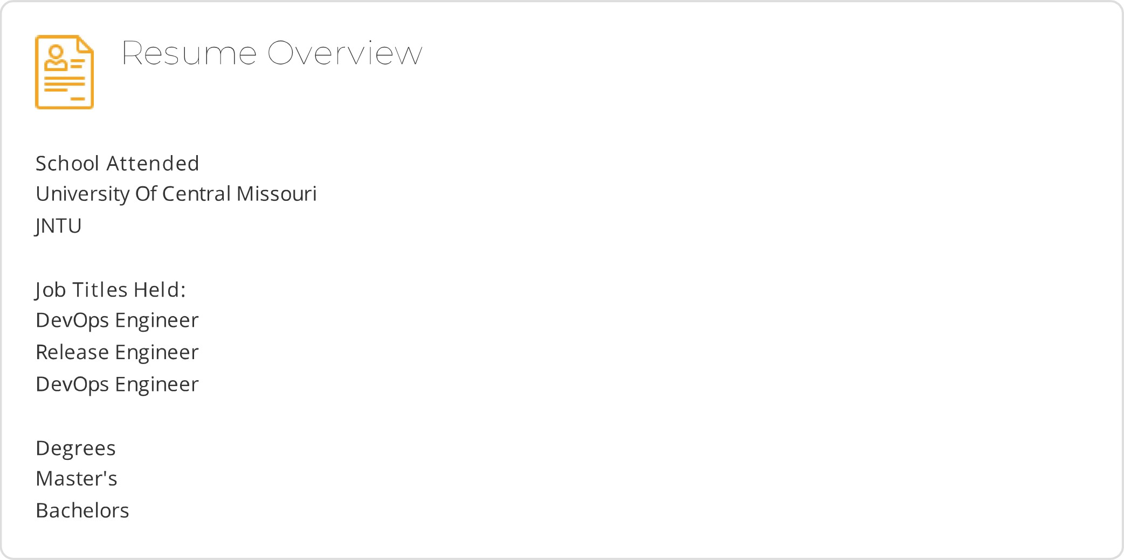
V'\/here C an I find a i
Build a Resume
Have a resume already
Have a pro write your resume for you
Create a cover letter
Profess I o n a
Since 2005, LiveCareer's team of career coaches, certified resume writers, and savvy technologists have been developing career tools that have helped over 10 million users build stronger resumes, write more persuasive cover letters, and develop better interview skills.
CREATE M RESUME

Similar Resume View All

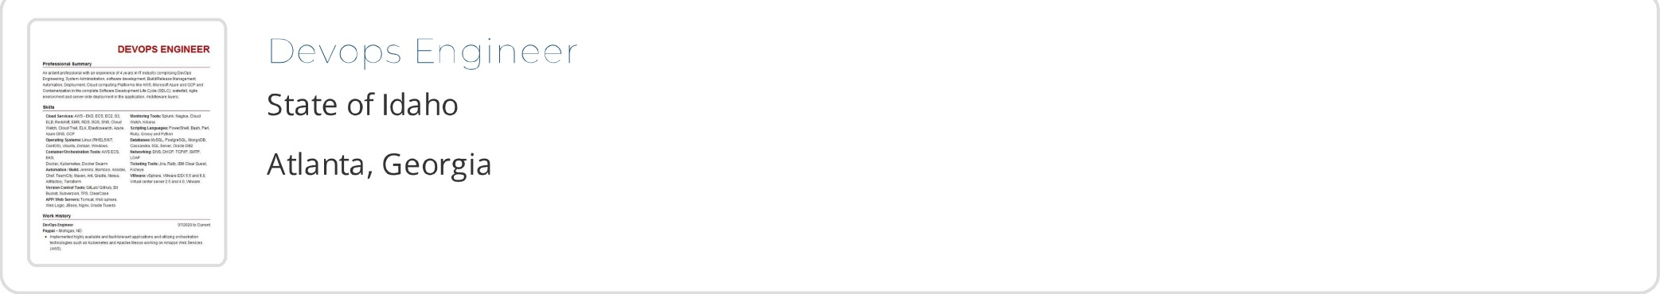
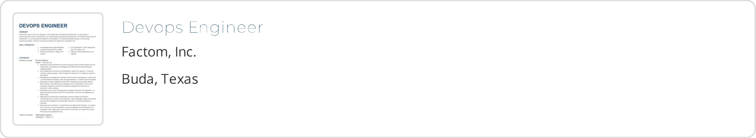
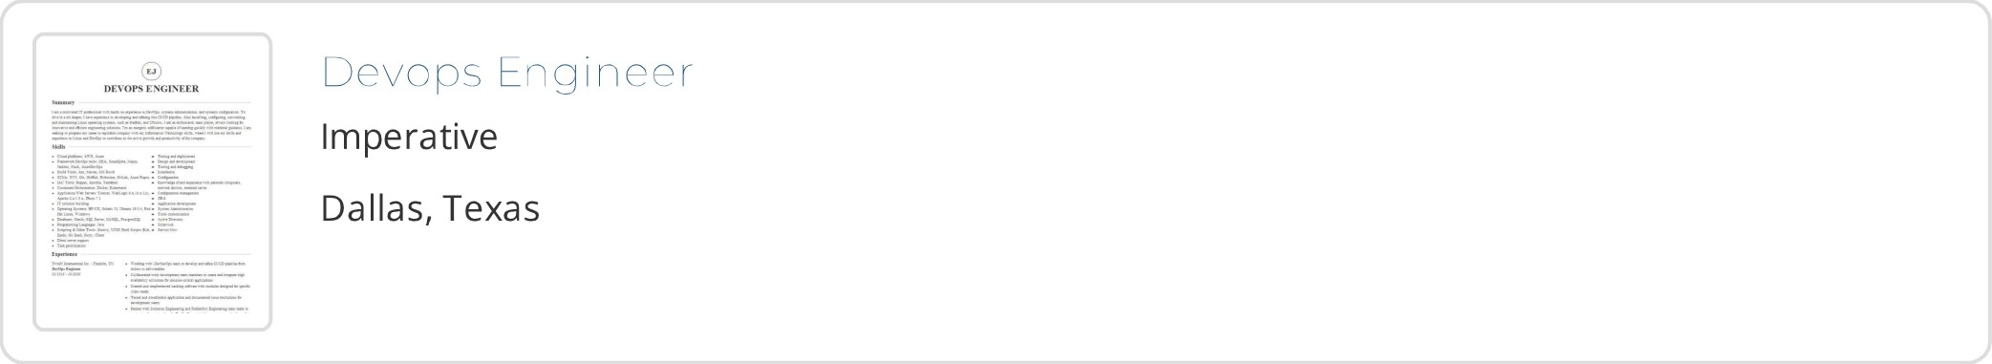



CST
About Us |  |  | DE | customerservice@livecareer.com
Priva cy | Work Here | UK | NL | 800-652-8430 Mon- Fri 8am - 8pm
Policy  Terms of  Use | Contact Us  FAQs  Accessibility | ES |  | CST  Sat 8am - 5pm CST, Sun 10am - 6pm
Stay in touch with us


© 2022, Bold Limited. All rights reserved.

