**Determination of oxalic acid employing a novel sensor based on graphene aerogel**

**Fereshteh Chekin*, a, Samira Bagherib and Sharifah Bee Abd Hamidb**

aDepartment of Chemistry, Ayatollah Amoli Branch, Islamic Azad University, Amol, Iran

bNanotechnology & Catalysis Research Centre (NANOCAT), IPS Building, University Malaya, 50603 Kuala Lumpur, Malaysia

*Corresponding author. Tel.: +98-121-2517000; Fax: +98-121-2517043; E-mail address: [fchekin@yahoo.com](mailto:fchekin@yahoo.com)

1. **Introduction**

Oxalic acid is widely distributed as calcium and magnesium salts in plant cells and cell walls (Hong et al., 2003). In human, precipitation of calcium oxalate may lead to the formation of kidney stones. The determination of oxalic acid is therefore of considerable significance, especially in clinical diagnosis. There have been various instrumental analytical techniques such as gas chromatography, liquid chromatography (Wu et al., 1999), flow-injection catalytic spectrophotometry (Ensafi & Kazemzadeh, 2000), ion exclusion chromatography (Yang et al., 2000) and enzymatic methods (Perez et al., 2001). However, most of the current adopted methods are time consuming or costly. So it can be expected that they can be easily detected electrochemically (Chekin et al., 2012)

Electrochemical analysis is a promising instrumental technique for the detection of oxalic acid, which is based on the catalytic or a noncatalytic oxidation of oxalic acid in the presence of air or oxygen (Zheng et al., 2009). The electrochemical behavior of oxalic acid at traditional electrodes such as platinum (Berna et al., 2004), gold (Berna et al., 2006), palladium (Martinez-Huitle et al., 2004) and boron-doped diamond electrode (Ivandini et al., 2006) has been extensively studied. Nevertheless, the oxidation of oxalic acid at traditional electrodes usually requires high overpotential. Thus, various modified electrodes such as cobalt phthalocyanine chemically modified glassy carbon (GC) electrode (Santos & Baldwin, 1986), Rh octaethylporphyrin modified carbon black electrode (Yamazaki et al., 2007), SiO2/SnO2 mixed oxide (Canevari et al., 2007), carbon nanotubes modified GC electrode (Zheng et al., 2009), palladium nanoparticle-loaded carbon nanofiber modified carbon paste electrode (Liu et al., 2010) and exfoliated graphite-polystyrene composite electrode (Manea et al., 2007) have been prepared to study the electrocatalytic oxidation of oxalic acid. In this work, we studied the electrochemical oxidation of oxalic acid using graphene aerogel-modified electrode. The result indicated that the oxidation of oxalic acid was significantly improved by the graphene aerogel. With such a graphene aerogel-modified electrode, oxalic acid in tomato and onion was successfully detected.

**2. Experimental**

**2.1. Chemicals and apparatus**

Graphite flakes were purchased from Asbury Graphite Mills, Inc (Asbury, N J). All the reagents like HCl (AR: 37.5%), H2SO4 (AR: 98%), H2O2 (AR: 30%) and H3PO4 (AR: 60 %) were obtained from Fluka Chemicals (Germany). Potassium permanganate was purchased from Tianjin Jiangtian Chemical Reagent Co. Oxalic Acid was of analytical grade from Merck. Other reagents were of analytical grade and purchased from Aldrich or Merck and used as received without further purification.

All voltammetric measurements were performed with an Autolab Potentiostat/Galvanostat (Netherlands) coupled to a Pentium ІV personal computer. The experiments were performed using a conventional three-electrode cell at room temperature. A working modified glassy carbon (GC) electrode, a saturated Ag|AgCl|KCl3M reference electrode, and a platinum wire auxiliary electrode were used. Hitachi S-3500N scanning electron microscope (SEM) was used for surface image measurements and chemical characterization of a specimen. The crystallization and purity of the synthesized samples were characterized by X-ray diffraction. All experiments were carried out at room temperature.

**2.2. Synthesis of graphene aerosols**

Graphene oxide was fabricated based on the modified Hammer’s method (Hummers & Offeman, 1958). To synthesize the self-assembled three dimensional reduced graphene oxides, 40 mL solution of 1 mg/mL homogeneous graphene oxide aqueous dispersion was sonicated for 15 minutes and then they were sealed in a 25-mL Teflon-lined autoclave for hydrothermal reaction at 180 °C for 18 hours. Then the autoclave left outside to cool naturally at room temperature and then the reduced graphene oxide hydrogel were taken out with help of tweezers and put on filter paper in order remove surface adsorbed water. Then for characterization purposes samples were transferred to freezer for 48 hours and then  freeze-drying for 24 h, freeze drying is used to fix three dimensional structure made by interlinked G-sheets and yields spongy assembly, after this all the solvents in as prepared hydrogel is removed and final 3D graphene aerogels were  synthesized that retain the morphology of parent hydrogel.

**2.3. Preparation of modified electrodes**

Prior to modification, the bare GCE was polished on chamois leather with 0.05 μm alumina powder. Then it was thoroughly sonicated in deionized water and absolute ethanol, respectively. 1.0 mg graphene aerosol was dispersed in 5 mL ethanol with the aid of ultrasonic agitation to give a black dispersion. The cleaned GCE was coated by casting 5 μL of the black graphene aerosol suspension and dried at 50 °C in an oven air to remove the solvent.

1. **Results and discussion**

**3.1. The SEM study**

The graphene aerosol SEM images at different magnitudes are shown in Fig. 1. GA shows interconnected porous structure. The porosity of GO aerogels is depended on the GO concentration used to prepare GO aerogels. They are randomly distributed on the whole but do have a regular arrangement.

**3.2. Powder X-ray diffraction study**

Fig. 1 represents XRD pattern of graphene oxide (GO) and graphene aerosol (GA). A sharp peak at 2θ= 10which correspond to (001) diffraction peak is correspond to GO structure. From brags equation, the interlayer spacing of GO is estimated around 9 ᵒA which is due to the oxygen functional groups in graphene oxide and definitely much higher than interlayer spacing in graphite at (002) diffraction peak reflection (about 3 ᵒA). This increment is because of oxygen-containing functional groups presence on GO sheets after oxidation of graphite. As we can see in diffraction pattern of GA the sharp peak 2θ=10 disappeared which bring more evidence for the reduction of GO. So the interlayer spacing of the GA was estimated around 3.83 ᵒA, which is much less than that of GO precursor (9 ᵒA) but a bit more than that of reported natural graphite interlayer spacing around 3.36 ᵒA. These results imply presence of some oxygenated functional groups on GA sheets and they can help for water encapsulation during self assembly due to their hydrophilic properties. In addition, this restacking of graphene sheets (reduction of interlayer spacing of GA) led to effective preparation of reduced graphene oxide hydrogel. Finally broad peak of XRD pattern of GA implies poor crystalline of graphene sheets along the stacking direction and demonstrate that the structure of the GA is consist of stacking of few layers graphene sheets.

**3.3. The Raman spectroscopy**

To further elaborate on the order/disorder degree in the sp2 network, Raman spectra of GO and GA are shown in Fig. 3. Two main characteristic peaks are well known for materials, G mode due to first order Fig. 2 scattering of the E2g photon of sp2 C atoms (~1585 cm-1), and D mode resulting from a breathing mode of j-point photons of A1g symmetry (~1348 cm-1). GA shows higher intensity ratio of D-band to G-band. The higher ratio quantifying the density of defects in sp2 carbon atoms suggests an increase in the number of smaller graphene domains (Chen et al., 2012; Lee et al., 2014).

**3.4. Electrochemical determination of OA at graphene aerosol modified GCE**

We have examined the electrocatalytic activity of graphene aerosolfilm deposited on GCE (GA/GCE) toward OA electrooxidation in buffer solution (pH 7.00) using cyclic voltammetry (Fig. 4). We obtained higher oxidation current with less positive potential for OA at GA/GCE. Bare GCE shows an oxidation wave at 1.4 V for OA (curve c). On the other hand, the GA/GCE exhibits a well-defined oxidation wave for OA at 1.15 (curve d). The obtained clear voltammetric signal with higher oxidation current and less positive potential for OA at GA/GCE was attributed that the oxidation of OA was catalyzed by graphene aerosol.

The cyclic voltammograms of the GA/GCE in 0.1 M PBS (pH 7.00) in presence of 0.03 mM OA at various scan rates. It was observed that the anodic peak current is linearly proportional to square scan rate (Fig. 5B), suggesting that the OA reaction is a diffusion-controlled process.

**3.5. Effect of pH on OA oxidation**

It well known, the electrochemical behavior of OA is dependent on the pH value of the aqueous solution (Zheng et al., 2009). The effect of pH value on the electrooxidation of OA at the surface of GA/GCE was investigated through the use of different 0.1 M phosphate buffer solutions (pH 3.00–9.00). The current response of OA at GA/GCE increases from pH 3.00 to 7.00 and then a decrease is obtained at pH values higher than 7.00 (not shown). Therefore, pH 7.00 was chosen as optimum pH and further studies were performed at pH = 7.00.

**3.6. Voltammetry determination of OA**

The cyclic voltammograms obtained for OA at GA/GCEin 0.1 M PBS (pH 7.00). The dependence of current response with respect to concentration of OA was linear from 4–100 μM with an detection limit of 0.8 µM at GA/GCE, a high sensitivity of 677.98 µA mM−1 and an correlation coefficient of 0.9901 (Fig. 6, inset).

The observed linear range and detection limit of OA were compared with the reported papers and are given in Table 1 (Ivandini et al., 2006; Liu et al., 2010; Manea et al., 2007; , Fakhari et al., 2012). As can be seen from Table 1, analytical parameters for OA detection of the sensor prepared in this work are comparable with other results. Further, the present modified electrode was highly stable and no tedious procedure was involved in electrode modification. In order to verify the reliability of the proposed method, the Pd/SBA-15/CPE was applied to analysis of OA in onion and tomato samples by cyclic voltammetry measurement. 1 mL of the onion and tomato water samples was diluted to 10 mL of 0.1 M PBS. The standard addition technique was used to examine the recovery of OA in onion and tomato samples. The analytical results are summarized in Table 2. Based on the same procedures for sample preparation, the content of OA detected using the proposed method was 4.27 ± 0.41 mg g-1 and 6.26 ± 0.54 mg g-1 for tomato and onion, respectively. The data obtained for the analysis OA was compared favorably with that obtained by the standard method (conventional KMnO4 titration). There is no significant difference between the labeled contents and those obtained by the proposed method. Therefore, the satisfactory results obtained with this method confirm the strong applicability of the GA/GCE in practical analysis.

**3.7. Interference study**

Possible interferences for the detection of OA at the GA/CPE was investigated by the addition of various compounds such as glycine, alanine, ascorbic acid, dopamine, uric acid, L-cysteine, glutathione, D-penicillamine, cystamine, N-acetyl-L-cysteine and lysine into pH 7.00 PBS in the presence of 0.05 mM OA. The results showed that these mentioned compounds did not show interference.

**3.8.** **Reproducibility and stability of the GA/GCE**

The operational stability of GA/GCE was tested by the CV method every 2 days in 2 weeks. The response to 0.1 mM OA decreased less than 14% after 2 weeks, so it has good stability. The fabrication reproducibility of five electrodes independently made, showed a R.S.D. of 5.2% for detecting 0.05 mM OA. The excellent reproducibility and stability of GA/GCE may be mainly attributed to the strong deposition of the graphene aerosol.

**4.** **Conclusion**

We have developed a graphene aerogel by an efficient and non-toxic hydrothermal synthesis. Structural characterization using SEM, XRD and Raman spectroscopy suggests that the graphene aerogel has highly porous structure. The graphene aerosol modified electrode has been successfully utilized in the selective detection of OA. The graphene aerosol modified electrode shows excellent linearity from 4 to 100 µM, lower detection limit of 0.8 µM, and sustaining stability for two weeks. The proposed method has been applied to the determination of oxalic acid in tomato and onion samples with satisfactory results. The present procedure has the advantages of the operation simplicity, rapidity and low analytical cost. It is simple, highly sensitive, and free from interference of common biological and pharmaceutical compounds and has much more practical value for the determination of trace oxalic acid in food samples.

**Figure caption**

**Figure 1.** SEM image of GA.

**Figure 3.** Raman spectroscopy of GA.

**Figure 4.** Cyclic voltammograms of (a) GCE and (b) GA/GCE in absence of OA and (c) GCE and (d) GA/GCE in presence of 0.01 mM in 0.1 M PBS (pH 7.00) at scan rate 50 mV s-1.

**Figure 5.** (A) Cyclic voltammograms of 0.03 mM of OA in 0.1 M PBS solution (pH 7.00) and 0.1 M KCl as supporting electrolyte at various scan rates: (a) 10, (b) 20, (c) 30, (d) 40, (e) 50, (f) 60 and (g) 70 mV s−1 at GA/GCE. (B) Plot of peak currents vs. scan rates.

**Figure 6.** (A) Cyclic voltammograms of GA/GCE in the presence of (a) 4, (b) 15, (c) 50, (d) 100, (e) 200 and (f) 300 µM of OA in 0.1 M PBS solution (pH 7.00) at scan rate of 50 mV s−1. (B) Plat of current vs. OA concentration.

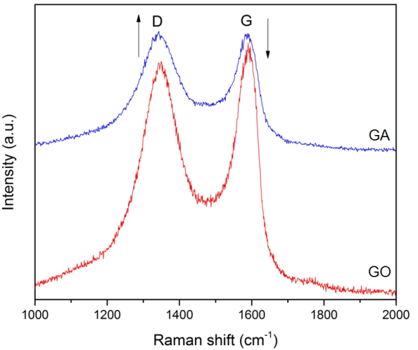

**Fig. 3**

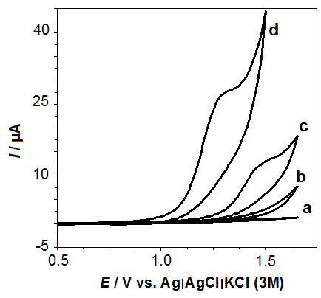

**Fig. 4**

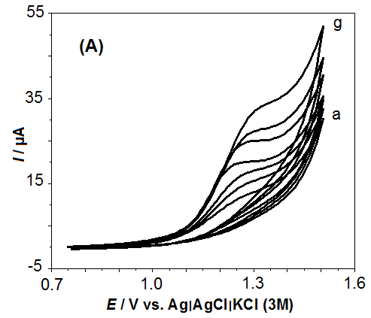

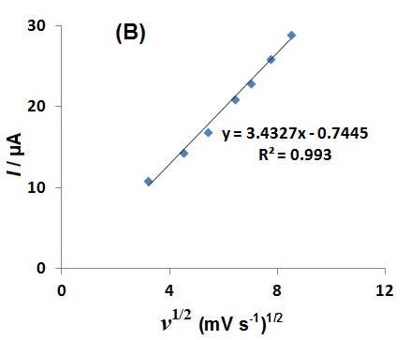

**Fig. 5**

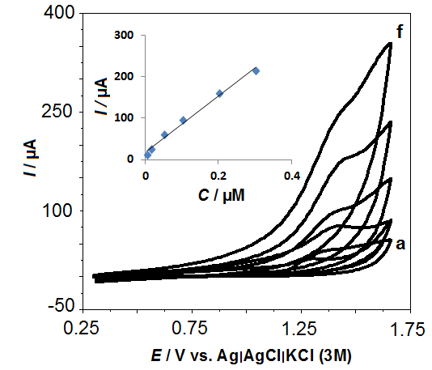

**Fig. 6**