**Code Repository Tool (Version Managemenet)**

To develope app. we write different types of files in projects (like java, xml,jsp etc..). All these files are stored finally in a central server ie Code Repository. It maintains the details of code. like

> How many times code is modified?

> Who modified what code(+/- added/removed)

> Changes done on what date and time? Maintaining these details is known as Version Management/Version Control.

*)In developement mostly used tool is GIT(gitHub).

*)It maintains two level repository process for cross verify and commit.

*)For this we need to create an account in github.com(using email id and verify email after creation).

*)It maintains staging area to select /verify/comment the file while adding to local repository.

*)Git Process:-

Git Repository Types:-

Public : Free for every one

Private : Paid version.

Remote Repository(Steps):

->goto https://github.com/

->SignUp(Register) with details

->Goto Email -and verfiy Link

->login with un and pwd

->Create Repository Type Public (Companies uses-PrivateType)

->Copy Git Link: https://github.com/abcd/testVen.git

it is secured with un,pwd.

==============================

*)In eclipse->window->Show Views search for "GIT" select GitRepository and GitStaging.

->Window->showView->History.

--------creating local repository----

->Right Click on Project->Team

->Share project->select checkbox "create or use repository"

->select option shown below

->click create repository button->finish

=x=x=x=x=x=x=x=x=x=x=x=x=x=x=x=x=x=x=x=x=

GIT Operations with Flow:-

i)add file to git staging (Click-drag-drop).

ii)Commit and Push

iii)Paste Git Link in URI input box

iv)enter userName and password.

v)next/next/finish.

vi)right click on project->team->pull->then ->rebase to update local from remote.

**)Can you provide GIT/Client/Apps URLs? No, Sorry.all details whar you are asking is private and confidencial. I can not provide those.

*)Who created your git account ?

Git administrator name-"XYZ",in my company. He handles all permission and auth. details.

*)What type of Account Repository areyou using?

It is private account handled by company.

*)When you check-in or push your code?

After Implementation of complete module and UnitTesting code in my local, I'll push to remote.

*)How will you find about one file all modification??

We use history option in eclipse

->right click->team->shown in history.

we can also choose any two files to compare with each other ex:select

any history options->right click->compare with each other.

*)How do you identify code modifications in GIT?

Using Symbols (+) code is added (-) code is removed.

*)What is the difference between commit and push?

commit: update code from workspace to Local Repository

push :Update code from local to remote repository.

*)How can you update you workspace/local with remote?

By using pull and rebase operations.

<https://github.com/>

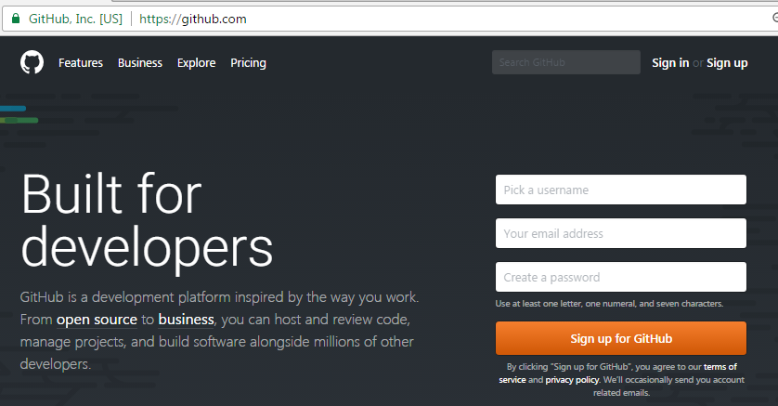

Goto email account and click on verify link.

Click on signin

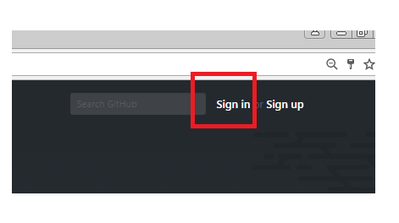

Enter un,pwd

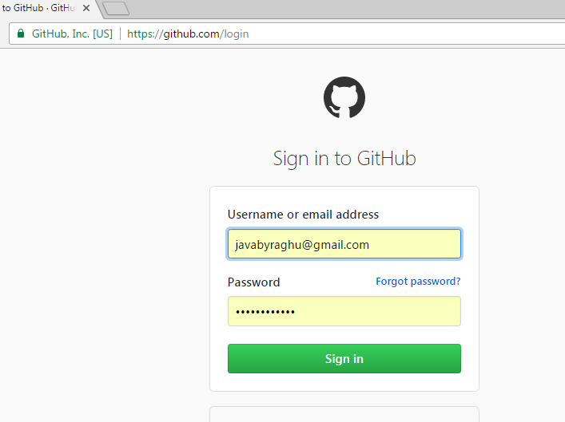

Click on new Repository

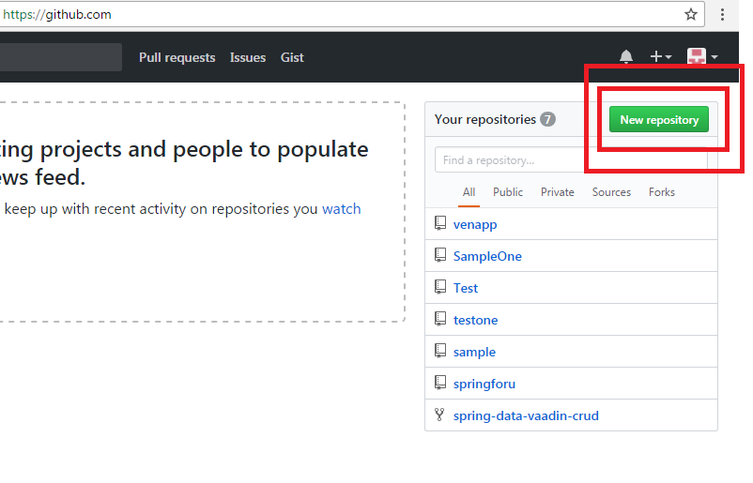

Provide Repository Details

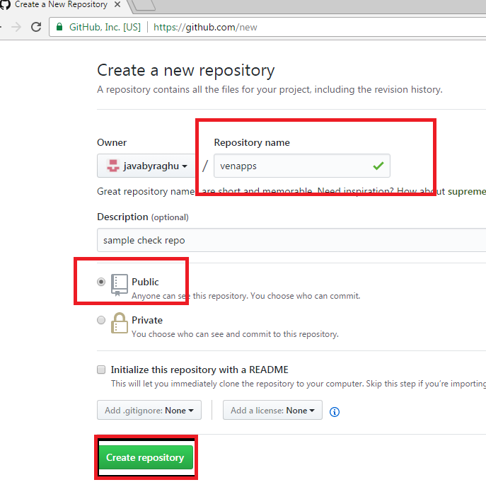

On click create repository

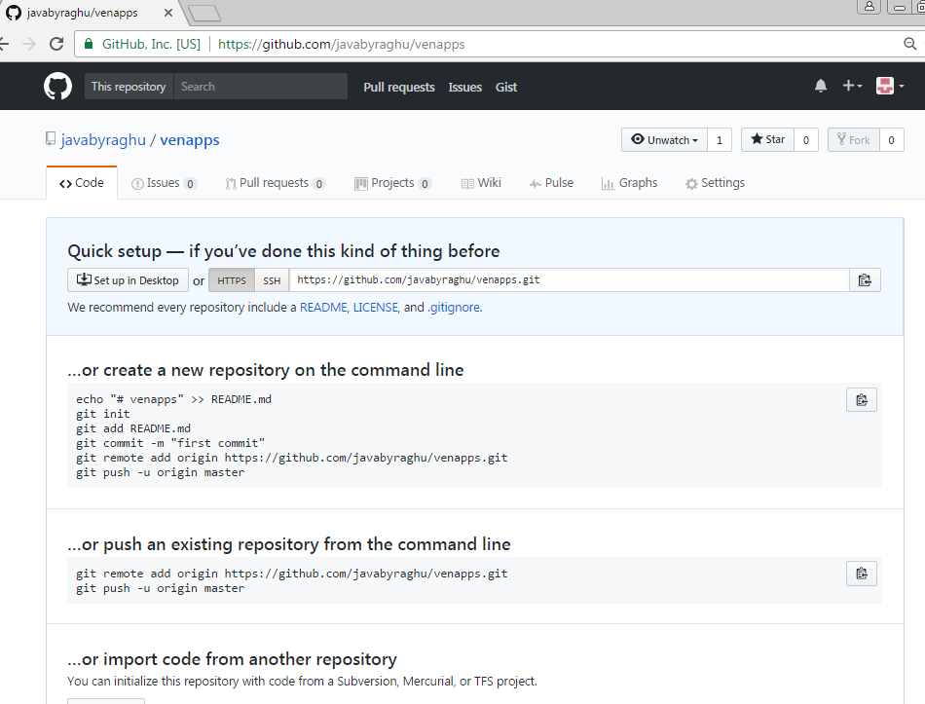

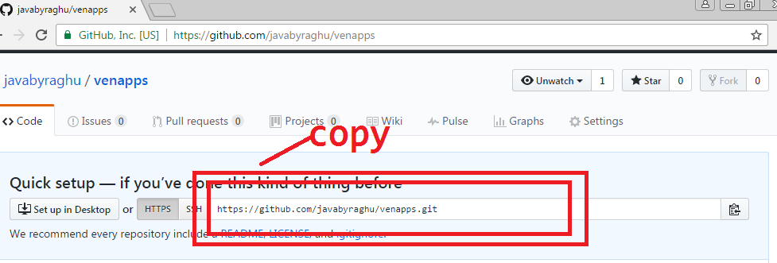

Ex : (Repository Link)

<https://github.com/javabyraghu/venapps.git>

Got Eclipse:

* Create A new Java Project **(project name and repository name**

**Should be same )**

* Add Git Views

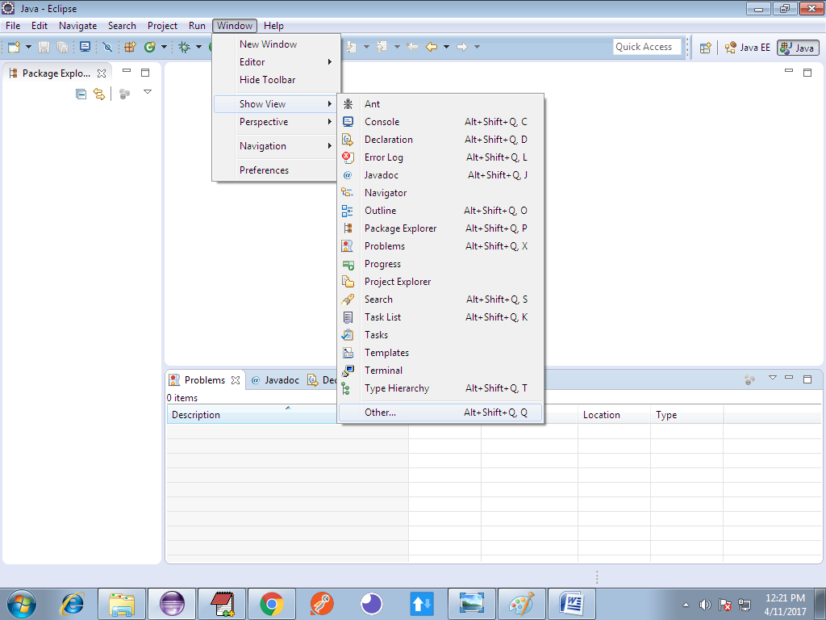

Serach with Git, select Git Repository, Staging

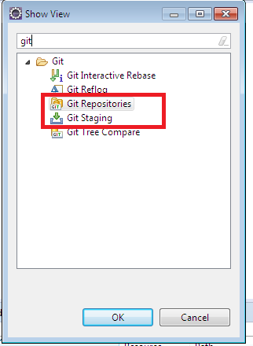

Observer options like

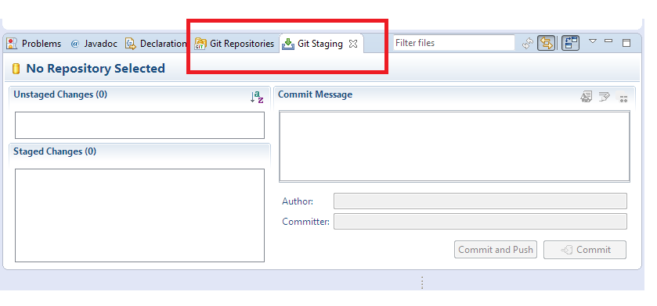

After writing of some code ex: Employee.java

>right click on project > tem > share project

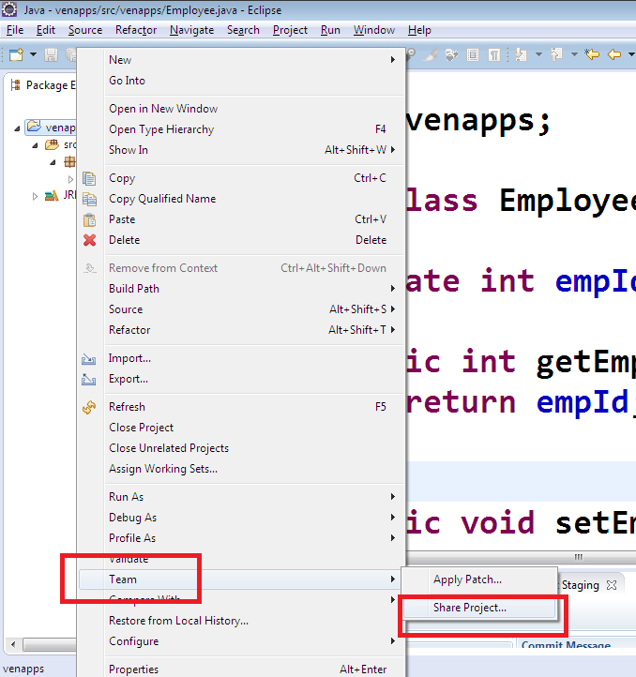looks as below:

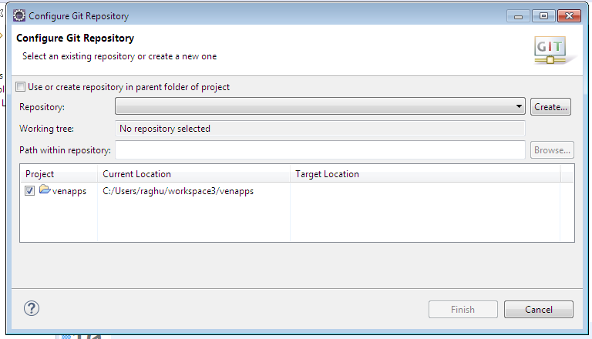

Click on check box:

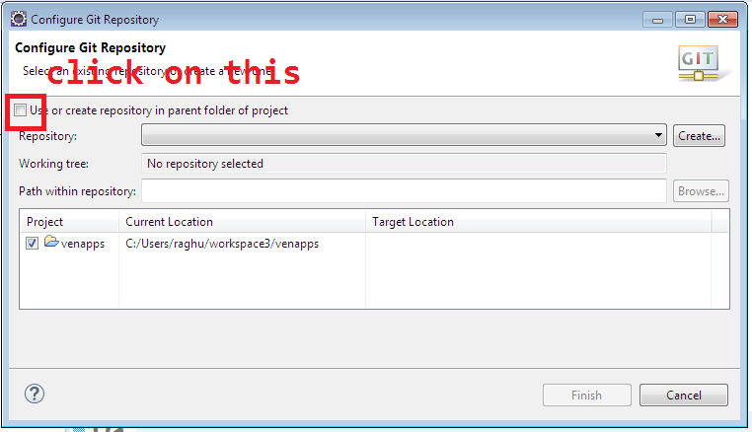looks as below:

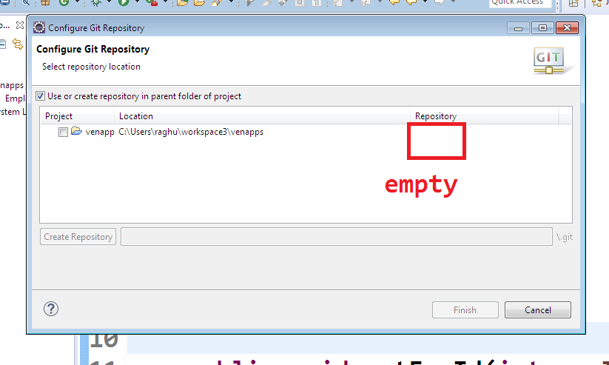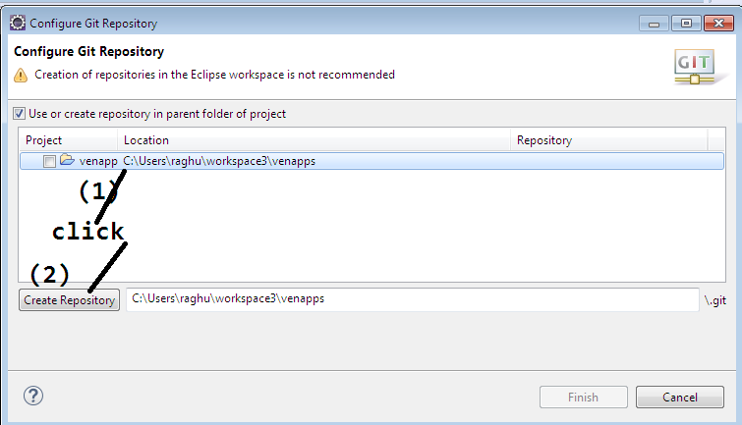then observe repository name:

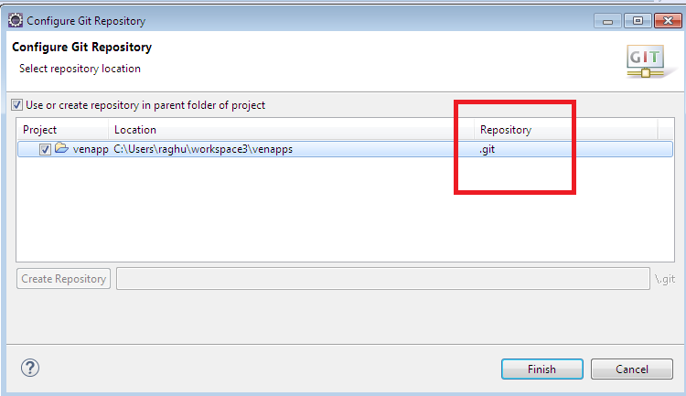click on finish.

By this we created local and remote repositories.

Now link local and remote, using firsh commit and push.

Come to git repositoes

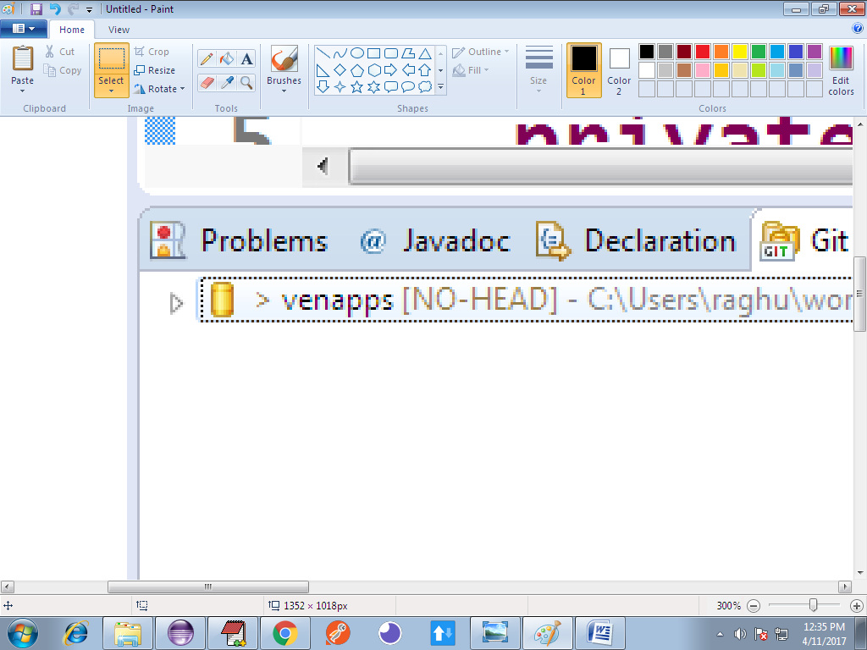

In staging are:

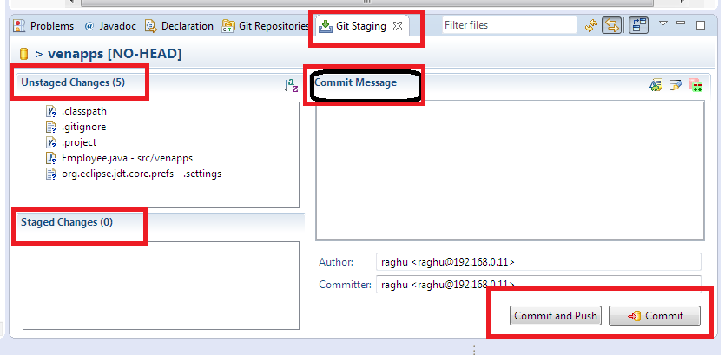

1)Unstaged changes : files which are not ready to send to local

2)staged chages: file which needs to move to local/remote

3)commit message: what is the purpose specify here as message for sending of this code.

4) click commit/ commit & push to send the code.

*)Click on a file in unstage drag and drop into stage.

Click and Drag:

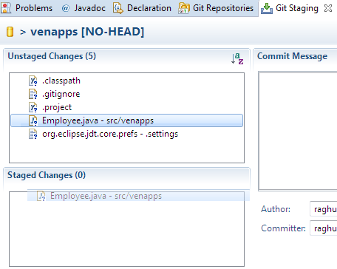

After drop

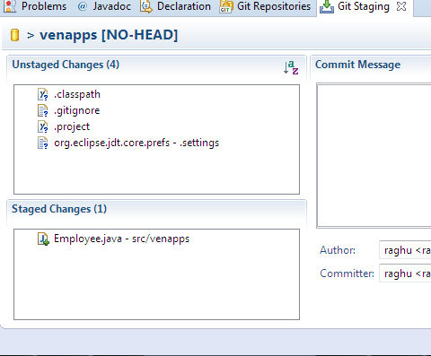

Enter commit message

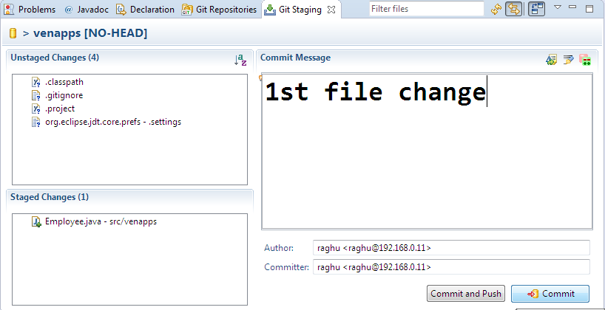

And click on commit

In GitRepository , right click on projectName>choose Push Branch master

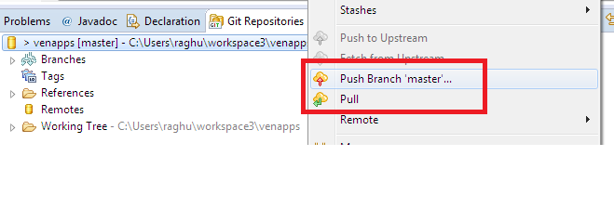

After Push option one screen looks below, there enter URI

(Repository link)

Ex: <https://github.com/javabyraghu/venapps.git>

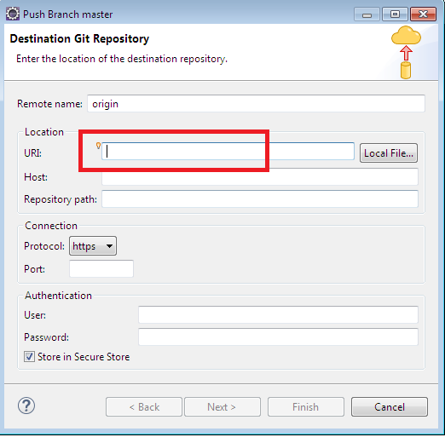

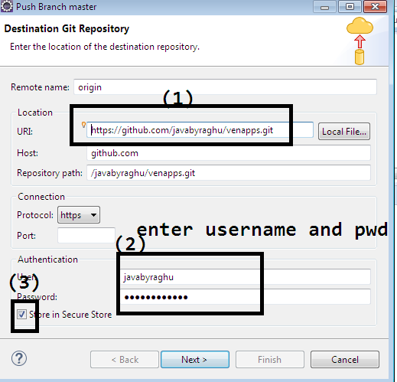

Click on next>next>finish

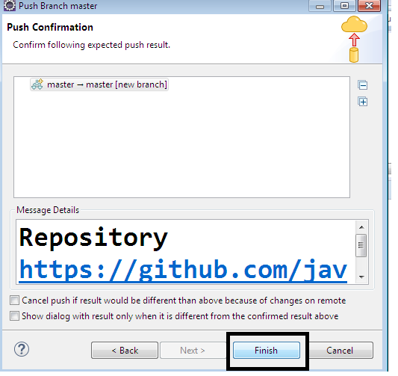

Shows as below:

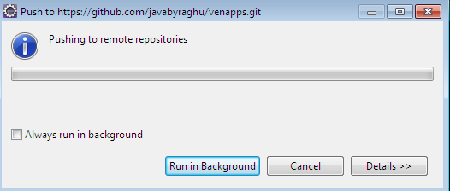

On success:

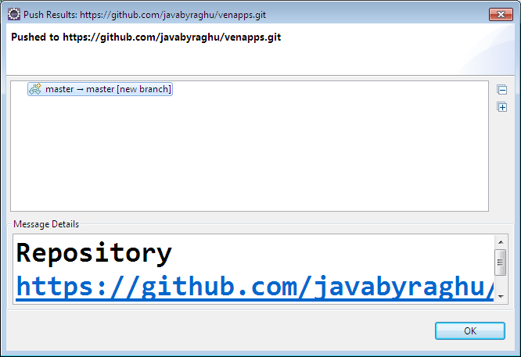

Come back to browser and refresh:

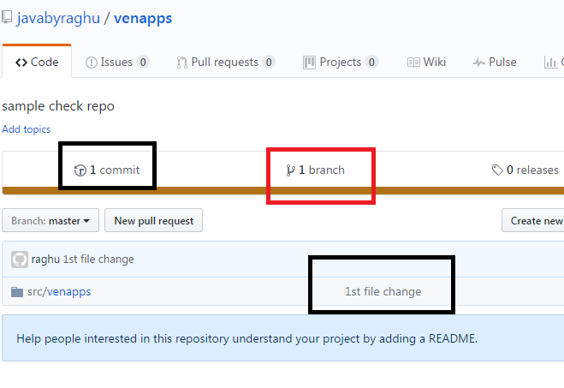

Click on src/venapp>Employee.java

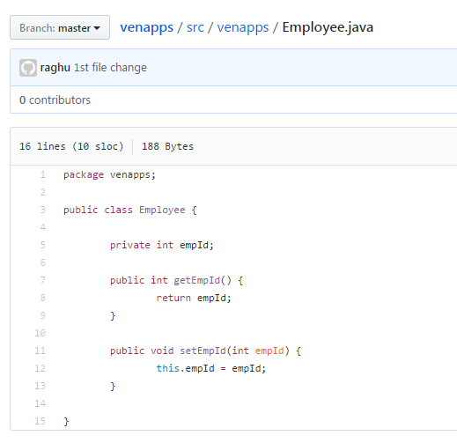

Right click on project: pull and then rebase for other update:

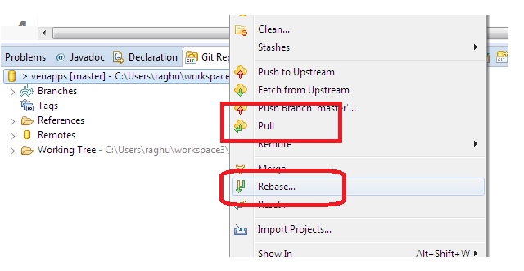

***)After Ading file to staging ,double click on that to comapre with

Old one (previous one)looks as :

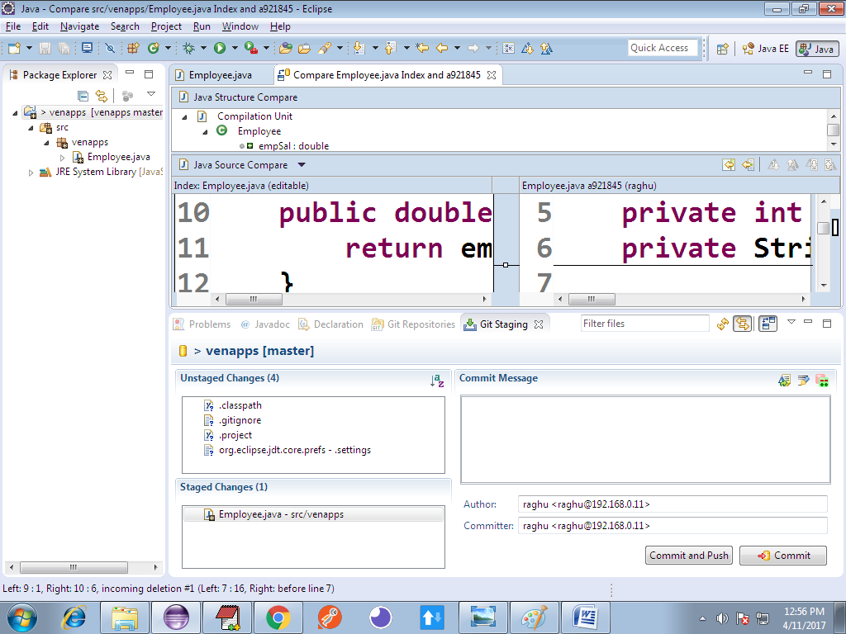

To see history:

Right click on File (ex: Employee.java)> Team>Showin History

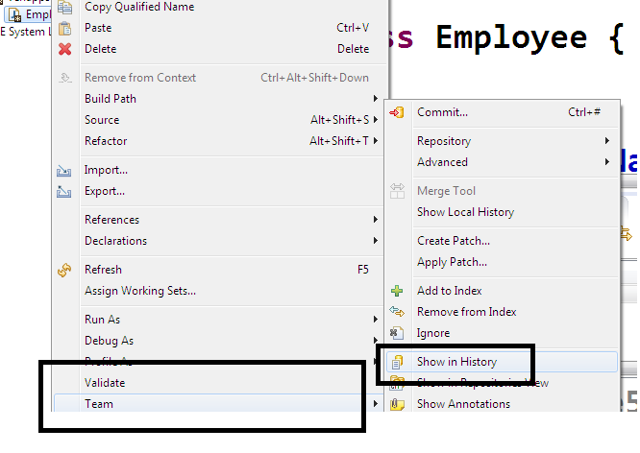

View history:

