Publishing/ Subscribe Messages to/from Kafka from Microservice (MSBuilder)

Things to know before configuring Kafka:

1. Kafka Cluster IP
2. Zookeeper Cluster IP
3. Topic Name

**Publishing Messages to Kafka:**

Configure core-config yaml in exe as below:

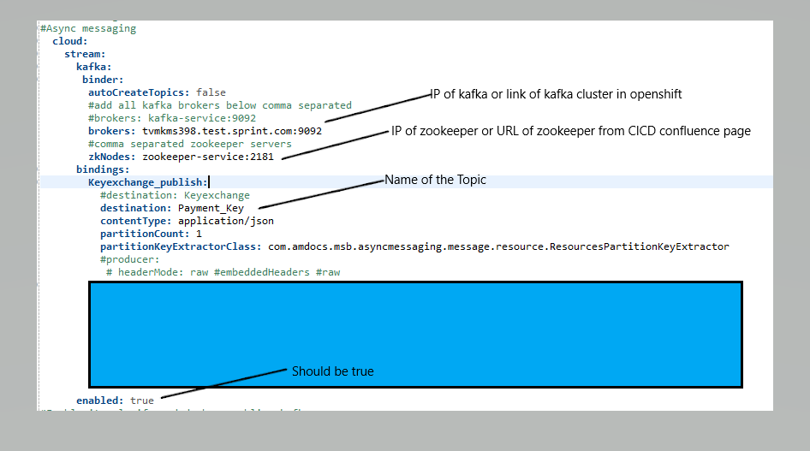

Create the Interface whose implementation will hold message data in *gateways.asyncmessaging.interface*

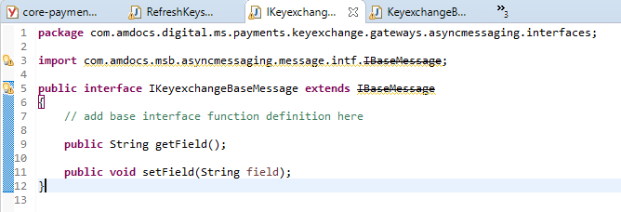



Create implementation of above in *gateways.asyncmessaging.implementation*

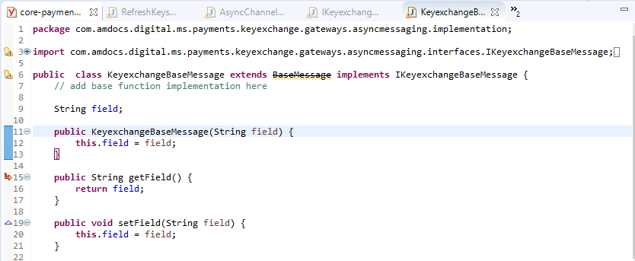



Create/edit delegate class in resource project

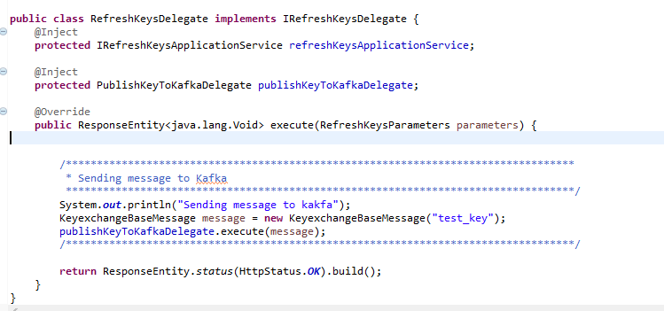



Create *PublishKeyToKafkaDelegate* extending *BaseDelegate* in gateway layer

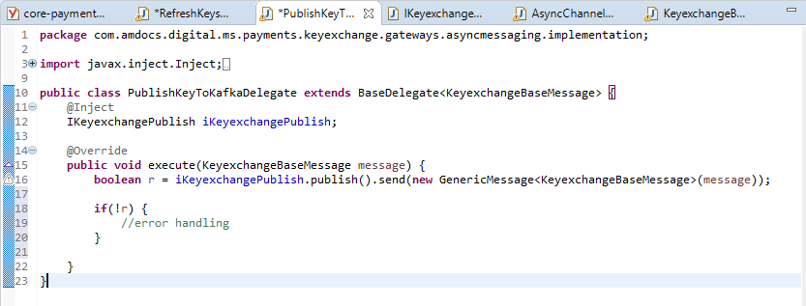



Create *IKeyexchangePublish* extending *ITopicPublish* in gateway layer

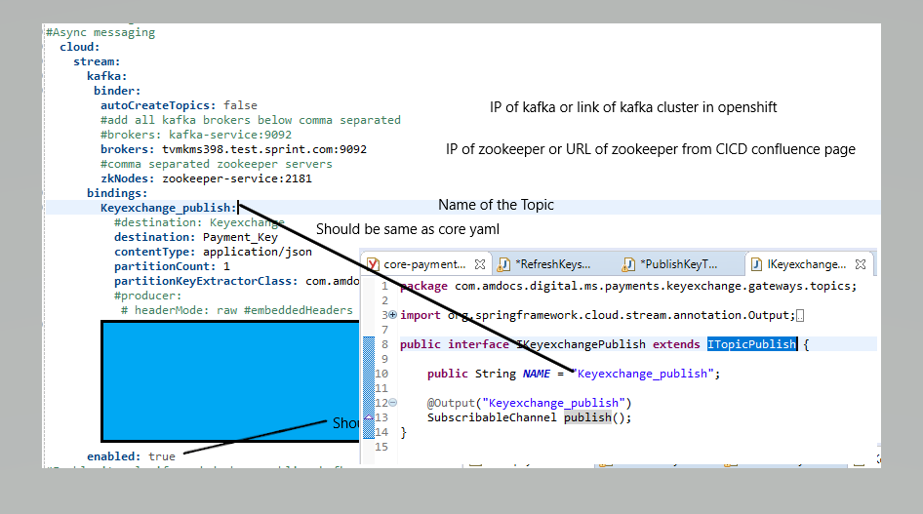

Enable binding with channel in *keyexchange.gateways.config*

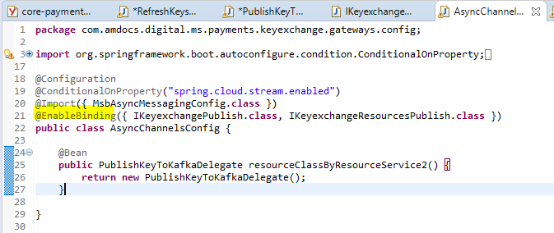



**Subscribing to the Kafka Topic**

Edit the core-config yaml as highlighted:

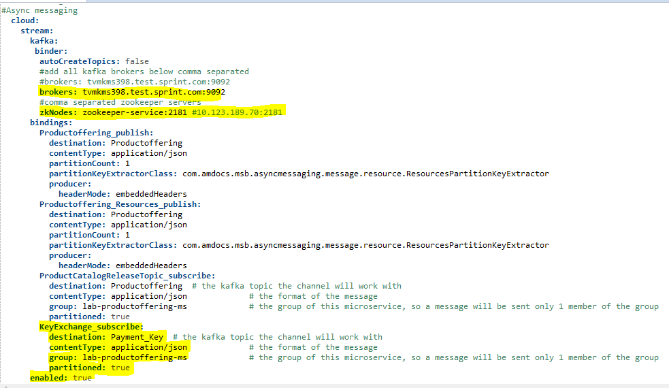

Edit /lab-productoffering-asyncmessages/src/main/resources/swagger/lab-productoffering-asyncmessages.*yaml* as below

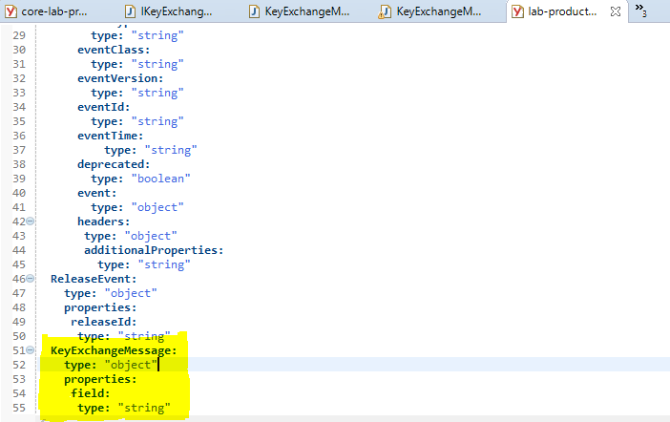

Run *maven clean install* to generate *KeyExchangeMessage.java* in lab-productoffering-asynmessages

Create Channel in gateway layer

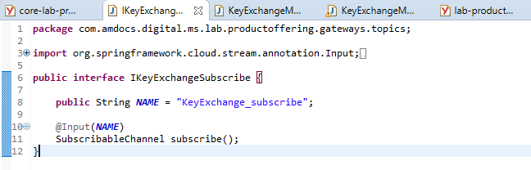



Create Handler in *gateways.asyncmessaging.implementation* extending *BaseHandleMessage*

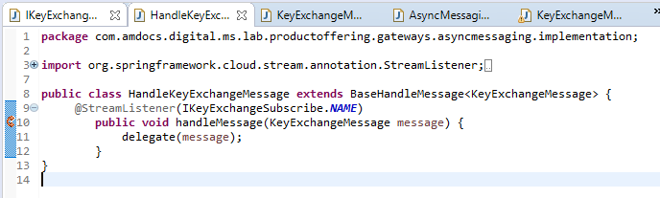

Create the Delegate in gateways.asyncmessaging.implementation

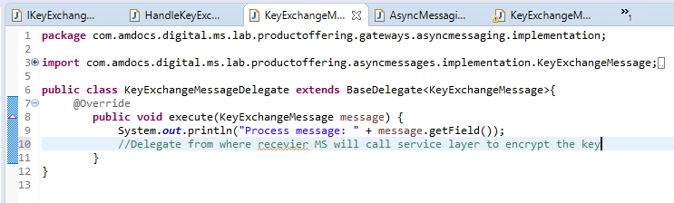

Configure above classes in AsynChannelsConfig.java in gateway layer and enable binding with the kafka channel

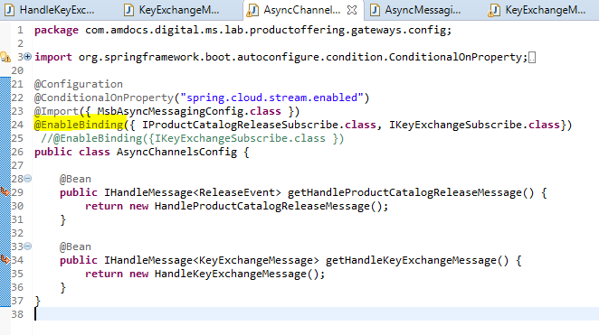

Configure the message in AsyncMessagingConfig.java

