

USER MANUAL

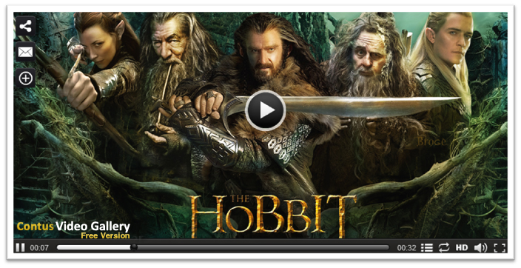

WordPress Video Gallery

Product Version : 2.3.1.0.1

Compatible : WordPress 3.0+

WordPress Video Gallery! Brings life to WordPress pages by allowing you to play popular video formats such as MP4, M4V, M4A, MOV, Mp4v,FLV and F4V in different browsers. With some salient features like HTML5 support to play videos in iPhones & iPads, RTMP streaming, Monetization, Native language support, and Social Bookmarking, the player promises to be ultimately unique.

CONTENTS

Preface | 4
- About This Document | 4
- Updates, Comments, and Suggestions | 4
- Disclaimer | 4
WordPress Video Gallery | 5
- Video Gallery Plugin | 5
- Video Gallery Widgets  - Downloading Video Gallery | 5  6
Installation Steps | 7
Video Gallery Plugin | 9
- All Videos | 10
- Settings | 15
- Categories | 21
- Video Ads | 21
Video Gallery Widgets | 24
- Using Video Gallery Widgets | 24
Video Gallery Short code  Contact Us | 26  28

Preface

About This Document

This document provides information on how to download, install, configure and use Video Gallery for WordPress.

Updates, Comments, and Suggestions

Please forward your valuable comments, suggestions or questions about the information contained in this document to assist@apptha.com.

Disclaimer

Apptha reserves the right to add, remove, modify business models, processes related to Packaging, selling, marketing, developing extensions and themes of Apptha.com at any time and without prior notification. Apptha reserves the right to add new features to its products based on research and market needs. Apptha reserves the right to remove any feature of its products that does not fulfill expectations.

WordPress Video Gallery

Video Gallery Plugin

It is the main functional unit of WordPress Video Gallery, which typically adds video player to your WordPress Site with the most advanced configurable options for playing or streaming videos on browsers. This WordPress Plugin is usually displayed in the main body area of a template (depends upon on the template).

When the “Video Gallery” is installed to your WordPress site/blog, the pages “Videos” and “Video Categories” with an appropriate plugin codes will be created automatically. The page “Videos” will be available in front end. On this page in front end, the video player will be displayed. Below the video player, the videos will be ordered as popular, featured and recent. In admin panel, the admin will have full control for this page.

- Display area: Videos page – The Gallery will become the main content of this page.

Video Gallery Widgets

These are lightweight and flexible units of WordPress Video Gallery, which helps visitors to search videos, list video categories and order videos as popular, featured, recent and related. These widgets can be added to any sidebar (based on template) by the default drag and drop feature of WordPress in admin panel. Each widget will have it's own settings so that you can configure widgets as per your needs.

- Display area: Not the Content of a page: Sidebar, header, footer, etc.

1. Search Videos
2. Video Categories
3. Popular Videos
4. Featured Videos
5. Recent Videos
6. Related Videos

Downloading Video Gallery?
Video Gallery for WordPress is available in two different versions namely Free Version and
Pro Version.

Free Version (Branded): This version comes at free of cost. It is suitable for non-commercial needs. In this package, our demo logo serves the branding purpose.

Pro Version (No Branding): By applying the commercial license, you can remove our demo logo effortlessly. It is suitable for commercial businesses since they require no branding. The commercial license can be purchased for your website by offering a onetime fee for brand removal.

Download Video Gallery free version for WordPress: The Video Gallery can be downloaded by clicking the link “Free Download” below.
http://downloads.wordpress.org/plugin/contus-video-gallery.2.3.zip

Download Video Gallery commercial version for WordPress: The Commercial license can be purchased by clicking the button “Buy Now” in the following page.
http://www.apptha.com/category/extension/WordPress/Video-Gallery

Installation Steps

Installing Video Gallery is really straight forward. You can install in two ways.
- You can install directly from http://www.wordpress.org website by searching Plugin in admin panel.
- Login to your WordPress administration area and go to Plugins > Add New > and type “Video Gallery” in search box and click search button.
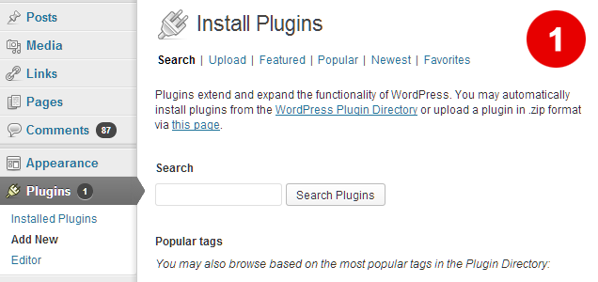

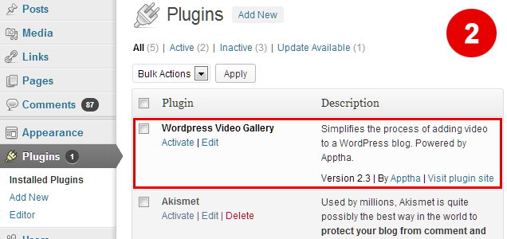

- Click “install now” link or download the file(plugin) from apptha.com or WordPress.org,

Login to your WordPress administration area and go to Plugins → Add New → Upload → choose the downloaded file and click install now.
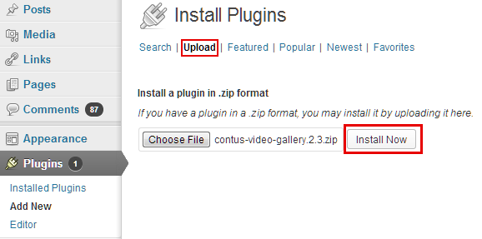

You have completed installation successfully.

Video Gallery Plugin

Using Video Gallery Plugin:

Once you installed plugin, it will automatically create two pages in the name “Videos” and “Video Categories”. “Videos” page is the main page for video gallery. The page “Video Categories” is a hidden page to access video more pages like “Popular Videos”, “Recent Videos”, “Featured Videos”, “Category pages”, and “Search Page”. Please don’t delete these two pages. If you don’t want to display “Video Categories” page in menu, then deleted the title of the page and save as “no title”.

Now, you can visit the frontend with the menu created for Video Gallery.
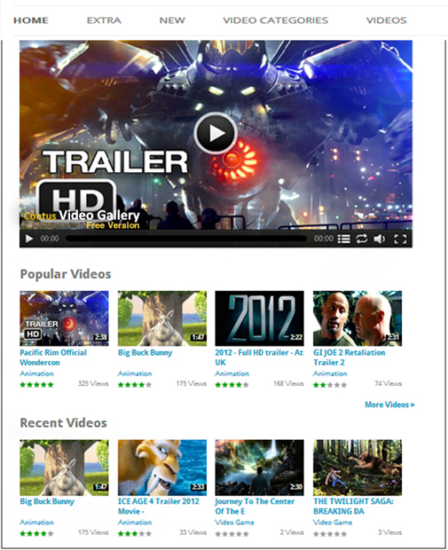
Configuring Video Gallery Plugin:

To configure Video Gallery plugin go to Admin > Video Gallery > All Videos.

All Videos – To Manage Videos:

This is the first tab and it is responsible to add videos. The Video Gallery accepts both streaming and normal videos. You can add videos through following methods: Upload, Custom URL, YouTube URL, RTMP and Embed video.

We provided few common options while adding videos,

- Title - This gives a title for the video added.
- Description - This provides an individual description for the video added.
- Category part - This option is provided to select the category name added. You can also add your new category in this portion.
- Tags/Keywords – These tags will be displayed below the video in front end. It helps user to find the page for relevant words through search engines. It also helps your site visitors to search videos through “Search videos” Widget.
- Featured Video – This option provides to enable or disable the featured option for videos.
- Post – roll ads - This option is used to add any video ads after the video and you can either enable or disable for any video.
- Pre – roll ads - This option is used to add any video ads before the video and you can either enable or disable for any video.
- Mid – roll ad - This option is used to display the banner ad while playing the video and you can either enable or disable for any video.
- IMA ad - This option is used to play the intermediate ad of the video and you can either enable or disable for any video.
- Download - This used to either enable /disable the download option for video.
- Publish – This is to publish or disable published video.

Adding Videos through Upload Method:

- If you would like to let users to switch videos between HD and Non-HD types, then you have to upload videos in both HD and Non-HD formats.
- If you don’t want to give the users a choice, then you can upload any one of the videos, either HD or Non-HD. Leave the second field “Upload HD Video (optional)” as blank.
- After uploading the videos, you also have to upload thumbnail image and preview image for the respective video. Below this, there is a video info section where you can add Title, Description, assign category, enable feature, enable download, enable post-roll, pre- roll ads for this video.
- When you are adding videos through YouTube method, we will get duration from YouTube. Whereas when you are adding videos through upload method, it is not possible to get duration from the uploaded video. For this purpose, we have FFMPEG option to generate duration for the uploaded video. For this you need to enter your FFMPEG path in Video Gallery Settings in the following path.
Admin -> Video Gallery -> Settings -> General Settings -> FFMPEG Path.

Adding Videos through Custom URL Method

Upload the videos and images through FTP to any location on your web server. For instance, you can add videos to videos folder and images to images folder on your web server and provide the absolute path here.
Like this:
Video URL: http://www.yourdomain.com/videos/video.mp4
Thumb URL: http://www.yourdomain.com/images/image.jpg

Below this, there is a video info section where you can add Title, Description, assign category, enable feature, enable download, enable post-roll, pre- roll ads for this video.

Adding Videos from You Tube:

To avoid bandwidth consumption from your web server, you can also add videos to the YouTube
and can provide YouTube link here. You can get the YouTube URL of the video from the top of the YouTube website.

Below this, there is a video info section where you can add Title, Description, assign category, enable feature, enable download, enable post-roll, pre-roll ads for this video.
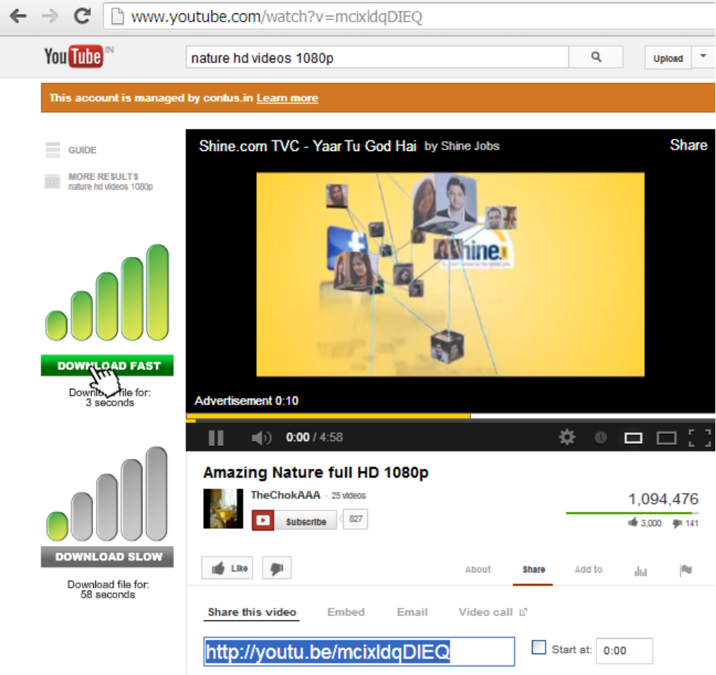

Adding videos through RTMP:

With Video Gallery we can stream RTMP videos, the RTMP video URL will be rtmp://streamer path/video file
For instance:
rtmp://edge01.fms.dutchview.nl/botr/bunnyflv
Streamer path = [protocol]/[server name]/[application]
URL= [stream name]
- [Protocol]: You can use the following protocols: rtmp, rtmpt, rtmpe, rtmpte, rtmps
- [Server name]: this is the IP Address, or the domain name of your server. (i.e., localhost).
- [Application]: use “vod” unless you have changed the name of the folder.
- [Stream name]: use the name of your video file (including the extension).
rtmp://localhost/vod/mp4:mystream.f4v
rtmpe://localhost/vod/myvideo.flv
When adding RTMP videos we need to provide few options:

- Streamer Path - You need to provide the streamer path as “edge01.fms.dutchview.nl/botr.”
- Is Live - This option is to enable/disable whether the video is live or not.
- Video URL - You need to provide the video URL as “bunny.flv.”
- Thumb URL - You can provide the thumb URL as “car.jpg.”
- Preview URL - This is just a preview option provided for Thumb image

Sorting/ordering the videos

Ordering or sorting the videos on Video Gallery plugin has become simpler now. It can be done easily by drag-and-drop.

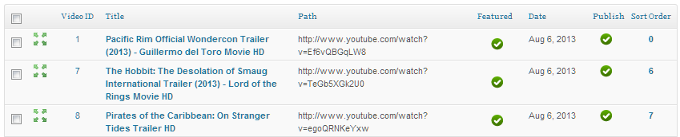

Adding videos via Embed code:

Using this method, videos can be added via embed code. You can display other players from different website in your website using embed codes. For example, you can display YouTube or Vimeo player in your site.

Example:

YouTube Embed code:-

<iframe width="560" height="315" src="//www.youtube.com/embed/mcixldqDIEQ" frameborder="0" allowfullscreen></iframe>

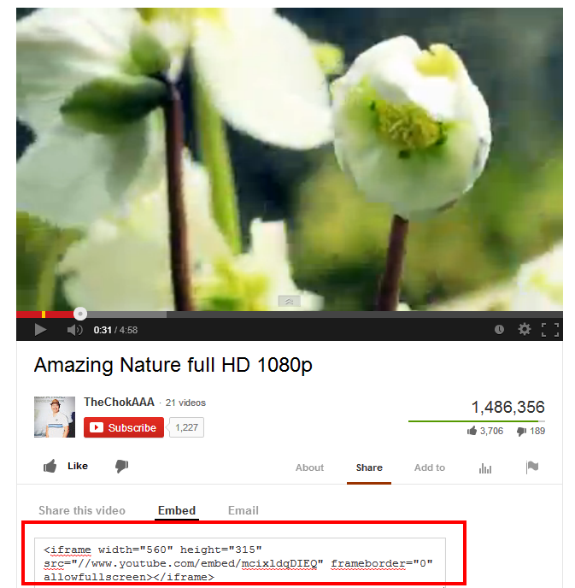

Vimeo Embed code:-

<iframe src="//player.vimeo.com/video/24456787" width="500" height="281" frameborder="0" webkitallowfullscreen mozallowfullscreen allowfullscreen></iframe>

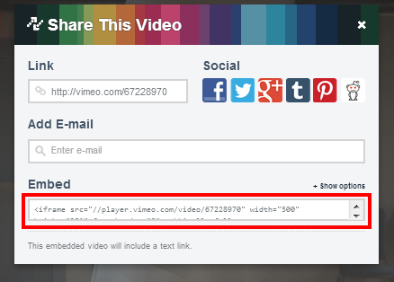

Settings - To Configure Player:

This is the global settings for Video Gallery. It has ten sections: License Configuration, Logo Configuration, Display Configuration, Playlist Configuration, Facebook Configuration, Ads Configuration, General Configuration, Video Configuration, Skin Configuration, Video Page Configuration.

Video Configuration

- Buffer time - You can set the buffer time of the player to save portions of a streaming Media file to local storage for a playback.
- Volume - You can set the default volume level when the video plays.
- Download - You can enable or disable Download button on the player.

License Configuration: License – If you are a purchased client, paste your license key here to remove logo from the player.

Playlist Configuration

- HD Default - You can set the HD videos to play by default. Make sure you have declared HD Video path/uploaded HD videos.
- Playlist - You can decide whether you want to display related videos within the player or not.
- Playlist Open - You can decide whether you want the related videos within the player always in open status or not.

- Playlist Auto play - You have two options for playlist auto play (enable/disable). If you enable the Option, it will start playing all the videos from the category. If you want to disable the option you need to select with play button for each videos.
- Related Videos view - You can decide whether you want to display the related videos center like YouTube or side.

General Configuration

- FFMPEG path - Declare the FFMPEG path given by your hosting provider if you want to generate duration for upload videos. You can leave it as it is if you are not aware of FFMPEG.
- Normal screen scale - You have three choices to set. Aspect ratio which controls the player size proportionally, fit-to-screen which plays the video to the player size that Declared, Original size plays in original video size irrespective of the Player size declared.
- Full screen scale - This setting affects only on full screen mode.
- Embed Visible - It is mainly used for embedding video onto web page. You can decide whether you want to display embed code under the player in front end or not
- Enable Ratings - You can enable/disable ratings of the videos here

Logo Configuration

- Logo alpha - You can set the transparency rate for the logo on the player.
- Logo align- You can set your logo position on the player.
- Logo target- You can set your logo target. When user clicks on the logo it will redirect to the mentioned URL.
- Logo path – Here upload your logo to appear on the player. Please note that, it will work only if you entered license key.

Skin Configuration

- Skin auto hide - You can enable/disable skin controls to be displayed on the player.
- Display Email - You can disabled/enabled Email here.
- Display Full screen - Full screen button can be disabled from here for player control.
- Display Progress Bar - Progress bar can be disabled from here for player control.
- Display Timer - Timer on the player controls can be enabled/disabled.
- Display Share - Share button on the player can be disabled here.
- Display Volume - Volume button on the player can be disabled here.

Player Color Configuration

- Share Popup Header Color - You can change the header color of the popup window when you click share button.
- Share Popup Background Color - You can change the background color of the popup window when you click share button.
- Share Popup Text Color - You can change the text color of the popup window when you click share button.
- Send Button Color - You can change the send button background color on the player.
- Send Button Text Color - You can change the send button text color on the player.
- Player Text Color - You can change the whole text color on the player.
- Skin Background Color - You can change the background color of the skin.
- Seek Bar Color - You can change the Seek bar color in the skin.
- Buffer Bar Color - You can change the buffer bar color.
- Skin Icons Color - You can change the all the icon colors of the skin.
- Progress Bar Background Color - You can change the background color of the progress bar.
- Play Button Color - You can change the play button color.
- Play Button Background Color - You can change the background color of the play button.
- Player Buttons Color - You can change the color of player buttons such as Share, Zoom, etc.
- Player Buttons Background Color - You can change the background color of player buttons such as Share, Zoom, etc.
- Related Videos Background Color - You can change the background color of related videos displaying inside the player. It is applicable only for “Side Related view” (Described below).
- Related Videos Scroll Bar Color - You can change the scroll bar color of related videos displaying inside the player. It is applicable only for “Side Related view” (Described below).
- Related Videos Scroll Bar Background Color - You can change the scroll bar background color of related videos displaying inside the player. It is applicable only for “Side Related view” (Described below).

Display Configuration

- Auto Play - If it is enabled, video will start playing without users clicking the play option, else you need to select play button if option is disabled in backend.
- Player Width - You can specify the width of the player in pixels (px).
- Player Height - You can specify the width of the player in pixels (px).
- Stage color - Set the background color for the player in the format.(Ex: 0xdddddd)
- Show Description - You can decide whether you want to display description of the video within the player or not.
- Display Default Image - You can decide whether you want to display default preview image (when it is not exist) for the video within the player or not.

Ads Settings

- Pre- roll ads - You can enable/disable the pre-roll ads.
- Post - roll ads - You can enable/disable the post-roll ads.
- Mid – roll Ads - You can enable/disable mid-roll ads.
- IMA Ads - You can enable/disable IMA ads.
- Ad Skip - You can decide whether you want to display skip ad while playing ads or not.
- Ad Skip Duration - You can enter the duration of the ads to be displayed.
- Track code - You can enter the Google track code.

Comment Settings

- Comment Type - You can select the type of commenting system you want. We are providing three types : Facebook, Disqus and Default WP Comments
- API ID – If you are using facebook comment, then you need to enter your Facebook API key here.
- Short Name - If you are using Disqus comment, then you need to enter your Short name key here. To use Disqus Comments, go to admin -> Plugins -> Add new and enter “disqus comments” in search box and install Disqus plugin. Now you need to create new account and register your site in Disqus site. They will give you short name for your account. Please enter that short name in video gallery settings page and save settings.

Video Page Configuration:

- Popular Videos - You can enable/disable and set rows/columns of popular videos in Home page.
- Recent Videos - You can enable/disable and set rows/columns of Recent videos in Home page.
- Featured Videos - You can enable/disable and set rows/columns of featured videos in Home page
- Category Videos - You can enable/disable category and set rows/columns of category videos in Home and More page.
- No of Categories in Home page - You can set the number of category videos to be displayed in Home page.
- More Videos - You can set rows/columns of more videos and it is for pagination
- Gutter Space (px) - You can adjust the gap between the thumb images displaying in Home page and More Pages.

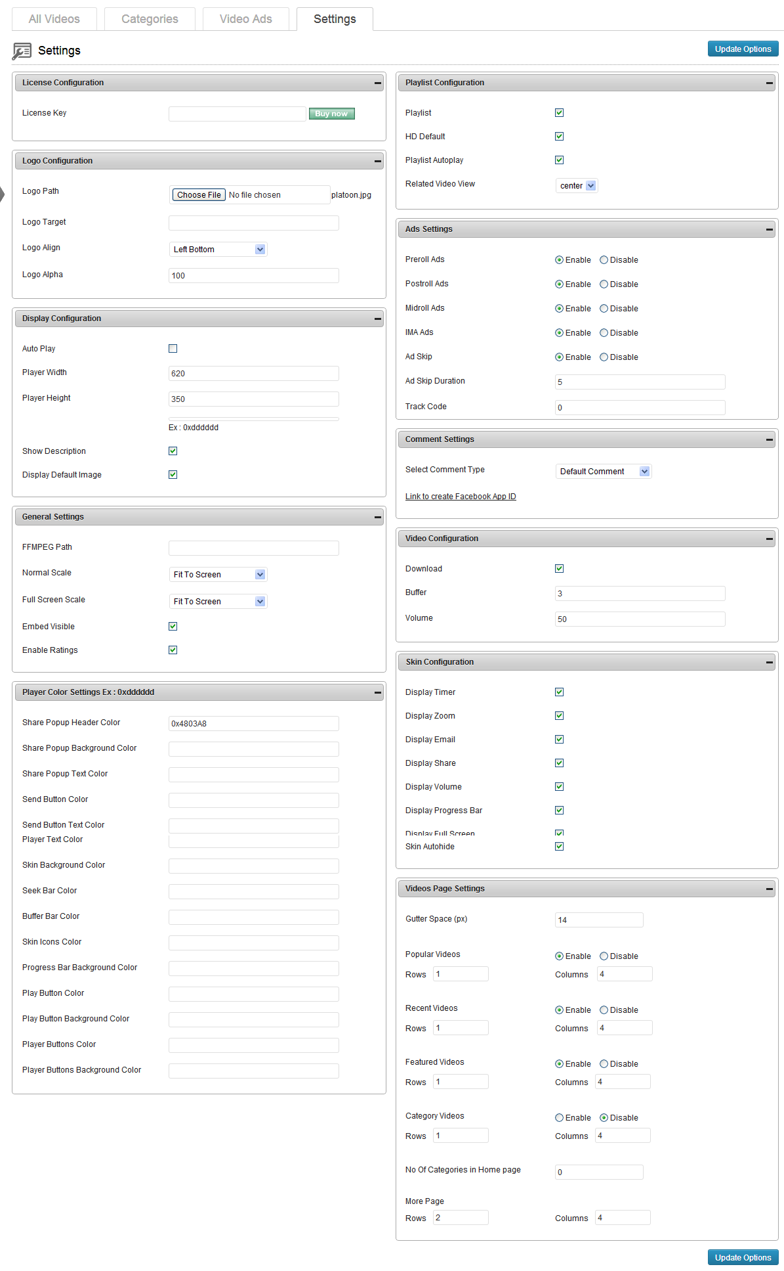

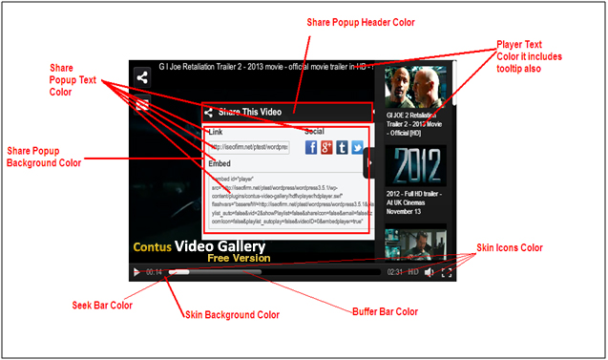

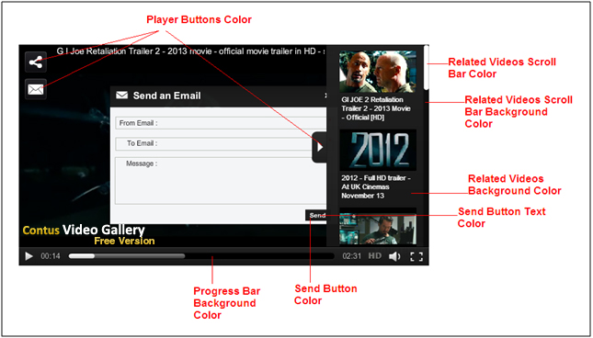

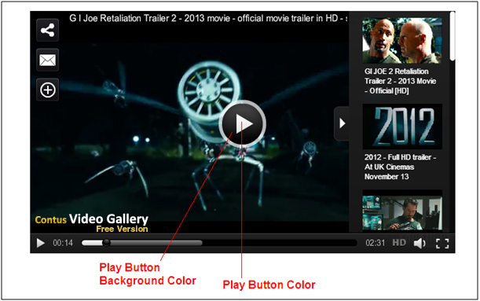

Category– To Manage Categories:

You can create a category by which you can categorize the videos. You can add multiple videos to a particular category.

Video Ads – To Manage Video Ads:

Pre-/Post-Roll:

- Here you can upload or provide URL to the video ads which can be set as pre-roll or post-roll ads while adding videos.

- Also you can provide Ad Name, Ad Description, Target URL, Click Hits URL, and Impression Hits.

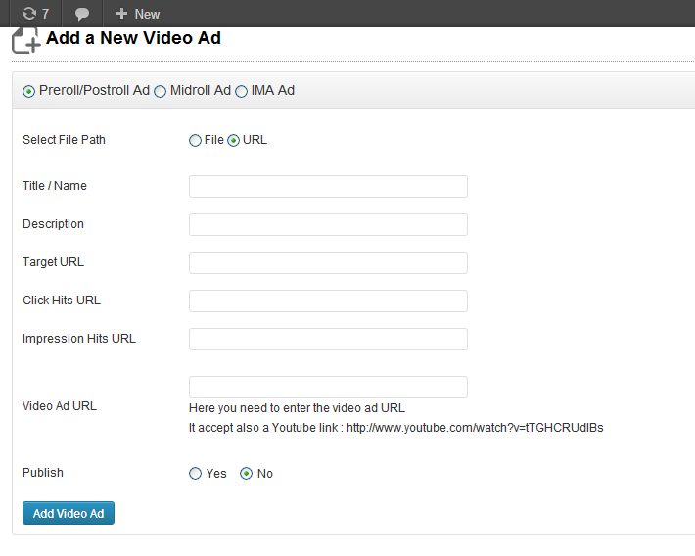

Mid Roll Ads:

Mid-roll is a text ad which displays on the player in the middle of the video.

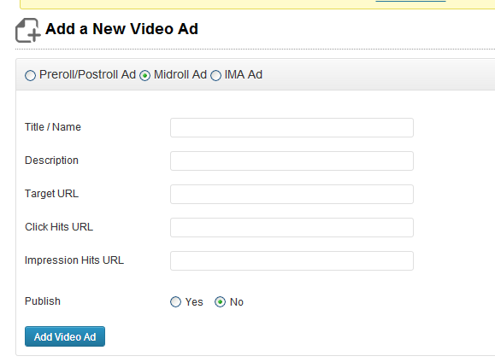

IMA Ads:

IMA ad may be text ad or video ad which displays on the player in the middle of the video.
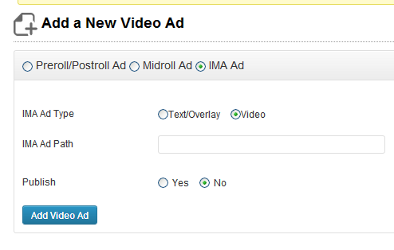

- Title/Name – Option to provides title for pre-/post-/mid-roll and ima ads.

- Description - This provides description for pre-/post-/mid-roll and ima ads.

- Target URL - Target URL for pre-/post-/mid-roll ads.

- Click Hits URL - URL of ad click count of pre-/post-/mid-roll ads.

- Impression Hits URL – Impression click count URL for pre-/post-/mid-roll ads.

- Publish - Option to publish/Unpublish ads.

Video Gallery Widgets

Using Video Gallery Widgets:

Go to Admin > Appearance > Widgets

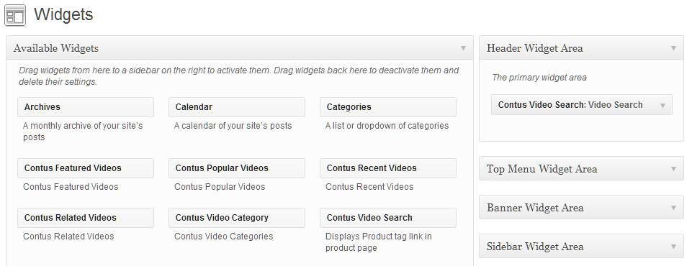

By drag and drop particular widget in the right position, you can display your widgets in particular position in your front end. You can also edit the name of the widget here.

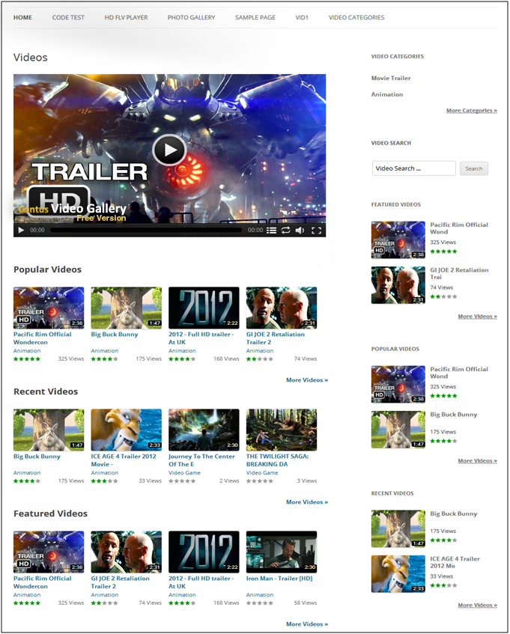

Video Gallery Short Codes

Using Video Gallery Short Codes:

You have the option to assign a player to any particular post or page using video gallery short codes. Go to Admin >Pages or posts > Add New.

Here you can add the short code in the following combination to call player for that particular page or post.

- [hdvideo id=3 playlistid=2 width=400 height=400 ]
- [hdvideo playlistid=2 ]
- [hdvideo id=3 ]
- [hdvideo id=3 flashvars=autoplay=true&zoom=false]
- [hdvideo id=1 ratingscontrol=on views=on title=on]

In the above line hdvideo is mandatory

- id – Get video id from Admin -> Video Gallery -> All videos page.
- autoplay - If you don’t want to auto start the video you can mention autoplay=”false.”
- zoom - If you don’t want zoom option in your player you can mention zoom=”false.”
- width – Player will be displayed in the mentioned width.
- height - Player will be displayed in the mentioned height.
- playlistid - If playlistid mentioned in the short code, then player will fetch videos from the mentioned category.
- ratingcontrol - If ratingcontrol mentioned in the short code, then rating of the video will be displayed under the player.
- views - If views mentioned in the short code, then views of the video will be displayed under the player.
- title - If title mentioned in the short code, then title of the video will be displayed above the player.

By default rating control, views and title will be on “off” status

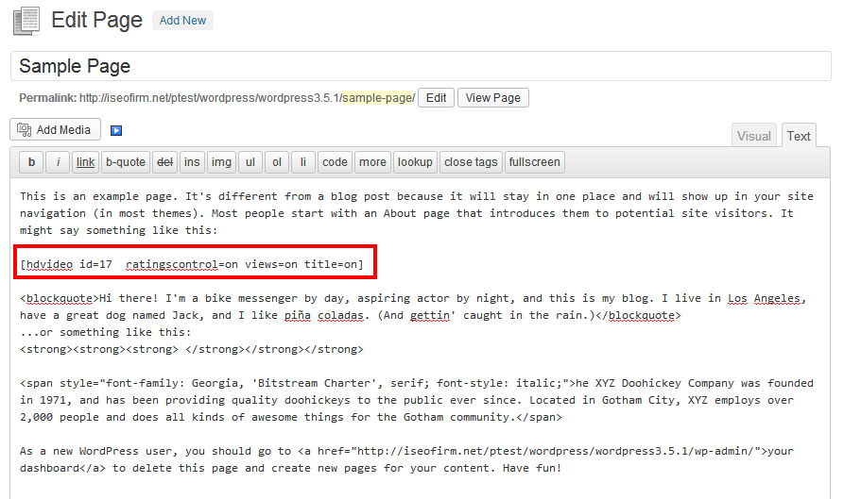
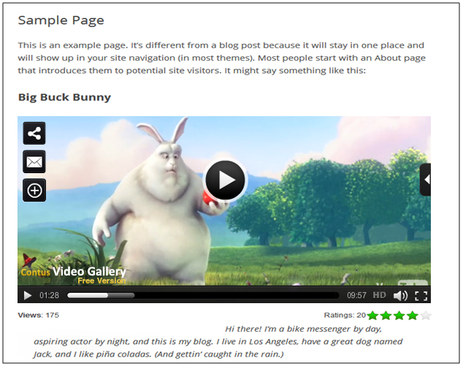

Contact us

Our support team is happy to help with any questions about using product. You may contact our support team through support forum & support tickets.

Your question may already be answered!
Forum: www.apptha.com/forum

Before you send us an email or raising tickets, take a look at Apptha.com/forum for any technical issues, common questions and more. We may have already answered your question.

Raise tickets for your specific questions!
Tickets: assist@apptha.com or www.support.apptha.com

Send an email to our support team to get answers to your specific questions. Our team will work to respond to your query promptly.

The best place to discuss about additional features!
Email: bdm@apptha.com

