Excerpt from mvn package output(10 test cases)
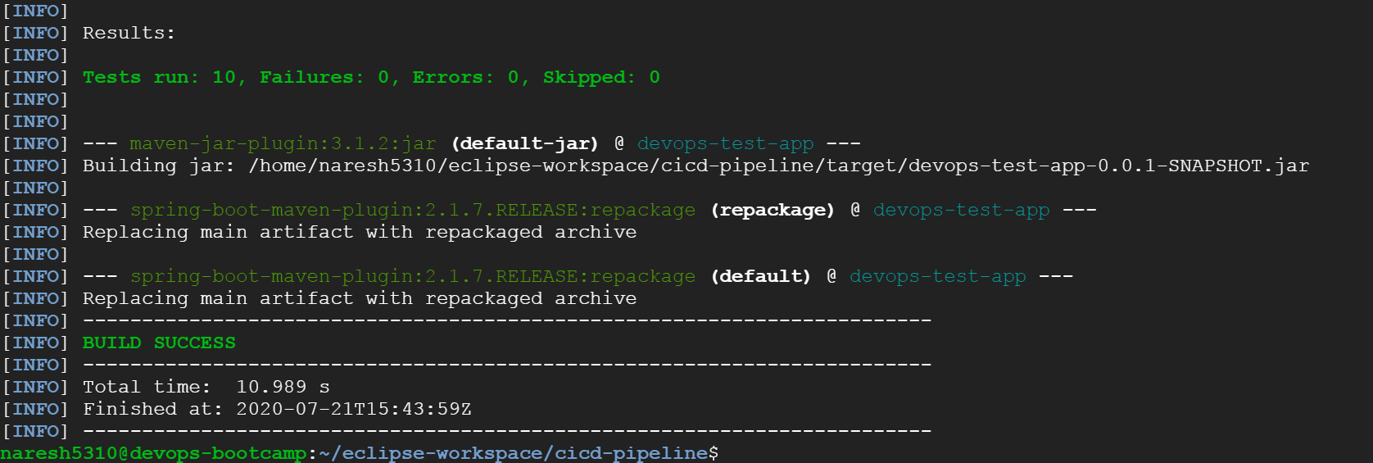
Run command output
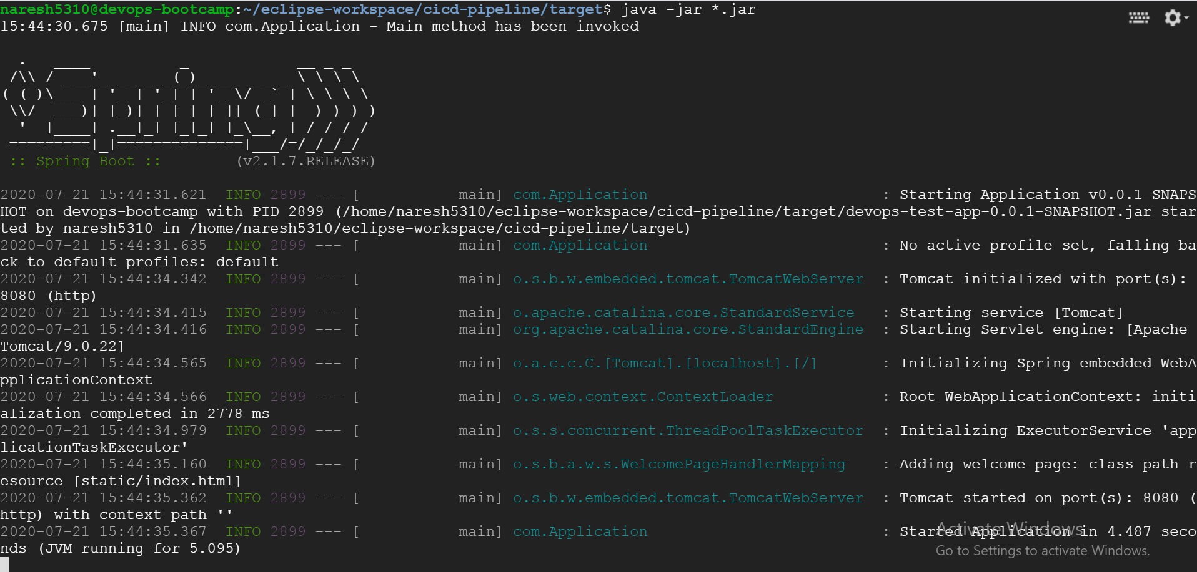
Front end output
Homepage
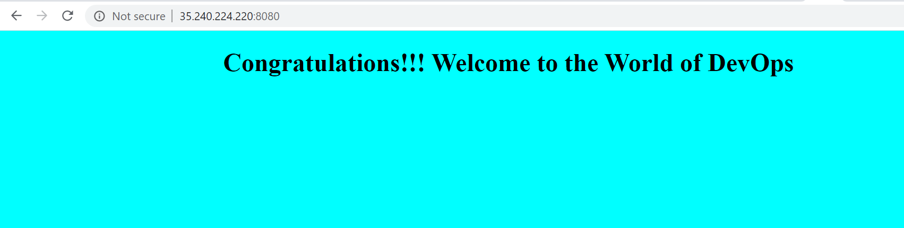
MessageService output
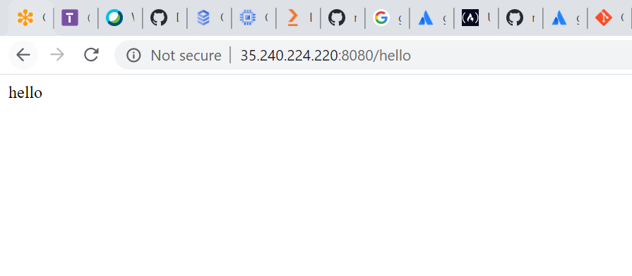
CalculatorService Output
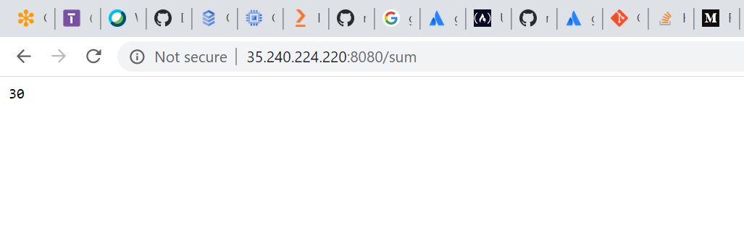
Individual test cases code for MessageService
@Test
public void testMessage() {
MessageService ms = new MessageService();
System.out.println("hello");
Assertions.assertEquals(ms.sayHello(), "hello");
}

@Test
public void testMessage2() {
MessageService ms = new MessageService();
System.out.println("hello");
Assertions.assertNotEquals("bye", ms.sayHello());
}

@Test
public void testMessage3() {
MessageService ms = new MessageService();
System.out.println("hello");
Assertions.assertSame("hello", "hello");

}
@Test
public void testMessage4() {
MessageService ms = new MessageService();
System.out.println("hello");
Supplier<String> message = null;
Assertions.assertTrue(true, message);

}
@Test
public void testMessage5() {
MessageService ms = new MessageService();
System.out.println("hello");
Assertions.assertNotNull("hello","It is Null");

}

Individual test cases code for CalculatorService
@Test
public void testSum() {

Assertions.assertEquals(30, calculatorService.sum());

}

@Test
public void testMultiply() {

Assertions.assertEquals(200, calculatorService.multiply());
}

@Test
public void testMinus() {

Assertions.assertEquals(-10, calculatorService.minus());
}

@Test
public void testDivide() {

Assertions.assertEquals(0, calculatorService.divide());
}
@Test
public void testnull() {

String messageSupplier = null;
Assertions.assertNotSame(calculatorService.sum(), calculatorService.multiply(), messageSupplier);
}

