Creating a git repository

https://github.com/nareshgandi/naresh-git-day2.git

Git Commands
Converts a directory into a local git repository.
git init - converts a directory into a git repository
naresh5310@devops-bootcamp:~/eclipse-workspace/cicd-pipeline$ git init
Initialized empty Git repository in /home/naresh5310/eclipse-workspace/cicd-pipeline/.git/
To add a single or muiltiple files to staging area
git add fileName or git add .
naresh5310@devops-bootcamp:~/eclipse-workspace/cicd-pipeline$ git add .
To commit the changes in the local repository.
git commit -m "commit message"
naresh5310@devops-bootcamp:~/eclipse-workspace/cicd-pipeline$ git commit -m "commit message"
[master (root-commit) 46c9d34] commit message
29 files changed, 472 insertions(+)
create mode 100644 .classpath
create mode 100644 .project
create mode 100644 .settings/org.eclipse.jdt.core.prefs
create mode 100644 .settings/org.eclipse.m2e.core.prefs
create mode 100644 README.md
create mode 100644 pom.xml
create mode 100644 src/main/java/com/Application.java
create mode 100644 src/main/java/com/CalculatorService.java
create mode 100644 src/main/java/com/MessageService.java
create mode 100644 src/main/resources/static/index.html
create mode 100644 src/test/java/com/TestCalculatorService.java
create mode 100644 src/test/java/com/TestMessageService.java
create mode 100644 target/classes/com/Application.class
create mode 100644 target/classes/com/CalculatorService.class
create mode 100644 target/classes/com/MessageService.class
create mode 100644 target/classes/static/index.html
create mode 100644 target/devops-test-app-0.0.1-SNAPSHOT.jar
create mode 100644 target/devops-test-app-0.0.1-SNAPSHOT.jar.original
create mode 100644 target/maven-archiver/pom.properties
create mode 100644 target/maven-status/maven-compiler-plugin/compile/default-compile/createdFiles.lst
create mode 100644 target/maven-status/maven-compiler-plugin/compile/default-compile/inputFiles.lst
create mode 100644 target/maven-status/maven-compiler-plugin/testCompile/default-testCompile/createdFiles.lst
create mode 100644 target/maven-status/maven-compiler-plugin/testCompile/default-testCompile/inputFiles.lst
create mode 100644 target/surefire-reports/TEST-com.TestCalculatorService.xml
create mode 100644 target/surefire-reports/TEST-com.TestMessageService.xml
create mode 100644 target/surefire-reports/com.TestCalculatorService.txt
create mode 100644 target/surefire-reports/com.TestMessageService.txt
create mode 100644 target/test-classes/com/TestCalculatorService.class
create mode 100644 target/test-classes/com/TestMessageService.class
naresh5310@devops-bootcamp:~/eclipse-workspace/cicd-pipeline$
To list the status of the files in staging area.
git status
naresh5310@devops-bootcamp:~/eclipse-workspace/cicd-pipeline$ git status
On branch master
nothing to commit, working directory clean
To configure the global username and email id
git config --global user.name = "Shubham"
git config --global user.email - "Shubham@gmail.com"

git config user.name = "Shubham"
git config user.email = "shubham@gmail.com"

naresh5310@devops-bootcamp:~/eclipse-workspace/cicd-pipeline$ git config --global user.name = "nareshgandi"

naresh5310@devops-bootcamp:~/eclipse-workspace/cicd-pipeline$ git config --global user.email = "naresh5310@gmail.com"

Connect and add Remote Repository.
To connect a local repository to a specific remote repository.
git remote add origin <ssh url>
git remote add origin https://github.com/shubhamkushwah123/DevOps.git
naresh5310@devops-bootcamp:~/eclipse-workspace/cicd-pipeline$ git remote add origin https://github.com/nareshgandi/naresh-git-day2.git
To Clone a remote git repository into a local git repository.
git clone <repo name>
git clone https://github.com/shubhamkushwah123/DevOps.git
naresh5310@devops-bootcamp:~/eclipse-workspace/cicd-pipeline$ git clone https://github.com/nareshgandi/naresh-git-day2.git
Cloning into 'naresh-git-day2'...
warning: You appear to have cloned an empty repository.
Checking connectivity... done.
To Pull the changes from master branch of the remote git repository.
git pull origin master
naresh5310@devops-bootcamp:~/eclipse-workspace/cicd-pipeline$ git pull origin master
fatal: Couldn't find remote ref master
To Push the changes to master branch of the remote git repository.
git push origin master

naresh5310@devops-bootcamp:~/eclipse-workspace/cicd-pipeline$ git push -u origin master

Username for 'https://github.com': nareshgandi

Password for 'https://nareshgandi@github.com':

Counting objects: 53, done.

Delta compression using up to 2 threads.

Compressing objects: 100% (42/42), done.

Writing objects: 100% (53/53), 14.32 MiB | 2.79 MiB/s, done.

Total 53 (delta 4), reused 0 (delta 0)

remote: Resolving deltas: 100% (4/4), done.

To https://github.com/nareshgandi/naresh-git-day2.git

* [new branch] master -> master

Branch master set up to track remote branch master from origin.

naresh5310@devops-bootcamp:~/eclipse-workspace/cicd-pipeline$

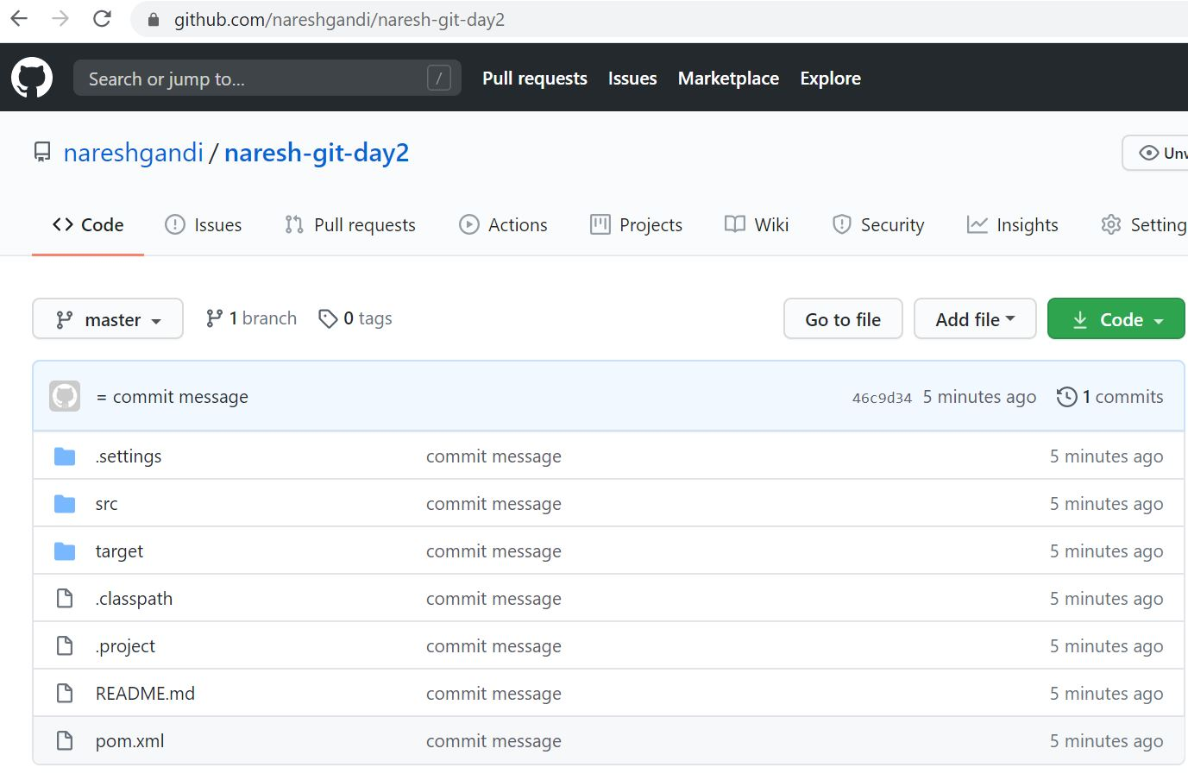

Branching
To create a new branch
git branch $branchName
naresh5310@devops-bootcamp:~/eclipse-workspace/cicd-pipeline$ git branch nareshbranch
To list branches
naresh5310@devops-bootcamp:~/eclipse-workspace/cicd-pipeline$ git branch
* master
nareshbranch
To switch to a branch
naresh5310@devops-bootcamp:~/eclipse-workspace/cicd-pipeline$ git checkout nareshbranch
Switched to branch 'nareshbranch'
Write a branch file and commit
naresh5310@devops-bootcamp:~/eclipse-workspace/cicd-pipeline$ vi branchtext.txt
naresh5310@devops-bootcamp:~/eclipse-workspace/cicd-pipeline$ git add branchtext.txt
naresh5310@devops-bootcamp:~/eclipse-workspace/cicd-pipeline$ git commit -m "Save Changes"
[nareshbranch 9844b93] Save Changes
1 file changed, 1 insertion(+)
create mode 100644 branchtext.txt
To switch to a master and merge branch and push to github
naresh5310@devops-bootcamp:~/eclipse-workspace/cicd-pipeline$ git checkout master
Switched to branch 'master'
Your branch is up-to-date with 'origin/master'.
naresh5310@devops-bootcamp:~/eclipse-workspace/cicd-pipeline$ git merge nareshbranch
Updating 46c9d34..9844b93
Fast-forward
branchtext.txt | 1 +
1 file changed, 1 insertion(+)
create mode 100644 branchtext.txt
naresh5310@devops-bootcamp:~/eclipse-workspace/cicd-pipeline$ git push -u origin master
Username for 'https://github.com': nareshgandi
Password for 'https://nareshgandi@github.com':
Counting objects: 3, done.
Delta compression using up to 2 threads.
Compressing objects: 100% (2/2), done.
Writing objects: 100% (3/3), 272 bytes | 0 bytes/s, done.
Total 3 (delta 1), reused 0 (delta 0)
remote: Resolving deltas: 100% (1/1), completed with 1 local object.
To https://github.com/nareshgandi/naresh-git-day2.git
46c9d34..9844b93 master -> master
Branch master set up to track remote branch master from origin.
naresh5310@devops-bootcamp:~/eclipse-workspace/cicd-pipeline$

To delete an existing branch
git branch -d $branchName

naresh5310@devops-bootcamp:~/eclipse-workspace/cicd-pipeline$ git branch -d nareshbranch

Deleted branch nareshbranch (was 9844b93).

naresh5310@devops-bootcamp:~/eclipse-workspace/cicd-pipeline$

naresh5310@devops-bootcamp:~/eclipse-workspace/cicd-pipeline$

naresh5310@devops-bootcamp:~/eclipse-workspace/cicd-pipeline$

Advance git commands
To create a file
naresh5310@devops-bootcamp:~/eclipse-workspace/cicd-pipeline$ vi StashFile.txt
There is a modified file
naresh5310@devops-bootcamp:~/eclipse-workspace/cicd-pipeline$ git status
On branch master
Your branch is up-to-date with 'origin/master'.
Untracked files:
(use "git add <file>..." to include in what will be committed)

StashFile.txt
nothing added to commit but untracked files present (use "git add" to track)
naresh5310@devops-bootcamp:~/eclipse-workspace/cicd-pipeline$

Add the file and check status
naresh5310@devops-bootcamp:~/eclipse-workspace/cicd-pipeline$ git add .
naresh5310@devops-bootcamp:~/eclipse-workspace/cicd-pipeline$ git status
On branch master
Your branch is up-to-date with 'origin/master'.
Changes to be committed:
(use "git reset HEAD <file>..." to unstage)

new file: StashFile.txt

naresh5310@devops-bootcamp:~/eclipse-workspace/cicd-pipeline$
To save the changes, when they are not in state of commit.
git stash
naresh5310@devops-bootcamp:~/eclipse-workspace/cicd-pipeline$ git stash
Saved working directory and index state WIP on master: 9844b93 Save Changes
HEAD is now at 9844b93 Save Changes
Now check the status
naresh5310@devops-bootcamp:~/eclipse-workspace/cicd-pipeline$ git status
On branch master
Your branch is up-to-date with 'origin/master'.
nothing to commit, working directory clean
To stash changes and clearing up the directory
git stash -u
naresh5310@devops-bootcamp:~/eclipse-workspace/cicd-pipeline$ git stash -u
No local changes to save
To List the stashes created.
git stash list
naresh5310@devops-bootcamp:~/eclipse-workspace/cicd-pipeline$ git stash list
stash@{0}: WIP on master: 9844b93 Save Changes
stash@{1}: WIP on master: 9844b93 Save Changes
naresh5310@devops-bootcamp:~/eclipse-workspace/cicd-pipeline$
To get the stashed work back.
git stash apply
naresh5310@devops-bootcamp:~/eclipse-workspace/cicd-pipeline$ git stash apply
On branch master
Your branch is up-to-date with 'origin/master'.
Changes to be committed:
(use "git reset HEAD <file>..." to unstage)

new file: StashFile.txt

To get the context and history of logs of a repository
git log
naresh5310@devops-bootcamp:~/eclipse-workspace/cicd-pipeline$ git log
commit 9844b93842f7c48a67b5aee762a92f4f35a0d0bf
Author: = <=>
Date: Tue Jul 21 14:05:44 2020 +0000

Save Changes

commit 46c9d3472ae7e3fffba249a35a3358c7c4692d2a
Author: = <=>
Date: Tue Jul 21 13:59:20 2020 +0000

commit message

git revert
Initiate new directory and create 5 files
naresh5310@devops-bootcamp:~/eclipse-workspace/git-revert-rebase$ git init
Initialized empty Git repository in /home/naresh5310/eclipse-workspace/git-revert-rebase/.git/
naresh5310@devops-bootcamp:~/eclipse-workspace/git-revert-rebase$
naresh5310@devops-bootcamp:~/eclipse-workspace/git-revert-rebase$ echo 'first' > first.html
naresh5310@devops-bootcamp:~/eclipse-workspace/git-revert-rebase$ git add . && git commit -m "1st git commit: 1 file"
[master (root-commit) e720ae3] 1st git commit: 1 file
1 file changed, 1 insertion(+)
create mode 100644 first.html
naresh5310@devops-bootcamp:~/eclipse-workspace/git-revert-rebase$
naresh5310@devops-bootcamp:~/eclipse-workspace/git-revert-rebase$ echo 'second' > second.html
naresh5310@devops-bootcamp:~/eclipse-workspace/git-revert-rebase$ git add . && git commit -m "2nd git commit: 2 files"
[master f8362aa] 2nd git commit: 2 files
1 file changed, 1 insertion(+)
create mode 100644 second.html
naresh5310@devops-bootcamp:~/eclipse-workspace/git-revert-rebase$
naresh5310@devops-bootcamp:~/eclipse-workspace/git-revert-rebase$ echo 'third' > third.html
naresh5310@devops-bootcamp:~/eclipse-workspace/git-revert-rebase$ git add . && git commit -m "3rd git commit: 3 files"
[master 486a9b7] 3rd git commit: 3 files
1 file changed, 1 insertion(+)
create mode 100644 third.html
naresh5310@devops-bootcamp:~/eclipse-workspace/git-revert-rebase$
naresh5310@devops-bootcamp:~/eclipse-workspace/git-revert-rebase$ echo 'fourth' > fourth.html
naresh5310@devops-bootcamp:~/eclipse-workspace/git-revert-rebase$ git add . && git commit -m "4th git commit: 4 files"
[master faae479] 4th git commit: 4 files
1 file changed, 1 insertion(+)
create mode 100644 fourth.html
naresh5310@devops-bootcamp:~/eclipse-workspace/git-revert-rebase$
naresh5310@devops-bootcamp:~/eclipse-workspace/git-revert-rebase$ echo 'fifith' > fifith.html
naresh5310@devops-bootcamp:~/eclipse-workspace/git-revert-rebase$ git add . && git commit -m "5th git commit: 5 files"
[master 370865d] 5th git commit: 5 files
1 file changed, 1 insertion(+)
create mode 100644 fifith.html

naresh5310@devops-bootcamp:~/eclipse-workspace/git-revert-rebase$ git reflog
370865d HEAD@{0}: commit: 5th git commit: 5 files
faae479 HEAD@{1}: commit: 4th git commit: 4 files
486a9b7 HEAD@{2}: commit: 3rd git commit: 3 files
f8362aa HEAD@{3}: commit: 2nd git commit: 2 files
e720ae3 HEAD@{4}: commit (initial): 1st git commit: 1 file

Now revert to 3rd commit stage
naresh5310@devops-bootcamp:~/eclipse-workspace/git-revert-rebase$ git revert 486a9b7
[master 1d46b90] Revert "3rd git commit: 3 files"
1 file changed, 1 deletion(-)
delete mode 100644 third.html
naresh5310@devops-bootcamp:~/eclipse-workspace/git-revert-rebase$
To revert back to the previous version of the file.

To check the files(notice third commit reverted)
naresh5310@devops-bootcamp:~/eclipse-workspace/git-revert-rebase$ ls -lrt
total 16
-rw-rw-r-- 1 naresh5310 naresh5310 6 Jul 21 14:36 first.html
-rw-rw-r-- 1 naresh5310 naresh5310 7 Jul 21 14:37 second.html
-rw-rw-r-- 1 naresh5310 naresh5310 7 Jul 21 14:37 fourth.html
-rw-rw-r-- 1 naresh5310 naresh5310 7 Jul 21 14:37 fifith.html
naresh5310@devops-bootcamp:~/eclipse-workspace/git-revert-rebase$
naresh5310@devops-bootcamp:~/eclipse-workspace/git-revert-rebase$
git rebase
Create M1, M2, C1,C2 and M3 files with M1,M2,M3 in master branch and C1,C2 in child branch in order M1, M2, C1,C2 and M3.

naresh5310@devops-bootcamp:~/eclipse-workspace/git-revert-rebase$ git reflog
31d0871 HEAD@{0}: commit: 4th git commit: m3 commit
25a70bb HEAD@{1}: checkout: moving from child to master
66aea94 HEAD@{2}: commit: 5th git commit: c2 commit
5b5f56a HEAD@{3}: commit: 3rd git commit: c1 commit
25a70bb HEAD@{4}: checkout: moving from master to child
25a70bb HEAD@{5}: commit: 2nd git commit: m1 commit
0099100 HEAD@{6}: commit (initial): 1st git commit: m1 commit
naresh5310@devops-bootcamp:~/eclipse-workspace/git-revert-rebase$
naresh5310@devops-bootcamp:~/eclipse-workspace/git-revert-rebase$ git log --oneline master
31d0871 4th git commit: m3 commit
25a70bb 2nd git commit: m1 commit
0099100 1st git commit: m1 commit
naresh5310@devops-bootcamp:~/eclipse-workspace/git-revert-rebase$
naresh5310@devops-bootcamp:~/eclipse-workspace/git-revert-rebase$ git log --oneline child
66aea94 5th git commit: c2 commit
5b5f56a 3rd git commit: c1 commit
25a70bb 2nd git commit: m1 commit
0099100 1st git commit: m1 commit
naresh5310@devops-bootcamp:~/eclipse-workspace/git-revert-rebase$
Now checkout to child and rebase master
naresh5310@devops-bootcamp:~/eclipse-workspace/git-revert-rebase$ git checkout child
Switched to branch 'child'
naresh5310@devops-bootcamp:~/eclipse-workspace/git-revert-rebase$
naresh5310@devops-bootcamp:~/eclipse-workspace/git-revert-rebase$ git rebase master
First, rewinding head to replay your work on top of it...
Applying: 3rd git commit: c1 commit
Applying: 5th git commit: c2 commit
naresh5310@devops-bootcamp:~/eclipse-workspace/git-revert-rebase$ git log --oneline master
31d0871 4th git commit: m3 commit
25a70bb 2nd git commit: m1 commit
0099100 1st git commit: m1 commit
naresh5310@devops-bootcamp:~/eclipse-workspace/git-revert-rebase$ git log --oneline child
38aad8c 5th git commit: c2 commit
a578483 3rd git commit: c1 commit
31d0871 4th git commit: m3 commit
25a70bb 2nd git commit: m1 commit
0099100 1st git commit: m1 commit
naresh5310@devops-bootcamp:~/eclipse-workspace/git-revert-rebase$ git reflog
38aad8c HEAD@{0}: rebase finished: returning to refs/heads/child
38aad8c HEAD@{1}: rebase: 5th git commit: c2 commit
a578483 HEAD@{2}: rebase: 3rd git commit: c1 commit
31d0871 HEAD@{3}: rebase: checkout master
66aea94 HEAD@{4}: checkout: moving from master to child
31d0871 HEAD@{5}: commit: 4th git commit: m3 commit
25a70bb HEAD@{6}: checkout: moving from child to master
66aea94 HEAD@{7}: commit: 5th git commit: c2 commit
5b5f56a HEAD@{8}: commit: 3rd git commit: c1 commit
25a70bb HEAD@{9}: checkout: moving from master to child
25a70bb HEAD@{10}: commit: 2nd git commit: m1 commit
0099100 HEAD@{11}: commit (initial): 1st git commit: m1 commit

