Day 4

Assignment 1: Build a project with pipeline code
Pipeline script
node{
stage('git checkout'){
git 'https://github.com/nareshgandi/war-test.git'
}

stage('mvn build'){
sh 'mvn clean package'
}
stage('code deploy'){
deploy adapters: [tomcat9(credentialsId: 'naresh', path: '', url: 'http://35.247.174.138:8080/')], contextPath: 'pipeline', war: '**/*.war'
}
}

Console output

Started by user nareshgandi
Running in Durability level: MAX_SURVIVABILITY
[Pipeline] Start of Pipeline
[Pipeline] node
Running on Jenkins in /var/lib/jenkins/workspace/bootcamp-pipeline
[Pipeline] {
[Pipeline] stage
[Pipeline] { (git checkout)
[Pipeline] git
No credentials specified
> git rev-parse --is-inside-work-tree # timeout=10
Fetching changes from the remote Git repository
> git config remote.origin.url https://github.com/nareshgandi/war-test.git # timeout=10
Fetching upstream changes from https://github.com/nareshgandi/war-test.git
> git --version # timeout=10
> git fetch --tags --progress https://github.com/nareshgandi/war-test.git +refs/heads/*:refs/remotes/origin/* # timeout=10
> git rev-parse refs/remotes/origin/master^{commit} # timeout=10
> git rev-parse refs/remotes/origin/origin/master^{commit} # timeout=10
Checking out Revision 571b06eb87e514c1ff1fec031f0387efb7796823 (refs/remotes/origin/master)
[Pipeline] stage
[Pipeline] { (mvn build)
[Pipeline] sh
+ mvn clean package
[INFO] Scanning for projects...
[INFO]
[INFO] ------------------------------------------------------------------------
[INFO] Building war-test Maven Webapp 0.0.1-SNAPSHOT
[INFO] ------------------------------------------------------------------------
[INFO]
[INFO] --- maven-clean-plugin:2.5:clean (default-clean) @ war-test ---
[INFO] Deleting /var/lib/jenkins/workspace/bootcamp-pipeline/target
[INFO]
[INFO] --- maven-resources-plugin:2.6:resources (default-resources) @ war-test ---
[INFO] Using 'UTF-8' encoding to copy filtered resources.
[INFO] skip non existing resourceDirectory /var/lib/jenkins/workspace/bootcamp-pipeline/src/main/resources
[INFO]

<<--OUTPUT TRUNCATED→
-------------------------------------------------------
T E S T S
-------------------------------------------------------
Running com.TestCalculator
hello
Tests run: 3, Failures: 0, Errors: 0, Skipped: 0, Time elapsed: 0.476 sec - in com.TestCalculator

Results :

Tests run: 3, Failures: 0, Errors: 0, Skipped: 0

[INFO]
[INFO] --- maven-war-plugin:2.2:war (default-war) @ war-test ---
[INFO] Packaging webapp
[INFO] Assembling webapp [war-test] in [/var/lib/jenkins/workspace/bootcamp-pipeline/target/war-test]
[INFO] Processing war project
[INFO] Copying webapp resources [/var/lib/jenkins/workspace/bootcamp-pipeline/src/main/webapp]
[INFO] Webapp assembled in [25 msecs]
[INFO] Building war: /var/lib/jenkins/workspace/bootcamp-pipeline/target/war-test.war
[INFO] WEB-INF/web.xml already added, skipping
[INFO] ------------------------------------------------------------------------
[INFO] BUILD SUCCESS
[INFO] ------------------------------------------------------------------------
[INFO] Total time: 3.416 s
[INFO] Finished at: 2020-07-23T20:49:52+00:00
[INFO] Final Memory: 19M/257M
[INFO] ------------------------------------------------------------------------
[Pipeline] }
[Pipeline] // stage
[Pipeline] stage
[Pipeline] { (code deploy)
[Pipeline] deploy
[DeployPublisher][INFO] Attempting to deploy 1 war file(s)
[DeployPublisher][INFO] Deploying /var/lib/jenkins/workspace/bootcamp-pipeline/target/war-test.war to container Tomcat 9.x Remote with context pipeline
[/var/lib/jenkins/workspace/bootcamp-pipeline/target/war-test.war] is not deployed. Doing a fresh deployment.
Deploying [/var/lib/jenkins/workspace/bootcamp-pipeline/target/war-test.war]
[Pipeline] }
[Pipeline] // stage
[Pipeline] }
[Pipeline] // node
[Pipeline] End of Pipeline
Finished: SUCCESS

Application access

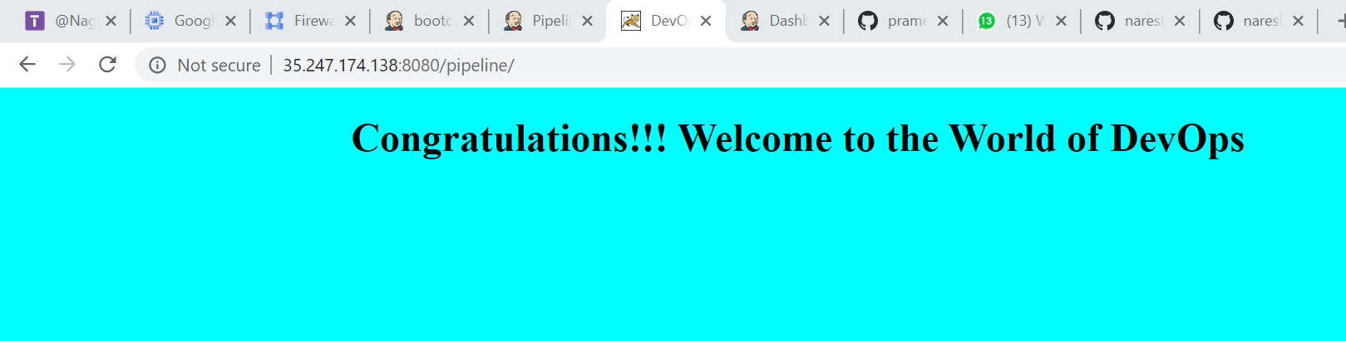

2. With runtime maven(pipeline code)

node{
stage('git checkout'){
git 'https://github.com/nareshgandi/war-test.git'
}

stage('mvn build'){
def mavenHome = tool name : 'maven-3', type : 'maven'
def mavenCMD = "${mavenHome}/bin/mvn"
sh "${mavenCMD} clean package"
}
stage('code deploy'){
deploy adapters: [tomcat9(credentialsId: 'naresh', path: '', url: 'http://35.247.174.138:8080/')], contextPath: 'pipeline', war: '**/*.war'
}
}

Console output

Code snippet

[Pipeline] { (mvn build)
[Pipeline] tool
[Pipeline] sh
+ /var/lib/jenkins/tools/hudson.tasks.Maven_MavenInstallation/maven-3/bin/mvn clean package
[INFO] Scanning for projects...
[INFO]
[INFO] -------------------------< org.test:war-test >--------------------------
[INFO] Building war-test Maven Webapp 0.0.1-SNAPSHOT
[INFO] --------------------------------[ war ]---------------------------------
Downloading from central: https://repo.maven.apache.org/maven2/org/apache/maven/plugins/maven-compiler-plugin/3.1/maven-compiler-plugin-3.1.pom
Progress (1): 2.7/10 kB
Progress (1): 5.5/10 kB
Progress (1): 8.2/10 kB
Progress (1): 10 kB

Downloaded from central: https://repo.maven.apache.org/maven2/org/apache/maven/plugins/maven-compiler-plugin/3.1/maven-

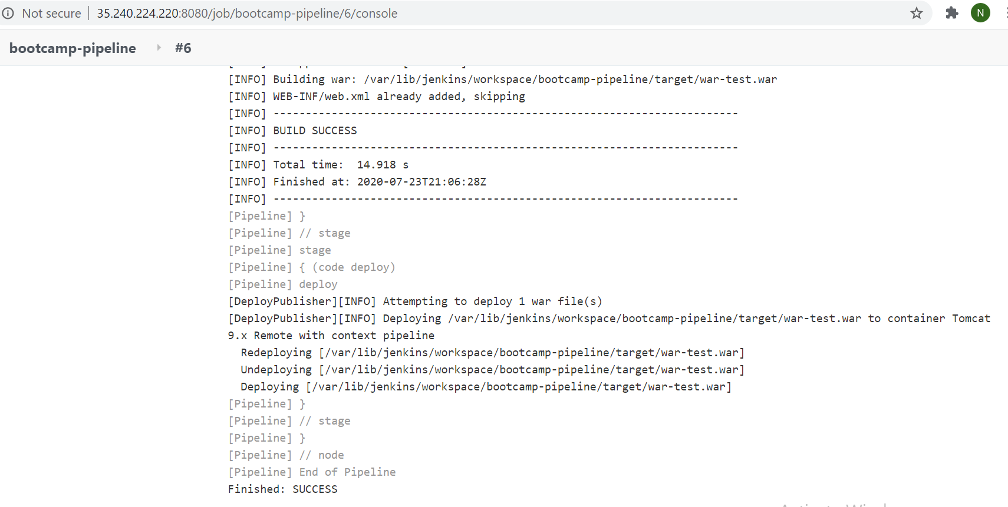

3. With docker image(Pipeline script)

node{
stage('git checkout'){
git 'https://github.com/nareshgandi/devops-bootcamp2.git'
}

stage('mvn build'){
def mavenHome = tool name : 'maven-3', type : 'maven'
def mavenCMD = "${mavenHome}/bin/mvn"
sh "${mavenCMD} clean package"
}
stage('docker build'){
sh 'docker build -t naresh5310/cicd-pipeline:5.0 .'
}
}

Build screenshot

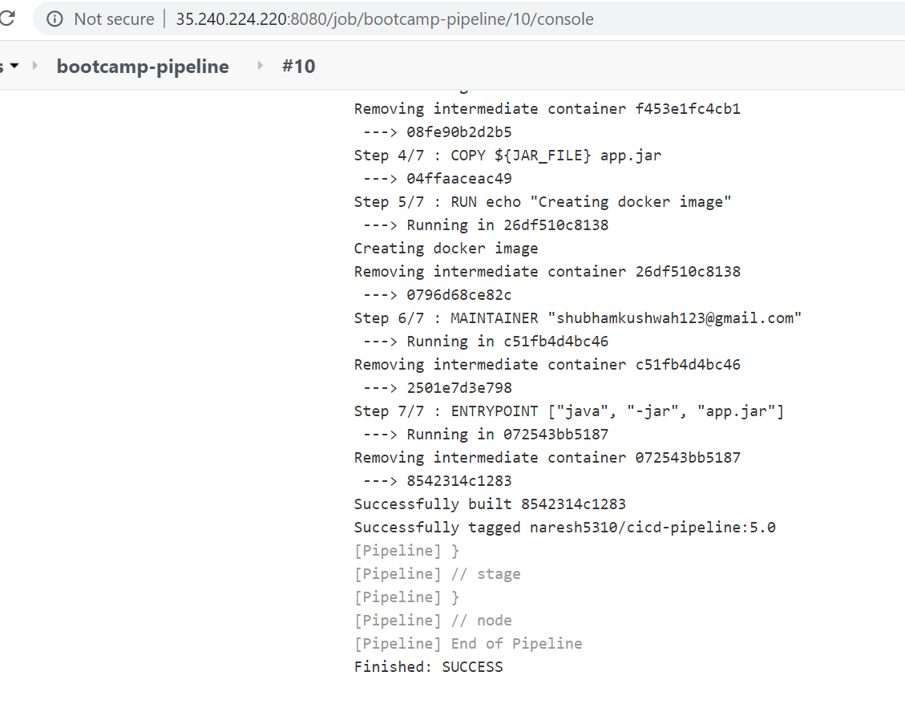

Run the docker container.

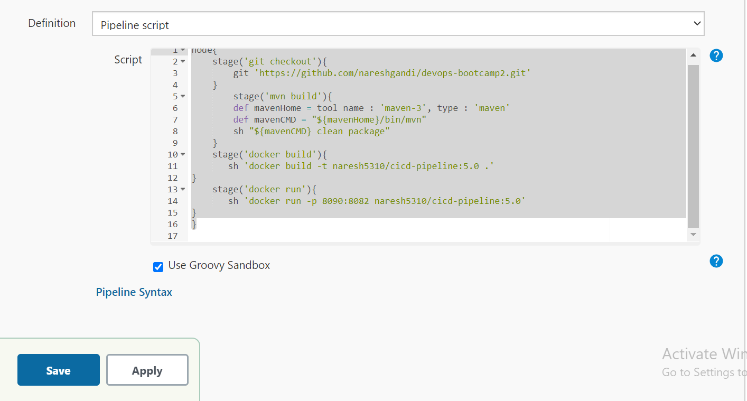

Screen Output

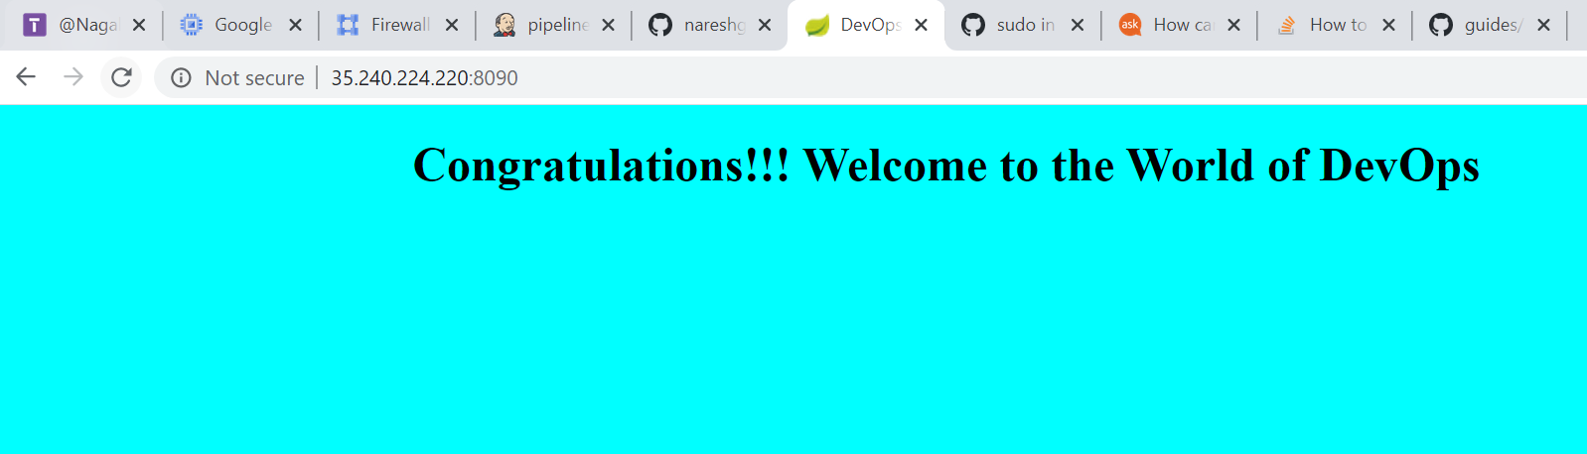

Console output

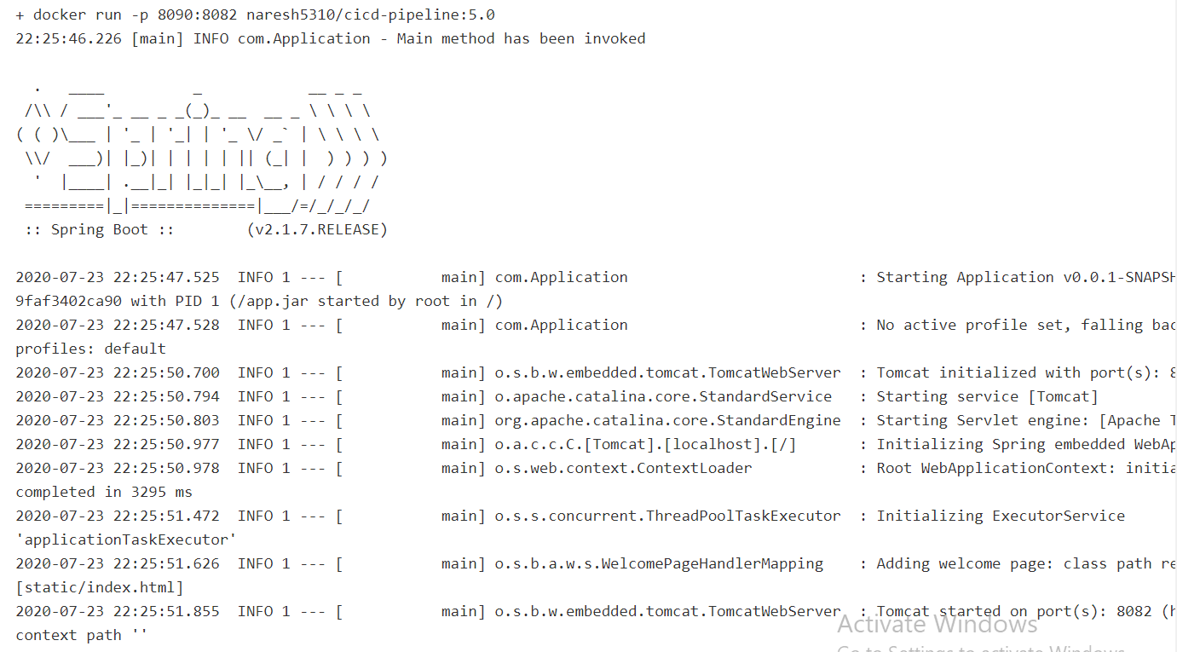

Push image to dockerhub using “with credentials plugin”

Pipeline script

node{
stage('git checkout'){
git 'https://github.com/nareshgandi/devops-bootcamp2.git'
}
stage('mvn build'){
def mavenHome = tool name : 'maven-3', type : 'maven'
def mavenCMD = "${mavenHome}/bin/mvn"
sh "${mavenCMD} clean package"
}
stage('docker build'){
sh 'docker build -t naresh5310/cicd-pipeline:5.0 .'
}
stage('docker push'){
withCredentials([string(credentialsId: 'dockerpwd', variable: 'DockerHubPassword')]) {
sh "docker login -u naresh5310 -p ${DockerHubPassword}"
}
sh 'docker push naresh5310/cicd-pipeline:5.0'
}
stage('docker run'){
sh 'docker run -p 8099:8082 -d naresh5310/cicd-pipeline:5.0'
}
}

Console output excerpt

[Pipeline] { (docker build)
[Pipeline] sh
+ docker build -t naresh5310/cicd-pipeline:5.0 .
Sending build context to Docker daemon 16.98MB

Step 1/7 : FROM openjdk:8-jdk-alpine
---> a3562aa0b991
Step 2/7 : EXPOSE 8888
---> Using cache
---> 263dd41da6c0
Step 3/7 : ARG JAR_FILE=/target/*.jar
---> Using cache
---> 697c917b980e
Step 4/7 : COPY ${JAR_FILE} app.jar
---> 2df5aea6aeee
Step 5/7 : RUN echo "Creating docker image"
---> Running in 5b6a28a500c3
Creating docker image
Removing intermediate container 5b6a28a500c3
---> 9fcd78144c4b
Step 6/7 : MAINTAINER "shubhamkushwah123@gmail.com"
---> Running in 606edbb190d1
Removing intermediate container 606edbb190d1
---> 853d94a42550
Step 7/7 : ENTRYPOINT ["java", "-jar", "app.jar"]
---> Running in 17b5dbf17ec8
Removing intermediate container 17b5dbf17ec8
---> 4a7302c87aad
Successfully built 4a7302c87aad
Successfully tagged naresh5310/cicd-pipeline:5.0
[Pipeline] }
[Pipeline] // stage
[Pipeline] stage
[Pipeline] { (docker push)
[Pipeline] withCredentials
Masking supported pattern matches of $DockerHubPassword
[Pipeline] {
[Pipeline] sh
+ docker login -u naresh5310 -p ****
WARNING! Using --password via the CLI is insecure. Use --password-stdin.
WARNING! Your password will be stored unencrypted in /var/lib/jenkins/.docker/config.json.
Configure a credential helper to remove this warning. See
https://docs.docker.com/engine/reference/commandline/login/#credentials-store

Login Succeeded
[Pipeline] }
[Pipeline] // withCredentials
[Pipeline] sh
+ docker push naresh5310/cicd-pipeline:5.0
The push refers to repository [docker.io/naresh5310/cicd-pipeline]
81b554a1c2ea: Preparing
ceaf9e1ebef5: Preparing
9b9b7f3d56a0: Preparing
f1b5933fe4b5: Preparing
f1b5933fe4b5: Layer already exists
ceaf9e1ebef5: Layer already exists
9b9b7f3d56a0: Layer already exists
81b554a1c2ea: Pushed
5.0: digest: sha256:c829df29d4c962d49765bb36960d725a29c2a4961f755cd56d6ccc1ab99b6587 size: 1159
[Pipeline] }
[Pipeline] // stage
[Pipeline] stage
[Pipeline] { (docker run)
[Pipeline] sh
+ docker run -p 8099:8082 -d naresh5310/cicd-pipeline:5.0
b89a1bd9f1eadf1477cc839d8d9a3ffd41e24876ad0db5f77fabf2d9fd4ed275
[Pipeline] }
[Pipeline] // stage
[Pipeline] }
[Pipeline] // node
[Pipeline] End of Pipeline
Finished: SUCCESS
