Running the spring boot as a docker container
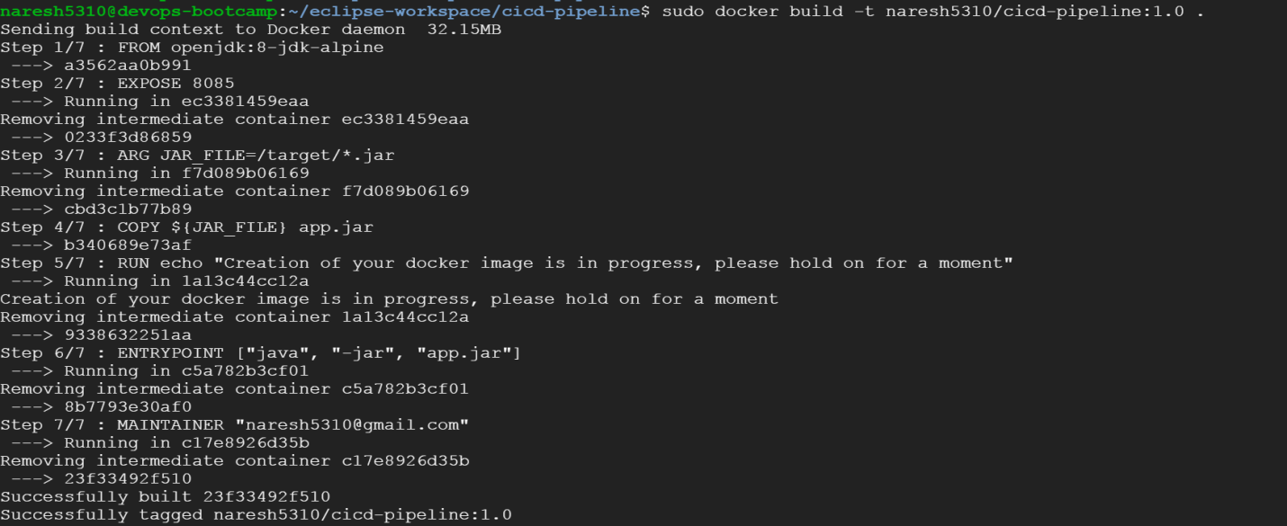
Fig: docker build command
Fig: docker run command
Dockerfile
FROM openjdk:8-jdk-alpine

EXPOSE 8085

ARG JAR_FILE=/target/*.jar

COPY ${JAR_FILE} app.jar

RUN echo "Creation of your docker image is in progress, please hold on for a moment"

ENTRYPOINT ["java", "-jar", "app.jar"]

MAINTAINER "naresh5310@gmail.com"

Output
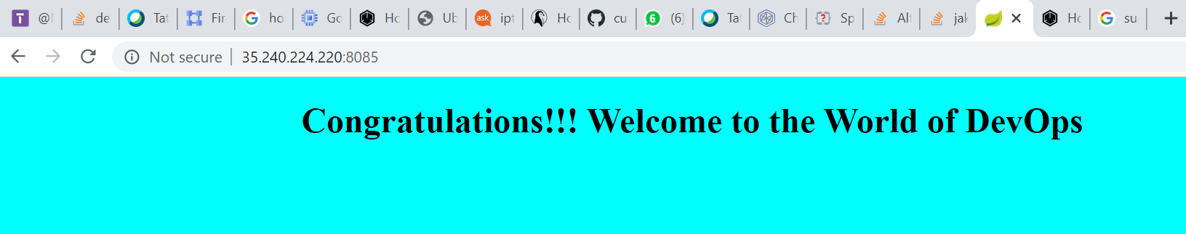
Write a dockerfile to run it on a tomcat server as a container

Dockerfile

FROM tomcat:8.0

MAINTAINER naresh5310@gmail.com

COPY /target/war-test.war /usr/local/tomcat/webapps/

CMD ["catalina.sh", "run"]

Building docker

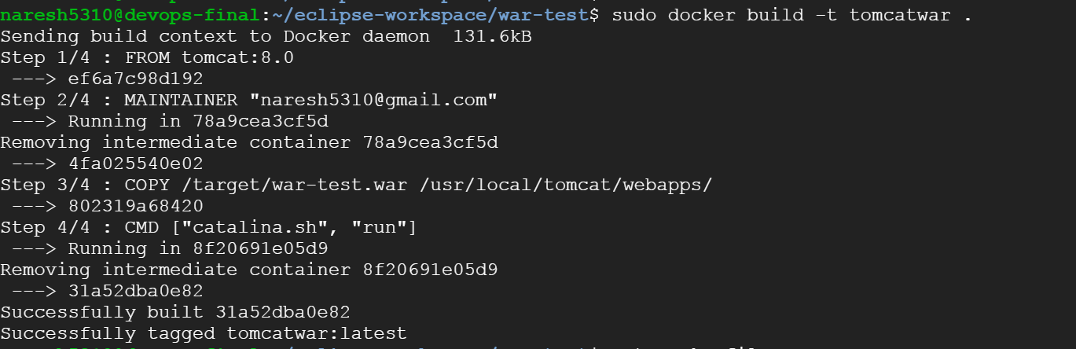

Running the docker container in interactive mode to understand how it is working with below command

sudo docker container run -p 8888:8080 -it 31a52dba0e82

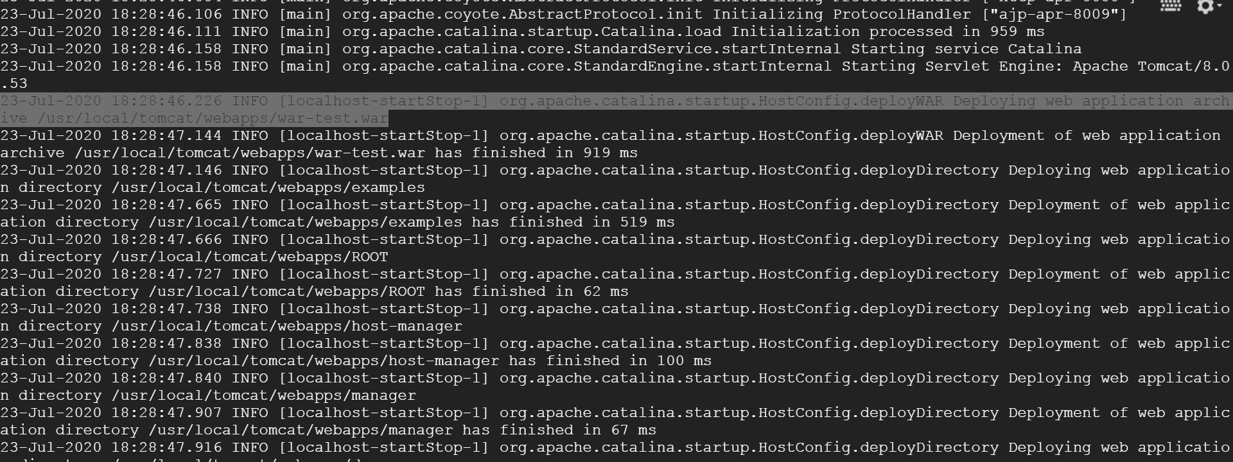

Check application:
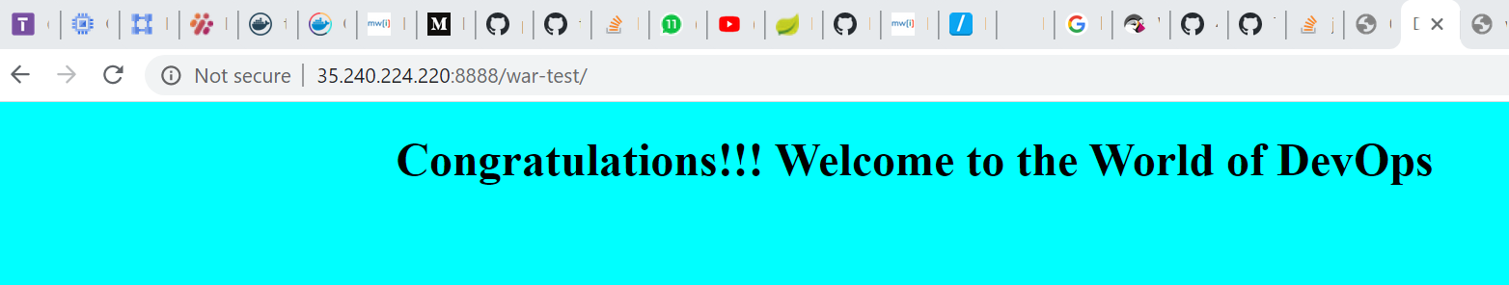
Run the application along with database with docker-compose

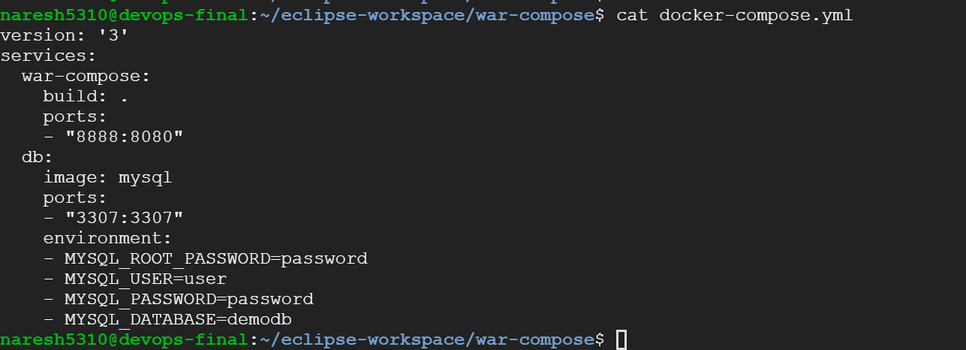

Fig: docker-compose.yml

Run the docker-compose command sudo docker-compose up --build

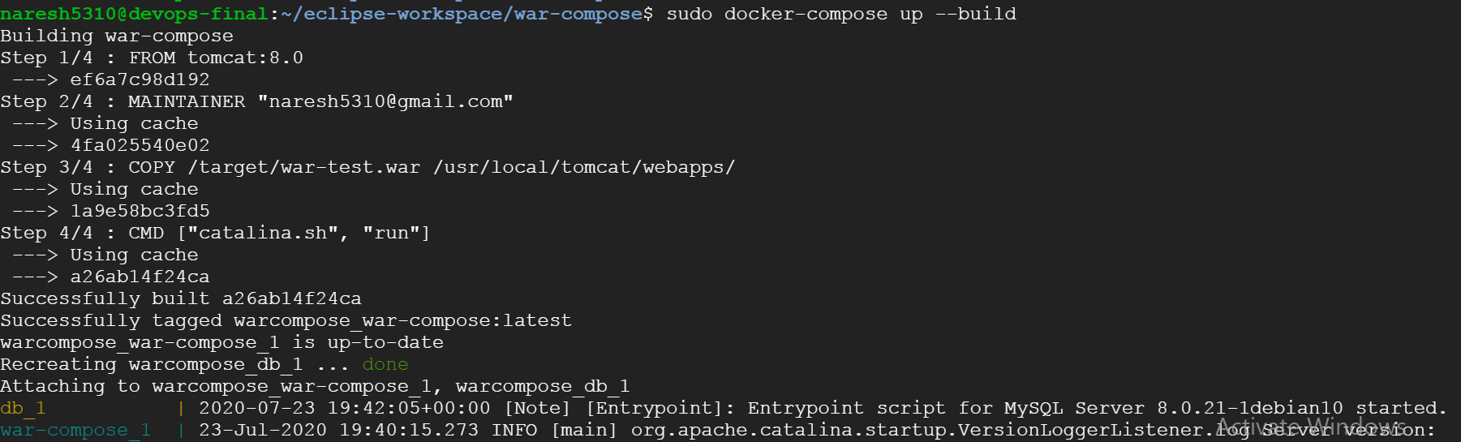

Database startup log

