Setting up new Responsive UI

Install NodeJS (<https://nodejs.org/>)

Install Git (<https://git-scm.com/download/win>)

open a Cmd Prompt to the Dashboard-ui module in your trunk checkout

(e.g. c:\projects\dashboard\trunk\dashboard-ui)

Run these commands:

git config --global url."https://".insteadOf git://

npm install

npm install bower -g

bower install

To run the ui in standalone mode, either:

grunt live

grunt server

live will run from the source files

server will run from a compiled/minified/concatenated version, as per the build scripts.

Add these extra redirects into your apache config: (replace web-core with the right context-root if needed)

ProxyPass /web-core/dashboard-ui http://localhost:9001/dashboard-ui keepalive=On ping=5

ProxyPassReverse /web-core/dashboard-ui http://localhost:9001/dashboard-ui

Running Dashboard in [IntelliJ](https://www.jetbrains.com/idea/download/)

Install [Maven 3.2.5](http://mirror.ox.ac.uk/sites/rsync.apache.org/maven/maven-3/3.2.5/binaries/apache-maven-3.2.5-bin.zip) if you haven’t already, and set these two [environment variables](https://www.microsoft.com/resources/documentation/windows/xp/all/proddocs/en-us/sysdm_advancd_environmnt_addchange_variable.mspx?mfr=true):

M2_HOME=C:\apache-maven-3.2.5

M3_HOME=C:\apache-maven-3.2.5

Go into Maven profiles, check embedded

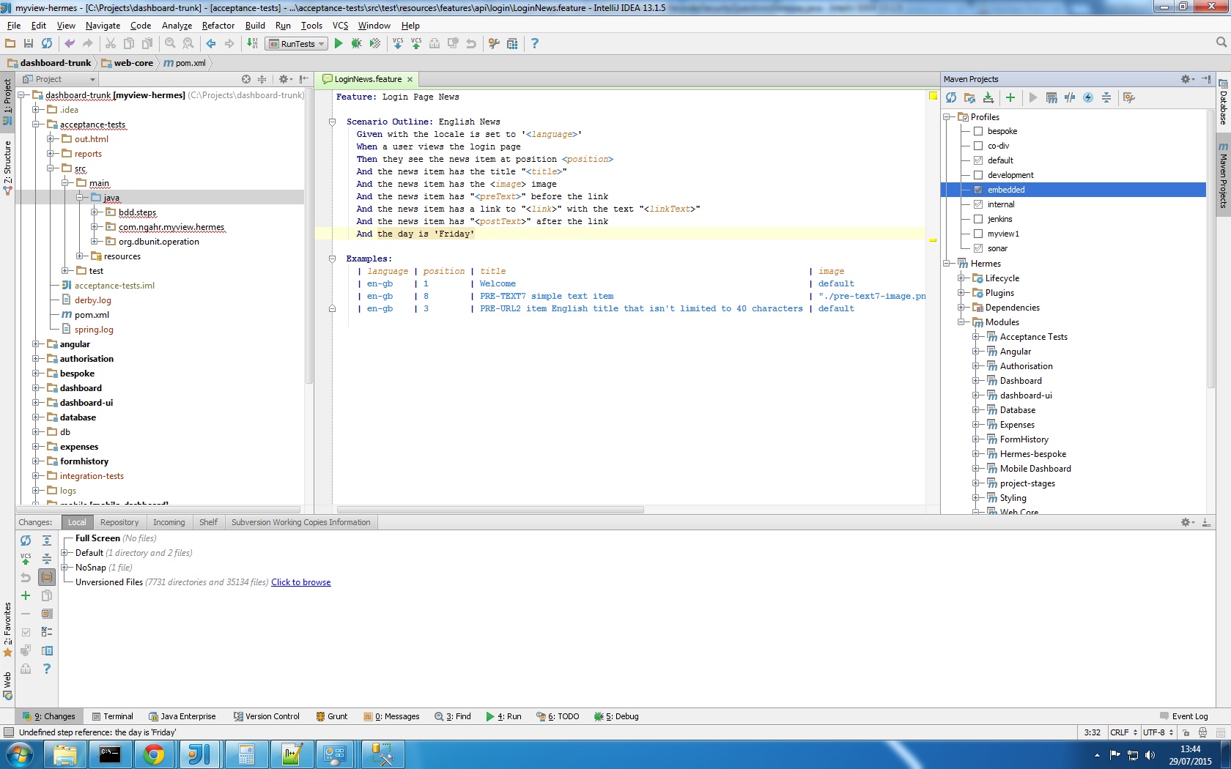

Set up a new ‘Application’ Run configuration

com.ngahr.myview.hermes.common.spring.DashboardSpringConfiguration

VM options

-ea -Xms256m -Xmx1024m -XX:MaxPermSize=768m -javaagent:spring-instrument-4.1.5.RELEASE.jar

working directory your dashboard directory e.g. C:\workspaces\mvdtrunk\dashboard

# Running with embedded Tomcat (this is what you normally do in development)

Enable the maven embedded profile

Set the profile to use the name of choice, either by:

* set JVM property, e.g. -Dspring.profiles.active=devcore
* change application.yaml**,** e.g.:

profiles:

active: devcore

Copy the myview.properties into dashboard/src/main/resources/

Adjust Apache proxy settings to:

* use HTTP and not AJP
* point to tomcat on the port configured in the application.yaml

# Externalising properties

In order to externalise application properties, create a new directory external to your project (note doco on this here [here](http://docs.spring.io/spring-boot/docs/current/reference/html/boot-features-external-config.html) )

Add in a copy of myview.properties and application.yaml to this external directory. From now on this directory needs to be in the classpath so you can tweak properties without changing the default ones.

Do this as follows for the dashboard module

<http://stackoverflow.com/questions/854264/how-to-add-directory-to-classpath-in-an-application-run-profile-in-intellij-idea>

# Running cucumber tests

Create run configuration:

1. main class: it.com.ngahr.myview.hermes.cucumber.junit.RunTests
2. VM options: **-Dspring.profiles.active=local,fitnesse** -Xms256m -Xmx1024m -XX:MaxPermSize=768m -javaagent:C:\workspaces\mvdtrunk\dashboard\spring-instrument-4.1.5.RELEASE.jar
3. change path in 2. to reflect local path
4. working dir: trunk\acceptance tests dir e.g. C:\workspaces\mvdtrunk\acceptance-tests
5. classpath of module: acceptance tests

You may need to externalise myview.properties and your run configuration as above.