**SOUTHWESTERN STATE COLLEGE**

**TRIBHUVAN UNIVERSITY**

**FACULTY OF HUMANITIES AND SCIENCE**



**A Project Report on**

**Medicine Recommendation system**

***Submitted to***

**Department of Computer of Application**

**SWSC - Basundhara, Kathmandu**

***In partial fulfillment of the requirements for the Bachelor in Computer Application***

***Submitted by***

Name: Naresh Khatri

TU Reg No: 6-2-530-20-2020

**SOUTHWESTERN STATE COLLEGE**

**TRIBHUVAN UNIVERSITY**

**FACULTY OF HUMANITIES AND SCIENCE**



# SUPERVISOR’S RECOMMENDATION

We here by recommend that this project is prepared by Naresh Khatri under supervision by Mr. Bijay Babu Regmi entitled “**Medicine Recommendation System**” in partial fulfillment of the requirements for the degree of Bachelor of Computer Application be processed for the evaluation.

**Mr. Kiran Ghimire**

**Supervisor**

**Head of Department of BCA**

**Southwestern State College**

# LETTER OF APPROVAL

This is to certify that this project is prepared by Naresh Khatri (6-2-530-20-2020) entitled “**Medicine recommendation system**” in partial fulfillment of the requirements for the degree of Bachelor in Computer Application has been evaluated. In our opinion it is satisfactory in the scope and quality as a project for the required degree.

**Mr. Bijay Babu Regmi**   **Kiran Ghimire**

**Project Supervisor Internal Supervisor**

**BCA Department SWSC**

**Bikash Parajuli Name**

**Internal Supervisor External Examiner**

**Tribhuvan University**

# ACKNOWLEDGMENT

For the partial fulfilment of the project this semester we would like to express our sincere gratitude to everyone who has directly and indirectly helped us to develop this project. There were times when we thought that this project was difficult or may be not possible to create but we are thankful to our respected supervisor **Bijay Babu Regmi** sir who continuously guided us to perform the project to complete in time. We could barely do anything without the help of teachers and friends who helped us throughout the whole journey and find and reconcile our mistakes.

I would also like to thank the Tribhuvan University for giving us this opportunity via the course of Computer Science and IT to help us understand the project ethics at this early stage and helped us to evaluate our knowledge and expand it a little more.

**With Respect,**

Naresh Khatri

(6-2-530-20-2020)

# ABSTRACT

The Medicine Recommendation System is made to provide individualized medical guidance, making it easier for people to manage their medical requirements. The Support Vector Machine (SVM) algorithm is used to analyze a patient's symptoms using the Support Vector Classifier (SVC) model. This model allows the system to identify possible diseases and suggest customized therapies, including diets, exercise regimens, and medication. This system simplifies the healthcare procedure in a similar way to how a travel booking system makes holiday planning easier by arranging all the important details. The system can precisely assess symptoms and pinpoint potential medical issues thanks to the SVM algorithm, which is well-known for its resilience in classification tasks. Serving as a personal healthcare assistant that helps people navigate their health journey, the platform is easy to use and intuitive. By offering tailored, well-informed advice,

***Keywords:*** *medicine,* *recommendation, SVC, SVM, predict, symptoms etc.*

**TABLE OF CONTENTS**

SUPERVISOR’S RECOMMENDATION ii

LETTER OF APPROVAL iii

ACKNOWLEDGMENT iv

ABSTRACT v

LIST OF FIGURES vii

LIST OF TABLES viii

LIST OF ABBREVIATIONS ix

CHAPTER1: INTRODUCTION 1

1.1 Introduction 1

1.2 Objective 1

1.3 Problem Statement 2

1.4 Scope and Limitations 2

1.4.1. Scope 2

1.4.2. Limitations 2

1.5 Development Methodology 3

1.6 Report Organization 6

CHAPTER 2: BACKGROUND STUDY AND LITERATURE REVIEW 8

2.1 Background Study 8

2.2 Literature Review 9

CHAPTER 3: SYSTEM ANALYSIS AND DESIGN 10

3.1. System Analysis 10

3.1.1. Requirement Analysis 10

3.1.2. Feasibility Analysis 11

3.1.3. System Modelling 13

CHAPTER 4: SYSTEM DESIGN 17

4.1 System Design 17

4.1.1. Refinement of Classes and object diagram 17

4.1.2. Refinement of Sequence diagram 18

4.1.3. Component Diagram 19

4.2 Algorithm Description 20

4.2.1. Support Vector Machine 20

CHAPTER 5: IMPLEMENTATION AND TESTING 22

5.1 Implementation 22

5.1.1 Tools Used 23

5.1.2 Implementation Details of Module 24

5.2 Testing 29

5.2.1 Unit Testing 29

5.2.2 System Testing 30

5.3 Result Analysis 31

CHAPTER 6: CONCLUSION AND FUTURE RECOMMENDATION 32

6.1 Conclusion 32

6.2 Lesson Learnt/ Outcome 32

6.3 Future Recommendations 33

REFERENCES 34

APPENDIX 35

# LIST OF FIGURES

Figure 1:Agile Methodology 5

Figure 2:Use case diagram of medicine recommendation system 10

Figure 3:Gantt Chart 12

Figure 4:Class Diagram 13

Figure 5: Sequence Diagram 14

Figure 6: State Diagram 15

Figure 7: Activity Diagram 16

Figure 8: Refined Class Diagram 17

Figure 9: Refined Sequence Diagram 18

Figure 10: Component Diagram 19

Figure 11: SVM Architecture 20

Figure 12: Imports and Setup for Medicine recommendation system 24

Figure 13: Flask Application Initialization for medicine recommendation system 24

Figure14: Dataset Loading and Preprocessing for medicine recommendation system 25

Figure 15: Label Encoding for Medicine Recommendation System 26

Figure 16: Homepage for Medicine Recommendations System. 28

Figure 17: Running Medicine Recommendation application 28

Figure 18:Result Analysis 31

Figure 19: Home page 35

# LIST OF TABLES

Table 1: Unit Testing for Textfield 32

Table 2: Testing for System 33

# LIST OF ABBREVIATIONS

**AI:** Artificial Intelligence

**CSS:** Cascading Style Sheet

**HTML:** Hyper Text Markup Language

**SVC:** Support Vector classifier

**ML:** Machine Learning

**SVM:** Support Vector Machine

**OOP**: Object Oriented Programming

**UML:** Unified Modeling Language

# CHAPTER1: INTRODUCTION

## **1.1 Introduction**

The Medicine Recommendation System is a user-friendly digital tool developed to make healthcare more personalized and accessible for everyone. By analyzing a patient's symptoms, it uses advanced algorithms to recommend the most suitable treatments, including medications, workout routines, and diet plans. Similar to how booking a trip has become easier with online platforms, this system simplifies the healthcare process, offering patients timely and accurate advice without the usual confusion or delays.

Many people face challenges when it comes to managing symptoms, finding a diagnosis, and choosing the right treatment options. This system eliminates the guesswork by streamlining everything into one simple process. It allows patients to easily track their symptoms and receive personalized health recommendations, tailored specifically to their needs. From workout routines to diet plans, it suggests ways to improve overall wellness, helping patients make informed choices about their health.

The ultimate goal of the Medicine Recommendation System is to empower patients, giving them more control over their health journey. By digitizing and optimizing the entire healthcare experience, it not only improves the accuracy of diagnosis and treatment but also ensures the process is easy to navigate, making personalized care more approachable for everyone.

## **1.2 Objective**

* To predict the disease based on the Symptoms
* To recommend the medicine, workout, and diet based on the Symptoms.

## **1.3 Problem Statement**

The Medicine Recommendation System addresses several critical challenges in modern healthcare. Traditional treatment methods often struggle to deliver highly personalized care due to the diversity of patient profiles, symptom variations, and the complexity of diagnoses. This system leverages machine learning to analyze individual symptoms, providing tailored treatment recommendations that enhance the relevance and effectiveness of care. Additionally, it reduces the risk of adverse drug reactions by analyzing medical histories and potential medication interactions, minimizing harmful prescriptions. By rapidly processing large volumes of data, the system also improves the accuracy and efficiency of treatment advice, supporting healthcare providers in making prompt, data-driven decisions. The continuous learning capability of the system allows it to refine recommendations over time, adapting to new medical findings and improving overall patient care quality. Through this, the Medicine Recommendation System transforms healthcare into a more personalized, efficient, and safer experience for patients and providers alike.

## **1.4 Scope and Limitations**

### **1.4.1. Scope**

The Medicine Recommendation System is an innovative healthcare tool designed to support individuals in understanding and addressing their health needs through advanced technology. The system functions by analyzing symptoms provided by users, allowing it to assess possible health concerns through the power of machine learning algorithms. These algorithms enable the system to make accurate predictions about potential diseases, leveraging data patterns to produce reliable diagnostic suggestions based on the information entered. Upon identifying the probable disease or condition, the system goes a step further by recommending appropriate medications, specifically chosen to address the individual’s unique symptoms and condition. This capability helps users take targeted actions in managing their health, all within an accessible and easy-to-use digital interface.

### **1.4.2. Limitations**

* The medicine recommendation system primarily focuses on backend processes such as data retrieval, predicting, and recommending, rather than on the front-end user interface. Consequently, the system prioritizes functionality over visual or interactive elements, resulting in a limited UI experience compared to systems designed with a stronger emphasis on user interface.
* The system's capacity to anticipate diseases and suggest treatments may be limited if it only responds to one symptom, encounters ambiguity, or falls outside of its taught knowledge set. To guarantee appropriate advise for difficult or extremely particular health concerns, the system may need to be further developed or healthcare professionals' help may be needed.

## **1.5 Development Methodology**

* Develop the system using Bootstrap and JavaScript for frontend and python for backend.
* This project adopted agile technique
* The development of a recommendation system for intelligent medicine requires the use of Support Vector Machines (SVM). SVM allows the system to accurately analyze user-inputted symptoms and suggest suitable therapies, such as drugs and exercise regimens, by training it on a sizable dataset of diseases and their corresponding medications. For customers looking for advice on how to manage their health, this method guarantees that the recommendations are both pertinent and tailored to them.

**Agile Methodology:**

This project adopted agile technique. The Agile methodology is a style of project management that divides a project into phases. It significantly enhances the development of recommendation system projects by promoting flexibility, collaboration, and iterative progress.

We have adopted this methodology as it helps to break down the project into manageable tasks and ensure that everyone on the team is working towards same goal, that is well suited for our final group project leading to maintenance in the team structure.

Here are the key steps followed to use agile model on the medicine recommendation system:

* Planning:

I defined the core functionality of the recommendation system, such as predicting the condition based on symptoms entered by the user and recommending appropriate treatments. They divide the work into manageable assignments that can be finished in a few weeks.

* Requirement Analysis:

I analyzed the key features that users might want from a medicine recommendation system.

This system predict the disease on the basis of user-inputted symptoms and suggest appropriate treatment.

* Design:

I planned the overall structure of the recommendation engine and how the user interface would present suggestions. The design aimed to balance ease of use with the complexity of the underlying recommendation algorithms.

* Coding:

I developed the recommendation engine first, followed by creating the user interface. The development process was iterative, with features being added gradually and tested frequently.

* Testing:

As each component was completed, I tested it to ensure the system generated relevant manga recommendations. I used feedback from initial tests to make adjustments and refine the recommendations.

* Deployment**:**

The system was deployed incrementally, with each version improving upon the last. The initial version provided basic functionality, with further enhancements added as the project progressed

In conclusion, Agile methodology enables the system project to be developed in small, manageable steps, ensuring quick delivery of essential features and continuous predict and recommend the medicine and workouts.

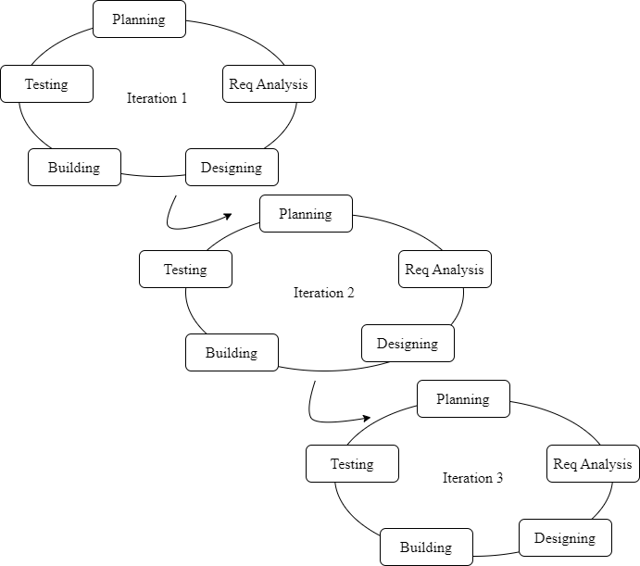

Figure 1:Agile Methodology

## **1.6 Report Organization**

**Chapter 1**

This chapter has the following sections: Introduction, Problem Statement, Objectives, Scope, and Limitations. In this chapter, a clear idea of what the system aims to achieve is explained. The Medicine Recommendation System is developed as a virtual assistant aimed at streamlining the process of identifying and recommending appropriate medications based on symptoms, thereby reducing the reliance on manual research or consultations for minor ailments. The primary goal is to provide quick, accurate recommendations to users about suitable over-the-counter medicines while ensuring essential safety guidelines are followed.

The system addresses the inefficiencies of traditional methods by offering real-time, automated suggestions based on symptom inputs. The scope includes delivering essential information through an AI-driven conversational interface, though it is limited by its dependency on accurate symptom input and its focus on backend data processing rather than an enhanced user interface. The project follows the Agile development methodology, enabling iterative progress and continuous improvements based on user feedback.

**Chapter 2**

In chapter 2, the background study explores the evolution of medicine recommendation system, This paper proposes a medicine recommendation system that uses AI and machine learning to predict diseases and medications based on symptoms entered by patients or users. AI and machine learning are multidisciplinary fields used in classification and predictive analysis, and medical professionals can use these systems to make more informed decisions. Advancements in AI and SVM technologies have also led to the rise of system, which can handle complex conversations, make recommendations, answer queries, and perform tasks for users. The system uses the Support Vector Machine (SVC) model to improve user experience, streamline processes, and reduce costs

**Chapter 3**

This chapter delves into the analysis of system requirements, covering both functional needs (e.g., user queries and responses) and non-functional aspects (e.g., user-friendly interface, 24/7 availability). It also includes feasibility analysis to ensure the project is technically, operationally, and economically viable. System modeling is presented through various diagrams, such as use-case, class, sequence, state, and activity diagrams, which collectively illustrate the chatbot's architecture, interactions, and workflows.

**Chapter 4**

This chapter focuses on the detailed architecture of the Medicine Recommendation System, using refined UML diagrams to illustrate the system's components and their interactions. It also covers the algorithmic approach, particularly the use of Support Vector Classifier (SVC) and Support Vector Machine (SVM), which are employed to enhance the system's recommendation capabilities. The SVC model enables the system to analyze user inputs more effectively by identifying patterns in the data, thereby generating accurate and contextually relevant medicine recommendations.

**Chapter 5**

This chapter outlines the implementation of the chatbot using tools like HTML, CSS, Python, flask, and Bootstrap for building the user interface, backend logic. Key modules include data cleaning, training the chatbot model, and managing user interactions. The testing phase involves unit testing of individual components and system testing to ensure reliable performance and accurate responses.

**Chapter 6**

The conclusion highlights the project's success in improving information the Medicine Recommendation System is a digital tool designed to make healthcare more personalized and accessible. It uses advanced algorithms to analyze patient symptoms and recommend suitable treatments, such as medications, workout routines, and diet plans. This system simplifies the healthcare process, providing timely and accurate advice without confusion. It empowers patients by empowering them with more control over their health journey and making personalized care more accessible.

# CHAPTER 2: BACKGROUND STUDY AND LITERATURE REVIEW

## **2.1 Background Study**

Most people tend to live a long and healthy life, but people are busy in their day to-day life and it is not possible for everyone to visit doctors for minor symptoms of a disease. Many people do not know about medicines and to visit a doctor and consult for minor symptoms for medicines is a time-consuming process. AI and machine learning like emerging technology can help us to create a recommended system that will prescribe medicine and this system can accurately predict a medicine to use. In this paper proposes the medicine recommendation system which will predict disease and medicine according to symptoms entered by patients/users. [1]

uses of artificial intelligence that have drawn interest from scholars worldwide. RSs are developed using a variety of machine learning algorithms. Selecting, The most difficult task in the field of RSs is determining the optimal machine learning algorithm to offer people a good or service [3]. The computer science discipline of artificial intelligence gave rise to machine learning (ML). Combining computer science algorithms with statistics, machine learning (ML) is a multidisciplinary field that finds extensive use in classification and predictive analysis . Medical professionals can choose the right medication for their patients with the help of medicine recommender systems. Such recommendation systems can be developed with the aid of today's cutting-edge technologies, perhaps resulting in more succinct decisions [2]. Because of the rise

With the advancements in AI and NLP technologies, Chatbot have become more sophisticated and can now handle complex conversations, make recommendations, answer queries, and even perform tasks for users. Today, chatbots are used in various industries, such as customer service, healthcare, finance, education, and entertainment, to enhance user experience, streamline processes, and reduce costs. In this system we use the SVC model that provides the Support vector machine algorithm [3]

## **2.2 Literature Review**

The unforeseen COVID-19 epidemic is currently posing a major threat to humanity worldwide. Numerous flaws in the medical and healthcare system are revealed by the onset of this pandemic. According to WHO standards, appropriate steps that aid in stopping the virus's transmission must be taken. It is quite challenging to track down infected individuals or patients worldwide. The lack of COVID-19 test kits hinders the testing procedure in many nations. In order to lower the infection rate, a testing procedure requires a reliable method to identify the infected patient. In order to tackle this problem, a machine learning-based COVID-19 test recommendation system based on symptoms is suggested and evaluated on actual data sets. The findings show that of the system are encouraging and up to 99% accurate. The suggested piece of work goes through four stages. First, it uses the Superintendent of the Physical Health Center's (Rajam) inputs to produce a synthesized data set. Second, random under-sampling (RUS) and synthetic minority over-sampling (SMOTE) are used to balance the synthesized data set. Third, the synthesized and balanced data sets are subjected to a variety of machine learning techniques, including K-Nearest Neighbor (KNN), Decision Tree (DT), Naïve Bayes, Random Forest (RF), Stochastic Gradient Descent (SGD), and Support Vector Machine (SVM), in order to categorize the subjects into distinct classes according to age, comorbidity (chronic disease), and other symptoms (cold, cough, fever, and dyspnea). Lastly, the best classification model is combined with the COVID-19 Test Recommended System. [4]

# CHAPTER 3: SYSTEM ANALYSIS AND DESIGN

## **3.1. System Analysis**

The project will be explained using dataflow diagrams, flowcharts, use-case diagrams, connection and entity diagrams, and so on.

### **3.1.1. Requirement Analysis**

**3.1.1.1. Functional Requirement**

* + The user shall be able to enter symptoms.
  + The user shall be able to view potential diseases.
  + The user shall be able to view descriptions of the diseases.
  + The user shall be able to access information about recommended medicines.
  + The user shall be able to access workout recommendations.
  + The user shall be able to access dietary recommendations.
  + The user shall be able to view suggested precaution.

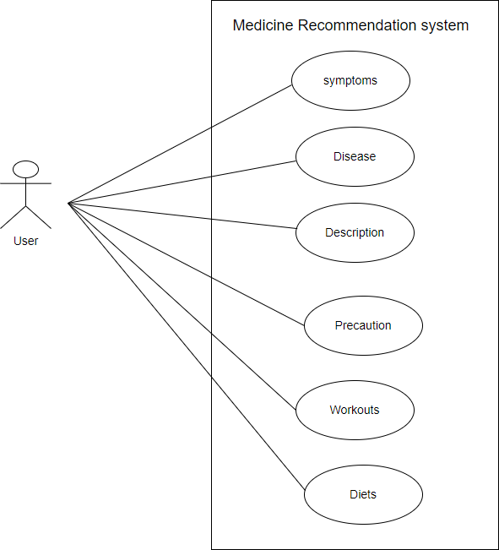

Figure 2: Use case diagram of medicine recommendation system

**3.1.1.2. Non-functional Requirement**

* The system must be user-friendly.
* The system must provide recommendations quickly.
* The system must be compatible with different system devices.

### **3.1.2. Feasibility Analysis**

A feasibility study for the Southwestern College chatbot involves evaluating whether developing and deploying the chatbot is practical and beneficial.

**3.1.2.1. Technical Feasibility**

Support Vector Classifier (SVC) with a linear kernel. This is the algorithm that was initialized, trained, and used for prediction and recommendations. Libraries like sk-learn in Python provide efficient implementations of support Vector Classifier, accuracy-score, confusion-matrix.

**3.1.2.2. Operational Feasibility**

The operational implementation is simple and efficient. Once the system is made, the technical skills are not required to manage the web application on a daily basis. Simple knowledge about the system mentioned in the user manual and some simple guidance will be enough for the owner/admin to utilize the features and operate the system i.e, the user of the system can cope up with the system easily without being professional or trained in technical field.

**3.1.2.3. Economic Feasibility**

The project can be developed in a very cost-effective way because the project would be using open-source software like Python and Bootstrap which are available free online. Also, the benefits of the project outweigh the cost. Hence the project can be deemed economically feasible.

**3.1.2.4. Schedule Feasibility**

It includes the total time for the completion of the project.

Gantt chart was used for scheduling the time for this project.

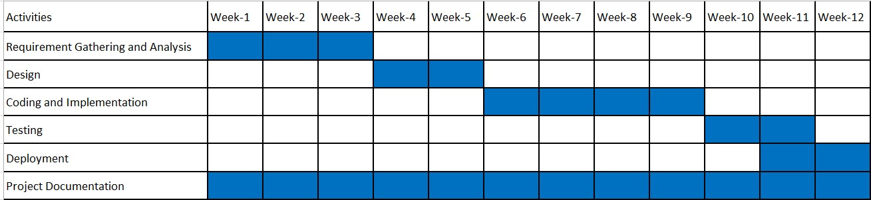

Figure 3: Gantt Chart

### **3.1.3. System Modelling**

**3.1.3.1. Object modeling using class and object diagram**

Class diagram is a major building block in object modeling. A class diagram shows the static structure of an object-oriented model: the object classes, their internal structure, and the relationships in which they participate. The figure below shows the object implementation of our project.

In the figure 4, The class diagram shows how the four primary parts of a Flask-based illness prediction and health management system_App, Model, DiseaseHelper, and SymptomProcessor—interact with one another. As the main component of the system, the app acts as the point of entry and coordinates interactions with other parts to process user requests and deliver relevant answers. The machine learning model that predicts diseases is represented by the Model component, which has tools for loading the model and making predictions about diseases using input symptom data. By offering comprehensive details regarding diseases, including their descriptions, preventative measures, prescription drugs, dietary guidelines, and exercise suggestions, the DiseaseHelper component improves the system. Furthermore, the SymptomProcessor manages symptom processing by using a list of diseases and a lexicon of based on the user's input, the most likely.

Figure 4: Class Diagram

**3.1.3.2. Dynamic modeling using State and Sequence Diagrams**

**Sequence Diagram**

A sequence diagram depicts the interactions among objects during a certain period of time. It shows the participating objects by their lifelines and the interactions among those objects arranged in time sequence by the messages they exchange with one another. The diagram below shows our implementation of the sequence diagram and State Diagram.

Figure 5: Sequence Diagram

The sequence diagram illustrates the workflow of a Flask-based disease prediction system, detailing the interactions between the user, application, template, model, and helper components. The process starts when the user accesses the system and loads the index page, prompting the application to render the index.html template. The user then submits a form with their symptoms, which the application validates to ensure the input is accurate and complete. Once validated, the symptoms are passed to the machine learning Model, specifically a Support Vector Classifier (SVC), which processes the input and predicts the disease by returning a corresponding disease index. The application then interacts with the Helper component to retrieve additional information about the predicted disease, such as its description, precautions, medications, diet recommendations, and workout plans. Finally, the application incorporates these details into the index.html template, rendering it with the prediction and related information, which is displayed to the user. This structured and modular approach ensures a smooth flow of data between components, providing accurate predictions and comprehensive health information in a user-friendly manner.

**State Diagram**

State Diagram is an illustration of the state/condition of the system or part of the system at finite instances of time.

Figure 6: State Diagram

In the above figure, the state diagram, the user requests the symptoms as input is processed with SVM which generates the output.

**3.1.3.3. Process modeling using Activity Diagrams**

Activity diagram in the UML is a type of diagram that visually presents a series of actions or flow of control in a system. It shows workflows of stepwise activities with support for choice, iteration and concurrency.

Figure 7: Activity Diagram

The above activity diagram shows the flow of the system where users enter the query which is pre-processed and bags of words are compared with existing tags to generate relevant output.

# CHAPTER 4: SYSTEM DESIGN

## **4.1 System Design**

System design is the process of representing architecture, interfaces, components that are included in the system. i.e., system design can be seen as the application of system theory to product development.

The UML diagrams are now refined to show more detailed description of the system component which makes it easier to understand the overall working of the system. Refined UML diagrams include class diagram, sequence diagram and activity diagram of different system modules.

### **4.1.1. Refinement of Classes and object diagram**

The refined class diagram is the detailed formed of the class diagram with the addition of precise definition of each attribute and operations of each class

Figure 8: Refined Class Diagram

### **4.1.2. Refinement of Sequence diagram**

A refined sequence diagram is a type of UML (Unified Modeling Language) diagram that provides a detailed view of the interactions between objects in a system or process. It shows the sequence of messages exchanged between objects or components of a system and the order in which these interactions occur.

Figure 9: Refined Sequence Diagram

### 

### **4.1.3. Component Diagram**

A component diagram is a type of UML diagram that shows the structural relationships and dependencies between the components of a software system. It illustrates how software components are connected and interact with each other within a system. Components can represent individual modules, libraries, executables, or other parts of a system.

Figure 10: Component Diagram

## **4.2 Algorithm Description**

### **4.2.1. Support Vector Machine**

Support Vector Machine (SVM) is a powerful and versatile supervised machine learning algorithm used for classification, regression, and outlier detection tasks. It works by finding the optimal hyperplane that best separates data points of different classes in a feature space.[3]

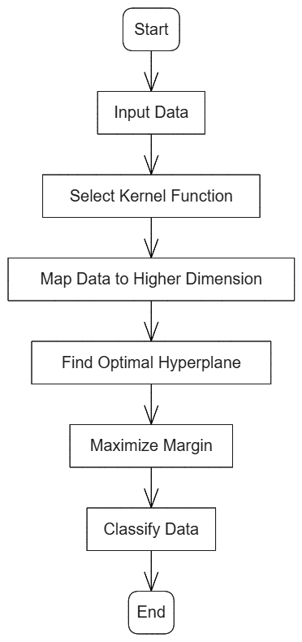

Figure 11: SVM Architecture

Support Vector Machines (SVM) can handle situations where there are more dimensions than samples and are very effective in high-dimensional domains. SVM is therefore especially well-suited for intricate datasets with a large number of characteristics. Furthermore, because SVM uses only a subset of training points—referred to as support vectors—in the decision function, it uses less memory. This methodical methodology guarantees computational effectiveness while preserving sound decision-making. Additionally, SVM is flexible since it can employ several kernel functions for the decision boundary. Common kernels like linear, polynomial, and RBF are easily accessible, but SVM also enables the specification of unique kernels to meet the needs of particular problems.[3]

The Support Vector Machine (SVM) algorithm works systematically to classify data points or perform regression tasks. Below are the detailed steps:

Input the Dataset:

* Collect and preprocess the dataset.
* Ensure data is clean, scaled, and normalized if necessary to improve the performance of SVM.

Select the Kernel Function:

* Choose a kernel function based on the nature of the data:
* Linear Kernel: For linearly separable data.
* Non-Linear Kernels: For complex relationships (e.g., Polynomial, RBF)

Map Data to a Higher Dimensional Space

* For non-linear data, use the kernel trick to transform the data into a higher-dimensional space where it becomes linearly separable.
* SVM does not compute this transformation explicitly but relies on kernel functions to calculate dot products in the transformed space.

Find the Optimal Hyperplane:

* Identify the hyperplane that separates the classes with the maximum margin.
* The margin is the distance between the hyperplane and the closest data points from each class.

Determine Support Vectors:

* Identify the data points closest to the hyperplane; these are the support vectors.
* These points define the margin and influence the position of the hyperplane.

# CHAPTER 5: IMPLEMENTATION AND TESTING

## **5.1 Implementation**

The Medicine Recommendation System is designed to streamline the process of accessing medical information and recommendations, making it more efficient and user-friendly. It features a comprehensive architecture that includes frontend, backend, and database components.

The frontend is built using HTML, CSS, and JavaScript, which together create a visually appealing and interactive user interface. This interface allows users to type in queries and receive responses from the system in a conversational format. JavaScript enhances this interactivity by enabling real-time communication with the backend without needing to refresh the page. The backend is developed in Python and serves as the brain of the system. It uses advanced machine learning techniques to understand user queries. Specifically, the recommendation system employs Support Vector Classifier (SVC), a supervised learning algorithm based on Support Vector Machines (SVM), which excels at classification tasks. This enables the system to analyze user input accurately and recommend appropriate medicines. Python libraries such as pandas and scikit-learn might be used for data processing and building the SVM model.

The development process adheres to the Agile methodology, which breaks the project into manageable tasks and promotes iterative progress. This approach allows for continuous feedback and improvements, ensuring the chatbot evolves based on real user needs and feedback. Testing is a critical phase, involving unit testing of individual components, integration testing to ensure all parts work together smoothly, and user testing to gather feedback on the chatbot’s effectiveness and usability. Similarly, Deployment involves releasing the chatbot to users, starting with core features and gradually adding enhancements based on feedback. Future improvements might include multilingual support to cater to a diverse user base, voice interaction capabilities for hands-free use, and personalized responses to enhance user experience.

Overall, the Medicine Recommendation System represents a significant step towards improving medical information accessibility and efficiency, leveraging cutting-edge technologies to offer a more responsive and user-friendly experience.

### **5.1.1 Tools Used**

* JavaScript

The main purpose of JavaScript, a popular and flexible programming language, is to give web pages more interaction. Along with HTML and CSS, it is a crucial component of the contemporary web development stack. By working with HTML components, modifying the Document Object Model (DOM), managing events, and much more, JavaScript gives developers the ability to provide dynamic content and improve user experience.

* PYTHON

Python is a popular, high-level programming language that is widely utilized in diverse applications like scientific computing, web development, data analysis, artificial intelligence, and more. It supports a wide range of object-oriented programming (OOP) concepts, including encapsulation, inheritance, and polymorphism. Python also boasts a rich collection of third-party frameworks and standard libraries for various applications, making it a popular choice for developers and organizations.

* Bootstrap

Bootstrap is a popular open-source front-end framework for building responsive, mobile-first websites and web applications. Initially developed by Twitter in 2011 by Mark Otto and Jacob Thornton, it provides a set of tools, including HTML, CSS, and JavaScript components, that help developers quickly design and customize web interfaces.

* Visual Studio Code

This is our code editor where we have written our all of codes. This tool is very user friendly and have lots of extensions which helps for making the coding process more efficient.

* Snipping Tool

This is a pre-installed tool on our Windows Machine which helps to take the screenshots of all required figures, documents and user interfaces.

* Microsoft Word

This tool is used to do all the documentation of our project from the scratch to the very end.

* Microsoft PowerPoint

This tool is used to make the PowerPoint slides to do presentation of our project.

### **5.1.2 Implementation Details of Module**

This model can be decomposed into following modules:

**Imports and Setup**

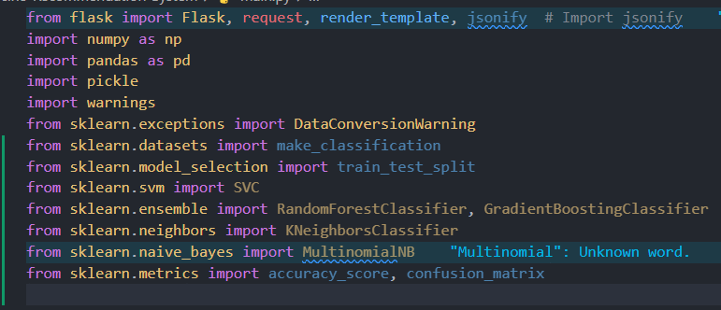In this module the code imports necessary libraries for data processing (pandas, numpy), building the machine learning model (SVC,SVM), handling web requests (Flask).

Figure 12: Imports and Setup for Medicine recommendation system

**Flask Application Initialization**

The line app = Flask(__name__) initializes a Flask web application by creating an instance of the Flask class. The argument __name__ helps Flask determine the root path of your application, allowing it to locate resources like templates and static files. This app object serves as the core of your web app, enabling you to define routes, handle HTTP requests, and control responses.

Figure 13: Flask Application Initialization for medicine recommendation system

**Dataset Loading and Preprocessing**

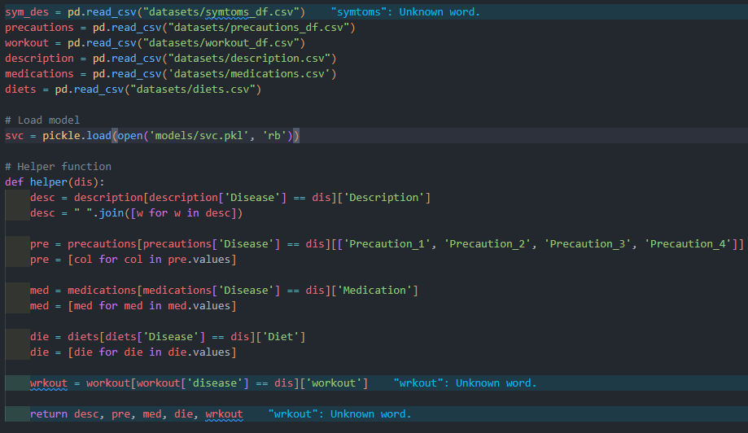This part of the code loads multiple CSV files that contain datasets essential for the system's functionality, including symptoms, precautions, disease descriptions, medications, diets, and workout recommendations. It then loads a pre-trained machine learning model (svc.pkl) using the pickle library. Additionally, the helper() function is designed to retrieve and organize specific information for a given disease. It extracts the disease description, a list of precautions, recommended medications, dietary suggestions, and workout plans from their respective datasets. This structured information is returned as a tuple to be used further in the application, ensuring that all relevant data for the disease is efficiently gathered and ready for use.

Figure14: Dataset Loading and Preprocessing for medicine recommendation system

**Label Encoding**

The preprocessing procedures for getting a dataset ready for machine learning are shown in the code sample. The first step is to extract the dataset's characteristics and target variable. While the target variable (y) is extracted as the prognosis column, the features (X) are extracted by dropping the prognosis column. The sklearn.preprocessing module's LabelEncoder is used to convert the target variable, which is categorical, into numerical values. The transform approach creates the encoded target Y by converting the distinct categories found in the target variable into numerical representations, which are then learned by the fit method. Lastly, the train_test_split function is used to divide the data into training and testing sets. Here, the random_state is set to 20 and 70% of the data is used for training and 30% for testing.

Figure 15: Label Encoding for Medicine Recommendation System

**Model Training and Model Definition**

A supervised machine learning approach for classification tasks, the Support Vector Classifier (SVC) is based on Support Vector Machines (SVM). Finding the best hyperplane to divide data points into distinct classes with the largest margin is how it operates. This margin, which is crucial in establishing the location of the decision boundary, is the separation between the hyperplane and the closest data points from each class, known as support vectors. Because it ignores other data points and concentrates only on these support vectors, SVC is resilient and less susceptible to noise. SVC employs kernels to translate input data into a higher-dimensional space where a linear hyperplane may successfully divide the classes when working with non-linearly separable data. Linear, polynomial, and radial basis functions are examples of common kernels.

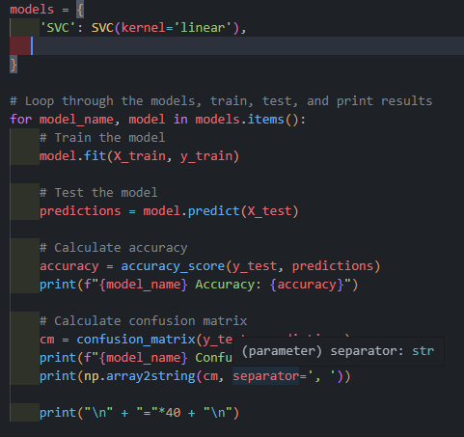

Figure 14: Model Definition for Medicine Recommendation Sy

**Web Application**

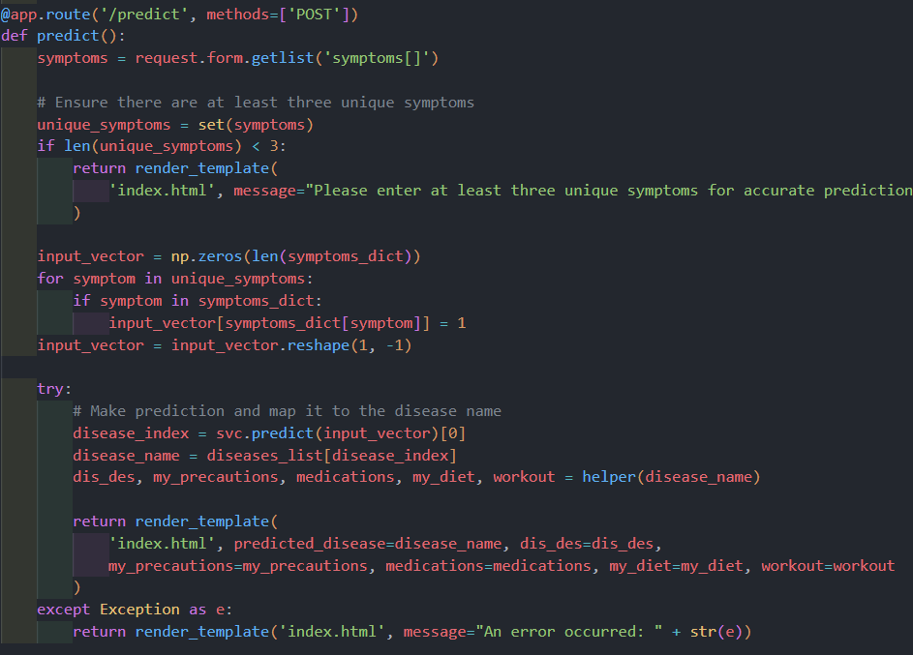The code defines a Flask web application with routes for handling user input and returning system responses. The web application uses AJAX to send asynchronous requests to the server and update the system response on the web page

Figure 16: Homepage for Medicine Recommendations System.

**Running Medicine Recommendation application**

This code ensures that the Flask application runs only when the script is executed directly, not when imported. The server runs in debug mode, making it easier to develop and troubleshoot your web application.

Figure 17: Running Medicine Recommendation application

## **5.2 Testing**

Testing is the process of evaluating and verifying whether the developed software or application works properly or not i.e., whether there is match between the actual results and expected results or not. Testing is carried out during the development of the software.

### **5.2.1 Unit Testing**

Unit testing is the part of the testing methodology which includes testing of individual software modules as well as the components that make up the entire software. The purpose is to validate each unit of the software code so that it performs as expected.

Table 1: Unit Testing for Input Field

|  |  |  |  |  |  |  |
| --- | --- | --- | --- | --- | --- | --- |
| Test Case ID | Testcase Description | Test Step | Test Data | Excepted Outcome | Actual Outcome | Remarks |
| 01 | Checking response of the single symptoms | Enter the symptoms | Fever | Enter multiple symptoms | Urinary tract infection | Failed |
| 02 | Checking response of the same symptoms multiple time | Enter the multiple same symptoms | Fever, fever, fever | Please enter the unique symptoms | Urinary tract infection | Failed |
| 03 | Checking t response of the different symptoms | Enter the different  symptoms | itching, skin_rash, stomach_pain, spotting_ urination | Drug Reaction | Drug Reaction | pass |

### **5.2.2 System Testing**

System testing is a process of verifying that a software system meets the specified requirements and works as intended. It evaluates the system as a whole and ensures its correct functioning.

Table 2: Testing for System

|  |  |  |  |  |  |  |
| --- | --- | --- | --- | --- | --- | --- |
| Test Case ID | Testcase Description | Test Step | Test Data | Excepted Outcome | Actual Outcome | Remarks |
| 01 | User should enter the symptoms that they have. | * Open the system * Enter the symptoms * Click on predict button | itching, skin_rash, stomach_pain, spotting_ urination | Drug Reaction | Drug Reaction | pass |
| 02 | User should enter the symptoms that they have. | * Open the system * Enter the symptoms * Click on predict button | fatigue, mood_swings, weight_loss, restlessness | Hyperthyroidism | Hyperthyroidism | pass |

## **5.3 Result Analysis**

Demonstration of the project shows that the system is successful in providing transparent medical information and recommendations to users. Both the functional and non-functional requirements were fulfilled during testing. The results showed that the project was able to meet its goals, but there is still room for improvement in terms of expanding the system's capabilities and providing even more accurate information.

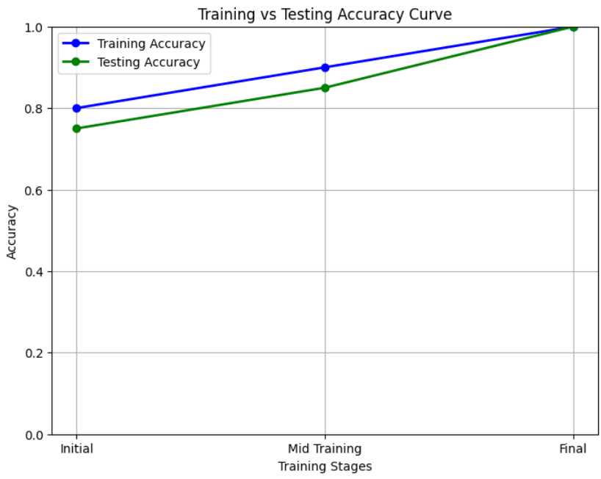

Figure 18:Result Analysis

# CHAPTER 6: CONCLUSION AND FUTURE RECOMMENDATION

## **6.1 Conclusion**

The Medicine Recommendation System is a digital tool designed to make healthcare more personalized and accessible. It uses advanced algorithms to analyze patient symptoms and recommend suitable treatments, such as medications, workout routines, and diet plans. This system simplifies the healthcare process, providing timely and accurate advice without confusion. It empowers patients by empowering them with more control over their health journey and making personalized care more accessible.

### **6.2 Lesson Learnt/ Outcome**

* Understanding of AI and SVC
* Developing this chatbot provided practical experience with AI technologies, particularly SCV and SVM networks. The project team gained a deeper understanding of how these technologies can be used to process and respond to user inputs effectively.
* Agile Methodology: The use of Agile methodology emphasized the importance of iterative development, collaboration, and continuous feedback. This approach allowed the team to adapt to changes and improve the system incrementally based on real-time feedback.
* Problem-Solving Skills: The team encountered various challenges related to training the SVC model, handling SVM words, and optimizing response accuracy. Overcoming these issues led to improved problem-solving skills and a better understanding of model tuning.\
* Technical Integration: The project demonstrated the importance of integrating multiple technologies (Python, Bootstrap, CSS, JavaScript ) to build a comprehensive solution. This integration enabled a seamless flow between frontend, backend connection use flask.

## **6.3 Future Recommendations**

The project can work on many things which will enhance the use of this system. Some modifications that can make are listed below:

* It is also possible to develop a system that operates through voice commands.
* Its accuracy may be improved by productive labor to a certain degree, where it can determine the precise output without error and respond in accordance with the associated symptoms.

# REFERENCES

|  |  |
| --- | --- |
| [1] | P. Khairnar1, Medicine Recommend System Using Machine Learning, Maharashtra, India: Aditya Hargane, 24 May 2022. |
| [2] | A. K. Binda, Medicine Recommender System: a Machine Learning Approach, Haryana, Indi: Glocal University, Saharanpur, 2022. |
| [3] | D. Cournapeau, Machine Learning in Python, scikit-learn, February 1st 2010. |
| [4] | Gloria Phillips-Wren, Manuel Mora, Fen Wang and Jorge Marx Gomez, Symptom based COVID-19 test recommendation system using machine learning technique, 18 April 2022. |
| [5] | ResearchGate, Hybrid Techniques to Predict Solar Radiation Using Support Vector Machine and Search Optimization Algorithms: A Review - Scientific Figure on ResearchGate. Available from: https://www.researchgate.net/figure/General-architecture-of-a-support-vector-machin. |

# APPENDIX

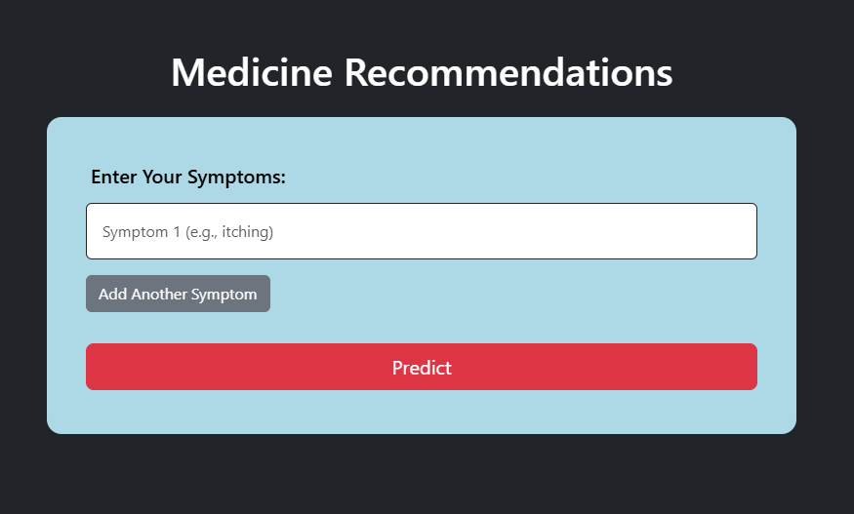

Figure 19: Home page

# 