**Session_3 Assignment**

**Task1**

**Dataset is sample data of songs heard by users on an online streaming platform. The Description of data set attached in musicdata.txt is as follows: -**

**1st Column - UserId**

**2nd Column - TrackId**

**3rd Column - Songs Share status (1 for shared, 0 for not shared)**

**4th Column - Listening Platform (Radio or Web - 0 for radio, 1 for web)**

**5th Column - Song Listening Status (0 for skipped, 1 for fully heard)**

* **Music data input dataset has been created as shown below.**

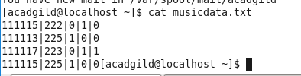

**Task 1.1**

Write Map Reduce program for finding the number of unique listeners in the data set.

* **I have placed the input file into HDFS for running the map reduce program.**

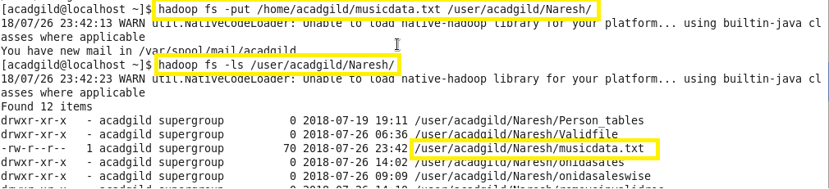

* **Running the MapReduce program using jar which was created**

Output:-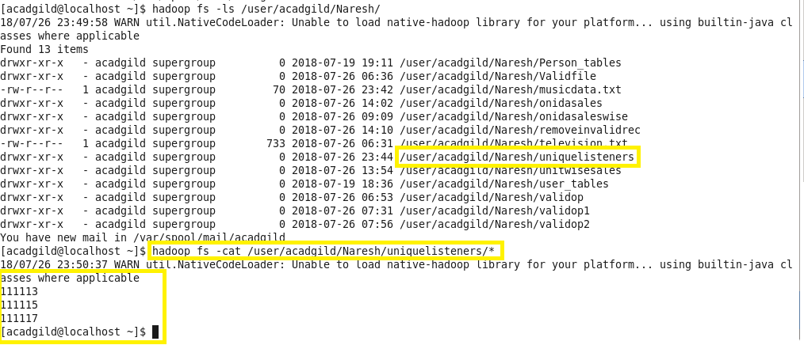

**Task 1.2**

Write a Map Reduce program to find the number of times a song was heard fully.

* **Running the MapReduce program using jar which was created**





Output:-

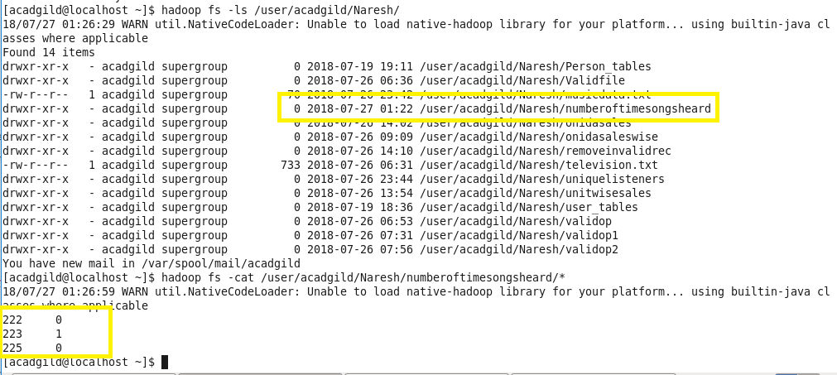

**Task 1.3**

**Write a Map Reduce program to find the number of times a song was shared**



* **Running the MapReduce program using jar which was created**



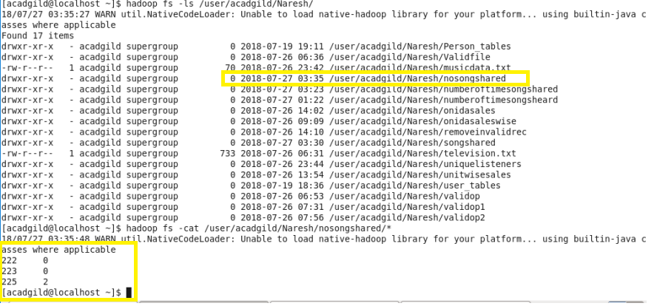

**Task 2**

**Task 2.1**

**Use Sqoop tool to export data present in SQOOPOUT folder made while demo of Import table**

* **Created the Person table under simplidb database and showed the description of the table**
* **Person Table Description**

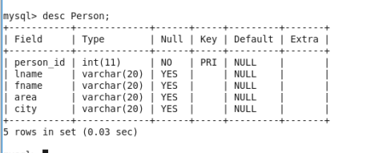

* **Records inserted into the Person table;**

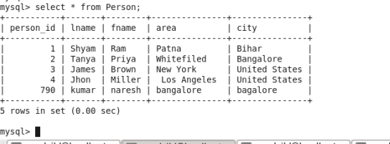

* **Now I have executed the following sqoop import command to fetch this data into HDFS path /Naresh/Sqoop_Assignment3/SQOOPOUT_SingleMapper/ folder**:



Output:-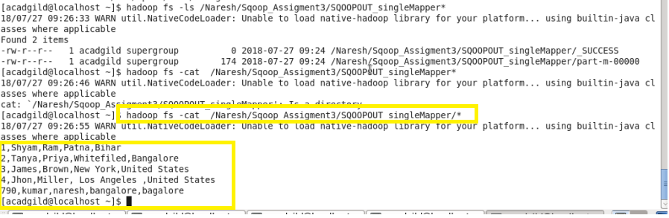

* **Deleted the records from Person table.**

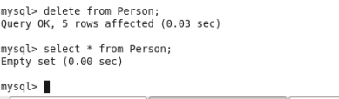

* **Now, I am going to use sqoop export command to transfer the data that I have gathered use sqoop import command in /Naresh/ Sqoop_Assignment3/SQOOPOUT_SingleMapper/ to MySql database simplidb database and table name “Person” as the following command:**



* **Records has been exported to person table as shown below.**

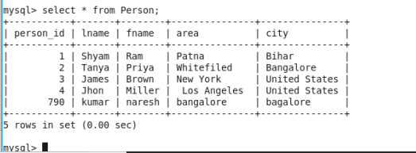

**Task 2.2**

**Use Sqoop tool to import data present in SQOOPOUT folder made while demo of Import table with parameter person_id =3.**

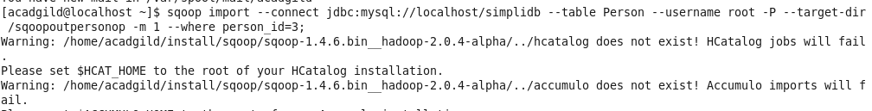

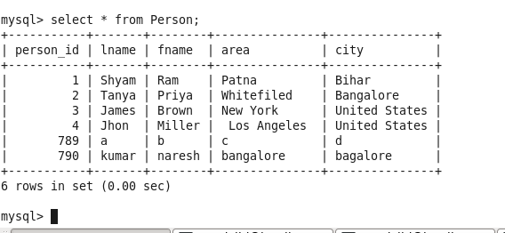

Output:-

