HDFS – Introduction

Assignment 1:-

Task 1:

1) Start Hadoop single node on AcadGild VM. The command is start-all.sh.

2) Run a JPS command to see if all Hadoop daemons are running.

3) Run few Unix commands like pwd, ls -ls, etc.

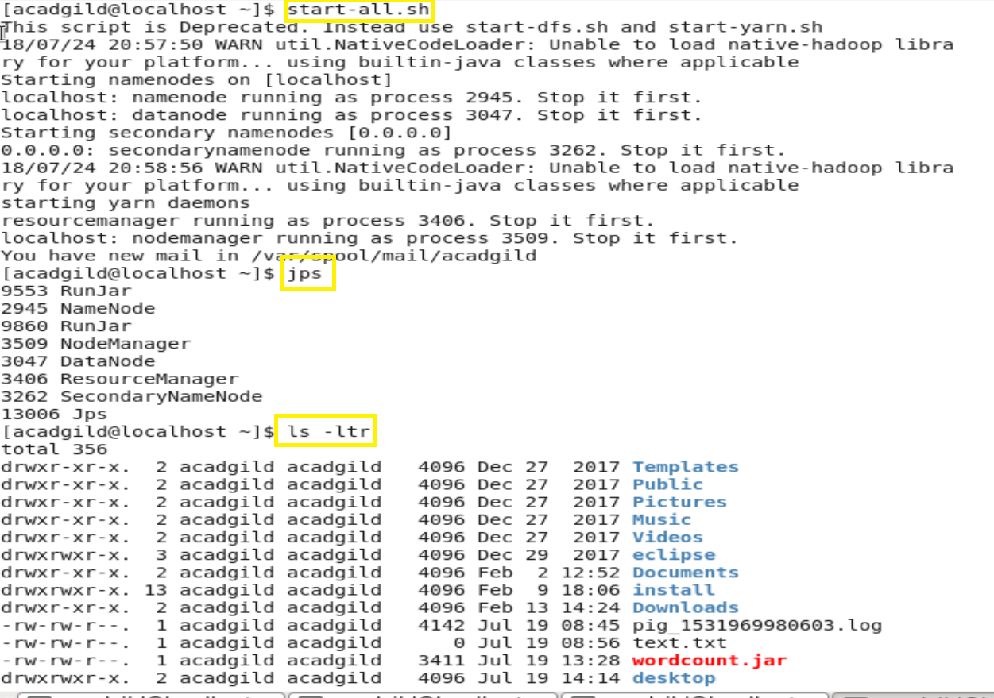

4) Create a file from the terminal using nano editor (example: nano test.txt), and add some content in it.

Cat it to see if the content is saved.

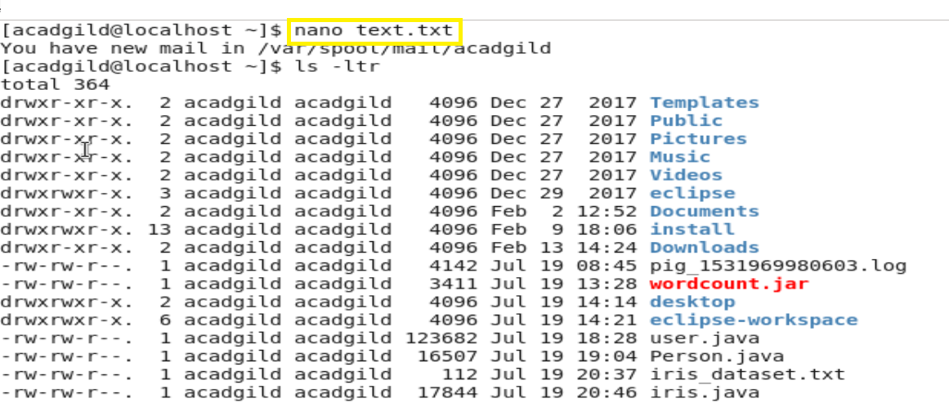

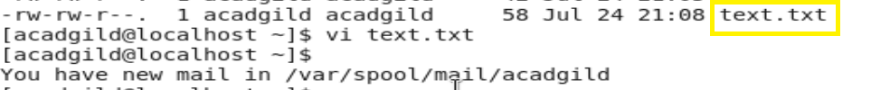

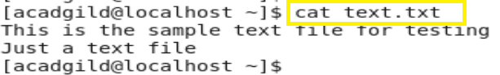

5)Open the hdfs web page by typing localhost:50070 in the browser. Check all the details of the HDFS.

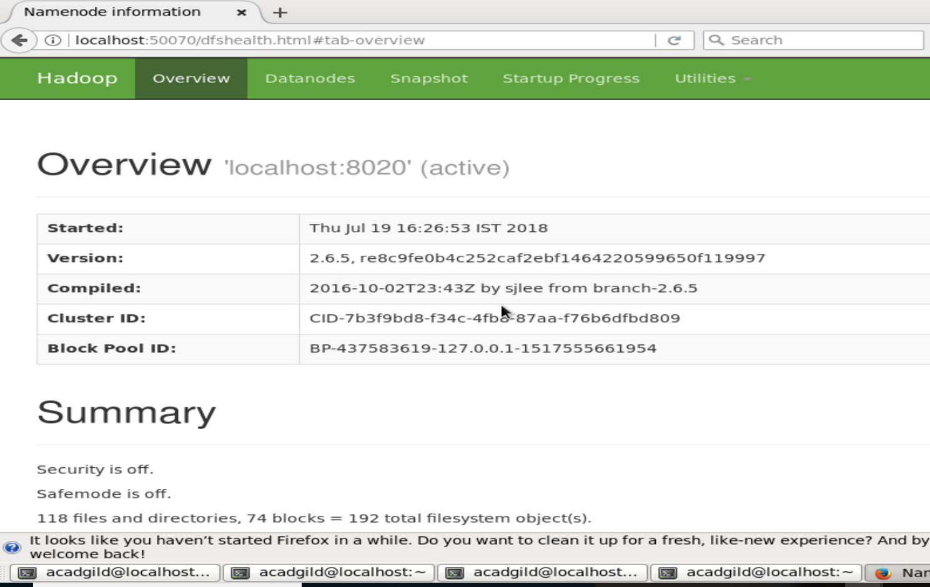

Task 2:

Check whether /user/acadgild directory exists or not in the HDFS.

If it doesn't exist, then create this.

Create a directory /user/acadgild/hadoop.

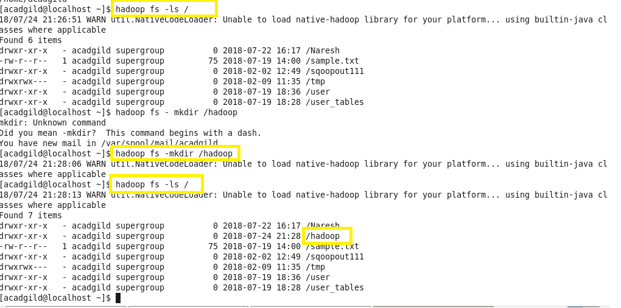

Task 3:-

Create a file in HDFS under directory /user/acadgild/hadoop, with name word-count.txt.

Whatever we type on screen should get appended to the file.

Try to type (on screen) few lines from any online article or textbook.



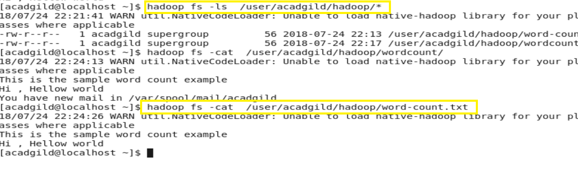

Task 4:

Create a file max-temp.txt in local FS.

Put some 10-15 records of date and temperature example:

dd-mm-yyyy,temperature

Example:

10-01-1990,10

10-02-1991,20

Move this file to HDFS at /user/acadgild/hadoop.

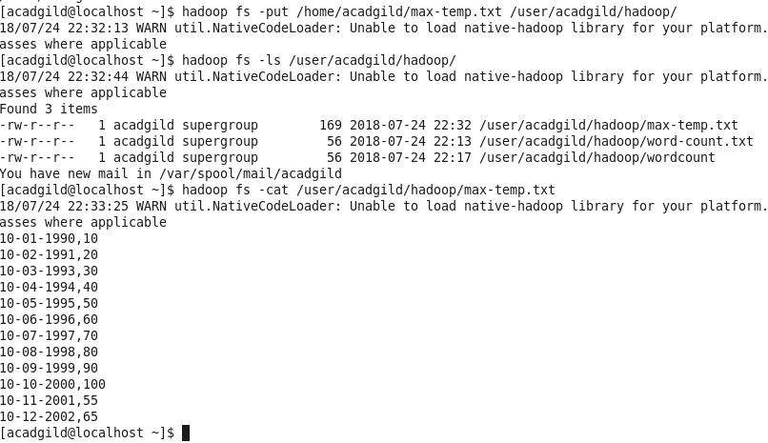

Task 5:

Change the permission of the file /user/acadgild/hadoop/max-temp.txt, such that only the owner and the group members have full control over the file.

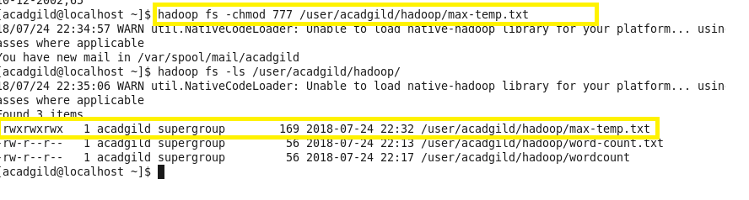

YARN -MR Assignment

Task 1:

Execute WordMedian , WordMean , WordStandardDeviation programs using hadoop-mapreduce-

examples-2.9.0.jar file present in your AcadGild VM.

* WordMedian

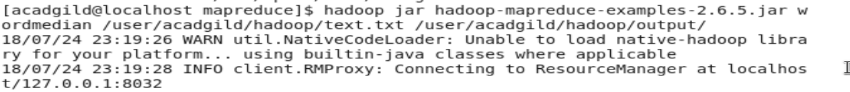

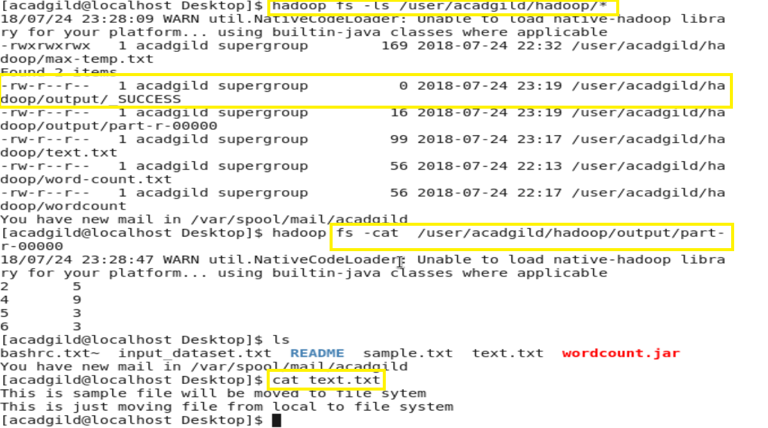

* WordMean:-



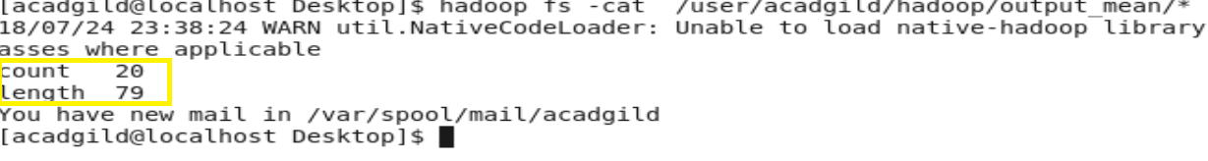

* WordStandardDeviation



