**YARN -MR Assignment**

**Task 1:**

Execute WordMedian , WordMean , WordStandardDeviation programs using hadoop-mapreduce-

examples-2.9.0.jar file present in your AcadGild VM.

* **WordMedian**

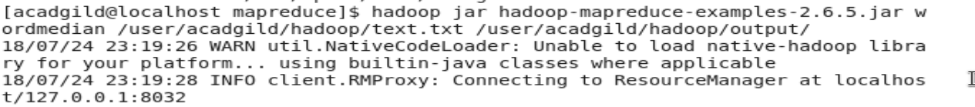

**Output:-**

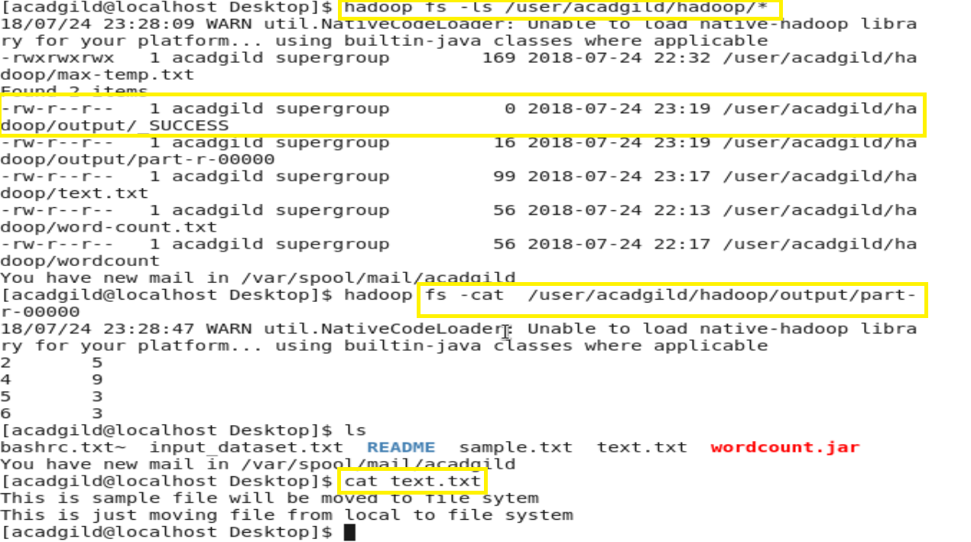

* **WordMean**



**Output:-**

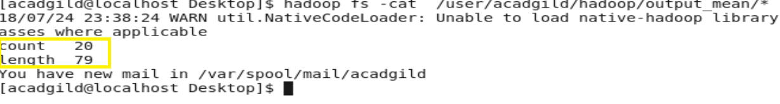

* **WordStandardDeviation**



**Output:-**

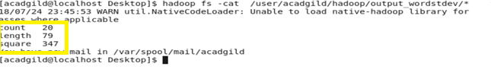

**Task2:**

Input file has been placed into the Hadoop filesystem for processing.

**Input file:- television.txt**

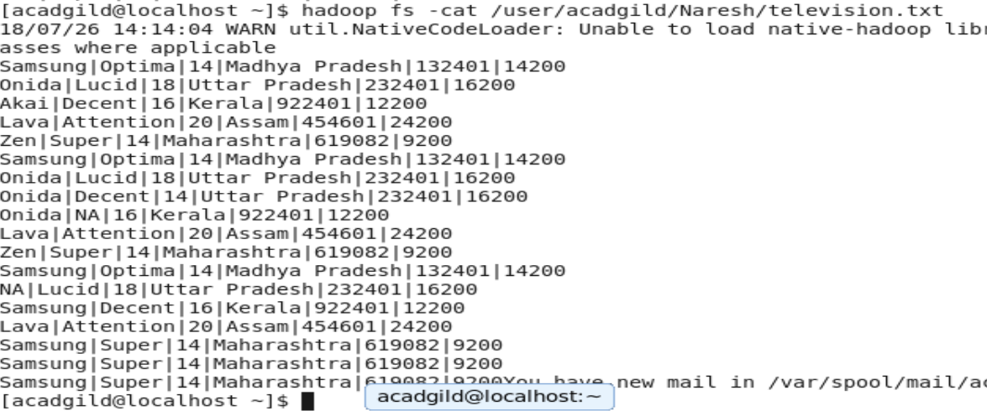

There are some invalid records which contain 'NA' in either Company Name or Product Name.

**Task 1.1**

Write a Map Reduce program to filter out the invalid records. Map only job will fit for this

context.



* Running the map reduce program to remove the invalid using jar file:-



**Output:-**

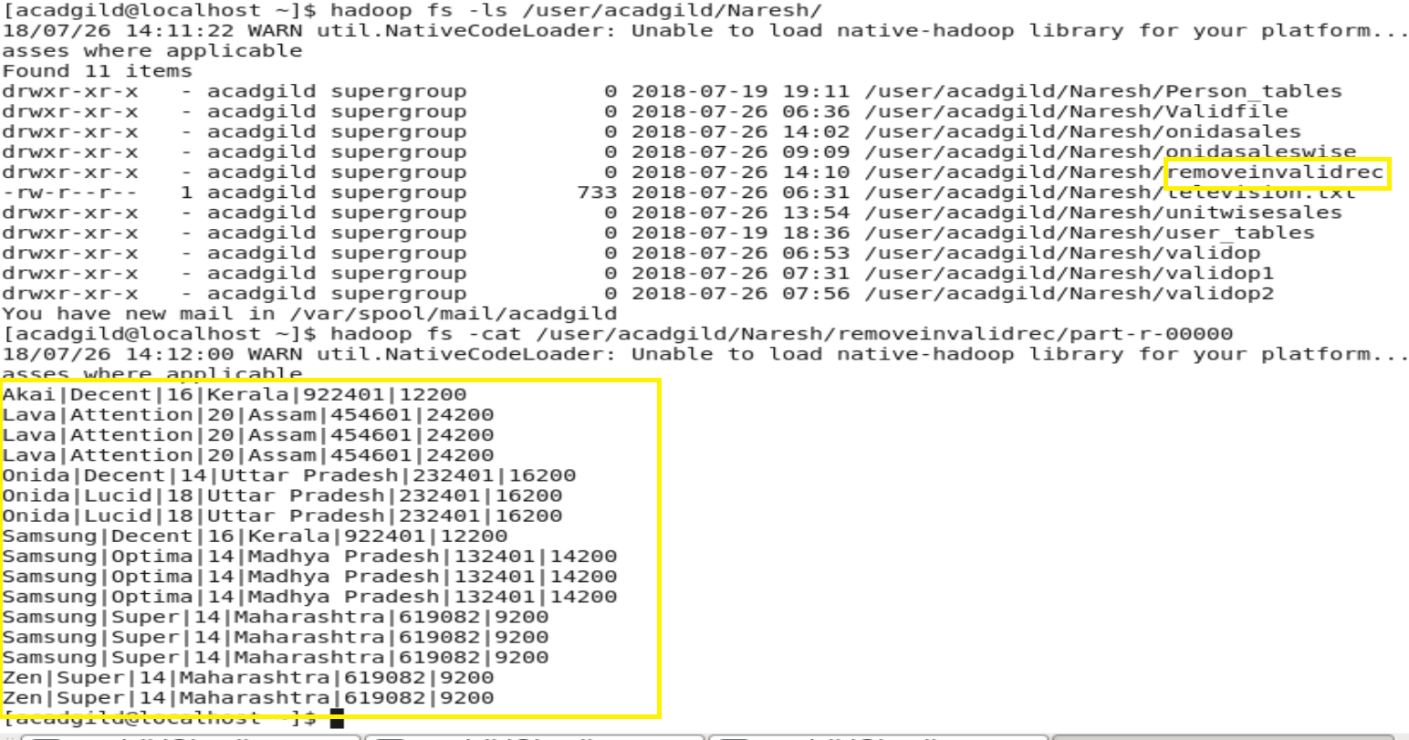

**Task 1.2**

Write a Map Reduce program to calculate the total units sold for each Company.



* Running the Map Reduce program to calculate the total unit sold for each company:-



**Output:-**

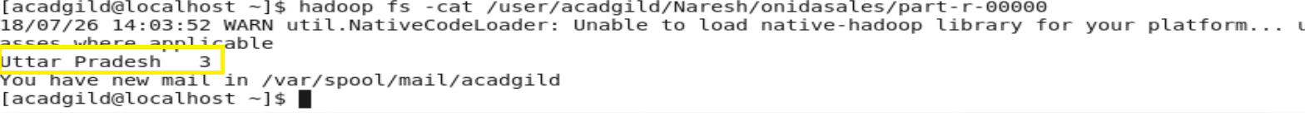

**Task 1.3**

Write a Map Reduce program to calculate the total units sold in each state for Onida

company.



* Running the map reduce job to calculate the total unit sold in each store for Onida company using jar file: -



Output:-

