EXP.NO: 3 Write a Servlet program that prints “Hello, World!”
when accessed through a browser.

AIM:
To write a basic Servlet program that demonstrates the use of Java Servlets by printing
“Hello, World!” when accessed through a browser.
ALGORITHM:
1. Input:
- The user makes an HTTP request (usually by entering a URL) through a browser.
2. Servlet Program Flow:
1. Create a Servlet Class:
- Define a Java class that extends the HttpServlet class.
- Override the doGet() method, which handles HTTP GET requests from the
client (browser).
2. Handle HTTP Request:
- In the doGet() method:
- Get the PrintWriter object to write the response to the browser.
- Set the response content type to text/html.3. Validate E-mail:
- Use a regular expression to check if the email follows the standard pattern:
name@domain.com.
- Ensure that the email contains no invalid characters and matches the
required pattern.
- If it doesn&amp;#39;t match, display an error message indicating an invalid
email format.
- Write the &amp;quot;Hello, World!&amp;quot; message to the response
3. Compile the Servlet Class:
- Compile the Java Servlet file using the javac command to generate a .class
file.
4. Deploy the Servlet:
- Place the compiled servlet class file in the appropriate directory of the web
application (typically in the /WEB-INF/classes folder).
- Configure the servlet in the web.xml file of the web application or use annotations.
5. Access the Servlet via Browser:
- Start the Apache Tomcat or another servlet container.
- Access the servlet by entering the appropriate URL (e.g.,
http://localhost:8080/your-webapp/hello).

Code:
HelloServlet.java
import java.io.*;
Import javax.servlet.*;
Import javax.servlet.http.*;

public class HelloServlet extends HttpServlet {

public void doGet(HttpServletRequest request, HttpServletResponse response)
throws ServletException, IOException {

response.setContentType(&quot;text/html&quot;);
PrintWriter out = response.getWriter();
out.println(&quot;&lt;h1&gt;Hello, World!&lt;/h1&gt;&quot;);
}
}

Web.xml:
&lt;web-app&gt;
&lt;servlet&gt;
&lt;servlet-name&gt;HelloServlet&lt;/servlet-name&gt;
&lt;servlet-class&gt;HelloServlet&lt;/servlet-class&gt;
&lt;/servlet&gt;
&lt;servlet-mapping&gt;
&lt;servlet-name&gt;HelloServlet&lt;/servlet-name&gt;
&lt;url-pattern&gt;/hello&lt;/url-pattern&gt;
&lt;/servlet-mapping&gt;
&lt;/web-app&gt;

OUTPUT:
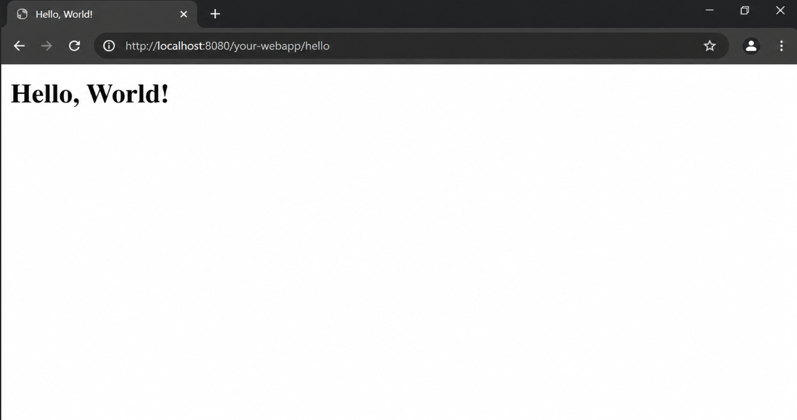

RESULT:
The browser will display the message &quot;Hello, World!&quot; returned by the Servlet

