EXP.NO: 11 Implement an application that writes data to the SD Card

AIM:
To develop an Android application using Android Studio that allows users to
enter data and store it in the device’s SD card (external storage).
ALGORITHM:
1. Input:
• The user enters text data in the application.
• The user clicks a button to save the data into the SD card.
2. Steps for Implementation in Android Studio:
1. Create a New Android Project:
• Open Android Studio
• Create a new project with an Empty Activity
• Choose Java or Kotlin as the programming language
2. Design the User Interface:
• Add the following components in the layout:
o EditText → to enter data
o Button → to save data
o TextView (optional) → to display status messages
3. Add Permissions in Manifest File:
• Declare permission to write to external storage
• For modern Android versions, also handle runtime permissions
4. Handle Runtime Permissions:
• Check if permission is granted
• If not, request permission from the user at runtime
• Proceed only after permission is granted
5. Check External Storage Availability:
• Ensure that:
o SD card is available
o SD card is writable
6. Create File in SD Card:
• Define a file name (e.g., mydata.txt)
• Select appropriate directory:
o App-specific folder (recommended)
o Or public directory
7. Write Data to SD Card:
• Read input from EditText
• Open file output stream
• Write the data into the file
• close the stream
8. Display Output to User:
• Show confirmation message:
o “Data saved successfully”
o Or error message if something fails
9. Handle Exceptions:
Manage:
o IOException
o Permission denial
o Storage unavailability
3. Testing the Application:
• Run the app on a real device/emulator
• Enter sample text
• Click Save button
• Verify file using file manager in external storage
4. Observations:
• Data is stored successfully in the SD card
• Runtime permission handling is essential
• External storage path must be handled carefully in newer Android
Versions
CODE:
<?xml version="1.0" encoding="utf-8"?>
<LinearLayout
xmlns:android="http://schemas.android.com/apk/res/android"
android:layout_width="match_parent"
android:layout_height="match_parent"
android:orientation="vertical"
android:padding="20dp"
android:gravity="center">

<EditText
android:id="@+id/editTextData"
android:layout_width="match_parent"
android:layout_height="wrap_content"
android:hint="Enter data here"
android:minLines="3"
android:gravity="top"
android:layout_marginBottom="20dp"/>

<Button
android:id="@+id/buttonSave"
android:layout_width="wrap_content"
android:layout_height="wrap_content"
android:text="Save to SD Card"/>

<TextView
android:id="@+id/textViewStatus"
android:layout_width="wrap_content"
android:layout_height="wrap_content"
android:text="Status will appear here"
android:layout_marginTop="20dp"/>

</LinearLayout>
MainActivity.java
package com.example.sdcardapp;

import androidx.appcompat.app.AppCompatActivity;
import androidx.core.app.ActivityCompat;
import androidx.core.content.ContextCompat;

import android.Manifest;
import android.content.pm.PackageManager;
import android.os.Bundle;
import android.os.Environment;
import android.widget.Button;
import android.widget.EditText;
import android.widget.TextView;

import java.io.File;
import java.io.FileOutputStream;

public class MainActivity extends AppCompatActivity {

EditText editText;
Button button;
TextView status;

private static final int REQUEST_CODE = 1;

@Override
protected void onCreate(Bundle savedInstanceState) {
super.onCreate(savedInstanceState);
setContentView(R.layout.activity_main);

editText = findViewById(R.id.editTextData);
button = findViewById(R.id.buttonSave);
status = findViewById(R.id.textViewStatus);

button.setOnClickListener(v -> {
if (checkPermission()) {
saveData();
} else {
requestPermission();
}
});
}

private boolean checkPermission() {
return ContextCompat.checkSelfPermission(this,
Manifest.permission.WRITE_EXTERNAL_STORAGE)
== PackageManager.PERMISSION_GRANTED;
}

private void requestPermission() {
ActivityCompat.requestPermissions(this,
new String[]{Manifest.permission.WRITE_EXTERNAL_STORAGE},
REQUEST_CODE);
}

@Override
public void onRequestPermissionsResult(int requestCode,
String[] permissions,
int[] grantResults) {
super.onRequestPermissionsResult(requestCode, permissions, grantResults);

if (requestCode == REQUEST_CODE &&
grantResults.length > 0 &&
grantResults[0] == PackageManager.PERMISSION_GRANTED) {

saveData();
} else {
status.setText("Permission Denied");
}
}

private void saveData() {
String data = editText.getText().toString();

if (data.isEmpty()) {
status.setText("Enter some data");
return;
}

try {
File dir = Environment.getExternalStorageDirectory();
File file = new File(dir, "mydata.txt");

FileOutputStream fos = new FileOutputStream(file);
fos.write(data.getBytes());
fos.close();

status.setText("Data saved to SD card:\n" + file.getAbsolutePath());
} catch (Exception e) {
status.setText("Error: " + e.getMessage());
}
}
}
OUTPUT:
• User enters text → Clicks Save
• Message displayed:
Data saved successfully to SD card
• File mydata.txt created in external storage containing user input
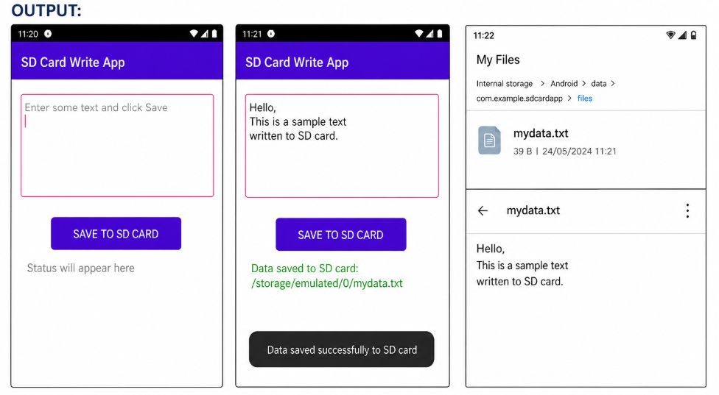
RESULT:
An Android application is successfully developed using Android Studio to write
data to the SD card with proper permission handling and storage management.

