EXP.NO: 2
Write JavaScript Programme to validate the
Following fields of HTML registration page
AIM:
To write JavaScript code to validate user input in a registration form. The validation will ensure that the data entered by the user meets specific criteria for each field. This will help in maintaining data integrity and prevent invalid submissions.
ALGORITHM:
1. Input:
- The user fills in the following fields: First Name, Password, E-mail, Mobile Number, Last Name, and Address.
2. Validation Steps:
1. Validate First Name:
- Check if the first name contains only alphabets.
- Ensure the length of the First Name is at least 6 characters.
- If any of these conditions fail, display an error message indicating the required
input.
2. Validate Password:
- Check if the password is at least 6 characters long.
- If it is less than 6 characters, display an error message.
3. Validate E-mail:
- Use a regular expression to check if the email follows the standard pattern:
- name@domain.com.
- Ensure that the email contains no invalid characters and matches the required
- pattern.
- If it doesn&#39;t match, display an error message indicating an invalid email
- format.
4. Validate Mobile Number:
- Check if the mobile number contains exactly 10 digits.
- Ensure there are no alphabets or special characters.
- If the number is invalid, display an error message indicating the correct
- format.

5. Validate Last Name:
- Ensure the Last Name field is not empty.
- If it is empty, display an error message.
6. Validate Address:
- Ensure the Address field is not empty.
- If it is empty, display an error message.
CODE:
<!DOCTYPE html>
<html>
<head>
<title>Online Campus Navigation + Registration</title>
<style>
body {
margin: 0;
font-family: Arial, sans-serif;
}

/* Layout */
.container {
display: flex;
height: 100vh;
}

/* Left Menu */
.menu {
width: 25%;
background-color: #e3f2fd;
padding: 20px;
box-sizing: border-box;
}

.menu h2 {
color: #0d47a1;
}

.menu a {
display: block;
margin: 15px 0;
text-decoration: none;
color: #0d47a1;
font-weight: bold;
}

.menu a:hover {
color: #d32f2f;
}
/* Right Content */
.content {
width: 75%;
padding: 10px;
box-sizing: border-box;
overflow-y: scroll;
}

iframe {
width: 100%;
height: 300px;
border: none;
}

h2 {
text-align: center;
color: darkblue;
}

p {
text-align: center;
}

img {
margin-top: 20px;
max-width: 100%;
}

/* Form Styling */
form {
margin-top: 20px;
padding: 15px;
border: 1px solid #ccc;
background: #f9f9f9;
}

input, textarea {
width: 90%;
padding: 8px;
margin: 5px 0;
}

input[type="submit"] {
background-color: #0d47a1;
color: white;
border: none;
cursor: pointer;
}

input[type="submit"]:hover {
background-color: #1565c0;
}
</style>

<script>
function validateForm() {

var fname = document.forms["regForm"]["firstname"].value;
var lname = document.forms["regForm"]["lastname"].value;
var password = document.forms["regForm"]["password"].value;
var email = document.forms["regForm"]["email"].value;
var mobile = document.forms["regForm"]["mobile"].value;
var address = document.forms["regForm"]["address"].value;

var namePattern = /^[A-Za-z]+$/;
if (!fname.match(namePattern)) {
alert("First Name must contain only alphabets");
return false;
}
if (fname.length < 6) {
alert("First Name must be at least 6 characters long");
return false;
}

if (password.length < 6) {
alert("Password must be at least 6 characters long");
return false;
}

var emailPattern = /^[^ ]+@[^ ]+\.[a-z]{2,3}$/;
if (!email.match(emailPattern)) {
alert("Invalid Email format");
return false;
}

var mobilePattern = /^[0-9]{10}$/;
if (!mobile.match(mobilePattern)) {
alert("Mobile number must be exactly 10 digits");
return false;
}

if (lname == "") {
alert("Last Name cannot be empty");
return false;
}

if (address == "") {
alert("Address cannot be empty");
return false;
}

alert("Form submitted successfully!");
return true;
}
</script>
</head>
<body>
<div class="container">
<!-- LEFT MENU -->
<div class="menu">
<h2>Campus Locations</h2>
<a href="#library">📚 Library</a>
<a href="#cse">💻 CSE Block</a>
<a href="#hostel">🏠 Hostel</a>
<a href="#admin">🏢 Admin Office</a>
<a href="#register">📝 Register</a>

<br>

<img src="bus.jpeg" alt="Bus Image" usemap="#busmap">

<map name="busmap">
<area shape="rect" coords="50,50,250,250" href="#" alt="Bus Details">
</map>
</div>

<!-- RIGHT CONTENT -->
<div class="content">

<h2 style="color: green;">Online Campus Navigation Map</h2>

<!-- Google Map -->
<iframe
src="https://www.google.com/maps/embed?pb=!1m18!1m12!1m3!1d15549.269530326945!2d79.99759085000001!3d13.015449599999998!2m3!1f0!2f0!3f0!3m2!1i1024!2i768!4f13.1!3m3!1m2!1s0x3a528c9ebac84723%3A0x18e2bf88dfefa3ed!2sRajalakshmi%20Engineering%20College!5e0!3m2!1sen!2sin"
loading="lazy">
</iframe>

<hr>

<h2 id="library">📚 Library</h2>
<p>Provides books, journals, and e-resources for students.</p>

<h2 id="cse">💻 CSE Block</h2>
<p>Contains computer labs and classrooms.</p>

<h2 id="hostel">🏠 Hostel</h2>
<p>Accommodation facility for students.</p>

<h2 id="admin">🏢 Admin Office</h2>
<p>Handles administration and student services.</p>

<hr>

<!-- REGISTRATION FORM -->
<h2 id="register">📝 Registration Form</h2>

<form name="regForm" onsubmit="return validateForm()">

First Name:<br>
<input type="text" name="firstname"><br>

Last Name:<br>
<input type="text" name="lastname"><br>

Password:<br>
<input type="password" name="password"><br>

E-mail:<br>
<input type="text" name="email"><br>

Mobile Number:<br>
<input type="text" name="mobile"><br>

Address:<br>
<textarea name="address"></textarea><br><br>
<input type="submit" value="Register">

</form>

</div>
</div>
</body>

</html>

OUTPUT:
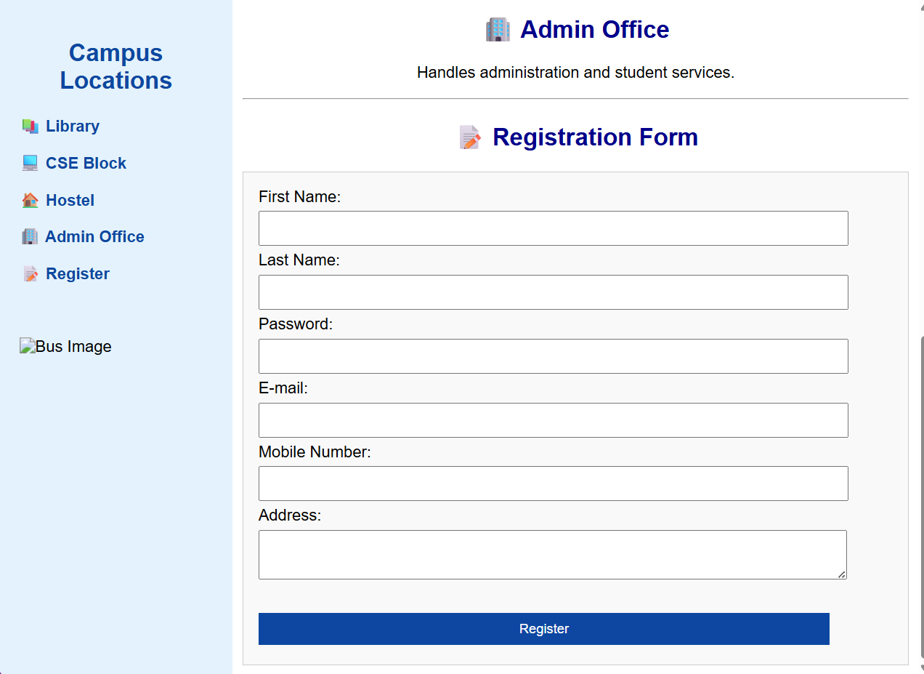
RESULT:
HTML page with Form is created and is validated using Javascript.

