EXP.NO: 10 Develop an application to change the font and color of
the text and display toast message when the user
presses the button.
AIM:
To develop an Android application that allows the user to change the font and color of text
displayed on the screen and display a Toast message when a button is pressed.
ALGORITHM:
1. Initialize the Android Application:
o Set up a new Android project in Android Studio.
o Create a MainActivity Java file for the main screen of the application.
2. Design the User Interface (UI):
o In the XML layout file, add the following UI components:
▪ TextView: For displaying the text whose font and color will be
changed.
▪ Button: To trigger the change in font and color, and show a Toast
message.
▪ Spinner or Color Picker: To let the user choose a color (optional, or a
simple button for a predefined color change).
▪ RadioButtons or a Dropdown Menu to select different font styles
(optional).
3. Declare Variables:
o Create references for the TextView, Button, Color Picker (if used), and
Radio Buttons (if used to change font style).
o Define variables for the font style, color, and the message to display in the
Toast.
4. Set Event Listener for the Button:
o Set an OnClickListener for the Button.
o Inside the onClick() method, write the logic to:
▪ Change the font of the TextView based on the selected font style.
▪ Change the color of the TextView based on the selected color.
▪ Display a Toast message indicating the action has been performed.
5. Implement Font Style Changes:
o Change the TextView’s font using setTypeface() to apply a selected font style
(e.g., bold, italic).
o You can either use predefined styles (like Typeface.BOLD or
Typeface.ITALIC) or let the user choose from a list of font styles.
6. Implement Color Change:
o Change the TextView’s text color by using the setTextColor() method and
applying the selected color (e.g., Color.RED, Color.BLUE, or a color from the
Color Picker).
o If using a color picker or dropdown, get the selected color and set it on the
TextView.
7. Show Toast Message:
o Display a Toast message to the user when the button is clicked, informing
them that the text style or color has changed. You can also show a message
like &quot;Font and color changed!&quot; or any other appropriate message.
8. End the Operation:
o After the changes are made, the application will display the updated TextView
with the new font and color, and the Toast message will appear to provide
feedback.
Code:
<?xml version="1.0" encoding="utf-8"?>
<LinearLayout
xmlns:android="http://schemas.android.com/apk/res/android"
android:layout_width="match_parent"
android:layout_height="match_parent"
android:orientation="vertical"
android:gravity="center"
android:padding="20dp">

<!-- TextView -->
<TextView
android:id="@+id/textView"
android:layout_width="wrap_content"
android:layout_height="wrap_content"
android:text="Hello Android"
android:textSize="24sp"
android:textStyle="normal"
android:layout_marginBottom="20dp"/>

<!-- Font Style Selection -->
<RadioGroup
android:id="@+id/radioGroup"
android:layout_width="wrap_content"
android:layout_height="wrap_content">

<RadioButton
android:id="@+id/radioNormal"
android:layout_width="wrap_content"
android:layout_height="wrap_content"
android:text="Normal"
android:checked="true"/>

<RadioButton
android:id="@+id/radioBold"
android:layout_width="wrap_content"
android:layout_height="wrap_content"
android:text="Bold"/>

<RadioButton
android:id="@+id/radioItalic"
android:layout_width="wrap_content"
android:layout_height="wrap_content"
android:text="Italic"/>
</RadioGroup>

<!-- Button -->
<Button
android:id="@+id/buttonChange"
android:layout_width="wrap_content"
android:layout_height="wrap_content"
android:text="Change Style"
android:layout_marginTop="20dp"/>

</LinearLayout>
MainActivity.java
package com.example.fontcolorapp;

import androidx.appcompat.app.AppCompatActivity;
import android.graphics.Color;
import android.graphics.Typeface;
import android.os.Bundle;
import android.widget.Button;
import android.widget.RadioButton;
import android.widget.RadioGroup;
import android.widget.TextView;
import android.widget.Toast;

public class MainActivity extends AppCompatActivity {

TextView textView;
Button button;
RadioGroup radioGroup;
RadioButton radioNormal, radioBold, radioItalic;

@Override
protected void onCreate(Bundle savedInstanceState) {
super.onCreate(savedInstanceState);
setContentView(R.layout.activity_main);

textView = findViewById(R.id.textView);
button = findViewById(R.id.buttonChange);
radioGroup = findViewById(R.id.radioGroup);

radioNormal = findViewById(R.id.radioNormal);
radioBold = findViewById(R.id.radioBold);
radioItalic = findViewById(R.id.radioItalic);

button.setOnClickListener(v -> {

// Change Font
if (radioBold.isChecked()) {
textView.setTypeface(null, Typeface.BOLD);
} else if (radioItalic.isChecked()) {
textView.setTypeface(null, Typeface.ITALIC);
} else {
textView.setTypeface(null, Typeface.NORMAL);
}

// Change Color (simple logic)
textView.setTextColor(Color.BLUE);

// Toast Message
Toast.makeText(MainActivity.this,
"Font and Color Changed!",
Toast.LENGTH_SHORT).show();
});
}
}
Output:
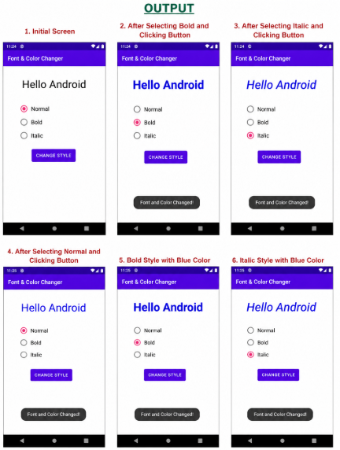
RESULT:
An mobile application is developed in Android studio to change the font and color of the text
and display toast message when the user presses the button.

