EXP.NO: 6 Write a Servlet to demonstrate session tracking using
HttpSession.

AIM:
To demonstrate session tracking using HttpSession in a Servlet-based web
application. The exercise involves implementing a simple login system where a user can log
in with their username and password, and their session will be tracked throughout their
interaction with the web application.
ALGORITHM:
1. Input:
• The user will enter their username and password in a login form.
• The servlet will validate the credentials and create an HTTP session for the user if
authentication is successful.
2. Steps for Implementing Session Tracking with HttpSession:
1. Create the Login Form (HTML):
o Create an HTML form with two input fields for username and password.
o Provide a submit button to send the data to the servlet for authentication.
2. Create the Login Servlet:
o Write a Java servlet class to handle login requests.
o The servlet will:
▪ Retrieve the username and password from the form.
▪ Authenticate the user by comparing the credentials to a stored value
(e.g., hardcoded or from a database).
▪ Create a new HTTP session for the user if the credentials are valid.
▪ Set session attributes such as the user&#39;s username to track the session.
3. Validate User Credentials:
o In the servlet, check if the username and password match the expected
values.
o If valid, create a session and store the username in the session.
o If invalid, redirect the user back to the login page with an error message.
4. Create and Track User Session:
o Upon successful login, use the HttpSession object to store the session data.
o Use the session.setAttribute(&quot;username&quot;, username) method to save the
username.
o Optionally, set session timeout using
session.setMaxInactiveInterval(time_in_seconds) to manage session
expiration.
5. Redirect to a Protected Page:
o After a successful login, the user will be redirected to a protected page (e.g., a
dashboard or home page).
o The protected page should check if the user is authenticated by checking the
session attribute.
6. Logout and Session Invalidation:
o Provide a logout feature that invalidates the session using session.invalidate()
when the user logs out.
o After logout, redirect the user back to the login page.
7. Session Expiration:
o If the session expires or the user manually logs out, the session will be
invalidated, and the user will be redirected to the login page.
CODE:
<!DOCTYPE html>
<html>
<head>
<title>Login Page</title>
</head>
<body>
<h2>Login Form</h2>
<form action="LoginServlet" method="post">
Username: <input type="text" name="username"><br><br>
Password: <input type="password" name="password"><br><br>
<input type="submit" value="Login">
</form>
</body>
</html>
Servlet.java
import java.io.*;
import javax.servlet.*;
import javax.servlet.http.*;
public class LoginServlet extends HttpServlet {
public void doPost(HttpServletRequest request, HttpServletResponse response)
throws ServletException, IOException {
response.setContentType("text/html");
PrintWriter out = response.getWriter();
String username = request.getParameter("username");
String password = request.getParameter("password");
if (username.equals("admin") && password.equals("1234")) {
HttpSession session = request.getSession();
session.setAttribute("username", username);
out.println("<html><body>");
out.println("<h2>Login Successful</h2>");
out.println("<h3>Welcome, " + username + "</h3>");
out.println("<a href='LogoutServlet'>Logout</a>");
out.println("</body></html>");
} else {
out.println("<html><body>");
out.println("<h2>Invalid Username or Password</h2>");
out.println("</body></html>");
}
}
}
web.xml
<web-app>
<servlet>
<servlet-name>LoginServlet</servlet-name>
<servlet-class>LoginServlet</servlet-class>
</servlet>
<servlet-mapping>
<servlet-name>LoginServlet</servlet-name>
<url-pattern>/LoginServlet</url-pattern>
</servlet-mapping>
<servlet>
<servlet-name>LogoutServlet</servlet-name>
<servlet-class>LogoutServlet</servlet-class>
</servlet>
<servlet-mapping>
<servlet-name>LogoutServlet</servlet-name>
<url-pattern>/LogoutServlet</url-pattern>
</servlet-mapping>
</web-app>
Output:
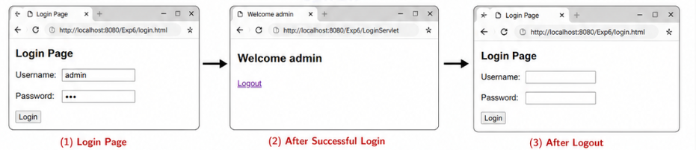
RESULT:
A simple login system is created where the user&#39;s session is tracked by a servlet to
demonstrate session tracking using HttpSession.

