EXP.NO: 5 Write a Servlet to demonstrate the difference between
HTTP GET and POST methods by creating a form and
handling requests accordingly.

AIM:
To demonstrate the difference between the HTTP GET and POST methods by creating a
form in an HTML page and handling the form submissions using two different HTTP
methods in a Java Servlet.
ALGORITHM:
1. Input:
• The user fills out a web form with their name and email.
• The form will use both GET and POST methods for data submission.
2. Steps for Creating and Handling the HTTP GET and POST Requests:
1. Create an HTML Form:
o Design an HTML form with two input fields: one for the name and one for the
email.
o Create two buttons to allow the user to submit the form using GET or POST
methods.
o Use the action attribute to define the Servlet URL and specify the form
method (either GET or POST).
2. Create the Servlet to Handle GET and POST Requests:
o Write a Java Servlet class that will handle both GET and POST requests.
o The servlet will have two methods:
▪ doGet() to handle the GET requests.
▪ doPost() to handle the POST requests.
o In both methods, retrieve the form data using request.getParameter().
o In the doGet() method, process and display the data in the URL.
o In the doPost() method, process and display the data in the HTTP request
body.
3. Handle GET Requests in the Servlet:
o In the doGet() method, use request.getParameter() to retrieve the name and
email submitted via GET.
o Output the data as a response, including the name and email in the URL
(visible to the user).
4. Handle POST Requests in the Servlet:
o In the doPost() method, use request.getParameter() to retrieve the name and
email submitted via POST.
o Output the data as a response, displaying the name and email without
exposing them in the URL (more secure).
5. Return the Output:
o The Servlet should return an HTML page displaying the name and email
entered by the user.
o For the GET method, the output should be visible in the URL.
o For the POST method, the output should be visible in the response body, not
the URL.
6. Deploy and Test the Servlet:
o Compile the Servlet class and deploy it to a Servlet container (like Apache
Tomcat).
o Test the form using GET and POST methods to see the difference in data
submission.
7. Observe and Compare GET and POST Results:
o Test the GET method: The form data is sent in the URL.
o Test the POST method: The form data is sent in the HTTP request body, not
visible in the URL.
CODE:
<!DOCTYPE html>
<html>
<head>
<title>GET and POST Demo</title>
</head>
<body>

<h2>Enter Your Details</h2>
<!-- GET Method Form -->
<form action="MethodServlet" method="get">
Name: <input type="text" name="name"><br><br>
Email: <input type="text" name="email"><br><br>
<input type="submit" value="Submit using GET">
</form>
<br><br>
<!-- POST Method Form -->
<form action="MethodServlet" method="post">
Name: <input type="text" name="name"><br><br>
Email: <input type="text" name="email"><br><br>
<input type="submit" value="Submit using POST">
</form>
</body>
</html>
Servlet.java
import java.io.*;
import javax.servlet.*;
import javax.servlet.http.*;
public class MethodServlet extends HttpServlet {
public void doGet(HttpServletRequest request, HttpServletResponse response)
throws ServletException, IOException {
response.setContentType("text/html");
PrintWriter out = response.getWriter();
String name = request.getParameter("name");
String email = request.getParameter("email");
out.println("<html><body>");
out.println("<h2>GET Method Used</h2>");
out.println("<h3>Name: " + name + "</h3>");
out.println("<h3>Email: " + email + "</h3>");
out.println("</body></html>");
}
public void doPost(HttpServletRequest request, HttpServletResponse response)
throws ServletException, IOException {
response.setContentType("text/html");
PrintWriter out = response.getWriter();
String name = request.getParameter("name");
String email = request.getParameter("email");
out.println("<html><body>");
out.println("<h2>POST Method Used</h2>");
out.println("<h3>Name: " + name + "</h3>");
out.println("<h3>Email: " + email + "</h3>");
out.println("</body></html>");
}
}
web.xml
<web-app>
<servlet>
<servlet-name>MethodServlet</servlet-name>
<servlet-class>MethodServlet</servlet-class>
</servlet>
<servlet-mapping>
<servlet-name>MethodServlet</servlet-name>
<url-pattern>/MethodServlet</url-pattern>
</servlet-mapping>
</web-app>

Output:
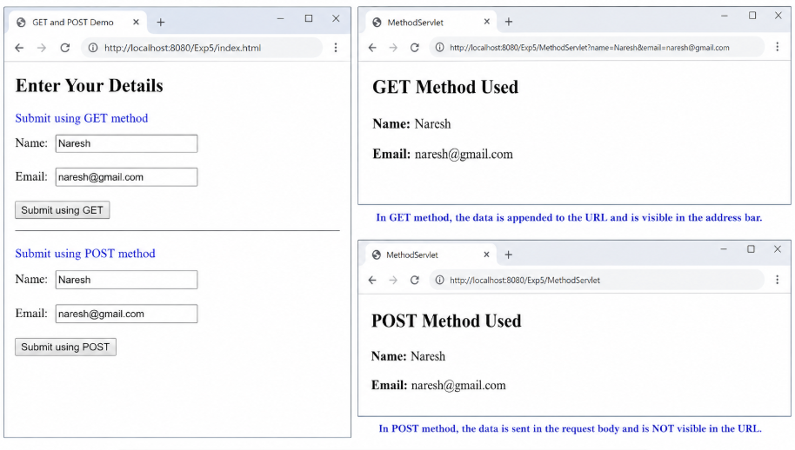

RESULT:
A Servlet is created to demonstrate the difference between HTTP GET and POST methods by
creating a form and handling requests accordingly.

