EXP.NO: 12 Develop a mobile application to send an email. DATE:

AIM:
To develop a mobile application that enables the user to send an email through the app. The
application will provide an interface to input the recipient&#39;s email address, subject, message
content, and optionally attach files. It will use Android&#39;s built-in email capabilities to send the
email,
ALGORITHM:
Initialize the Android Application:
• Set up a new Android project in Android Studio.
• Create a MainActivity for the UI where the user will input email details (recipient
address, subject, message, and attachment if any).
Design the User Interface (UI):
• In the XML layout file, create the following UI components:
o EditText fields for entering:
▪ Recipient&#39;s email address.
▪ Subject of the email.
▪ Message content.
o Button to trigger the email sending process.
o Optional: Button to select file attachments (if required).
o TextView or Toast for displaying feedback to the user (e.g., success or
failure).
Declare Variables:
• Declare variables for EditText fields (for email address, subject, and message).
• Declare a Button for sending the email and another Button for attachment (optional).
• Declare a String variable to hold the recipient email, subject, and message content.
Set OnClickListener for Send Button:
• Set an OnClickListener for the Send Email Button.
• Inside the onClick() method, retrieve the values entered by the user:
o Get the email recipient, subject, and message using getText().toString() for the
EditText fields.
Validate User Input:
• Ensure that the email address is in a valid format (e.g., name@domain.com).
• Check if all necessary fields (email, subject, message) are not empty.
• If any validation fails, show an error message (Toast) and do not proceed.
Create an Intent to Send the Email:
• Use an Intent to trigger the email client (e.g., Gmail, Outlook, etc.).
o Set the action to Intent.ACTION_SENDTO.
o Use mailto: URI scheme to trigger the email client and set the recipient,
subject, and message as parameters.
o Example: mailto:recipient@example.com?subject=Subject&amp;body=Message
• Set the email fields (recipient, subject, message) in the intent.
Optional: Attach Files (if applicable):
• If attachments are required, use Intent.EXTRA_STREAM to attach a file (e.g., an
image or document).
• Use a file picker to allow the user to select the attachment, then add the file URI to the
intent.
Send the Email:
• Call startActivity(intent) to invoke the email client and send the email.
• If the email client is installed, it will open with the email details prefilled, and the user
can press the send button.
• If the email client is not installed or an error occurs, display an appropriate Toast
message informing the user.
Display Feedback:
• If the email was successfully sent, show a Toast or update the UI with a success
message.
• If there was an error (e.g., invalid email, missing email client), display an error Toast
or show an error message in the TextView.
End the Operation:
• After the email has been sent or if there was an error, the operation is complete. The
user can send another email or exit the app.

CODE:
<?xml version="1.0" encoding="utf-8"?>
<LinearLayout
xmlns:android="http://schemas.android.com/apk/res/android"
android:layout_width="match_parent"
android:layout_height="match_parent"
android:orientation="vertical"
android:padding="20dp">

<!-- Email -->
<EditText
android:id="@+id/editTextEmail"
android:layout_width="match_parent"
android:layout_height="wrap_content"
android:hint="Enter recipient email"
android:inputType="textEmailAddress"/>

<!-- Subject -->
<EditText
android:id="@+id/editTextSubject"
android:layout_width="match_parent"
android:layout_height="wrap_content"
android:hint="Enter subject"
android:layout_marginTop="10dp"/>

<!-- Message -->
<EditText
android:id="@+id/editTextMessage"
android:layout_width="match_parent"
android:layout_height="wrap_content"
android:hint="Enter message"
android:minLines="4"
android:gravity="top"
android:layout_marginTop="10dp"/>

<!-- Send Button -->
<Button
android:id="@+id/buttonSend"
android:layout_width="wrap_content"
android:layout_height="wrap_content"
android:text="Send Email"
android:layout_marginTop="20dp"/>

</LinearLayout>
MainActivity.java
package com.example.emailapp;

import androidx.appcompat.app.AppCompatActivity;
import android.content.Intent;
import android.net.Uri;
import android.os.Bundle;
import android.util.Patterns;
import android.widget.Button;
import android.widget.EditText;
import android.widget.Toast;

public class MainActivity extends AppCompatActivity {

EditText email, subject, message;
Button send;

@Override
protected void onCreate(Bundle savedInstanceState) {
super.onCreate(savedInstanceState);
setContentView(R.layout.activity_main);

email = findViewById(R.id.editTextEmail);
subject = findViewById(R.id.editTextSubject);
message = findViewById(R.id.editTextMessage);
send = findViewById(R.id.buttonSend);

send.setOnClickListener(v -> sendEmail());
}

private void sendEmail() {

String to = email.getText().toString().trim();
String sub = subject.getText().toString().trim();
String msg = message.getText().toString().trim();

// Validation
if (to.isEmpty() || sub.isEmpty() || msg.isEmpty()) {
Toast.makeText(this, "All fields are required", Toast.LENGTH_SHORT).show();
return;
}

if (!Patterns.EMAIL_ADDRESS.matcher(to).matches()) {
Toast.makeText(this, "Invalid Email Address", Toast.LENGTH_SHORT).show();
return;
}

// Intent to send email
Intent intent = new Intent(Intent.ACTION_SENDTO);
intent.setData(Uri.parse("mailto:" + to));
intent.putExtra(Intent.EXTRA_SUBJECT, sub);
intent.putExtra(Intent.EXTRA_TEXT, msg);

try {
startActivity(intent);
} catch (Exception e) {
Toast.makeText(this, "No Email App Found", Toast.LENGTH_SHORT).show();
}
}
}
Output:
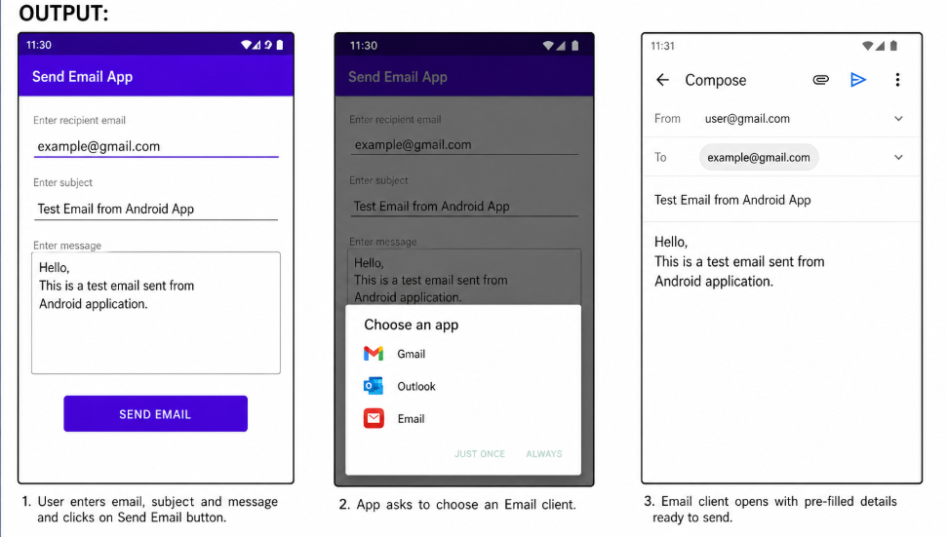
RESULT:
A mobile application is developed to send an email.

