EXP.NO: 4 Create a web form that accepts a user&#39;s name and age.
Write a Servlet to process the form data and display it back on the browser.

AIM:
To create a simple web application that includes a form to accept a user&#39;s name and age, and
then use a Servlet to process the submitted data. The Servlet will retrieve the form data,
process it, and display the values back on the browser.

ALGORITHM:
1. Input:
• The user fills out a web form with their name and age and submits it.
2. Form Handling and Servlet Processing:
1. Create the Web Form:
o Create an HTML form with two input fields: one for the user&#39;s name and one
for the user&#39;s age.
o Add a submit button to the form.
o Set the form&#39;s action attribute to the URL of the Servlet and the method to
POST (or GET).
2. Create the Servlet Class:
o Write a Servlet that processes the form data submitted by the user.
o The Servlet will override the doPost() (or doGet() depending on the form
method) to handle form submissions.
o The Servlet will retrieve the name and age parameters from the request
object using request.getParameter(&quot;name&quot;) and request.getParameter(&quot;age&quot;).
3. Process the Data in the Servlet:
o Extract the name and age values submitted from the form.
o Validate the input (e.g., check if the age is a valid number).
o Prepare a response that will display the user&#39;s name and age back on the
browser.
4. Send Response to the Browser:
o The Servlet will send a response to the browser containing a message like:
▪ &quot;Hello, [name]! You are [age] years old.&quot;
o The response will be displayed to the user in the browser.
5. Deploy the Servlet:
o Compile the Servlet and deploy it to a Servlet container (like Apache
Tomcat).
o Ensure the web.xml file or Servlet annotations are used to map the Servlet to
the URL defined in the form&#39;s action attribute.
6. Test the Application:
o Open the web browser, fill in the form with the name and age, and submit it.
o The Servlet will process the data and display the message back to the user in
the browser.
CODE:
<!DOCTYPE html>
<html>
<head>
<title>User Form</title>
</head>
<body>

<h2>Enter Your Details</h2>

<form action="UserServlet" method="post">
Name: <input type="text" name="name"><br><br>
Age: <input type="text" name="age"><br><br>
<input type="submit" value="Submit">
</form>
</body>
</html>
Servlet File
import java.io.*;
import javax.servlet.*;
import javax.servlet.http.*;

public class UserServlet extends HttpServlet {

public void doPost(HttpServletRequest request, HttpServletResponse response)
throws ServletException, IOException {

response.setContentType("text/html");
PrintWriter out = response.getWriter();

String name = request.getParameter("name");
String age = request.getParameter("age");

out.println("<html><body>");
out.println("<h2>Hello, " + name + "!</h2>");
out.println("<h3>You are " + age + " years old.</h3>");
out.println("</body></html>");
}
}
web.xml
<web-app>

<servlet>
<servlet-name>UserServlet</servlet-name>
<servlet-class>UserServlet</servlet-class>
</servlet>

<servlet-mapping>
<servlet-name>UserServlet</servlet-name>
<url-pattern>/UserServlet</url-pattern>
</servlet-mapping>
</web-app>
Output:
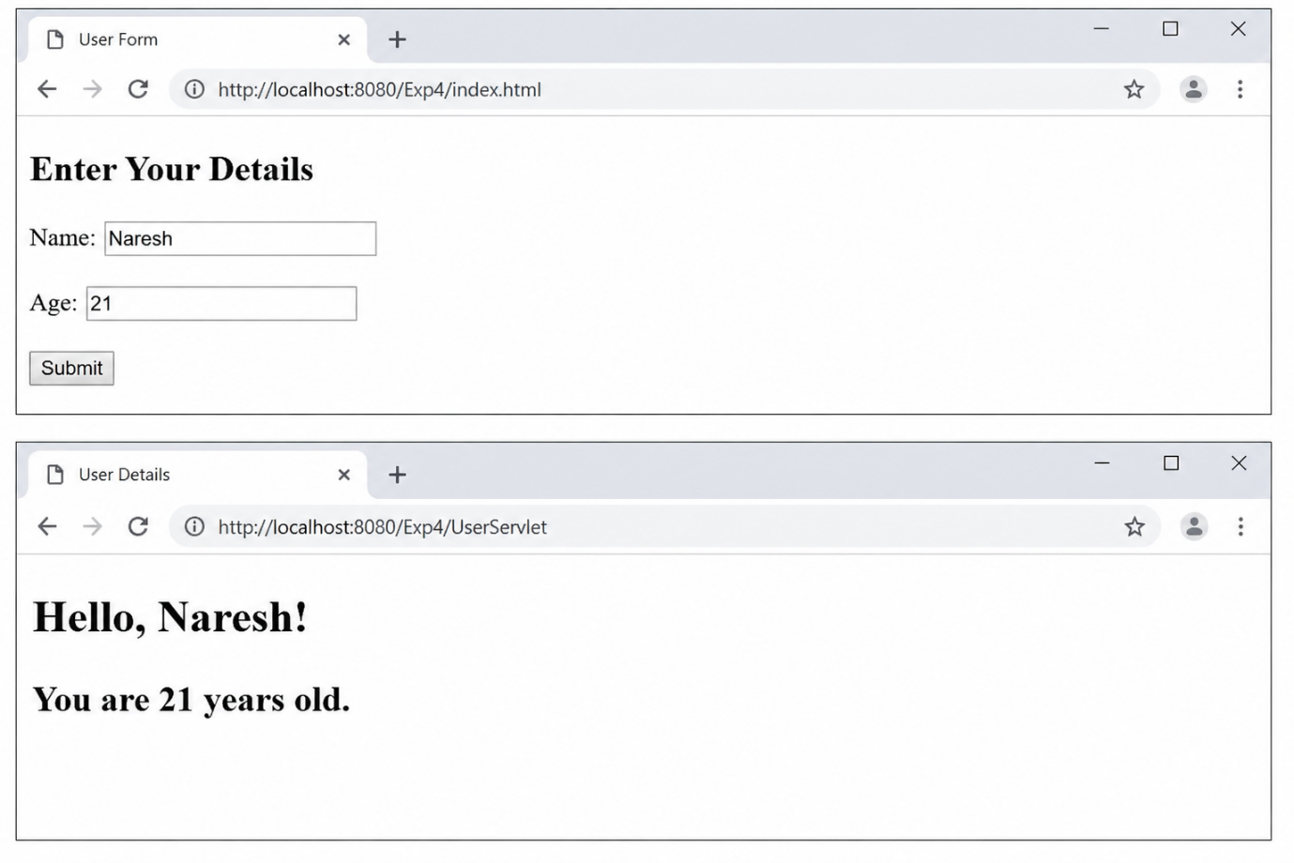

RESULT:
A servlet is created to process the HTLM form data and display it back on the browser.

