EXP.NO: 8 Develop a JavaScript-based validation mechanism for a
Library Management System and integrate it with a
Servlet/JSP-based backend for database access.
AIM:
To design a client-side validation system using JavaScript for forms in a Library
Management System and ensure proper data handling before sending it to a
Servlet/JSP-based backend connected to a database.
ALGORITHM:
1. Input:
The user interacts with various forms such as:
o User Registration Form
o Book Entry Form
o Book Issue/Return Form
2. Steps for Form Validation Using JavaScript:
1. Identify Forms and Fields:
Registration Form:
o Name, Email, Phone Number, Membership ID
Book Form:
o Book ID, Title, Author, ISBN
Issue Form:
o User ID, Book ID, Issue Date, Return Date
2. Apply Validation Rules (Client-Side):
Name: Should not be empty, only alphabets allowed
Email: Must follow standard email format
Phone Number: Must be exactly 10 digits
Membership ID / Book ID: Should not be empty and must follow a
specific format
ISBN: Must be numeric and valid length
Dates:
o Issue date cannot be in the future
o Return date must be after issue date
3. Implement Validation Logic:
When the user submits a form:
o JavaScript checks each field based on rules
o If invalid → show error message and prevent submission
o If valid → allow form submission
4. Provide User Feedback:
Display error messages near the fields
Highlight incorrect inputs
Allow correction before submission
3. Integration with Servlet/JSP Backend:
1. Form Submission:
After successful validation, form data is sent to a JSP/Servlet using HTTP
POST
2. Server-Side Processing:
Servlet receives request parameters
Performs additional validation (security layer)
Interacts with database:
o Store user details
o Add/update book records
o Manage issue/return transactions
3. Database Access:
Use JDBC in Servlet to:
o Insert records (Registration, Book Entry)
o Retrieve records (Search books, user history)
o Update records (Issue/Return status)
4. Generate Response:
JSP page displays:
o Success messages (e.g., “Book Issued Successfully”)
o Error messages (if server validation fails)
4. Assumptions (Business Logic):
Each user must have a unique Membership ID
A user can borrow maximum 3 books at a time
A book cannot be issued if no copies are available
Return date must be greater than issue date
Fine is applied if the book is returned after due date
ISBN is considered unique for each book
Only registered users can issue books
Admin privileges are required to add or remove books
5. Deployment and Testing:
Deploy application on a server (e.g., Apache Tomcat)
Test different scenarios:
o Invalid inputs (empty fields, wrong formats)
o Valid inputs (successful submission)
o Database updates and retrieval
6. Observations:
JavaScript validation reduces invalid data submission
Server-side validation ensures security and consistency
Integration ensures smooth data flow between frontend and backend
CODE:
HTML + JavaScript
<!DOCTYPE html>
<html>
<head>
<title>Library Management</title>
<script>
function validateForm() {
var name = document.forms["libForm"]["name"].value;
var email = document.forms["libForm"]["email"].value;
var phone = document.forms["libForm"]["phone"].value;
if (name == "") {
alert("Name cannot be empty");
return false;
}
if (!email.includes("@")) {
alert("Enter valid email");
return false;
}
if (phone.length != 10) {
alert("Phone number must be 10 digits");
return false;
}
return true;
}
</script>
</head>
<body>
<h2>Library Registration Form</h2>
<form name="libForm" action="LibraryServlet" method="post" onsubmit="return validateForm()">
Name: <input type="text" name="name"><br><br>
Email: <input type="text" name="email"><br><br>
Phone: <input type="text" name="phone"><br><br>
<input type="submit" value="Submit">
</form>
</body>
</html>
Servlet.java
import java.io.*;
import javax.servlet.*;
import javax.servlet.http.*;
public class LibraryServlet extends HttpServlet {
public void doPost(HttpServletRequest request, HttpServletResponse response)
throws ServletException, IOException {
String name = request.getParameter("name");
String email = request.getParameter("email");
String phone = request.getParameter("phone");
response.setContentType("text/html");
PrintWriter out = response.getWriter();
out.println("<h2>Registration Successful</h2>");
out.println("Name: " + name + "<br>");
out.println("Email: " + email + "<br>");
out.println("Phone: " + phone);
}
}
OUTPUT:
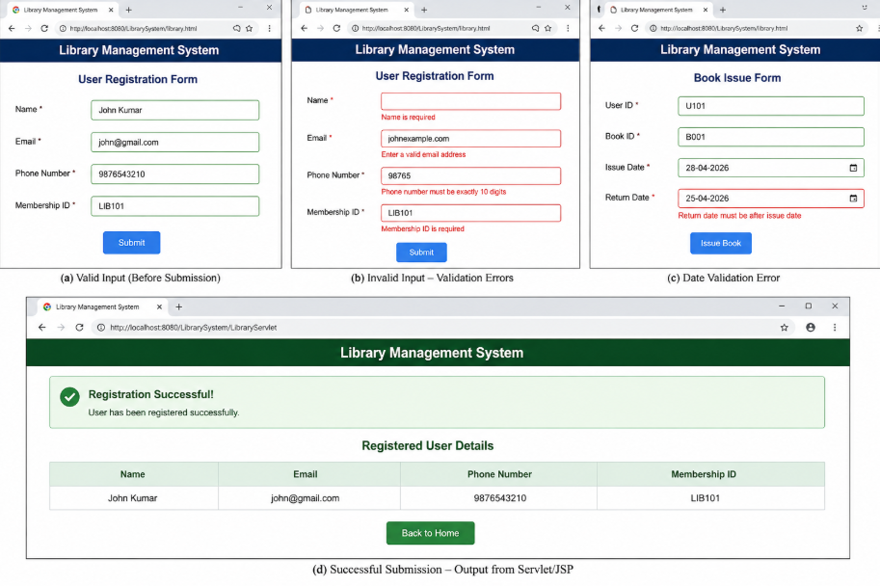
RESULT:
A JavaScript-based validation system is successfully implemented for a Library
Management System, ensuring correct user input before submission and
seamless integration with a Servlet/JSP backend for database operations.

