RTMS
(Remote Terminal Managment System)

Application Notes for RTMS

Revision 1.1

Linkwell Telesystems Pvt. Ltd.
Gowra Klassic 1-11-252/1/A, Begumpet, Hyderabad - 500016. Andhra Pradesh, INDIA.
Ph: +91-40-66388000, Fax: +91-40-66388006 Email: info@visiontek.co.in

Remote Terminal Managment System:

RTMS is a process to remotely monitor and update the hand held terminal ( POS device) by means of different communication media.

It has be performed in two different stages
1.Health Status Updation
2.Firmware Upgrade
3.Application Upgrade

Needs of RTMS:
- To monitor the field devices on regular basis depends on user requirement.
- To upgrade the devices with new softwares as well as applications
- To know the health status of the each and every IO module on daily basis..i..e the health status of all the modules(Ex:printer,sam,ifd,fingerprint etc..)
- To upgrade the existing version softwares to updated softwares which includes u-boot,kernel,rootfs and also application by using several communication medias.

Server Registration:

- Server Registration is mandatory for the device to know the status or if it needs any updates from the server.
- Intially POS device has to register with the server before performing any remote operation in POS device.
- The Registrartion can be done in two ways

      - Manual Registration
      - Through Excel file

- In Manual Registration details of the device like serial number . Terminal ID etc.. are entered manually in the server page to register the particular device.
- Bulk Number of devices can be registered by keeping their serial numbers and terminal ids in a specified format in an excel file.
- Server maintains the details of each and every device details in server database.
- Once the device got registered , user can see the latest updates of health status on the server GUI.as well as update the device softwares.

1.Health Status Updation:

- After every first boot of the device and under succesful network connection the health status of the device is sent to the server on one time basis.
- Examination of all the IO Modules is performed and the status is updated to a file in the POS.That file is sent to server and in the server user can view the status of each and every module.
- The figure below indicacated the RTMS server GUI for updating health status.The highlighted icons inidicate that modules are working fine and non highlighted indicates problem with the IO module.All the information about current software details,project details ,patch details will be available here.
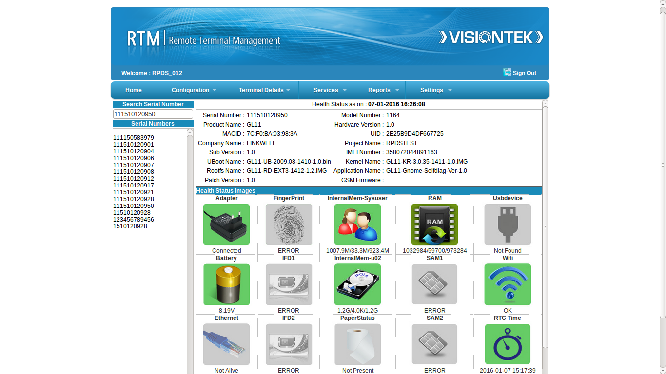

2. Firmware Upgrade:

Firmware Upgrade:

Firmware Upgrade is a mechanism to upgrade the kernel ,Uboot, application(Selfdiag) and other files related to the rootfile system(Rootfs).

Need For Firmware Upgrade:

- To improve the product performance and add new features .It is recommended to check and update the firmware versions periodically.
- Keeping the firmware up-to-date helps in attaining the maximum reliability and functionality of the system.
- Firmware releases might also contain bug fixes and enhancements.

Current Version Details:

Point of Sale (POS) device maintains current firmware version. The current version details are retrived from a file in POS . Whenever the firmware gets upgraded to the latest version the same gets replicated in that particular file.

Sample Visiontek_release file consists of the following parameters

PATCH_VERSION=1.0
PATCH_DATE=20022015-21:44

- PATCH_VERSION indicates the current version in the device
- PATCH_DATE indicates the last updated date

Prerequisites For Firmware Upgrade:

Inorder to initiate Firmware Upgrade process ensure that the below two conditions are met without fail

Battery :

Before going for an firmware upgrade please ensure that battery is connected with adaquate charge. Firmware upgrade fails if battery is in low charge condition.

Internet Connectivity:

Firmware upgrade should be initiated only after proper internet connection is established through any means of communication such as GPRS , Ethernet or WIFI. Firmware Upgrade fails to download the files from the server if the connectivity check fails.

Firmware Upgrade POS-SETUP:

The POS machine must contain set of binaries scripts and files to be placed in their respective directories for the firmware upgrade mechanism to function effectively.For enabling this feature device specific software needs to be loaded in the POS device.

Firmware Upgrade SERVER-SETUP:

It explains about server side configuration for the Firmware download application.
The server has to be well equipped with the all the required files has to take
care about the number of update versions available.All the updated version numbers
are maintained in the server in the file.

Config-patchversions:

This file contains the information about new updates with version releases.

Sample config-patchversions file

PATCH_VERSION=5.0
PATCH_VERSION=4.0
PATCH_VERSION=3.0
PATCH_VERSION=2.0
PATCH_VERSION=1.0

The file depicts that 5 patch versions has been released so far.

Update files:

Patch files are identified with the patch version included in Server Configure files.

example:

patch-1.1.zip

2.1.Application Update:

Application Update:

Application Update is a mechanism to update the latest application and its related files to the rootfile system.

Need For Application Update:

Application update enables user to get required functionality of the application which improves the product performance through added features .It is recommended to check and update the application with latest versions periodically.Keeping the application up-to-date helps in attaining the maximum reliability and functionality of the system.

Current application version Details:
Point of sale(POS) device maintains current application version.This current version details are retrieved from application_version file locate in /mnt/sysuser/ directory of the rootfile system.

Whenever application gets update to the latest version the same gets replicated in the application_release file.

Sample application_details file consists of the following parameters

APP_TYPE:100
APP_VERSION:1.1

APP_VERSION indicates the current application version of the device.

Prerequisites for Application Update:

In order to initiate Application Update process please ensure that the below two conditions are met without fail.

Battery:
Before going for an application update process make sure that the battery is connected with adequate charge. Application update fails if battery is in low charge condition(voltage).

Internet Connectivity:
Application update should be initiated only after proper internet connection is established through any means of communications such as GPRS, Ethernet or WiFi.Application download fails to download files from the server if the connectivity check fails.
Application Update POS SETUP:
The POS machine must contain set of binaries,script and files to be placed in their respective directories for the application update mechanism to function effectively.

Application Download Server Setup:

It explains about the server side configuration for the application update.

The server has to be well equipped with the all the required files and has to take care about number of update versions available.

Config-appversion:

This file contains the information about latest update with version release.
sample config-appversion file

APP_VERSION=5.0
APP_VERSION=4.0
APP_VERSION=3.0
APP_VERSION=2.0
APP_VERSION=1.0

This file represent total 5 applications are released so far.

App files:
Application files are identified with the application version included in server configuration file

example:
app-1.1.zip

Linkwell Telesystems Pvt. Ltd.
Gowra Klassic, Begumpet, Hyderabad 500 016. INDIA.
E-mail: info@visiontek.co.in
www.visiontek.co.in

Disclaimer: VISIONTEK® is a registered trademark owned by Linkwell Telesystems Pvt. Ltd. Other brands and names mentioned herein may be the trademarks of their respective owners. Neither the whole nor any part of the information contained in, or the product described in, this document may be adapted or reproduced in any form without the prior written permission of the copyright holder. The product described in this document is subject to continuous developments and improvements. All particulars of the product and its use contained in this document are given by Linkwell Telesystems Pvt. Ltd. in good faith. However, all warranties implied or expressed, including but not limited to implied warranties of merchantability, or fitness for purpose, are excluded. This document is intended only to assist the reader in the use of the product. Linkwell Telesystems Pvt. Ltd. shall not be liable for any loss or damage arising from the use of any information in this document, or any error or omission in such information, or the use or inability to use the product.

