RHMS
(Roles And Responsibilities)

Application Notes for RHMS

Revision 1.0

Linkwell Telesystems Pvt. Ltd.
Gowra Klassic 1-11-252/1/A, Begumpet, Hyderabad - 500016. Andhra Pradesh, INDIA.
Ph: +91-40-66388000, Fax: +91-40-66388006 Email: info@visiontek.co.in
INTRODUCTION

RTMS (Remote terminal management system) is a process for remotely monitoring the hand held terminals ( POS devices) by means of different communication media which includes GSM, wifi and Ethernet. RHMS implies Simplicity and Smartness of handling devices.

RTMS is an inclusion of the following

1.RHMS
2.Firmware upgrade
3.Application upgrade

Each of the above mentioned stages will be discussed later.

RTMS hiearchy

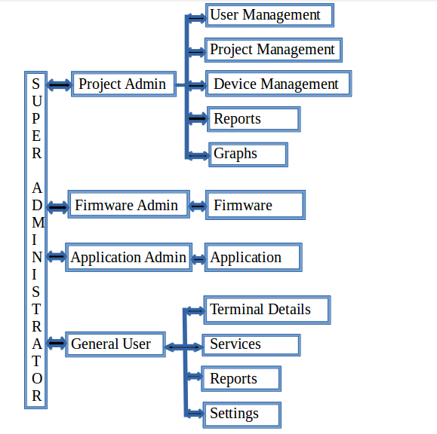

Super Administrator
- A project can only be created by Super Administrator.
- He is responsible for creating project admin, firmware admin, application admin and number of general users.
- The credentials of all administrators will be under him. Since he is the owner of the project he has permissions for all the updates and changes w.r.t to firmware and application.

Project Administrator
The following are the roles of Project administrator
- Device Management
- Project Management
- User Management

Device Management
- In Device Management, server registration of the devices
can be done. It is mandatory because if the device is not registered
with RTM server, it will not get any requests and responses from the server.
- Registration can be done by two ways
1) Through excel file
Through excel file we can register bulk number of serial ids at a time.
2) Through manually
Where as Manual registration we can do only one at a time.

For registration, firstly login into RTM server.

Follow the below procedure to login.

RTM LOGIN PROCEDURE :

1) http://202.53.78.186:5052/rtm/frmLoginPage.aspx enter this url to get into RTM Page.

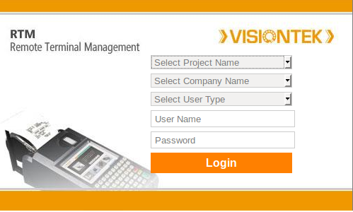

2) You will see the above window and here you need to select Project Name, Company name, User Type, and enter User name and Password.

Example: Select project Name - FMS
Select Company Name - LINKWELL
Select User Name - Project admin
User Name - fms123
Password - XXXXXX

REGISTRATION PROCEDURE

1) Through excel file

After login into RTMS, select Device Management and it will show two options ,
- Import excel
- Registration

As shown in below figure.

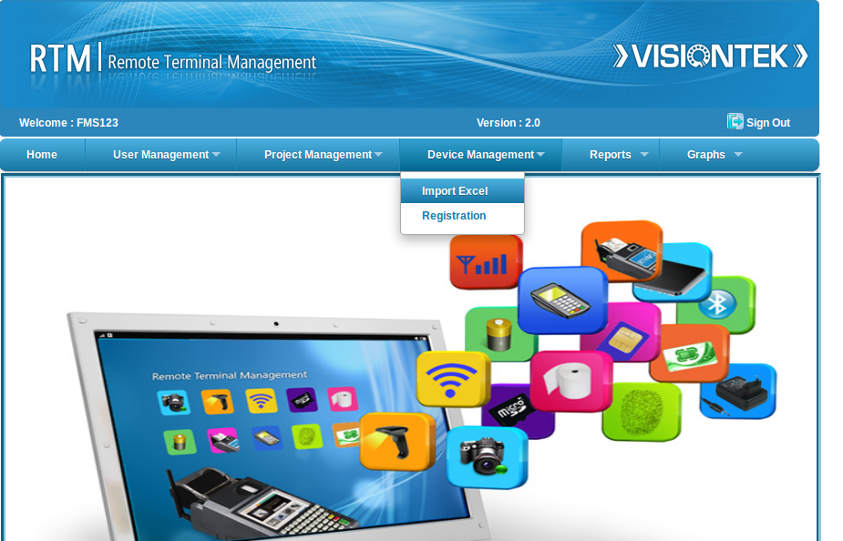

Figure: Through excel file Registration.

- Click on the Import Excel option.
- Before Registration, we should know the Configuration Name, That configuration name is nothing but a Model Number (Provided by hardware team ).
- After that, Click on Model number. It will show the list of Model numbers.
Select model number or configuration name required. Please refer below select model number figure.
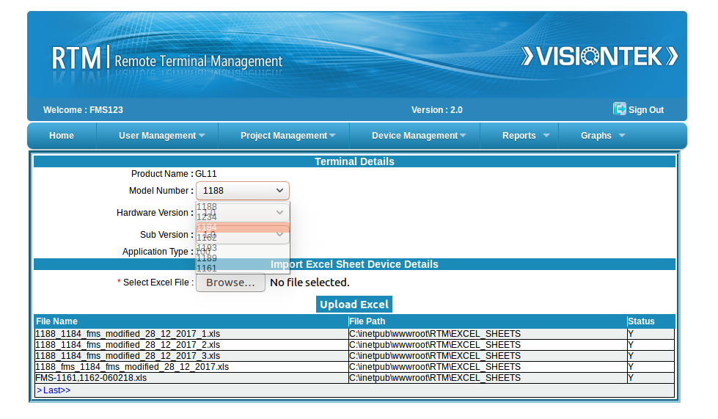
Figure : Select model number or config Number.

NOTE: If Model number is not present in the list, we should create or Register Model Number.
** Model numbers are unique and these are provided by Hardware Team.
- If you want to create new model number, follow the below procedure.
Creating new model number :
Select Project Management ->Firmware.
Click on the Model Number, a list of options will be displayed, Select the option as “--New--” and enter new model number and submit it.

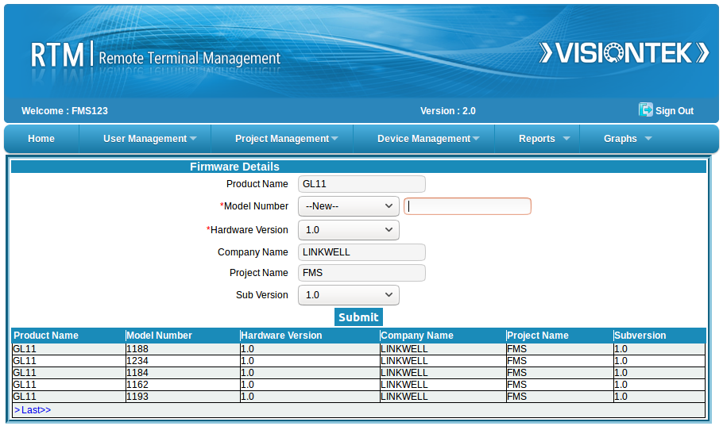

Figure: new model number creation
After creation of new Model Number again select

Device Management -> import excel and Select Model Number.

- After that, upload your excel file through Browse option.
A sample file wll be provided to you, It is mandatory to use the file format for serial numbers and macids.

The excel file should be in the below mentioned format.
1) excel file Must be saved with .xls
2) And format cells should be -1234 format.

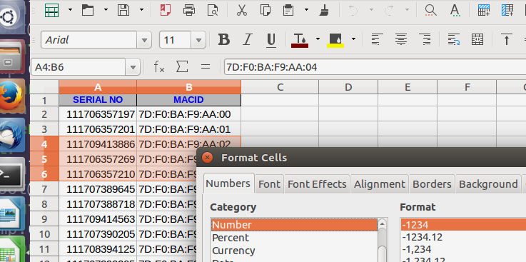

Figure : Excel Document format.

Suggesting save as .xls file with proper file name example: FMS_Modelno_Noofuplaoding_date.xls FMS_1188_2300_28022018.xls

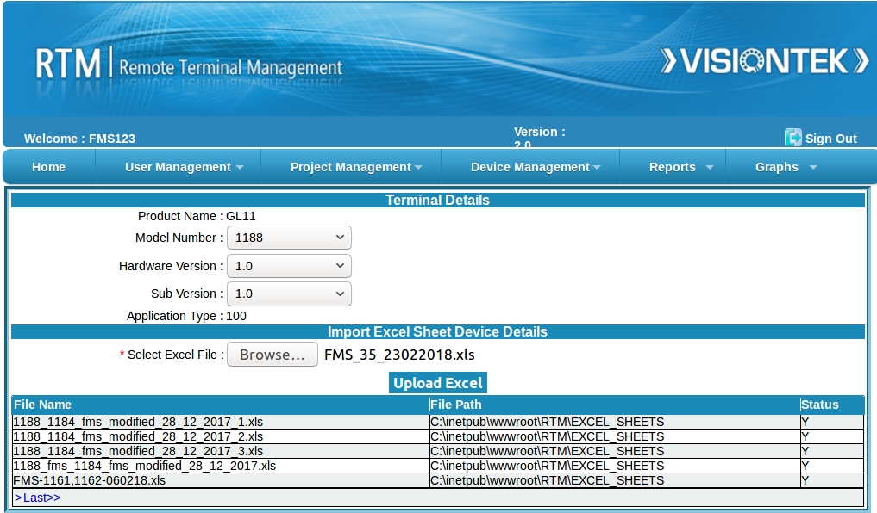

Select .xls (Forrmatted .xls execl file) through Browse option.

Click on upload Excel.

- 2) Through manually

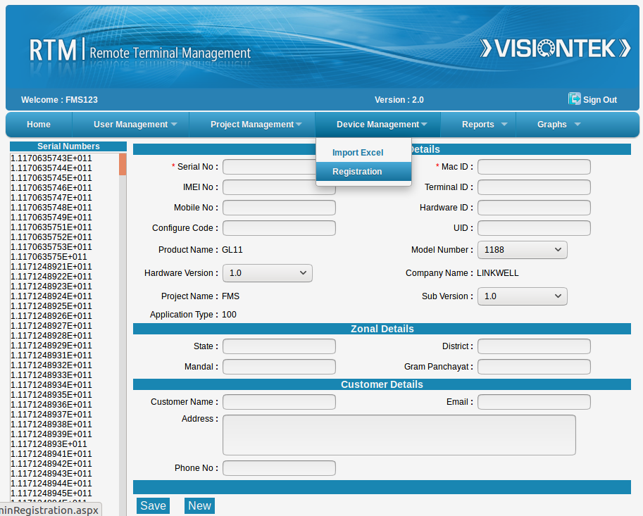
Figure : Through Manual Registration.

In manual registration ,we should enter macid and serial number for the particular device as shown in figure above.
After successful registration we can see the serial number of the device
in serial number list.

- The Server maintains the database of all the registered devices.
- Once the device gets registered, user can see the latest updates of health status on the server, upload and download latest firmwares,applications etc.

Project Management
1.Firmware
2.Application

Firmware :
If the Model Number / Hardware version / Sub version of a product or project is changed, Project admin need be update them. So the Project administrator will do the Updates accordingly.

Application :
Different application types and different application versions need to be maintained by project admin.

User Management

- Project Admin can create New Users for each project.
- The Maximum Number of users allowed wiil be decided by project creator (super admin).
- Users can verify the health status of the registered devices, Number of terminals connected to server, etc.
- Change of passwords of the existing users has been allowed in this user management.

Reports

Project administrator can see the following reports
1.consolidated scanner ID details
2.summary scanner ID details
3.firmware id details
4.application details
5.Multiple scannerid details
6.Daily device status report
7.Scanner ID not updated report
8.search
i) Serial Number
ii) MACID
iii) Scanner ID

Consolidated scanner ID :
This report shows the consolidated list of the scanner ID’s of the registered terminals. Scanner id details are necessary to register with Management server for RD services.

Summary scannerid :
This report shows the summary of all scannerid’s of the devices registered
terminals.

Firmware details :
This report has number of connected and not connected devices,
one can know the number of devices updated with different firmware versions.

Application details :
In this menu one can know the number of connected and not connected devices,
one can know the number of devices updated with different application versions.

Multiple scanner Id details :
This has info regarding different scanner id’s for the same terminal (applicable when
finger print device is replaced).

Daily Device Status report :
This menu has daily report of connected and not connected devices to RTM server.

Scanner ID not updated report :
This has list of registered devices whose scanner id is not reflected in the server.

Search :
One can search the device whether registered or not by means of serial number or
MACID or scanner ID.

Graphs :
This has graphical representation for device status in daily,monthly basis

Firmware Administartor
- Firmware admin has the responsibility for uploading the latest firmwares to the server under project administrator guidance.
- The server has to be well equipped with the all the required files and patches, one should be careful about the patch versions also i.e, higher versions of the patches only need to be uploaded.

Application Administartor
- Application admin has the responsibility for uploading the latest application types and application versions to the server under project administrator guidance.
- The server has to be well equipped with the all the required files and patches, one should be careful about the patch versions also i.e, higher versions of the patches only need to be uploaded.

General User
All general users has the provision of watching the devices status teminals reports, health image status reports and also sending and receiving messages from server and the device and vice versa.

Menus:
- Terminal Details
- Services
- Reports
- Settings

Terminal Details :
The User need to enter the serial number of the device of which he need to view the terminal details .
Health status : In terminal Details -> Health status user can view the IO details,software versions of the specified terminal.

Services :
Messages : All the messages regarding health status w.r.t serial number and date can be viewed in this page

Reports :
Terminal Details Report is the details of the terminal in pdf file format with Report Date and time .
Health Report from specified from date to date can be viewed in this page.

Device Status Report shows the no.of connected and Not connected terminals in that particular date up to a week

Health Image Status report shows health status possible cases for all the io modules

Settings :
This page is used to change the password for the user .

FIRMWARE UPGRADE

INTRODUCTION

Firmware Upgrade
Firmware Upgrade is a mechanism to upgrade the kernel ,Uboot, application(Selfdiag) and other files related to the rootfile system (Rootfs).

Need For Firmware Upgrade
Firmware Upgrade is the mechanism to improve the product performance and add new features. It is recommended to check and update the firmware versions periodically. Keeping the firmware up-to-date helps in attaining the maximum reliability and functionality of the system. Firmware releases might also contain fixes and enhancements.

Current Version Details
Point of Sale (POS) device maintains current firmware version. The current version details are retrived from visiontek_release file located in etc directory of the rootfile system. Whenever the firmware gets upgraded to the latest version the same gets replicated in the visiontek_release file.

Sample Visiontek_release file consists of the following parameters

PATCH_VERSION=1.0
PATCH_DATE=20022015-21:44

- PATCH_VERSION indicates the current version in the device
- PATCH_DATE indicates the last updated date

Prerequisites For Firmware Upgrade
In order to initiate Firmware Upgrade process ensure that the below two conditions are met without fail

Battery
Before going for an firmware upgrade please ensure that battery is connected with adaquate charge. Firmware upgrade fails if battery is in low charge condition.

Internet Connectivity
Firmware upgrade should be initiated only after proper internet connection is established through any means of communication such as GPRS, Ethernet or WIFI. Firmware Upgrade fails to download the files from the server if the connectivity check fails.

Firmware Upgrade POS-SETUP
The POS machine must contain set of binaries scripts and files to be placed in their respective directories for the firmware upgrade mechanism to function effectively.

Files :

1. Visiontek_release
The visiontek_release file must be placed in the /etc directory. This file provides the information regarding the current firmware version the POS.

2. hw_details:
The device contains a file in /etc directory named hw_details this file contains information related to hardware for that particular device as shown below.

ProductName: ex: GL11

ModelNumber: ex: 1164

HardwareVersion: ex: 1.0

3. user_server_details:
This file present in /etc directory named user_server_details it contains information about the server and information related to company which is under taken the project maintanence.
This file should be filled by the user so that whenever updating process start it will take all the following details for downloading the required updated files.

Company: ex: Linkwell

Project: ex: RAJPDS (Project name)

SubVersion: ex: 1.0

Server FTP Details:

RTMServerIP: ex: 192.168.x.xx

PortNo: ex: 8080

UserID: ex: user name of ftp

Password: ex: password of ftp

4. rtm_response:
The device contains this file in /etc directory named rtm_response this file contains information related to the server details along with user application path.Which is update with the RHMS response.

This file is written by the RHMS response details this includes

RTMServerIP: RHMS Server IP

PortNo: RHMS Port No

UserID: User id of server

Password: Password of Server

FTP_PATH_APP: FTP PATH for downloading Application

ApplicationImageName: Application build name

ApplicationVersion: Application version present in the device

FirmWarePatchVersion: Patch version in the device

Script Files:

1. download_config.sh
This script file is placed in /vision directory. This script is used to download the config-patchversions file from the server, which contains all the patch versions released so far. Once the file gets downloaded the latest patch version is compared with the current patch version of the POS machine. If the latest version is equal to the current version a pop up is displayed with the message " Already Updated to The Latest Version".
If version is higher than the current version another pop up message is dispalyed leaving a message "Updates Found Do You Want to Downlaod". If Yes is clicked the entire patch file gets downloaded otherwise the application gets exit.

2. download_patch.sh
This script file is placed in /vision directory. This script is used to download the main patch file from the ftp server and place it in /mnt/sysuser/FirmwareUpgrade directory.
Once the patch file is downloaded successfully a pop up is displayed with a mesaage "Patch Downloaded successfully Do You Want to Update". If Yes is clicked the system will reboot and software gets updated. Otherwise if No is clicked Software gets updated when the user poweroff the device.

3. patch_apply.sh
This script file is placed in /vision directory. This script is used to verify the md5check sum of the downloaded patch file .

4. update.sh
This script file is placed in /vision directory. This script updates the pos machine with the latest firmware.

Binaries:

1. Download
This executable is placed in /vision directory. Here the initial requirements for the firmware upgrade is performed. It checks the battery existence and also the internet connectivity. If everything is fine it executes download_config.sh and download_patch.sh scripts consequently.

2. Patch
This binary is also placed in /vision directory. If updates are found this binary is gets the information about the total number of updates found and provides the arguments to
downlaod the requiued patch file from the server.

3. bat_check
This binary is present in the /vision directory. This is used to check the required battery status/minimum voltage present for applying patch.

Firmware Upgrade SERVER-SETUP
This Chapter explains about server side configuration for the Firmware download application.
The server has to be well equipped with the all the required files has to take care about the number of update versions available.

Config-patchversions
This file contains the information about new updates with version releases.

Sample config-patchversions file
PATCH_VERSION=5.0
PATCH_VERSION=4.0
PATCH_VERSION=3.0
PATCH_VERSION=2.0
PATCH_VERSION=1.0

The file depicts that 5 patch versions has been released so far.

Patch files

Patch files are identified with the patch version included in Server Configure files.

example:

patch-1.1.zip

APPLICATION UPDATE

VISIONTEK APPLICATION UPDATE
Application Guide
Revision 1.0

Inkwell Telesystems Pvt. Ltd.
Gowra Klassic 1-11-252/1/A, Begumpet, Hyderabad - 500016. Andhra Pradesh, INDIA.
Ph: +91-40-66388000, Fax: +91-40-66388006 Email: info@visiontek.co.in

Introduction

Application Update
Application Update is a mechanism to update the latest application and its related files to the rootfile system.

Need For Application Update
Application update enables user to get required functionality of the application which improves the product performance through added features. It is recommended to check and update the application with latest versions periodically. Keeping the application up-to-date helps in attaining the maximum reliability and functionality of the system.

Current application version Details
Point of sale(POS) device maintains current application version.This current version details are retrieved from application_version file locate in /mnt/sysuser/ directory of the rootfile system.

Whenever application gets update to the latest version the same gets replicated in the application_release file.

Sample application_details file consists of the following parameters

APP_TYPE:Test
APP_VERSION:1.1

APP_VERSION indicates the current application version of the device.

Prerequisites for Application Update
In order to initiate Application Update process please ensure that the below two conditions are met without fail.

Battery
Before going for an application update process make sure that the battery is connected with adequate charge. Application update fails if battery is in low charge condition(voltage).

Internet Connectivity
Application update should be initiated only after proper internet connection is established through any means of communications such as GPRS, Ethernet or WiFi.Application download fails to download files from the server if the connectivity check fails.

Application Update POS SETUP

The POS machine must contain set of binaries,script and files to be placed in their respective directories for the application update mechanism to function effectively.

Files

1. app_ver:
This application_version file must be placed in /mnt/sysuser/ directory. This file provide the information regarding the current application version of the POS device.

2. hw_details:
The device contains a file in /etc directory named hw_details this file contains information related to hardware for that particular device as shown below.

ProductName: ex: GL11

ModelNumber: ex: 1164

HardwareVersion: ex: 1.0

3. user_server_details:
This file present in /etc directory named user_server_details it contains information about the server and information related to company which is under taken the project maintanence.
This file should be filled by the user so that whenever updating process start it will take all the following details for downloading the required updated files.

Company: ex: Linkwell

Project: ex: RAJPDS (Project name)

SubVersion: ex: 1.0

Server FTP Details:

RTMServerIP: ex: 192.168.x.xx

PortNo: ex: 8080

UserID: ex: user name of ftp

Password: ex: password of ftp

rtm_response:
This rtm_response file placed in /etc directory. This file contains the server information which are updated with RHMS response.

sample rtm_response file

RTMServerIP: Server ip for connection

PortNo: Server port number

UserID: Server userid for access

Password: Server password for access

FTP_PATH: server ftp path of application

UbootImage: Current u-boot version

KernelImage: Current kernel version

RootfsImage: Current rootfile system version

ApplicationVersion: latest app version present in server

PatchVersion: latest patch version present in server

script files:
download_application.sh
This script file is placed in /vision directory. This file is used to download the main application file from the ftp server and place it in /mnt/sysuser/ApplicationUpdate directory.

Binary File:
application_download
This binary file is place in /vision directory. This file is used to download the application file and update with latest version.

Application Download Server Setup:

This chapter explains about the server side configuration for the application update.

The server has to be well equipped with the all the required files and has to take care about number of update versions available.

Config-appversion
This file contains the information about latest update with version release.
sample config-appversion file

APP_VERSION=5.0
APP_VERSION=4.0
APP_VERSION=3.0
APP_VERSION=2.0
APP_VERSION=1.0

This file represent total 5 applications are released so far.

App files
Application files are identified with the application version included in server configuration file

example:
app-1.1.zip

Application Flow
1. Application Download mainly depends on two criteria
1.application type
2.application versions
These two details are maintained in /mnt/sysuser/app_ver

2. By running RHMS current application version and type details are sent to the server. If any application updates are found all the updates gets downloaded by enabling application download option. The download totally based on application type.

For example :
1. Current version of application is ver-1.1 and application type is RPDS .
And in server the updated ver is 1.3 with same application type i..e RPDS.
The application patch ver 1.2 and 1.3 gets downloaded.
Note: For similar application types it is sufficient to download the latest patch versions of that particular application type.

2. If current version of the application in device is 1.2 with application type is RPDS
and in the server the application version and type is updated to 1.4 and TSPDS .
The application zip app-1.4.zip gets downloaded.

Note:application zip file app-1.1.zip is a combination of app-1.0.zip+app-patch-1.1.zip file

app-1.0.zip + app-patch-1.1 = app-1.1.zip

app-1.1.zip+app-patch-1.2 = app-1.2.zip

Note: The application user must prepare application patch file as well as application zip file

The clear description regarding the application patch and zip file preparation is shown as below

How To Migrate From One Application(RPDS) To Another Application(TSPDS)

When The user want to move from one application to another application,Then it should be notified with the RHMS Response file with the details as shown below
App_ver < 1.4 > # To which ver the application to get update
app_type < TSPDS > #to which the user want to move
after receiving these details the user has to download the latest application with specified version file with type.

After successfull download of the latest application follow the below steps:

Step 1: Exit from the previous application

Step 2: Run the provided script “application_erase.sh”

Step 3: it will automatically erase the previous application and loads the latest application .
Note:1.Here,/mnt/sysuser,/mnt/jffs2 & /mnt/u02 gets totally erased.
2.please take backup of all your databases,files etc..

Step 4: after successful reboot ,the latest application will pop up in the device.

How To Prepare Application Patch

To prepare application patch initially you need to know files required for the preparation of patch.
Step-1:
For this create a directory with name patch and make respective sub directories like
for binaries bin directory
for libraries lib directory etc...

Step-2:
Create a directory name misc it contains the all the required files which need to be placed in rootfs.
Sample application file:
app_ver It contains the latest application version.
Sample app_ver file
APP_VERSION:3.1

bin:
bin directory contains set of binaries related to application
Sample bin file looks like:
GPRS_Settings, Segam_fp ,WiFi ..etc
lib:
it is a directory which contains the libraries and symbolic links related to application

misc:
It contains all miscellaneous files related to rootfile system.
Sample misc directory
mb-applet-gprs.desktop , images.png , gnome-WiFi.png

frm_download.sh
This is script file used for the Firmware Upgrade Process.If user want to update the firmware then user has to run this script.

User.sh:
This is user script file it contain the information related to autostart application and also for running firmware upgrade process.
If user want to make any changes they can use this file to modify according to their requirement.
Sample user.sh file
Example:
if [ -f /mnt/sysuser/bin/application ];
then
/mnt/sysuser/bin/application &
else
echo "User Application Not Found"
fi
sh /mnt/sysuser/frm_download.sh & // This is to enable or disable the firmware download.

The /mnt/sysuser directory also contains a script file named early_user.sh.

early_user.sh
This is a script file which describes the changes to be done to the rootfile systems so that the root file system will get updated according to the application.
There will be a version checking file named as /home/dataversion that will specify the information whether the device is previously updated or not.
example:
For copying new mb-applet file named mb-applet-gprs.desktop to the root file systems simply place the mb-applet-gprs.desktop files in the misc directory,open the script file and make appropriate command statements in the script like as shown below.

Sample early_user.sh

dataVer=/home/usrdataVersion2
if [ ! -f $dataVer ];
then
rm -rf /home/usrdataVersion*
cp /mnt/sysuser/misc/mb-applet-gprs.desktop /usr/share/applications
cp /mnt/sysuser/misc/Module_Test.directory /usr/share/matchbox/vfolders/
touch $dataVer
else
echo "User Files Already Copied"
fi

Linkwell Telesystems Pvt. Ltd.

Gowra Klassic, Begumpet, Hyderabad 500 016. INDIA.
E-mail: info@visiontek.co.in
www.visiontek.co.in

Disclaimer: VISIONTEK® is a registered trademark owned by Linkwell Telesystems Pvt. Ltd. Other brands and names mentioned herein may be the trademarks of their respective owners. Neither the whole nor any part of the information contained in, or the product described in, this document may be adapted or reproduced in any form without the prior written permission of the copyright holder. The product described in this document is subject to continuous developments and improvements. All particulars of the product and its use contained in this document are given by Linkwell Telesystems Pvt. Ltd. in good faith. However, all warranties implied or expressed, including but not limited to implied warranties of merchantability, or fitness for purpose, are excluded. This document is intended only to assist the reader in the use of the product. Linkwell Telesystems Pvt. Ltd. shall not be liable for any loss or damage arising from the use of any information in this document, or any error or omission in such information, or the use or inability to use the product.

FAQ’s

* What is model Number ?

Model Number : Model Numbers are unique one used to differentiate one configure to other.

Here we can say these particular registered device comes under this Model number.

