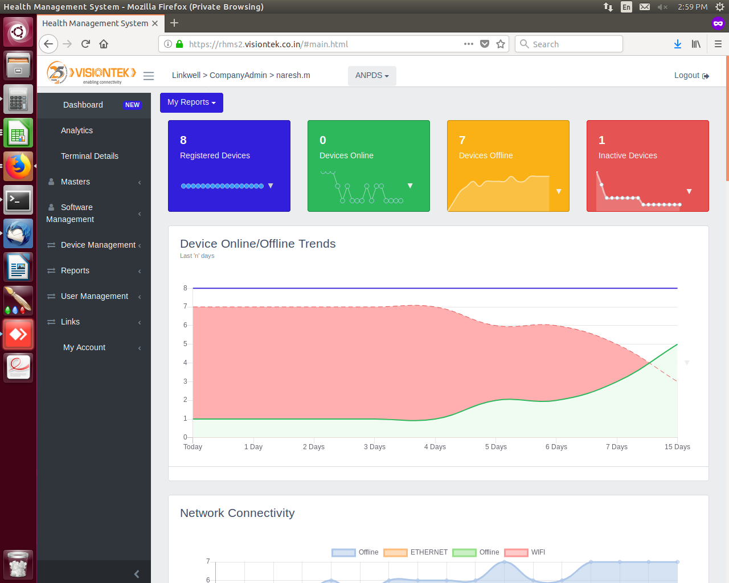

Dashboard Image

Dashboard

Dashboard is to see how many devices are registered under a particular project.
And to see the online and offline devices as well as inactive devices till now.
And there you can see the network connectivity graphs and finger print rd graphs and sim status graphs.

And at the right side corner Logout option is there to Logout from the account.

In Dashboard we can switch from one project to another project.

Daily wise connection status can seen at Device offline/online trends.

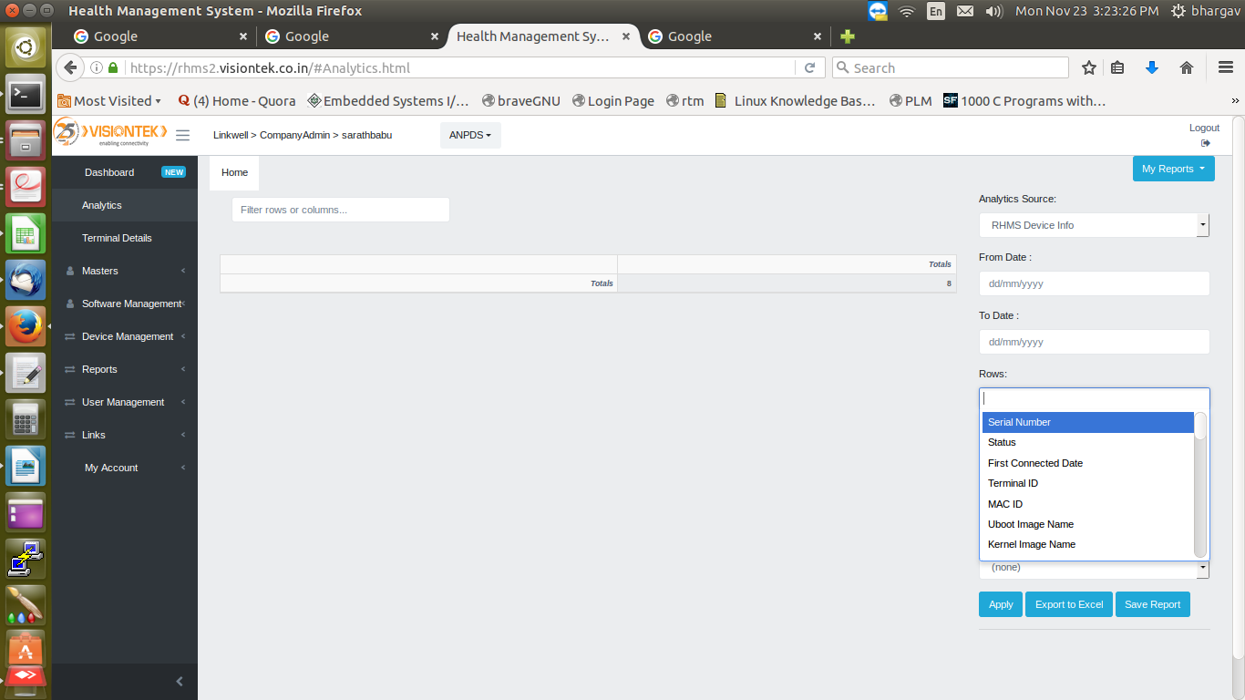

Analytics Image

Analytics

Analytics is used to search any particular field like serial number,Uboot image .
And at the selection of Rows have to select the field which want to search and click on Apply and it will provide information regarding to the selection field.

After that you can export the excel sheet by clicking on export to excel.

Date wise searching is also available in analytics.

Terminal Details
In Terminal Details serial number wise searching is available there . Before searching the serial number have to select the required project name.

And after entering the serial number click on search icon you can see all the details in the images format .

If you want to search one more serial number first have to clear the previous one by clicking on clear.
In Terminal Details click on All Projects, if you click on that you can search any serial number in any project.

Masters



If you want to create any new project . Click on masters then you can see Manage Masters.

After Clicking on Manage Projects, it will ask to select the product there you have to select the product like(GL11,GL14..).

And if you want to create product name like GL11,GL14 you have to login into admin login in there have to click on masters -> manage masters

There at the type you have to select product name or company name and at the name have to give the name and click on submit.

At the Project Name have to give the project name.

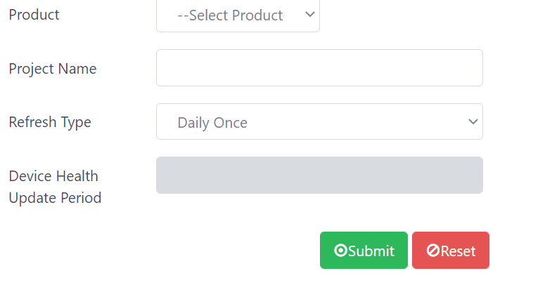
And at the Refresh Type have to select Refresh Type according to the refresh type selection device will run the RHMSClient Application .

Here Daily Once means RHMSClient Application will run once in a day.
On Every Boot means RHMSClient Application will run every boot of the device.
If you select hours in Refresh type have to mention the hours in Device Health Update Period. If you give 5 hours RHMSClient Application will run for every 5 hours.
Hours must be in between 1-23 hours only.

If you select minutes in Refresh type have to mention the minutes in Device Health Update Period. If you give 50 minutes RHMSClient Application will run for every 50 minutes
Minutes must be in between 1-59 minutes only.

Software Management

In if you click on Software Mangement there can see four options.

1)Create Firmware details
2)Create Application details
3)Upload Firmware
4)Upload Application

In Create Firmware details , New firmware can be created
at the firmware name should give firmware name.
Like 2G,3G.

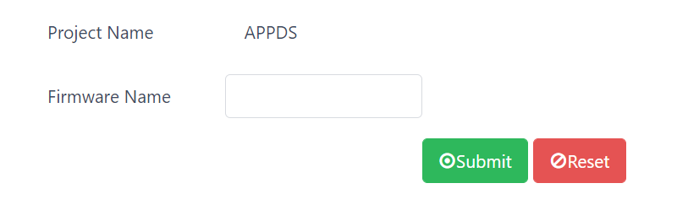
Click on submit and the firmware will be created.

Create Application Details

In Application Details have to give Application type and Application Name and click on submit.

Here Application Type is given because, One device can have more than one application like PDS application, Banking Application..

That's why divided into application type.

And at the application name have to give the name of the application going to create.And click on submit icon.
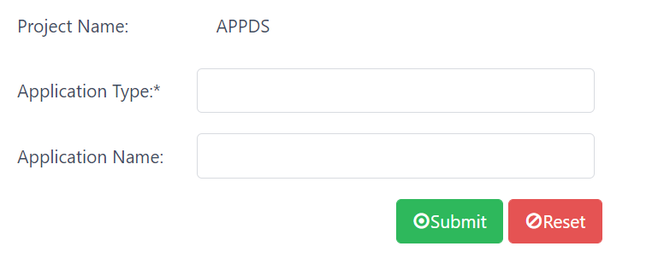
Upload Firmware

In upload firmware at firmware name have to select name under which firmware the firmware patch should upload.And at the firmware name you can see the firmwares which you created earlier.
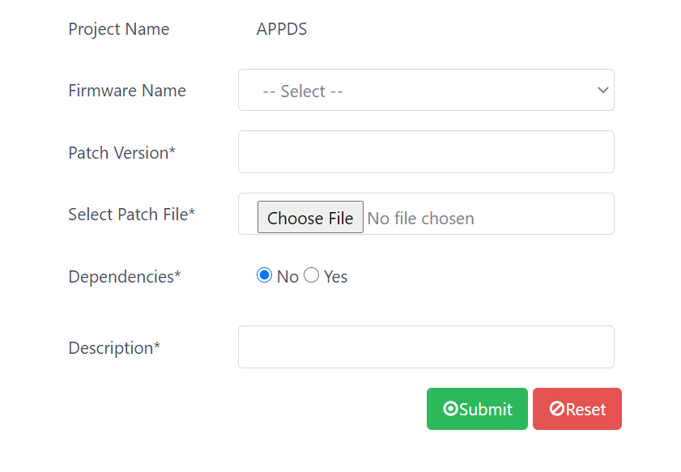

At patch version have to give the patch version.
At select pacth file have to select the patch file which is to upload to server.

At the Description have to write the description of the patch

Application

In application at application type have to select name under which application the application patch should upload.

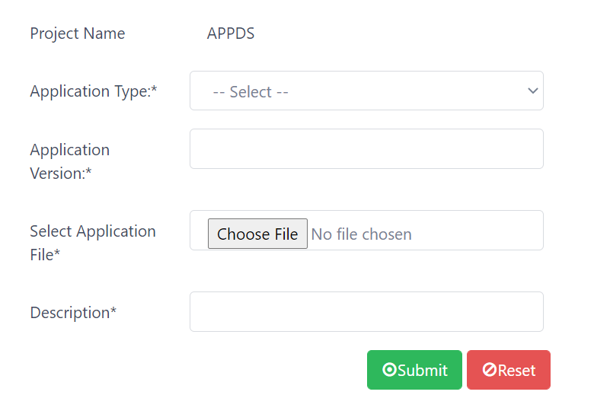
At application version have to give the application patch version.
At select application file have to select the patch file which is going to upload to server.

User Management

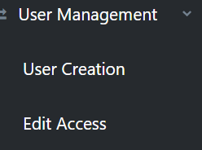

In user creation company admin can create,User profile like Project Admin , Firmware Admin...

In Edit Access at top right corner two options will be there Edit Role and Edit Project.

In Edit Project can assign the project to the user. In Edit Role can give access as Project Admin, Firmware Admin..

Device Management

If you click on Device Management there you can see categories like registration and deregistration.

1) Bulk registration
2)single registration
3)Bulk deregistration
4)Device Info

Here bulk registration means if you want to register more than one serial numbers have to make them in .xlsx format.Standard procedure is there to create the .xlsx file.

In bulk registration have to select under which firmware and application it should register and at the select excel file have to select the .xlsx file and click on submit.

At the status you can check the status of that .xlsx file where it is succesfully registered.

If the status shows success means devices are registered succesfully.
If the status shows file loading means devices are not registered may be wrong format of .xlsx file.

And at the result state click on view import status in that at the result if it shows SUCCESS means devices are registered succesfully, if it shows UPDATED means if you want to move serial numbers from the same project to different firmware it will show updated.

And if you register any serial number that is already there in any another project it will give error message and it will also give under which project it is registered.

Single registration means if you want to register any single device serial number can register here.

And in that some madatory fields are there you select there under which firmware and under which application it should register and after giving all the details click on submit. If that serial number is not there in any project it will register succesfully.

If the device serial number is already there in any project it wont register it will error message like devices skipped to some project.It will show the project name also.

Bulk De-registration means if you want to deregister multiple serial numbers from a particular project that you can make into a .xlsx format and at the bulk deregistration you can select the .xlsx file for deregistration.Click on upload excel.

In Device Info all device information like serial number , macid, firmware,application will be there you can export the excel at export to excel option.

If you want to deregister single device in Device Info you search for that particular serial numbe and there you can deregistration option click on deregister and the device will be deregistered.
Drag to right there you can see deregister option.

Reports

Device Details

In Device Details you can search with serial number it will display all the boot time,health,hardware status iinformation.
Date wise searching is also available in Device Details.

Device History

In Device History also have to searh with serial number but in history it will show all the details of a particular device . In Device Details it will show the latest device status received from device,but in history it will show the information of all the of all multiple runs and previous dates information.

Download Report

In Download Report we can see the device installation pending count for every version in both firmware and application.

Firmware Versions

In firmware versions it will display how many devices are updated with particular firmware version.It will display in count.
And there is a graphical representation is there.

Application Versions

In application versions it will display how many devices are updated with particular application version.It will display in count.
And if you click on that count you can able to see device serial numbers.
And there is a graphical representation is there.

Sim Count Status

In Sim Count Status it will display the information about the sim slots.
In this it will display how many devices are using sim1 as slot and how many devices are using sim2 as slot.
It will display no sim status also.

Connection Abstract

It will show the connected and not connected devices status and count date wise.
And it will show the registered and deregistered count. Firmware and application response and boot response it will show in date wise.

Sim Operator Details

It will show the sim operator details date wise . It will dislpay the network(airtel,bsnl,idea...) names and count of the sims using particular network.
And it will shows the maximum and minimum dB.

Hardware Changes

If any hardware changes like analog board or digital board or fingerprint scanner comes under hardware changes and it will display the serial numbers and date of change of hardware.

Scanner Installations

Date wise scanner installations count it will show.

Consolidated Details

In consolidated details it will show all the device details and device active and inactive state.

Here in Consolidated details there you can see communication details report and external details report and consolidated scannerid details report.

In communication details report it will show communication type of each and every device.
And also particular serial number search is also available.

In external details report it will show external devices information like barcode, weighing scale details of each and every device.
And also particular serial number search is also available.

Web Api Log

It shows the xml file information which is send from the device, the information will be seen in xml format.

My Account

If you want to change password of any user in my account change password option will be there and here you can search for a paricular user and change the password.

