**Design**

Diagram shows soccer pitch and coordinates as per the problem statement.

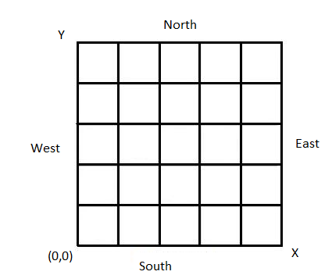

Fitibits Application is developed in object oriented way.

Using oops concepts I created the following classes

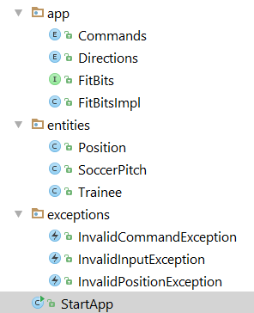

FitBitImpl contains the fitbit implementation logic.

As per the requirement ,trainee will change direction when the command is either L or R and moves forward when its M.

To change direction first I ordered the directions as rightDirectionsOrder( N E S W) and leftDirectionsOrder(W S E N).

For example if the current direction is W and command is R then i will get the next right direction as N.

And when the command is M then I get the current direction and increment/decrement x or y coordinates.

FitbitApp accepts input from either console or file.

For testing I used powermock,mockito and Junit frameworks. Wrote 14 test cases which covers different scenarios.

Overall code coverage 91%.

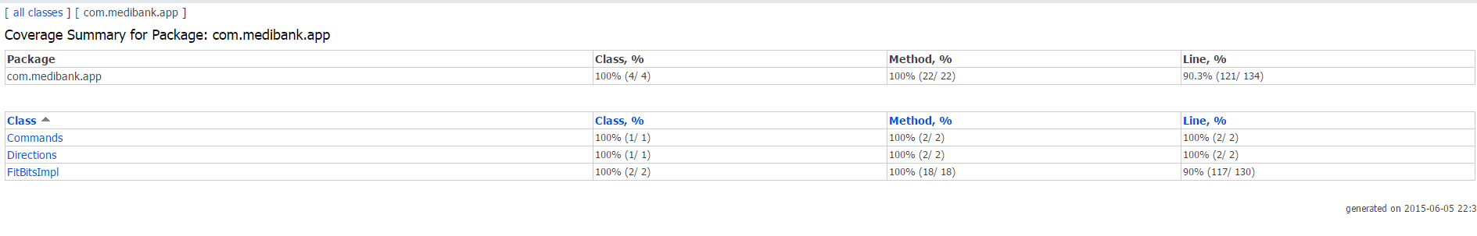

Please go through the javadoc for better understanding of code .

**FitBitsApp Output Screenshots**

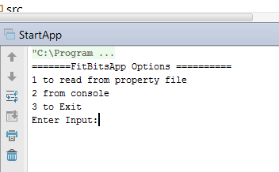

Input 1 to read Input from properties file located at src/main/resources

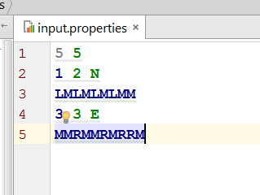

**Final trainee Position{x=1, y=3, direction=N} is printed in the below logs.**

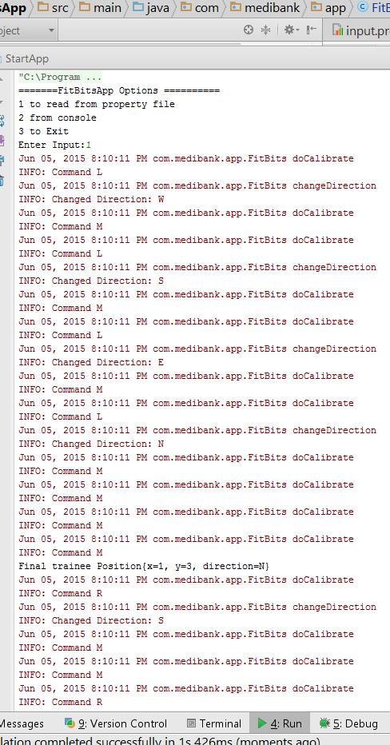

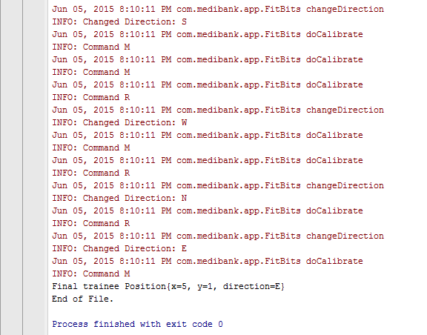

**When option 2 (Console Input)**

