**Hooks**

[**https://www.youtube.com/watch?v=cF2lQ_gZeA8&list=PLC3y8-rFHvwgg3vaYJgHGnModB54rxOk3&index=44**](https://www.youtube.com/watch?v=cF2lQ_gZeA8&list=PLC3y8-rFHvwgg3vaYJgHGnModB54rxOk3&index=44)

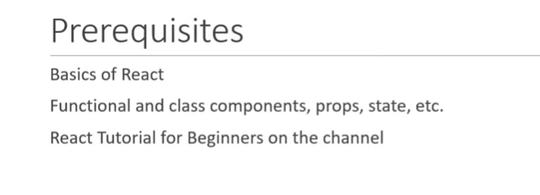

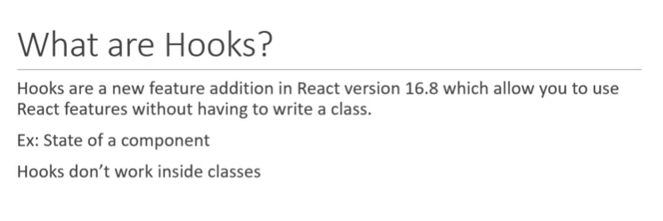

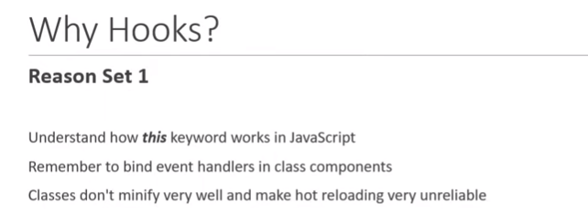

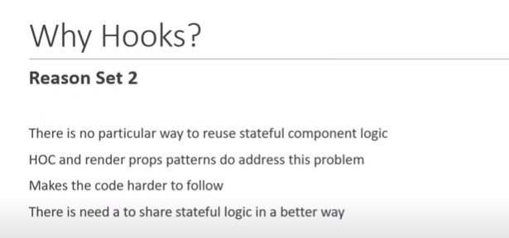

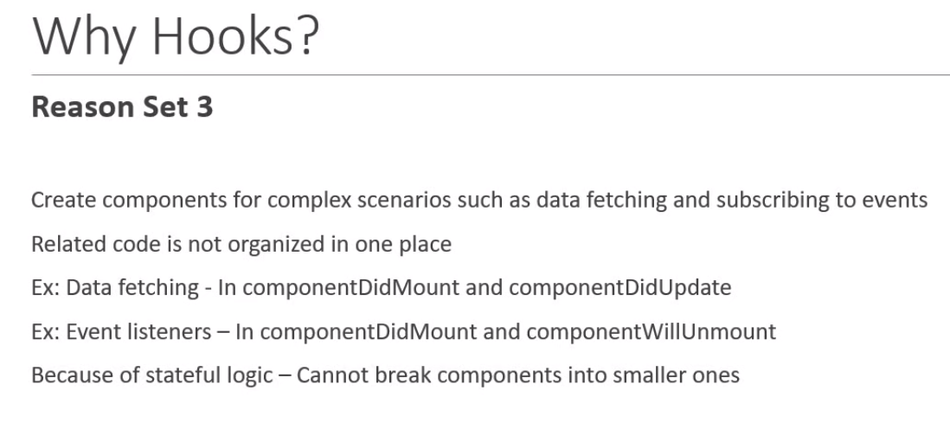

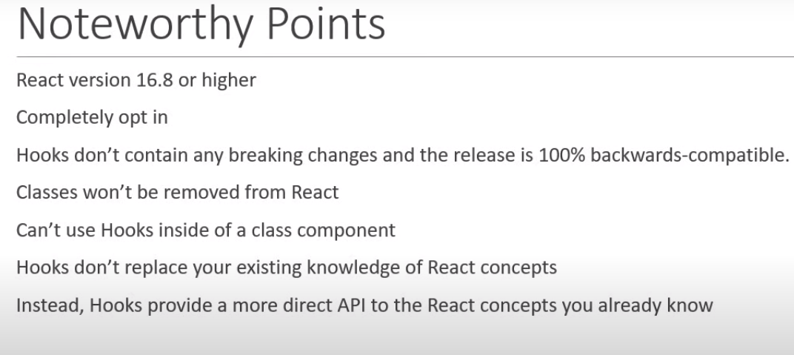

**Summary**

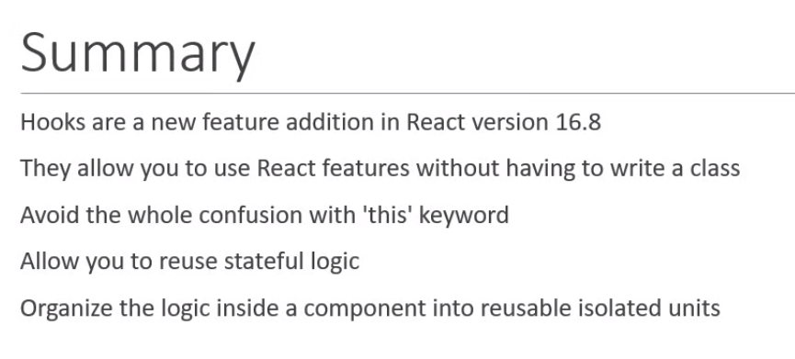

0:

React Hooks Tutorial - 2 - useState Hook

[**https://www.youtube.com/watch?v=lAW1Jmmr9hc&list=PLC3y8-rFHvwgg3vaYJgHGnModB54rxOk3&index=45**](https://www.youtube.com/watch?v=lAW1Jmmr9hc&list=PLC3y8-rFHvwgg3vaYJgHGnModB54rxOk3&index=45)

**-src –component folder –create ClassCounter.js and rce –class component and rconst-constructor**

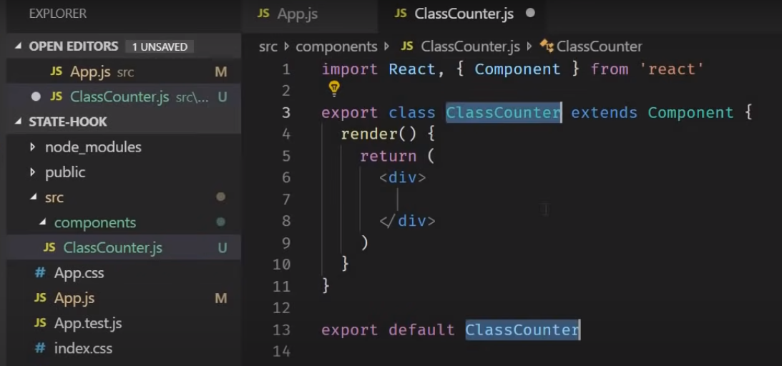

**We are going to increase the count by click.**

**S1- step define and declare the count value i.e int count; - in java**

**But where is in react this.state = {**

**Count = 0**

**}**

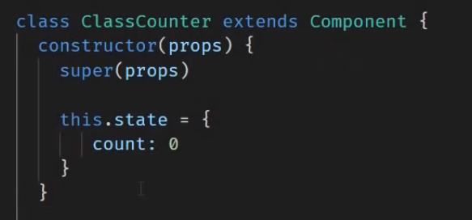

**Define a method very you increase the count in the method –using setState()-**

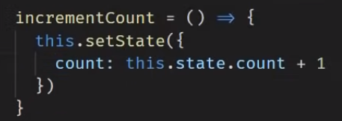

**By button click it should called incrementCount method and render the count value**

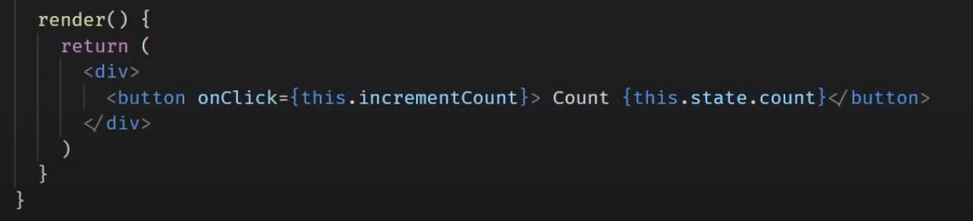

**On the App.js – define the class- <ClassCounter />**

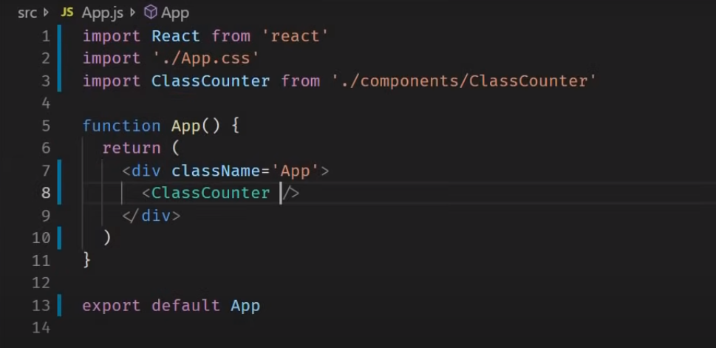

**Output**

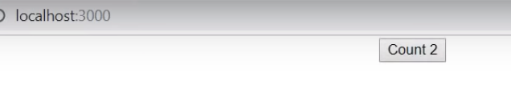

**Using useState**

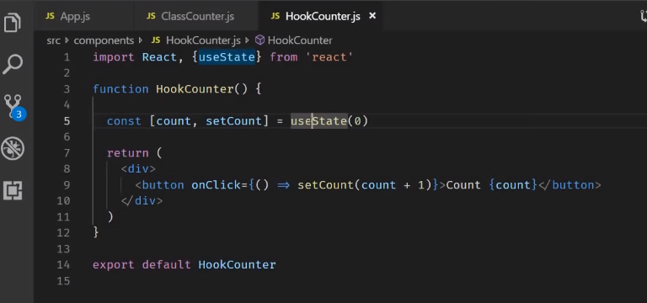

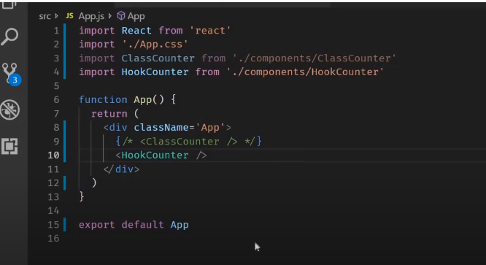

**OUTPUT**

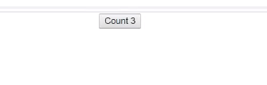

**Rules**

