GA4 with Dataform
Case Study Solution
Bronze / Silver / Gold Medallion Architecture
over the Public GA4 Sample E-Commerce Dataset

Data Engineering Assignment
Dataform on Google Cloud Platform

1. Overview
This Dataform project implements a Bronze → Silver → Gold medallion architecture over the public Google Analytics 4 obfuscated sample e-commerce dataset in BigQuery.
The pipeline extracts purchase events, denormalises nested GA4 fields, filters out deleted data, and produces a monthly business report that ranks traffic source mediums by purchase value and volume.

2. Data Lineage
The diagram below shows the complete data flow from the raw GA4 public dataset through to the final business report table.
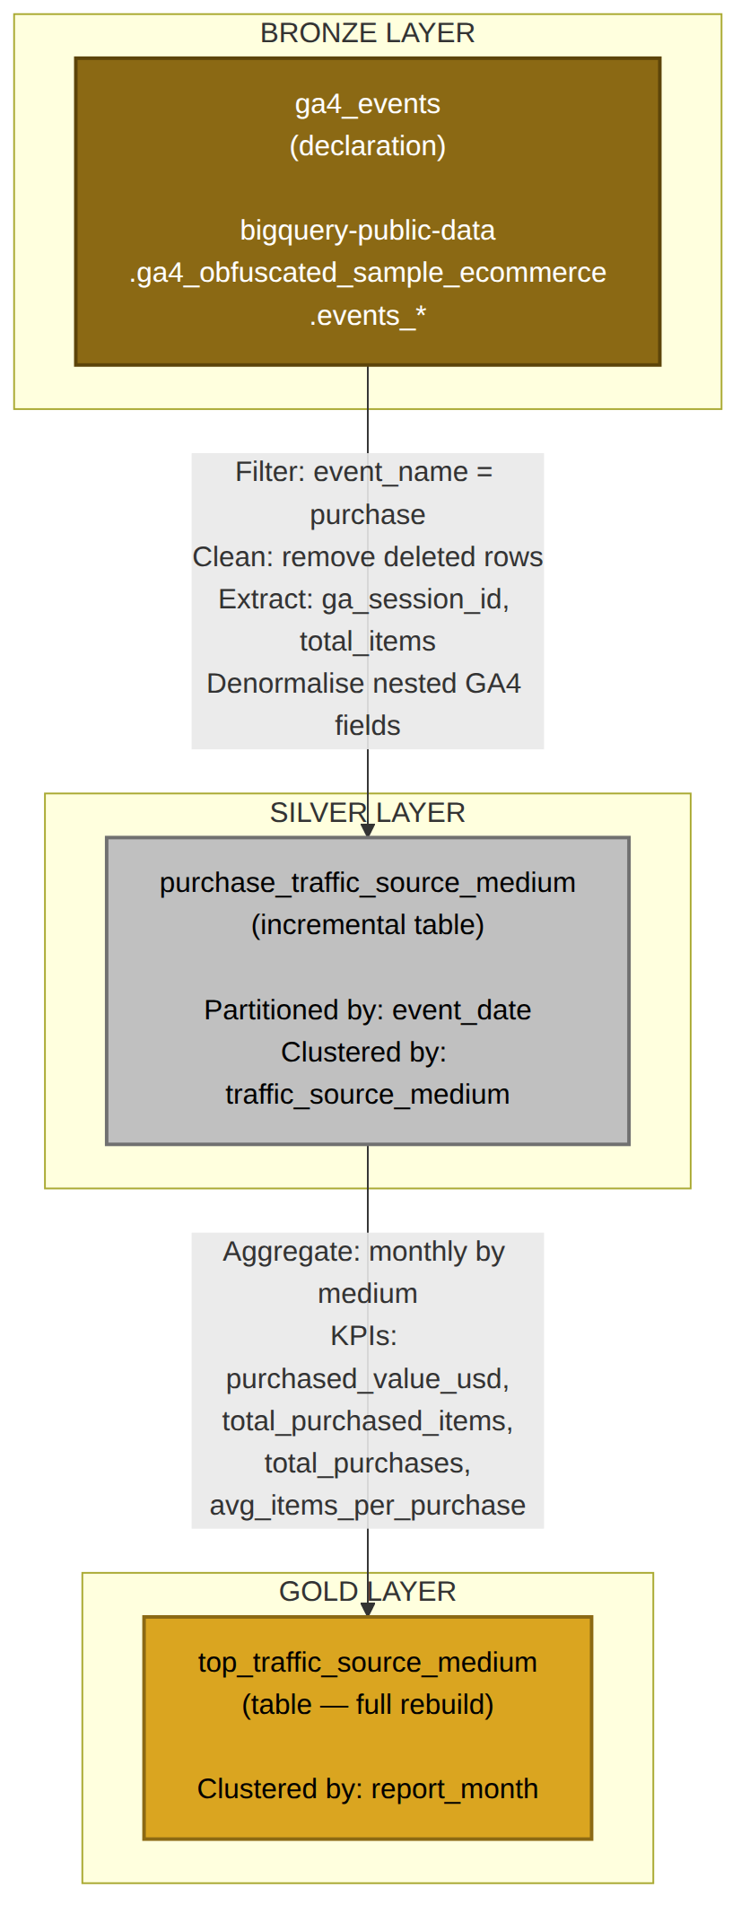
Figure 1: Data Lineage — Bronze → Silver → Gold

3. Repository Structure
Path | Purpose
dataform.json | Legacy Dataform config (CLI compatibility)
workflow_settings.yaml | Modern Dataform on GCP configuration with variables
package.json | NPM dependencies (@dataform/core 2.9.0)
definitions/sources/ga4_events.sqlx | BRONZE — Declaration of public GA4 dataset
definitions/silver/purchase_traffic_source_medium.sqlx | SILVER — Incremental, denormalised purchase events
definitions/gold/top_traffic_source_medium.sqlx | GOLD — Monthly aggregated business report
includes/constants.js | Shared constants (source project/dataset)
docs/ARCHITECTURE.md | Architecture deep-dive & design decisions
exports/top_traffic_source_medium.csv | Exported gold-layer output (deliverable)
cloudbuild.yaml | CI/CD pipeline for compilation validation

4. Layer Details

4.1 Bronze — Source Declaration
Property | Value
File | definitions/sources/ga4_events.sqlx
Dataform type | declaration
Target | bigquery-public-data.ga4_obfuscated_sample_ecommerce.events_*

No data is materialised. This declaration registers the external dataset in Dataform’s dependency graph so downstream actions can reference it with ${ref("events_*")}. If the source ever moves, only this one file needs to change.

4.2 Silver — purchase_traffic_source_medium
Property | Value
File | definitions/silver/purchase_traffic_source_medium.sqlx
Dataform type | incremental
Partitioned by | event_date
Clustered by | traffic_source_medium
Grain | One row per purchase event (user × session × timestamp)

Columns:
Column | Type | Description
event_date | DATE | Date of the purchase event
traffic_source_medium | STRING | Medium from the user’s original traffic source (organic, cpc, referral, etc.)
user_pseudo_id | STRING | GA4 anonymous user identifier
ga_session_id | INT64 | Session identifier extracted from event_params
event_value_in_usd | FLOAT64 | Purchase value in USD
event_timestamp | INT64 | Event timestamp in microseconds (epoch)
total_items | INT64 | Number of items in the purchase (sum of item quantities)

Business rules applied:
- Only rows where event_name = ‘purchase’ are retained.
- Rows whose traffic_source.medium contains “(data deleted)” are excluded (GDPR/consent removals).
- ga_session_id is extracted from the nested event_params ARRAY.
- total_items is the sum of item quantities from the nested items ARRAY.
- On incremental runs, only new date partitions are processed.

4.3 Gold — top_traffic_source_medium
Property | Value
File | definitions/gold/top_traffic_source_medium.sqlx
Dataform type | table (full rebuild)
Clustered by | report_month
Grain | One row per (report_month × traffic_source_medium)

KPI columns:
Column | Type | Description
report_month | DATE | First day of the month (truncated from event_date)
traffic_source_medium | STRING | Traffic source medium (NULL coalesced to “(not set)”)
purchased_value_usd | FLOAT64 | Total purchase value in USD for the month
total_purchased_items | INT64 | Total items purchased in the month
total_purchases | INT64 | Number of purchase events (transactions)
avg_items_per_purchase | FLOAT64 | Average items per transaction

Full table rebuild is chosen over incremental because the gold table is a small aggregation and full rebuild guarantees correct aggregates without merge complexity.

5. Design Decisions
Decision | Rationale
Incremental silver, full-rebuild gold | Silver handles large raw data efficiently; gold is a small aggregate where full rebuild is cheap and avoids merge edge cases.
Partitioning by event_date | Aligns with GA4’s date-sharded export pattern; enables efficient incremental loads and query pruning.
Clustering by traffic_source_medium | Optimises the GROUP BY in the gold-layer query, reducing bytes scanned.
COALESCE for NULL mediums | Prevents NULL dimension keys in the gold report, following GA4 “(not set)” conventions.
SAFE_DIVIDE for averages | Prevents division-by-zero errors in edge cases.
Inline assertions | nonNull and rowConditions provide data quality guardrails that run automatically with each execution.

6. How to Run

6.1 Prerequisites
- A GCP project with BigQuery and Dataform enabled.
- The Dataform service account needs roles/bigquery.dataViewer on bigquery-public-data.
- The Dataform service account needs roles/bigquery.dataEditor on your target dataset.

6.2 Setup
- Create a Dataform repository in the GCP Console under BigQuery → Dataform.
- Link this repository (push code to the connected Git repo, or paste files via the web IDE).
- Update workflow_settings.yaml: replace ‘your-gcp-project-id’ with your actual project ID.
- Update dataform.json: replace ‘your-gcp-project-id’ with your actual project ID.

6.3 Execution
Full run (all tags):
dataform run
Run only the silver layer:
dataform run --tags silver
Run only the gold layer:
dataform run --tags gold
Dry run (compile and validate only):
dataform compile
In the GCP Console, you can trigger runs manually via the Dataform UI or set up scheduled workflow configurations for daily execution.

7. Assertions & Data Quality
Layer | Assertion | Purpose
Silver | nonNull: [event_date, user_pseudo_id] | Ensures critical identifiers are present
Silver | event_value_in_usd >= 0 OR IS NULL | Catches negative purchase values
Gold | nonNull: [report_month, traffic_source_medium] | Ensures dimension keys are populated
Gold | total_purchases > 0 | Validates every row has at least one purchase
Gold | avg_items_per_purchase >= 0 | Ensures non-negative averages

Assertion results are visible in the Dataform execution logs and can trigger alerts via Cloud Monitoring.

8. Cost & Performance Considerations
- Partitioning: Queries against the silver table that filter on event_date scan only relevant partitions, reducing cost.
- Clustering: The traffic_source_medium cluster key on silver and report_month on gold improve query performance for GROUP BY operations.
- Incremental loads: After the initial backfill, daily runs process only the delta, keeping slot usage and bytes scanned minimal.
- Public dataset: Reading from bigquery-public-data is free in terms of storage but billed for query bytes scanned under your project’s on-demand pricing.

9. Exporting Gold-Layer Data
After running the pipeline, export the gold table to CSV using any of the following methods:
Option A — BigQuery Console:
Open the table in BigQuery → click Export → Export to local file (CSV).
Option B — bq CLI:
bq extract --destination_format=CSV your-project:ga4_dataform.top_traffic_source_medium gs://bucket/export.csv
Option C — SQL EXPORT DATA:
EXPORT DATA OPTIONS(uri='gs://bucket/export_*.csv', format='CSV', overwrite=true, header=true) AS SELECT * FROM table ORDER BY report_month DESC;
The pre-exported CSV is included in the exports/ directory of the repository.

