**SPA Assignment 2**

**Group 181**

**Nareshkumar P (2020FC04122)**

**Kommajyosula VNS Kanth (2020fc04120)**

**Dola Tejesh (2020fc04459)**

**SPA Assignment 2 Group 181 Video link: (Google drive link)**

<https://drive.google.com/file/d/1TtELE7EHI0SsdfTuMV9HyevWh5PpgfEh/view?usp=sharing>

**Note:** Python code files (.ipynb, .py) for this assignment will be attached along with this document during submission.

**Exercise 1:** (Script filename: GRP_181_SPA_Assignment_2.ipynb)

From the given dataset, We have decided to go for unsupervised learning (K-Means Algorithm) for the prediction.

Using Elbow method, No. of clusters are finalized as 5.

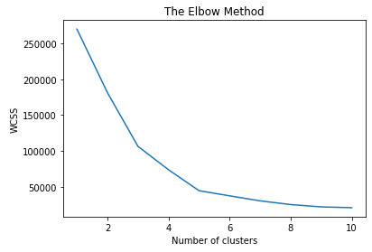

After applying K-means algorithm on the dataset, we found below results.

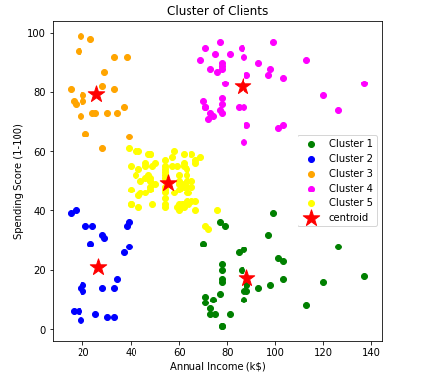

**Exercise 2:** (Script filename: GRP_181_SPA_Assignment_2.ipynb)

From the above model predictions, we have found following insights on each cluster.

**Cluster 1 (Green Cluster): (Annual Income > 70, Spending Score <= 40)**

Customers with High income and a low number of transactions (These are the target customers. Company should provide initial discounts and more offers to do more transactions)

**Offer Example:** Buy One Get Two pizza and get 2 free coupons worth of Rs.199 each (Conditions Apply)

**Cluster 2 (Blue Cluster): (Annual Income <= 40, Spending Score <= 60)**

Customers with low income and a low number of transactions (Customers are not often showing interest to do transactions. To encourage their transactions, company can provide one or two free limited services every month)

**Offer Example:** Buy a Pizza today and get 2 free coupons worth of Rs.99 each

**Cluster 3 (Orange Cluster): (Annual Income <=40, Spending Score > 60)**

Customers with low income but a High number of transactions (Company can provide offers/discount to these customers to continue their transactions in future)

**Offer Example:** Get 20% off on buying pizzas upto Rs.100

**Cluster 4 (Magenta Cluster): (Annual Income > 70, Spending Score > 60)**

Customers with High income and a High number of transactions (Profitable customers hence provide the existing discounts/offers to the customers)

**Offer Example:** Get 10% off on buying pizzas upto Rs.50

**Cluster 5 (Yellow Cluster): (Annual Income > 40 and Annual Income <= 70, Spending Score > 40 and Spending Score <= 60)**

Customers with medium income and a medium number of transactions (Customers always doing transactions whenever needed hence no additional offers/discounts needed for them)

**Offer Example:** Visit our store today for our new exciting menus and get compliment drink

**Exercise 3:** (Script filename: Customer_Kafka_Producer.py)

**Customer movement simulation problem:**

Step 1: Fixed the Shop latitude and Shop longitude by some default value (Eg: shop_lat=20.00 and shop_long=80.00)

Step 2: By using shop_lat and shop_long variables, Generating new latitude and longitude random values which are near to the shop’s latitude.

Step 3: Along with the random latitude and longitude values, generating the customer data as well.

We are generating random customer data along with latitude and longitude like below.

Customer - > Random number between 1 and 300

Phone number -> Random number between 9000000000 and 9999999999

Current_Time -> Current date and time

Latitude -> Random Latitude location nearby shop (Eg: 20.45)

Longitude -> Random Longitude location nearby shop (Eg: 80.04)

Step 4: Sending the customer data to kafka topic

**Exercise 4:** (Script filename: Customer_Kafka_Consumer.py, Send_SMS.py)

**Streaming Data Pipeline Architecture:**

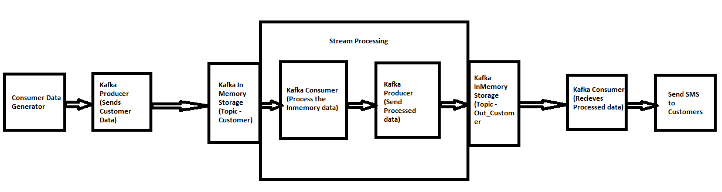

**Components Used:**

**Python Script:** To generate Customer data, To filter the non-registered customers, To send SMS to Customers

**Kafka Producer:** To send data to Kafka Topic

**Kafka Topic:** In Memory Storage

**Kafka Consumer:** To receives data from the topic

**Data flow Steps:**

Step 1: Generate the Customer data using python code

Step 2: Use Kafka producer to sends the customer data to Kafka topic (Topic-Customer)

Step 3: Kafka topic where the data resides for few days. It’s the inMemory storage

Step 4: Kafka Consumer receives the message from Topic and process the data (Filter the non-registered customers) using python script.

Step 5: Kafka Producer sends the processed data to another topic (outcustomer)

Step 6: Another Kafka consumer receives the data from the topic and send SMS to the customer and their offers using python script.

**Business Logic:**

Receives all the customers data who is near to the shop and filter the non-registered customers. Based on K-means clustering model, Check the customer’s cluster and sends offer through SMS based on the previous transactions.

If customer’s Annual Income > 70, and Spending Score <= 40

Send SMS Message:

Phone_Number: 9XXXXXXXXX - Hello Customer!! Buy One Get Two pizza and get 2 free coupons worth of Rs.199 each (Conditions Apply). Promo_Code:B1G2

If cutomer’s Annual Income <= 40 and Spending Score <= 60

Send SMS Message:

Phone_Number: 9XXXXXXXXX - Hello Customer!! Buy a Pizza today and get 2 free coupons worth of Rs.99 each. Promo_Code:Get2Free

If customer’s Annual Income <=40 and Spending Score > 60

Send SMS Message:

Phone_Number: 9XXXXXXXXX - Hello Customer!! Get 20% off on buying pizzas upto Rs.100. Promo_Code:Get20Off

If customer’s Annual Income > 70 and Spending Score > 60

Send SMS Message:

Phone_Number: 9XXXXXXXXX - Hello Customer!! Get 10% off on buying pizzas upto Rs.50. Promo_Code:Get10Off

If customer’s Annual Income > 40 and Annual Income <= 70 and Spending Score > 40 and Spending Score <= 60

Send SMS Message:

Hello Customer!! Visit our store today for our new exciting menus and get compliment drink. Promo_Code:Compldk