**EXPERIMENTAL INVESTIGATION AND STRENGTH ASPECTS OF SELF COMPACTING CONCRETE USING ADMIXTURES AND CRUSHING DUST**

*A Dissertation work submitted to Jawaharlal Nehru Technological University in partial fulfillment of the requirements for the award of the Degree of*

**MASTER OF TECHNOLOGY**

**In**

**STRUCTURAL ENGINEERING**

**By**

**Mr. D. SANDEEP KUMAR**

**(H.T.NO: 185T1D2003)**

Under the guidance of

Faculty of Civil Engineering Department

**INTERNAL GUIDE**

**Mr. K. RAMBABU**

**ASST. PROFESSOR (CIVIL), AIET**



**Department of Civil Engineering**

**ASHOKA Institute of Engineering & Technology**

**(Approved By AICTE & Affiliated to JNTU. Hyd)**

**Malkapur (V). Choutuppal (M). YadadriBhuvanagiri Dist-508252**

**2019-2020**

**ASHOKA**

**Institute of Engineering & Technology**

Malkapur (V), Choutuppal (M), Nalgonda (D) –508252

[Approved by AICTE, New Delhi; Recognized by the Govt. of TS and Affiliated to JNTU, Hyd]



**CERTIFICATE**

This is to certify that the project work **“ EXPERIMENTAL INVESTIGATION AND STRENGTH ASPECTS OF SELF COMPACTING CONCRETE USING ADMIXTURES AND CRUSHING DUST”**, is the bonafide work of **Mr. D.SANDEEP KUMAR**, bearing H. T. No. **185T1D2003** submitted in partial fulfillment of the requirement for the award of **Master of Technology in Civil Engineering (SPECIALISATION IN STRUCTURAL ENGINEERING)** during the academic year 2019-2020.

This is further certified that the work done under my guidance, and the results of this work have not been submitted elsewhere for the award of any other degree.

**Internal Examiner HOD**

**External Examiner Principal**

**Declaration**

I hereby declare that the project work entitled **“EXPERIMENTAL INVESTIGATION AND STRENGTH ASPECTS OF SELF COMPACTING CONCRETE USING ADMIXTURES AND CRUSHING DUST”**, submitted **to Department of Civil Engineering of ASHOKA INSTITUTE OF ENGINEERING & TECHNOLOGY. MALKAPUR,** affiliated to **JNTU Hyderabad** in partial fulfillment of the requirement for the award of the degree of **Master of Technology in STRUCTURAL ENGINEERING** is the work done by me and has not been submitted elsewhere for the award of any& other degree.

**Mr. D.SANDEEP KUMAR**

**H.T.NO: 185T1D2003**

**ACKNOWLEDGEMENT**

It gives us intense pleasure to express our deep sense of gratitude and we extol the genuine cooperation, inspiration and affection offered to us by the higher management of our institution and the principal **Dr.M. Sreedhar Reddy, Mr.B.Ganesh** Head of the Department (CIVIL Engineering) **ASHOKA Institute of Engineering and Technology**, right from the initiation of the work till completion of the manuscript. The present work discloses their aspiration at every stage, the impression of their wise counsel and concrete callous attention to detail. It is indeed privilege for us work under their unending inspiration and indomitable spirit and we owe them a huge debt of gratitude forever in our lives.

We are highly thankful to and delighted as well in the presence of our parents, friends and all for their cooperation and suggestions.

We may have missed to mention to list the names of some of our teachers, professors, colleagues, friends and well-wishers who directly or indirectly helped us in our task but we are really thankful to one and all of them.

**Mr. D.SANDEEP KUMAR**

**H.T.NO: 185T1D2003**

**CONTENT**

|  |  |
| --- | --- |
| Certificate | 2 |
| Declaration | 3 |
| Acknowledgement | 4 |
| Contents | 5 |
| Abstract | 13 |
| 1. Introduction | 14 |
| 1.1 General | 14 |
| 1.2 Objectives | 14 |
| 1.3 Need of the Study | 15 |
| 2. Literature Review | 16 |
| 3. Self-Compacting Concrete | 23 |
| * 1. Definition | 23 |
| 3.2 Advantages & Dis-Advantages | 23 |
| 3.3 Application | 24 |
| 3.4 Materials | 24 |
| 3.4.1 GGBS | 24 |
| 3.4.2 Ultrafine Natural Steatite Powder | 26 |
| 3.4.3 Masterglenium Ace 30(Jp) | 27 |
| 4. Properties of Materials | 28 |
| 4.1 Cement | 28 |
| 4.2 Fine Aggregate | 30 |
| 4.3 Coarse Aggregate | 31 |
| 4.4 GGBS | 32 |
| 4.5 UFNSP | 33 |
| 4.6. Masterglenium Ace 30(Jp) | 34 |
| 5. Test Procedures | 36 |
| 5.1 Tests on Cement | 36 |
| 5.1.1 Specific Gravity of Cement | 36 |
| 5.1.2 Initial And Final Setting Time | 37 |
| 5.1.3 Fineness Test on Cement | 40 |
| 5.1.4 Soundness of Cement By Le-Chateliers Method | 41 |
| 5.2 Tests on Fine And Coarse Aggregate | 43 |
| 5.2.1 Sieve Analysis | 43 |
| 5.2.2Specific Gravity And Water Absorption of Aggregate | 45 |
| 5.2.3Specific Gravity of Fine Aggregate | 46 |
| 5.2.4 Determination of Aggregate Impact Value | 48 |
| 5.2.5 Determination of Aggregate Crushing Value | 50 |
| 5.3 Casting of Test Specimens | 51 |
| 5.3.1 Mixing | 52 |
| 5.3.2 Placing and Compacting | 52 |
| 5.3.3 Curing | 52 |
| 5.3.4 Preparation of Test Specimen | 52 |
| 5.3.5 Testing of Specimens | 52 |
| 5.3.5.1 Compressive Strength Test | 52 |
| 5.3.5.2 Flexural Strength Test | 55 |
| 5.3.5.3 Split Tensile Test | 57 |
| 5.4 Experimental Study of Fresh SCC | 58 |
| 6. Mix Design | 67 |
| 6.1 Mix Design Procedure for M40 OPC | 67 |
| 6.1.1 Stipulations For Proportioning | 67 |
| 6.1.2 Test Data For Materials | 68 |
| 6.1.3 Target Strength For Mix Proportioning | 69 |
| 6.1.4 Selection Of Water Cement Ratio | 69 |
| 6.1.5 Selection Of Water Content | 69 |
| 6.1.6 Calculation Of Cement and GGBS Content | 69 |
| 6.1.7 Proportion Of Volume Of Coarse Aggregate And Fine Aggregate Content | 70 |
| 6.1.8 Mix Calculations | 70 |
| 6.1.9 Corrections For Water Absorption | 72 |
| 6.1.10 Mix Proportions For 1m3 | 72 |
| 7. TEST DATA and Results | 76 |
| 7.1 Test Data | 76 |
| 7.1.1 GGBS Addition | 76 |
| 7.1.1.1 Compressive Strength Test | 76 |
| 7.1.1.2 Flexural Strength Test | 78 |
| 7.1.1.3 Split Tensile Strength Test | 80 |
| 7.1.2 UFNSP Addition | 81 |
| 7.1.2.1 Compressive Strength Test | 81 |
| 7.1.2.2 Flexural Strength Test | 83 |
| 7.1.2.3 Split Tensile Strength Test | 86 |
| 7.2 Test Results | 88 |
| 7.2.1 With GGBS Content | 88 |
| 7.2.1.1 Compressive Strength Results | 88 |
| 7.2.1.2 Flexural Strength Results | 89 |
| 7.2.1.3 Split Tensile Strength Results | 90 |
| 7.2.2 With UFNSP Content | 91 |
| 7.2.2.1 Compressive Strength Results | 91 |
| 7.2.2.2 Flexural Strength Results | 92 |
| 7.2.2.3 Split Tensile Strength Results | 93 |
| 8. Conclusions | 94 |
| 9. References | 95 |

**LIST OF TABLES**

|  |  |  |
| --- | --- | --- |
| **Table No** | **Table Description** | **Page No** |
| 4.1. | Properties Of Opc | 29 |
| 4.2. | Fine Aggregate Properties | 30 |
| 4.3. | Coarse Aggregate Properties | 31 |
| 4.4. | Ggbs Chemical Composition | 32 |
| 4.5. | Ggbs Physical Properties | 33 |
| 4.6. | Ufnsp Physical Properties | 33 |
| 4.7. | Master Glenium Test Data | 35 |
| 5.1 | Cement Standard Specification | 39 |
| 5.2 | Initial, Final Setting Time Of Cement | 40 |
| 5.3 | Fineness Of Cement Observations | 41 |
| 5.4 | Is Sieves For Analysis | 44 |
| 5.5 | Standards For Sieve Analysis | 44 |
| 5.6 | Classification Of Aggregate Impact Value | 50 |
| 5.7 | Properties Of Fresh SCC1 | 58 |
| 5.7 | Properties of fresh SCC1 | 63 |
| 6.1 | M40 Opc Of Control Mix | 72 |
| 6.2 | M40 Opc Of 20% Ggbs | 72 |
| 6.3 | M40 Opc Of 40% Ggbs | 73 |
| 6.4 | M40 Opc Of 60% Ggbs | 73 |
| 6.5 | M40 Opc Of 80% Ggbs | 73 |
| 6.6 | M40 Opc Of 5% Ufnsp | 74 |
| 6.7 | M40 Opc Of 10% Ufnsp | 74 |
| 6.8 | M40 Opc Of 15% Ufnsp | 74 |
| 6.9 | M40 Opc Of 20% Ufnsp | 75 |
| 7.1 | Compressive Strength Test Data For 3 Days | 76 |
| 7.2 | Compressive Strength Test Data For 7 Days | 77 |
| 7.3 | Compressive Strength Test Data For 28 Days | 77 |
| 7.4 | Flexural Strength Test Data For 3 Days | 78 |
| 7.5 | Flexural Strength Test Data For 7 Days | 79 |
| 7.6 | Flexural Strength Test Data For 28 Days | 79 |
| 7.7 | Split Tensile Strength Test Data For 3 Days | 80 |
| 7.8 | Split Tensile Strength Test Data For 7 Days | 80 |
| 7.9 | Split Tensile Strength Test Data For 28 Days | 81 |
| 7.10 | Compressive Strength Test Data For 3 Days | 81 |
| 7.11 | Compressive Strength Test Data For 7 Days | 82 |
| 7.12 | Compressive Strength Test Data For 28 Days | 82 |
| 7.13 | Flexural Strength Test Data For 3 Days | 83 |
| 7.14 | Flexural Strength Test Data For 7 Days | 84 |
| 7.15 | Flexural Strength Test Data For 28 Days | 85 |
| 7.16 | Split Tensile Strength Test Data For 3 Days | 86 |
| 7.17 | Split Tensile Strength Test Data For 7 Days | 86 |
| 7.18 | Split Tensile Strength Test Data For 28 Days | 87 |
| 7.19 | Compressive Strength Test Results | 88 |
| 7.20 | Flexural Strength Test Results | 89 |
| 7.21 | Split Tensile Strength Test Results | 90 |
| 7.22 | Compressive Strength Test Results | 91 |
| 7.23 | Flexural Strength Test Results | 92 |
| 7.24 | Split Tensile Strength Test Results | 93 |

**LIST OF FIGURES**

|  |  |  |
| --- | --- | --- |
| **Figure no** | **Figure description** | **Page no** |
| 5.1 | Vicat Apparatus | 38 |
| 5.2 | Le chatelier Apparatus | 42 |
| 5.3 | Crushing apparatus | 50 |
| 5.4 | Flexural Strength Test Arrangement | 55 |
| 5.5 | split tensile strength test | 57 |
| 5.6 | Passing Ability test of SCC | 59 |
| 5.7 | Segregation Resistance test of SCC | 60 |
| 5.8 | Filling Ability Test of SCC1 | 62 |
| 5.9 | Passing Ability Test of SCC2 | 64 |
| 5.10 | Segregation Resistance Test of SCC2 | 65 |
| 5.11 | Filling Ability Test of SCC2 | 66 |

**LIST OF GRAPHS**

|  |  |  |  |
| --- | --- | --- | --- |
| **Figure no** | **Figure description** | **Page no** | |
| Fig. 5.2 | Graph showing Passing Ability of SCC1 | | 58 |
| Fig. 5.3 | Graph showing Segregation Resistance of SCC1 | | 60 |
| Fig. 5.4 | Graph showing Filling Ability of SCC1 | | 61 |
| Fig. 5.5 | Graph showing Passing Ability of SCC2 | | 64 |
| Fig. 5.6 | Graph showing Segregation Resistance of SCC2 | | 65 |
| Fig. 5.7 | Graph showing Filling Ability of SCC2 | | 66 |
| Fig 7.1 | Graph showing compressive strength results | | 88 |
| Fig 7.2 | Graph showing flexural strength results | | 89 |
| Fig 7.3 | Graph showing split tensile strength results | | 90 |
| Fig 7.4 | Graph showing compressive strength results | | 91 |
| Fig 7.5 | Graph showing flexural strength results | | 92 |
| Fig 7.6 | Graph showing split tensile strength results | | 93 |

**EXPERIMENTAL INVESTIGATION AND STRENGTH ASPECTS OF SELF COMPACTING CONCRETE USING ADMIXTURES AND CRUSHING DUST**

**ABSTARCT**

An experimental study was performed in self-consolidating strength concrete (SCC) houses using ultrafine natural steatite powder (UFNSP) as a substitute for cement and grand granulated blast furnace slag (GGBS). Evaluations performed in test tubes of 15% and 20% UFNSP substituted for cement load and compared with control samples and GGBS replacements at 20%, 40%, 60% and 80%. Maximum tested and verified with mainstream suggestions. Compression strength performs in all samples for 3-day, 7-day, and 28-day powers. The hardened samples tested for their powerhouses according to IS standards. GGBS further growth of up to 40% ended in an electrical pressure surge of maximum 40%, 57.43 N / mm2 in 28 days of treatment. Adding additional GGBS reduces the homes' strength. In the case of UFNSP, the energy would increase by an additional 10% and then decrease. The maximum pressure value of 59.92% is received in 28 days of curing. Moreover, the addition of UFNSP will increase the samples' microstructure density, which will lead to increased energy.

**Keywords:** Self-compacting concrete, UFNSP, GGBS, Compressive strength.

**1.INTRODUCTION**

**1.1 GENERAL**

Self-consolidating concrete (SCC) is a The elegance of concrete with a high flow capacity, able to flow under its weight, and achieve full compression without vibrators. The proper pressure of concrete minimizes air voids and thus ensures the highest density. The presence of highly congested reinforcements in structural sections greatly hinders the concrete's appropriate positioning and compaction during the casting process. Adequate pressure is vital to achieving long-term durability and historically dependent on employee capacity. Improper compression can also cause structural and ground defects and insufficient growth of bonds with rebar. To overcome these shortcomings, reducing dependence on workers' skills and increasing productivity, Self-Compacting Concrete (SCC) can be used.

Originally from Japan, SCC quickly became popular with construction companies around the world. It expects that more than half of the world's concrete will be self-pressing concrete in a few years. Self-compacting concrete generally uses a material with higher powder content (better rubble with a particle length of fewer than 125 μm) and a higher proportion of broad mix to achieve progressive sliding housing. The well proportioned SCC ensures a loose flow of concrete in formwork paints under your weight. Additionally, it fills the reinforced reinforcement with bound sand with little or no separation. The three main properties of SCC are high deformability, high flow ability, and excessive insulation resistance. Must well evaluate to ensure the impact of positioning and general performance of concrete.

**1. 2 OBJECTIVES**

1. To discover the feasibility of adding unique additives in self-tamping concrete.
2. To distinguish the addition of GGBS and ultra-fine natural soapstone powder.
3. To Learn the mechanical properties of concrete while adding GGBS and UFNSP to the mix with extraordinary possibilities..
   1. **NEED OF THE STUDY**

Self-compacting concrete is used in the rapid manufacture of precast concrete units and frequent structural devices for large-scale forgings on site. Therefore, processing and turnaround strategies are very vital in manufacturing.

1. **REVIEW OF LITERATURE**

"A pilot study on the use of immersion stone dust and marble clay dust as an alternative to natural sand in self-consolidating concrete," Nageswararao et al. (2015) replaced fine aggregates with crushed stone dust (CSD) and sand dust. Marble sludge powder (MSP). In different proportions combined. Six mixes designs were arranged by partial substitution of CSD and MSP at 0%, 20%, 40%, 60%, 80% and 100%. The super plasticizer is brought into various proportions of 0.35, 0.3 and 0.25 to obtain flux housing. The properties of fresh and hardened concrete (compressive energy, compressive electricity, and bending electricity) show subtle effects in the partial substitution of MSP (60%) and CSD (40%) with materials with lower water content. However, the durability results cannot compare to self-compressing concrete in daily use. Self-merging concrete can be operated with a low ratio of water to cement with superplastic material.

SelcukTurkel and Ali Kandemir(2010) concluded that the origin of coarse-alloy and mineral additives is of prime importance in terms of new and mechanical properties of SCC "Fresh and hardening properties of SCCs made from various aggregates and mineral additives". The effect of mineral additives (fly ash, limestone dust, coarse aggregate forms, limestone and olivine basalt) on fresh and hardened SCC investigates within a laboratory test series. The results confirmed that the effect of mineral additives in clean homes appears to be more widespread than the overall impact. Limestone powder and limestone mixtures have superior mechanical and shiny properties compared to compact basalt groups.

"Flow Performance of High Fludity Concrete" (2004), Zhuguo Li; Taka-aki Ohkubo and Yasuo Tanigawa have concluded that the paper proposed a particle aggregation version for high-flow concrete in the bright state. This particle aggregation consists of non-coherent particles (granular aggregates) and cohesive particles (cement granules) surrounded by mixing water membranes. Using a microscopic approach and expanding the idea of ​​Eyring's modifier method's viscosity, the drift mechanism of high-flow concrete with inter-friction and its path change with the flow curve to try demonstrated. Moreover, the results of normal deformation and ambient temperature on the overflow concrete's sliding behavior are quantified. Finally, shear validation equipment develops, and a series of shear assessments perform to confirm the theoretical results received.

**“**The effect of mineral additives on the clean and hardening properties of self-pressurized concrete ", Shriram et al. (2013) completed an experiment on the properties of mineral additives and hardening of self-compacted concrete by partial replacement of cement with cement kiln dust (CKD). ERC is a cement manufacturing waste product. Four have prepared. Designs for mixtures of varying proportions (10%, 20% and 30%) of the substitute in combination with regular SCC and the addition of a surprising plasticizer along the way to achieve flux housing and operability. Flow houses are specified according to EFNARC guidelines to recover the water powder ratio. Flow further development up to 20% partial replacement of cement by CKD and reduction over 20% replacement A 2% increase in compressive strength found with a partial CKD replacement of 20%. In comparison, tensile electricity and bending strength indicated a slight marginal growth of 3 % Compared to normal SSC.

Properties of Self-Adhesive Concrete Manufactured with Large Quantities of Complementary Cement Materials (2013), Hassan Al-Shabeeb and Adnan Syed. This article provides an in-depth experimental examination of the development of high-performance self-compaction concrete containing large quantities of complementary cementitious materials. Developed and tested 20 general concrete mixtures designed to alter up to 70% of Portland cement with cementitious materials including C-elegance, fly ash F, slag and silica smoke. Bright concrete mix houses rated for streamlining, deformation, fill capacity, air content and separation resistance. Other properties such as permeability, uncontrolled shrinkage, tensile strength and compressive energy are also examined at different ages. A critical evaluation of the results gained indicates that self-compacting concrete of overall excessive-performance can develop through the use of double, triple, or quadruple binders with up to 70% of the cement being altered by fly ash, slag and/or silica fume. These concrete compositions' properties are similar and progress from time to time over those rigid formulations made of 100% Portland cement.

"An investigation of self-compacting concrete using ultra-fine natural soapstone as an alternative to cement," P. Kumar et al. , (2017). An experimental study was conducted on the floating houses and compressive strength of Self-Tamping Concrete (SCC) with UFNSP as a substitute for cement. Evaluations were performed in test tubes of 5%, 10%, 15%, 20% and 25% of UFNSP substitute for cement load and compared with test tubes with tamper-proof. The flow characteristics of all samples were checked and verified to the maximum with indications. The piezoelectricity test was changed to all samples at 7 days, 14 days, 28 days, and 56 days. The annealed samples were analyzed to determine their exact structural behavior, and the Mg, Ca, and Si factors were determined.

"The effect of ultra-fine natural soapstone powder on time determination and cement strength development," K Sudalaimani and M. studied as an alternative to cement. The initial setting time, the last set time, and the slurry dice's strength have been studied, given that the best Cement state herbal powder is 5%, 10%, 15%, 20% and 25% replaced with the help of the cement mass. The setting time of fresh cement bonding paste and the electrostatic pressure of the mortar cubes were detected. Scanning electron microscopy (SEM) and X-ray diffraction (XRD) were implemented to investigate the microstructure behavior and distribution of chemical details within the cement bond matrix. The results indicate a shortened duration of the period of inactivity. Highly satisfying herbal soapstone powder substitute with cement reduces the initial setting time and final setting time and increases the mortar cube's compressive strength.

An 'Experimental Look at Self-Compacted Concrete', Dinesh et al. (2017) investigated SCCs with partial substitution of 5, 10, 15, 20 and 25% of unconventional Portland cement by fly ash and two of five, 7.5 and 12.5% ​​using fumes Silica. The use of silica fume advanced the clean property (operability) and hardening properties (split tensile strength and compressive strength) of SCC at the same time that the addition of fly ash allowed the clean assets to repair and the hardening property reduced.

"The effect of mineral additives on self-tamping concrete housing," Uysal Wilmas (2011) studied SCC with a partial alternative to Portland cement through mineral additives that include limestone dust, basalt dust, and marble dust. Three kinds of the metallic mixture had a good effect on SCC's workability in the clean state, among which the marble dust was first class. Other than that, mineral mixtures have excellent results on the solid active ingredients at Saudi Cable Company, and doses of certain amounts of marble dust produced the maximum electrical pressure. Finally, the belief drew that metallic additive could be a subtle method of reducing the price according to the unit's pressure energy.

"The effect of water / cement ratio in clean, hardened, self-pressurized concrete houses," Velikoglu et al. (2007) experimented with five mixtures with specific water-cement ratios (a / c) and dose levels of the super plasticizer. They performed an analysis of intuition drift, V-suppression, and L-field to investigate the combined parameters that give the mixture's greatest amount of self-compressibility. Electricity, Young's modulus, and split tensile electricity were also tested. The results confirmed that the conditioning ratio by volume was zero. Eighty - four to at least one. 017 offers the most suitable self-pressure, and the group is blocked or disconnected outside this range. Meanwhile, it has reported that SCC has better drawing strength and lower Young's modulus than NVC, and the everyday self-pressure conditions cannot be for all SCC types.

"An evaluation between the mechanical properties of self-tamping concrete and the corresponding properties of normal concrete," Pearson (2001) completed a numerical and experimental examination of material properties of SCC such as Young's modulus, strength, creep and shrinkage, and a comparison with the results of vibrating concrete (NVC). In the experiment, where the properties of creep through age to loading evaluates over two to ninety days, samples used containing eight different formulations with the water-binding ratio, w / b, ranging from 0 24 to 0 8. The experimental results showed that the coefficient of The creep, shrinkage, and elasticity of SCC is nearly stable with NVC's coefficient under constant force. The creep modulus of SCC decreases greatly because the resistance will increase the concrete.

"The strength, permeability and microstructure of self-tamping concrete containing rice husk ash." Divyachopra et al. (2015) examined the strength, permeability, and fine structure of self-compressing concrete containing Rise Husk Ash. Change the cement with Rice Husk Ash (RHA) as an additional cement cloth. SCC examines for a fresh and hardened country for four exceptional blends. The cement husk ash is replaced by cement with a variable probability of 0, 10, 15 and 20. To this improve workability, wonderful high diversity plasticizers are used in the water reducer up to 25% without a lack of operability. Replacement of 15% RHA indicates correct operability and extended strength of up to 33%. The substitute was accelerated to 20% energy. However, the RHA blend by 20% indicated growth in porosity, but it was still much lower than the mixture that manipulates. In this test, the porosity decreases with age. It is mainly due to the large C-S-H gel formation as a dense shape form, and thus the porosity is reduced. XRD and SEM analysis indicate that the formation of C-S-H gel in concrete substitute with 15% RHA aids the growth of compressive strength. Pores and cracks were the most common for the delivery mix. The densest structure was discovered to replace 15% with RHA, resulting in the mixture's highest compressive energy.

A pilot study of self-tamping concrete with copper slag. Edwin Fernando et al. (2014) conducted an experimental investigation on self-compressing concrete by altering fly ash as a filler cloth and copper slag as an outstanding aggregate of 5%, 10%, 15%, and 20 and 25%. The mixture is designed according to EFNARC specifications while maintaining the ratio of water and cement to zero. All forty prominent combinations and plasticizers use to increase slip housing. The concrete's luminescence and hardness properties were changed to be checked according to the standards and compared with average SCC and SCC with partial replacement of fly ash and copper slag. The result shows a marginal development in replacing the cement with fly ash of up to 40%.

Production of self-tamping long-range concrete using LFS as the filler fabric. Kosmas et al. (2015) replaced ladle kiln slag, a by-product of the steelmaking method, as a filler fabric to manufacture self-pressing concrete compositions of various profiles. Seven special formulations of Self-Pressing Concrete SCC 25-30 LF, SCC 25-30 LFS 15%, SCC 25-30 LFS 25%, SCC 30-37 LF, SCC 30-37 LFS 15%, SCC 30-37 LFS 25% And SCC 35-45. Ladle furnace slag uses as an alternative filler cloth that replaces aggregates in 4 SCC blends with a 15% and 25% chance compatible with cement weight. Crucible furnace slag is an excellent material as 100% passes 96 μm sieve, and 95% passes 45 μm sieve. High-range carboxylic polymeric additives are delivered to reduce water at unusual doses to achieve self-pressure in the case of CSCs. It has observed that the addition of LFS took a step forward in the brightening properties of SCC blends, resulting in a reduction in the observed amount of plasticizers required in the C25 / 30 SCC groups, the compressive strength of SCC25 / 30 blends slightly doubled at later ages when used. The electrophoresis effect was greater in SCC30 / 37 blends as higher doses of LFS were introduced. LFS SCC containers' durability was improved, especially in mixtures produced with a higher amount of LFS and lower w / c ratio. Both carbonation and chloride resistance has improved. This increase became even more significant in the total SCC30 / 37 produced with 25p.CLFS as each strength index was identical to the values ​​measured in the SCC35 / 45 group.

"The effect of GGBS and GBS on the properties of self-contained compacted concrete". Nilina et al. (2014) replaced crushed blast furnace slag and granulated blast furnace slag as filler material using a water-to-cement ratio of 0.45. Six specific mix ratios with partial cement substitution of 30%, 40%, 50% GGBS, 30%, 40% and 50% GBS were prepared as a satisfactory substitute for the partial mixture. The superplasticizer uses to obtain self-pressure. Preferred checks ran for fresh and hardened concrete and found a small surge in piezoelectricity best achieved for a partial replacement of 20% GGBS and GBS. But the ultrasound rhythm of the pulse indicates a surprising result that there are no cracks or ripples within the sample.

“MATERIAL PROPERTIES OF SELF-FLOWING CONCRETE”,(1998),**Jin-Kenn Kim, Member, ASCE, Sang Hun Han Yon Dong Park, and Jae Ho Noh.** In this test, the self-flowing concrete housing, whose slip was more significant than 600 mm, and contained fly ash, was investigated experimentally and compared with standard concrete. For five self-flowing concrete mixes and three forms of regular concrete mixes, numerous tests have been conducted. Including slip test, intuition test, O suppression test, container test, L type test and verification preparation time completed making homes have flowability and operability Glossy concrete. The hardened concrete's mechanical housing was also examined for piezoelectricity, split tensile strength, elastic modulus, strain-strain relationship, creep, and drying shrinkage. The fresh concrete found that self-flowing concrete is excellent workability and flowability compared to standard concrete. The expansion ratio of the coarse mix with concrete greatly stimulated its flowability and workability. Self-flowing concrete also had good mechanical properties at both early and expired ages with compressive strengths of 40 MPa in 28 days. The creep of inspected self-flowing concrete became more creep than regular concrete at an early age, and the drying shrinkage became much better.

"Powerful Blends of SCC by Mix Design", (2013), Paula Millhero-Oliveira, Ph.D.; Joanna Souza Coutinho, Ph.D.; And Joaquin Figueras, Ph.D. One of the main limitations of SCC's much broader use is its sensitivity to small differences in constituent materials, mixing ratios, and other external factors. This paper's main objective is to show a method for examining and checking the durability of improved mixes step-by-step with several economic parameters while maintaining the water/cement ratio and target properties of the Fresh Kingdom. The optimization derives from numerical models. An important composite design has developed to explain group parameters' effect and their associated results on deformability, fill-and-scroll efficiencies, and electrophoresis. Strategies to increase the robustness of SCC clusters and current methodologies for their evaluation presented and discussed. Applying these methodologies has demonstrated that durability can be improved by better converting material to batch ratios. Reducing the dose of the superplasticizer and increasing the paste (using a better filler than limestone) to maintain suitable cold housing has been determined to be the most superficial criteria for decorating the durability of SCC mixtures.

"Durability of Self-Compacting Concrete Manufactured with Low Fines Content" (2013), L. García, M. Valcuende, Ph.DS Balasch, Ph.D. and J. Fernández-LLebrez. Viscosity release additives (VMA) are frequently used to increase the durability of Self Compacted Concrete (SCC). Still, concrete produced in this way requires a higher cement content or additives than that made with additional limestone filler. It is, therefore, less attractive from an economical and sustainable point of view. Given this, this work's objective became to monitor the durability of an SCC made with VMA and a material with a low fill content and to determine whether or not it is commercially similar to SCC, with a high content of limestone packing and less cement. Three forms of SCC were produced with water/cement (w / c) = 0.6 with aqueous contents between -7.5% and 7.5%. A linear regression version generated from the experimental statistics for each of the properties analyzed to provide an easy way to calculate the desired percentage of water content variable in concrete meets specific durability requirements. This edition provides a comparison of SCC'sSCC's unique varieties and, as a result, helps the concrete product select the appropriate mixes. The results show that the versions in fluidity and compressive energy due to water content modifications were very similar in the three types of concrete considered in this study. However, while VMA replaced the filler, the texture's cohesive properties (viscosity and separation resistance) confirmed the evolution. In an SCC made with additional limestone fines, the T50 oblique flux propagation time and V-funnel time were the two most contributing houses to the network.

**3.SELF COMPACTING CONCRETE**

* 1. **DEFINITION:**

**Self-consolidating concrete** or **self-compacting concrete**(SCC) is It is characterized by poor performance, excessive deformation, and sizeable fine viscosity to ensure uniform suspension of stable particles throughout transportation, placement (without external pressure), and after that until concrete aggregates. This concrete can use in casting tightly reinforced sections. In these places, the vibrators may not have access to compression, in complex mold shapes that may also be impossible to pour in any other situation, giving a much better surface than conventional concrete. The SCC concept was made in 1986 by Professor Okamura at Auchi University, Japan.

* 1. **ADVANTAGES & DIS-ADVANTAGES**

ADVANTAGES OF SCC:

* Eliminate problems associated with vibration.
* Faster production.
* Improving working conditions and productivity in the construction industry.
* Greater freedom of distribution.
* Less noise from vibrators and less risk of hand-arm vibration syndrome (HAVS).
* Ease of employment leads to cost savings by reducing hardware and labor requirements.
* It improves the smoothness, rigidity and reliability of concrete systems due to better concrete mixing and homogeneity.
* Reducing wear and tear in bureaucracy due to vibrations.
* Low permeability.

**DISADVANTAGES OF SCC:**

* Larger volume and component material monitoring.
* Requires additional test batches in the laboratory, as well as in prefabricated composite concrete plants.
* More expensive than conventional concrete based on the concrete (excluding the placement value).
* Lack of common standards and designs for mixing around the world.
* The strongest need in choosing materials.
  1. **APPLICATIONS**

Self-compacting concrete used to make precast concrete for bridges, houses, etc. and manufacture forged concrete on site in major works such as nuclear power flowers, pylons, railway bridges, etc.

* 1. **MATERIALS**

The first SCC era used in North America has become characterized by aiding the use of surprisingly excessive binder content plus excessive doses of chemical additives, and generally, excellent plasticizer to enhance the ability and weight stability. This high-performance concrete has commonly used in repair programs. And pour concrete in prohibited areas. The first generation SCC is now featured and premium for specialty packages.

The tremendous cost of the materials used in this concrete prevents its full-size use in various sectors of the construction industry, including industrial innovation. Still, productivity economics takes over access to favorable performance advantages and works reasonably in a pre-forged sector. Powder incorporation, which includes additional cementing materials and fillers, can increase the amount of paste, thus enhancing the susceptibility to deformation. It can also increase paste cohesion and concrete equilibrium. Reduction in cement content and growth in packing density for materials finer than eighty micrometers, such as fly ash etc. It can reduce the water-to-cement ratio and the versatile excessive water reducer (HRWR). Dropping in bulk water can ease the concentration of the viscosity improving mixture (VEA) necessary to achieve a certain correct balance during pouring until the onset of solidification. It has been demonstrated that a complete sand content of about 50% of the total composition is suitable for SCC design.

**3.4.1 GGBS (GROUND GRANULATED BLAST FURNACE SLAG) :**

**GGBFS** It is obtained by cooling cast iron slag (a by-product of iron and metal manufacturing) from a smelting furnace in water or steam to provide a granular glass product that is dried and then ground into an exceptional powder.

**PRODUCTION AND COMPOSITION:**

The slag's chemical composition varies greatly depending on the design of the raw materials in the iron production system. Silicate and aluminates impurities from ore and coke mixed inside a blast furnace with a flux that reduces the slag's viscosity. In the case of iron ore production, the change generally consists of a mixture of limestone and forsterite or, in some instances, dolomite. In a blast furnace, the slag floated over the iron and poured for separation. The slow cooling of the molten slag results in a non-reactive crystalline material formed by the Ca-Al-Mg silicates assembly. The slag melt wanted to cool or quench at speeds below 800 ° C en route to prevent it from crystallizing the merwinite and milliliter to get excellent hydraulic or reactive components of the slag. A form of granulation can be used whereby the molten slag is exposed to jets of water or air under tension to cool and break down the slag. Alternatively, in the granulation system, the liquid slag is partially cooled with water and then finally dropped into the air using a rotating cylinder. The obtained parts ground to the same degree of fineness as Portland cement to obtain a suitable reaction.

The important components of blast furnace slag are CaO (30-50%), SiO2 (28-38%), Al2O3 (8-24%) and MgO (1-18%). In general, the increase in CaO content is a consequence of slagging in the increase in slag fundamentals and electrostatic pressure growth. The content of MgO and Al2O3 shows the same trend up to 10-12% and 14%, respectively, after which a similar development cannot obtain. Various mounting ratios or so-called hydraulic indices correlate slag formation with hydraulic ammunition; The latter is mainly expressed as the binder's compressive energy.

The glass content in slag suitable for mixing with Portland cement ranges from 90 to 100% and depends on the cooling method and the temperature at which cooling is initiated. The shape of the tempered glass is mainly dependent on the ratios of network forming factors, including the network modifiers Si and Al, including Ca and Mg, and to a lesser extent, Al. Increasing amounts of community modifiers lead to higher levels of deploy merization and network reaction. Standard crystalline components of blast furnace slag are Maronite and milliliter. Other secondary features that can form at some point in the eruptive crystallization stage are billet, mountain state, uraninite, last onsite, and street. Trace amounts of reduced sulfur are present in the form of old hamite.

**Applications:**

GGBS is It is used to make long-life concrete systems with ordinary Portland cement and other pozzolanic materials. GGBS has been used widely in Europe and increasingly in the United States and Asia (specifically Japan and Singapore) for its superior durability in concrete, extending the useful life of buildings from fifty years to one hundred years.

The two main uses of GGBS are in the production of high-quality clinker cement, specifically Portland blast furnace cement (PBFC) and blast furnace cement (HSBFC), with GGBS content typically between 30 and 70% and within the manufacture of long-life conditioned, mixed or mixed concrete on website.

GGBS cement concrete is slower than regular Portland cement, depending on the amount of GGBS within the cement material. However, it also continues to gain strength over the long term in manufacturing cases. This results in less heat for wetting and lowering of temperature and makes removing cold joints less difficult. However, it can affect build programs that require a short application.

The use of GGBS dramatically reduces the risk of damage due to the alkaline silica response (ASR), provides better resistance to chloride ingress, reduces the risk of corrosion of the reinforcement, and provides more excellent resistance to attack. Through sulfates and various chemicals.

**3.4.2 ULTRAFINE NATURAL STEATITE POWDER**

**Soapstone** (also known as **steatite** or **soap rock**) is a Talc-schist, which is a type of metamorphic rock. It consists mainly of the mineral-rich in talc. It produced through dynamic transformation and metasomatism, which occurs in areas where tectonic plates are submerged, changing rocks with the help of heat and pressure, with fluid inputs, but without melting. It has been a vehicle of sculpture for hundreds of years. In rock terms, soapstone mainly composed of talc, with varying amounts of chlorite and amphiboles (usually tremolite, anthophyllite, and cummingtonite) due to its outdated call, magnesium-cummingtonite, and allusions to slight iron and chromium oxides. Oily or colossal. Soapstone formed with metamorphism of ultrafine elemental stones (such as Dunita or serpentinite) and metasomatic of siliceous dolomite. [2] Because it also uses in general as a carving material. However, this mineral no longer usually has one of the experiments with soaps as the statute stone. It mainly consists of the massive mineral talc with much less than 1.5% CaO and Fe2O3 and much less than 4% Al2O3. It exists naturally and is also known as soapstone, soapstone and French chalk. The soapstone is unique in India. Defining a more pure type of compact and massive talc while using the phrase hope stone is restricted O on a slightly impure variety of soapstone containing between 50 and 80% talc. It comes in a no-nonsense and odorless white color. The value of soapstone lies in its extreme softness, smoothness, slip and lubrication properties, high luster and luster, chemical inertness, excessive melting point, low heat, electrical conductivity, etc. expander of pigment.

**Nominal Chemical Formula:** 3MgO*4SiO2*4H2O

**Applications:**

It meets some specifications for ceramic insulator bodies. In the form of blocks, it is often known as soapstone. Steatite panels are rented as linings for many types of stoves, ovens and chimneys. Bricks made of crushed soapstone, bonded with soda silicate, are used to manufacture furnaces in which the raw lead alloy softened before silver removed. It is used as a pigment in paints, rubbers, soaps, and varnishes. Soapstone is especially used in papermaking, beauty, fertilizers and ceramic pesticides.

UFNSP purchased from UltraFine Mineral Pvt. Ltd., India, as an herbal blend. UFNSP is manufactured using extremely gentle rippers and ultra-fine crushers. UFNSP is thinner than cement.

**3.4.3 MASTER GLENIUM ACE 30(JP)**

* **Master Glenium ACE 30 (JP)** is new technology blend based on polycarboxylic ether polymer from the second age with high initial strength gain, free of chloride and low in alkali content. It's like thinking about all kinds of cement. It is suitable for the manufacture of precast concrete agents in any aspect of workability consisting of decomposing or ultra-high performance concrete with a flowing consistency, no separation, low water bond content and thus high initial and final strength.

**4. PROPERTIES OF MATERIALS**

**4.1 CEMENT**

**Ordinary Portland Cement:**

OPC is mainly used to distinguish current cement from the tissues of its previous cousin - herbal cement. OPC is a form of "industrial cement" in which various clays and mixtures that do not have similar properties or small properties to cement are burned at a very high temperature to convert them into calcium (specifically tricalcium silicates and tricalcium aluminate), resulting in slowness. Putting instrumental parts out of the concrete we used these days.

Natural cement contains high active substances similar to herbal adhesives, and you don't want it to burn at the same temperature you use for OPC. However, as a final result, it ended up with dicalcium silicates and dicalcium aluminate instead of triple, which expired in a much faster specific time, but also a much weaker final energy.

The Bureau of Indian Standards (BIS) has designated Ordinary Portland Cement (OPC) in 3 unique grades. The category is mainly based on cement with compressive strength of some fashionable sand component by weight, with the ratio of water to cement determined differently.

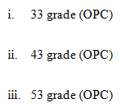

The gradient range shows the minimum compressive energy of cement-sand mortar in 28 days, as tested by the above technique.

**Table 4.1 Properties of OPC**

|  |  |  |  |
| --- | --- | --- | --- |
| 53 Grade OPC Bharathi Cement Test Report | | | |
| S.no. | Property (Physical) | Bharathi Cement Values | Requirements as per IS 12269-1987 |
| 1 | Fineness(sqm/kg) | 325 | 225(min.) |
| 2 | Soundness(mm) | 1 | 10(max.) |
| 3 | Setting time-Initial(minutes) | 150 | 30(min.) |
| 4 | Setting time-Final(minutes) | 260 | 600(max.) |
| 5 | Compressive strength(Mpa) | 70 | 53(min. for 28days) |

* 1. **FINE AGGREGATE:**

**TABLE 4.2 FINE AGGREGATE PROPERTIES**

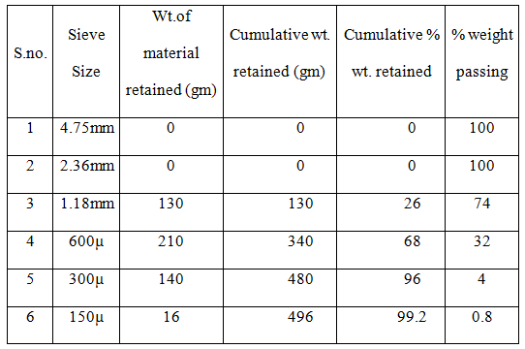

* 1. **COARSE AGGREGATE**

**TABLE 4.3 COARSE AGGREGATE PROPERTIES**

|  |  |  |  |  |  |
| --- | --- | --- | --- | --- | --- |
| S.No. | Sieve Size | Wt. of material retained (gm) | Cumulative wt.retained (gm) | Cumulative % wt. retained | % weight passing |
| 1 | 80mm | 0 | 0 | 0 | 100 |
| 2 | 40mm | 0 | 0 | 0 | 100 |
| 3 | 20mm | 0 | 0 | 0 | 100 |
| 4 | 12.5mm | 98 | 98 | 1.96 | 98.04 |
| 5 | 10mm | 828 | 926 | 18.52 | 81.48 |
| 6 | 6.3mm | 2840 | 3766 | 75.32 | 24.68 |
| 7 | 2.36mm | 1164 | 4930 | 98.86 | 1.14 |
| 8 | 1.18mm | 52 | 4982 | 99.64 | 0.36 |
| 9 | 600µ | 14 | 4996 | 99.92 | 0.08 |
| 10 | 300µ | 4 | 5000 | 100 | 0 |
| 11 | 150µ | 0 | 5000 | 100 | 0 |

.

**4.4 GGBS**

Ground granulated blastfurnace slag (GGBS) is a It is derived from the blast furnaces used to make iron. These operate at around 1500 ° C and are fed with an airtight mixture of iron ore, coke, and limestone. Iron ore turns into iron, and the final materials form slags that float to iron. This slag periodically removed as a molten liquid, and if mileage use to make GGBS, it should be quickly quenched with large quantities of water.

GGBS is obtained by cooling cast iron slag (a by-product of iron and steel manufacturing) from a smelting furnace in water or steam to provide a granular glass product that is dried and then ground into a high-quality powder.

**CHEMICAL COMPOSITION**

The slag's chemical composition varies greatly depending on the raw materials' design within the iron production system. The silicate and aluminates impurities from ore and coke combined inside a blast furnace with a flux reduce the slag's viscosity. In the case of iron ore production, the change usually consists of a mixture of limestone and fosterage or, in some instances, dolomite. In a blast furnace, the slag floated on the iron and poured for separation.

**Typical chemical composition**:

**TABLE 4.4 GGBS CHEMICAL COMPOSITION**

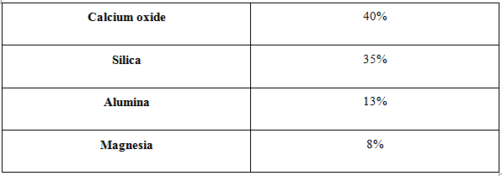

The glass content in slag suitable for mixing with Portland cement ranges from 90 to 100% and depends on the cooling method and the temperature at which cooling is initiated. The vitreous shape of tempered glass depends on the ratios of lattice forming elements, including the network modifiers Si and Al over which include Ca, Mg, and Al. It gives larger quantities of societal rates leading to higher levels of community polymerization and reactivity. It is a granular product with minimal crystalline composition and is completely cementitious and natural to cement smoothness and hydrate like Portland cement.

**Typical physical properties:**

**TABLE 4.5 GGBS PHYSICAL PROPERTIES**

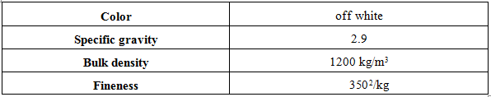

**4.5 Ultrafine Natural Steatite Powder**

UFNSP was received from Ultra Fine Mineral Pvt. Ltd., India, as an herbal blend. UFNSP manufactured using surplus ultra fine crushers and crushers. UFNSP is thinner than cement.

**TABLE 4.6 UFNSP PHYSICAL PROPERTIES**

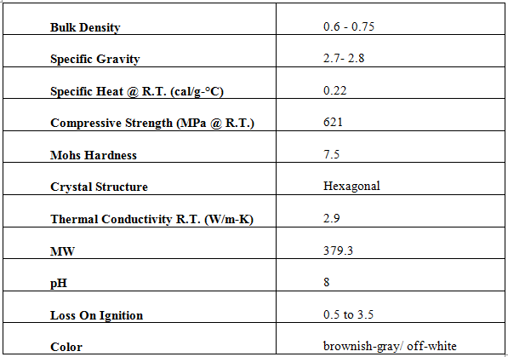

* 1. **MASTER GLENIUM ACE 30 (JP)**

**Master Glenium ACE 30(JP)**

Formerly known as Glenium ACE 30 (JP) Early Excess Energy, a large variety of excellent water-reducing / elastomers and additives for precast concrete. **DESCRIPTIONDESCRIPTION**

**Master Glenium ACE 30 (JP)** It is a combination of a new technology mainly based on the polycarboxylic 2d polymer ether technology with the benefits of excessive initial strength.

**Master Glenium ACE 30 (JP)** does not contain chlorides or low alkalis. It blends well with all types of cement. **RECOMMENDED USES**

**FEATURES AND BENEFITS**

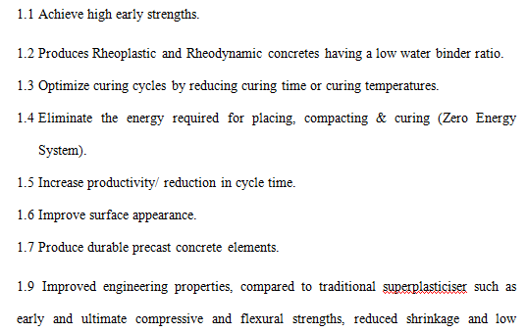

**PERFORMANCE TEST DATA**

**TABLE 4.7 MASTER GLENIUM TEST DATA**

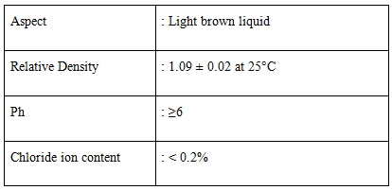

**PROPERTIESPERTIES**

**Master Glenium ACE 30 (JP)** has a The chemical form differs from conventional super plasticizers based on PCE polymers. The core PCE molecule used to formulate Master Glenium ACE30 (JP) specifically synthesized using nanotechnology to allow significant dispersion with minimal hydration methods. It consists of a carboxylic ether polymer with long faceted chains and short leading chains. At the start of the mixing process, the electrostatic dispersion mechanism works just like the conventional hyper plasticizer. Still, the short primary chains facilitate the quick start of the hydration method. The rapid adsorption of the molecule on the cement residue, mixed with a green splash effect, continues operability but exposes the accelerated surface of the cement grains to react with water. As a result of this effect, it is possible to harvest in advance the development of water temperature, the rapid growth of the strength of moisturizing products, and thus an increase in power at a very young age.

The optimal dose of Master Glenium ACE 30 (JP) should determine in the test mixtures. A dosage range from 500ml to 1200ml depending on 100kg of cement cloth is usually recommended as a guide. Due to specific substance versions and website process conditions and schedules, external doses of the recommended variety may be required.

Effects of an overdose

A severe overdose of Master Glenium ACE 30 (JP) can lead to the following:

2.1 Air intake

2.2 Splitting mix, short lack of operability

2.3 Increase plastic shrinkage

**5.TEST PROCEDURES**

**5.1 TEST ON CEMENT**

**5.1.1 SPECIFIC GRAVITY OF CEMENT**

1. Cement singularity is the ratio of the charge of a specific object of a substance to the amount of an identical water body. It is a negligible class and indicates how many times a sense is as heavy as water.
2. Material gravity = density in weight of material/weight. Density of water
3. It is required to determine the weight of the safe size cement and carry the corresponding volume of water to find the cement's exact gravity. When cement reacts with water, its specific gravity is determined by referencing a non-reactive liquid such as kerosene.
4. Cement specific weight w.R. To kerosene = weight of cement/weight of a similar amount of kerosene
5. To determine the microgravity of kerosene W.R. To water = by weight. Of kerosene/weight of an identical amount of water
6. The cement's specific gravity is calculated by multiplying the cement w.R. For kerosene with the particular gravity of kerosene W.R.

**Processing:**

1) Clean, dry and weigh one gravity bottle

2) Take a safe amount of cement (about a quarter of the bottle in the bottle and consider (m2)

3) Pour the kerosene over the cement to fill the bottle and find the total weight (w3)

4) Clean the bottle well with kerosene and fill the bottle with kerosene and weigh (W4)

5) Finally, dilute the bottle with water and weight (w5)

### Tabulation:

Weight of bottle+cement(w2)

### **Calculation:**

**5.1.2 INITIAL & FINAL SETTING TIME: (IS 4031-PART 5:1988)**

The initial setting time is the period between the arrival of the water into the cement and when the needle of a 1 mm square section fails to penetrate the cement paste, placed in a Vicat mold from 5 mm to 7 mm from the bottom of the mold.

The final setting time is the period between the time the water turns cement and the time the 1mm needle makes an impression on the paste inside the mold, but the 5mm fixer now makes no impression.

**APPARATUS**

**MEASURING INSTRUMENTS**

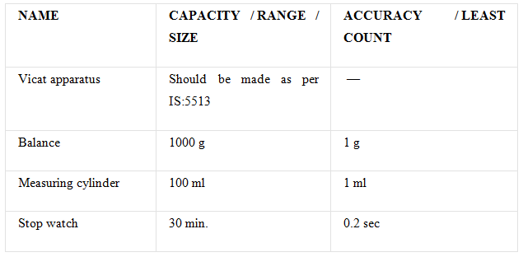

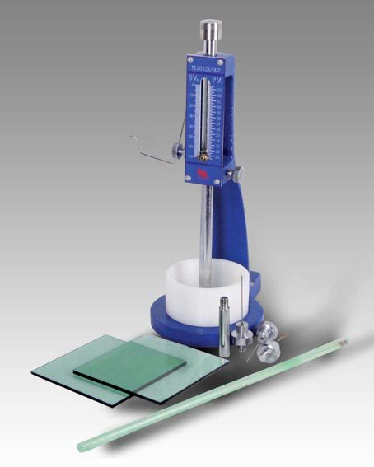

**Figure 5.1: Vicat Apparatus**

**ENVIRONMENTAL CONDITION**

|  |  |
| --- | --- |
| Temperature | 27 ± 20C |
| Relative Humidity | 90 % (min) |

**Procedure**

**(a)Test block preparation**

1. Before spending time looking around, do a consistency check to get the water needed to give your pasta its natural consistency (P).

2. Take 400g of cement and add a clean cement paste with 0.85 P of water for each cement weight.

3. The measurement time is stored between three to five minutes. Begin preventive monitoring as soon as the water reaches the cement. Record this time (t1).

4. Fill the Vicat mold, resting on a jug dish, with calibrated cement paste as mentioned above. Fill the mold, and the noodle surface is easy to remove, with the top of the mold flattening. The concrete block, thus organized, is known as a control block.

**(b) The time of the initial deposit**

1. Place the limited pilot block in the mold and rest it on the non-porous plate, just below the applicator that holds the needle.

2. Gently lower the needle until it comes into contact with the test block's surface and is quickly released, allowing it to penetrate the test mass.

3. At first, the needle completely penetrates the test block. Repeat this method, for example, Quick Needle Release, after every 2 minutes until the needle does not penetrate the block for about 5 mm, measured from the template's bottom. Note this time (t2).

**(C)Final Setting Time**

1. To determine the time of the last insertion, update the needle on the Vicat with the needle with the loop attachment.

2. Cement is taken into consideration in the final set when the finished fixing needle is gently applied to the surface of the control block; the needle strikes it while the attachment is not doing a record this time (t3).

**Calculation**

Where,

t

**Standard Specification**

# **Table 5.1: Cement Standard Specification**

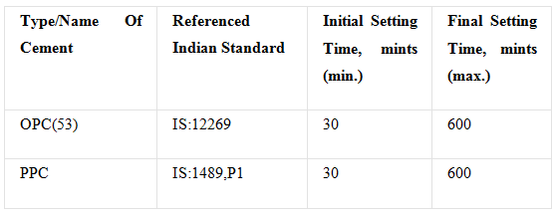**Result:**

# As per the cement test guarantee supplied by the business

# **Table 5.2: Initial, final setting time of cement**

|  |  |  |  |
| --- | --- | --- | --- |
| **Type/Name Of Cement** | **Referenced Indian Standard** | **Initial Setting Time, mints** | **Final Setting Time, mints** |
| OPC(53) | IS:12269 | 135 | 190 |
| PPC | IS:1489,P1 | 145 | 215 |

**5.1.3 FINENESS TEST ON CEMENT**

**Theory**

Improving concrete strength is the end result of the reactions of water with cement particles. Reactions usually begin with the cement on the rubble floor. Therefore, the space available for response as well as the humidification rate is large. The rapid development of strength requires an additional degree of dexterity. However, it is also considered an excessive amount of softness. Fine cement degrades faster while exposed to air and may target additional shrinkage, but is less prone to bleeding.

**Apparatus**

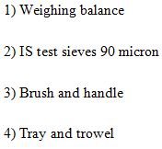

**Procedure**

1. Accurately weigh 100 grams of cement and place it into ISsieve 90 micron scale.
2. Crunch the air masses in the sample with your fingers, but do not run over the sieve.
3. Continuously sieve the model by holding the sieve with both hands, and giving a gentle click to the wrist or a mechanical sieve shaker can be used for this purpose.
4. Weigh the remaining residues after 15 minutes of sifting, and these residues should not exceed the specified limits.

**Observation:**

**Table 5.3: Fineness of cement observations**

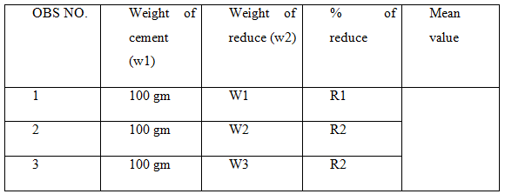

**5.1.4 SOUNDNESS OF CEMENT BY LE-CHATELIERS METHOD (IS:4031-PART 3-1988)**

## Measuring Instruments

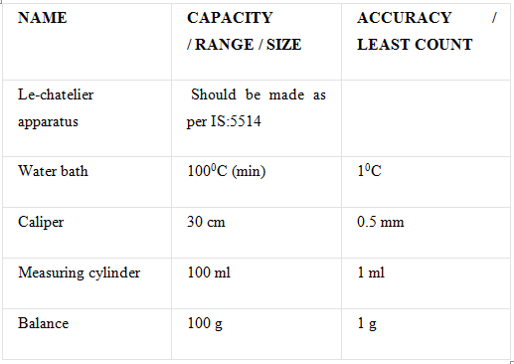

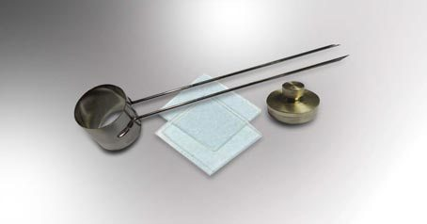

**Figure 5.2 Le chatelier Apparatus**

# Environmental Conditions

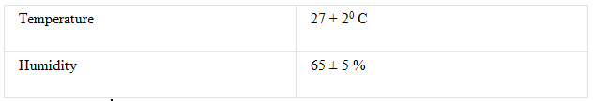

# PROCEDURE

1. Before starting the setting time test, check the consistency to achieve the water needed to provide the paste's daily consistency (P).

2. Make a paste using 0. Seventy-eight times of the water are required to obtain a paste of known consistency (i.e., 0.78P).

3. Grease the Le-chatelier mold with a little paint and place it on a light-oiled glass plate.

4. Fill the mold with the prepared cement putty. In the mold packing system, gently hold the mold threshold collectively.

5. Cover the mold with any other piece of the light-oil glass sheet, and place a small weight on the protective glass sheet.

6. Immerse the entire set in the water at a temperature of 27 ± 20 ° C and keep it there for 24 hours.

7. Remove the complete set from the water bucket and measure the gap keeping the indicator factors separate to the nearest 0.5 mm (L1).

8. Dip the entire set again in a bath of water and let the water bath come to a boil within 25 to 30 minutes. Keep it at boiling temperature for 3 hours.

9. After completing 3 hours, let the water bath temperature drop to room temperature and completely eliminate the pool.

10. Measure the distance between the two points of the indicator to the nearest 0. 5 mm (L2).

# **Calculations**

.

**5.2 TESTS ON FINE AND COARSE AGGREGATE**

**5.2.1 SIEVE ANALYSIS**

**Theory**

The mixture that passes through most of the IS 475mm sieve is evaluated as a satisfactory aggregate and is maintained on a 4.75mm sieve classified as a coarse mixture that can be purchased. The sample can be well classified, misclassified, or uniformly classified. Period D10 or effective size represents the start of the sieve, such that 10% of particles are finer than this length. Likewise, D30 and D60 can also be received from the histogram. So, the uniformity factor.

The coefficient of fitness is a term that refers to the roughness or fit of a fabric. It was obtained by adding the accumulated probabilities of aggregates' properties retained in each of the sieves and dividing them by a hundred.

**Apparatus:**

• Balance

• Sieves of the size indicated in Office 1 according to IS: 460-1962 will be used for the collection of tests.

• Sample: The load of the pattern available now should not be significantly less than the load given in Table 2

I.S SIEVES FOR ANALYSIS OF AGGREGRATES FOR CONCRETE

**Table 5.4 : IS sieves for analysis**

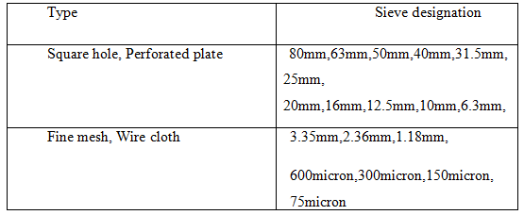

**Table 5.5: Standards for Sieve analysis**

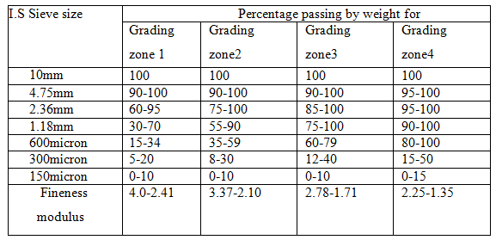

**Procedure**

* The sample is allowed to air dry before weighing and sieving, either by drying at room temperature or by heating to a temperature ranging from 100 ° C to 110 ° C.
* The dry standard is weighed.
* The weighted standard is placed on the sieve and sieved consecutively through appropriate sieves, starting with the largest.
* Shake each sieve separately on an easy tray so that no more than one trace will pass, but still for at least two minutes. Vibration is completed with a varied movement, back and forth. Lumps of fine material, if given, can be broken off by slight tension with the palm on the face of the sieve.
* Upon completing the sifting, the 150 microns, and 75-micron sifters are cleaned from the bottom with a light brush with a gentle bristle brush.
* On final touch screening, each screen's retained fabric is weighed collectively with whatever cloth is cleaned from the mesh.
* This technique is used for all fine and coarse aggregates.
* A curve is drawn between the percentage of passage and the size of the sieve for fine aggregates.

**5.2.2 SPECIFIC GRAVITY & WATER ABSORPTION OF AGGREGATE (IS:2386-PART 3-1963)**

Equipment & Apparatus

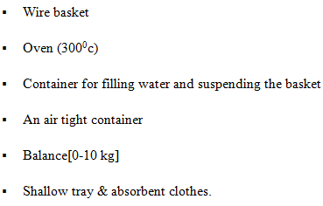

**Preparation of Sample**

The sample to be analyzed is separated from the volume in quarters or using a sample divider.

**Procedure**

1. Approximately 2 kg of mixed sample washed to remove the fine particles, after which it is placed inside wire basket and immersed in distilled water at a temperature between 22 and 320 ° C with a cap of at least 50 mm of water over the top. From the basket
2. Immediately after immersion, the trapped air is removed from the sample by raising the basket containing it 25 mm above the bottom of the tank and allowing it to descend 25 times at a rate of approximately one drop per second. The basket and the kit should keep fully submerged in water for 24 ± 0.5 hours after that.
3. The basket and gauge are then weighed while suspended in water at a temperature of 22 to 320 ° C. Weight is indicated until suspended in water (W1) g.
4. Remove the basket and aggregate from the water and leave it to drain for a few minutes, after which the aggregate transferred to a dry absorbent cloth.
5. Then the empty basket returns to the water tank, vibrates 25 times, and weights in water (W2) g.
6. The surface of the debris inside the dry absorbent clothing is dried so that no more moisture can remove through the clothes.
7. The mixture is then transferred to the second layer of dry cloth in a single layer covered with a blanket and left to dry for at least 10 minutes until the aggregates are completely dry on the surface. Drying for 10 to 60 minutes may be desirable. The dry surface composition then weighed W3 g.
8. Place the mixture in a shallow tray and store it in an oven at 1100 ° C for 24 hours. Then it is taken out of the range, cooled in an airtight container, and weighed W4g.

**Calculation**

Weight of saturated surface dry aggregate in air = W4 g

[Aggregate sp gravity 1](https://i0.wp.com/civilblog.org/wp-content/uploads/2013/05/Aggregate-sp-gravity-1.jpg)

[Aggregate apparent sp gravity 1](https://i2.wp.com/civilblog.org/wp-content/uploads/2013/05/Aggregate-apparent-sp-gravity-1.jpg)

[Aggregate water absorption 1](https://i2.wp.com/civilblog.org/wp-content/uploads/2013/05/Aggregate-water-absorption-1.jpg)

**5.2.3 SPECIFIC GRAVITY OF FINE AGGREGATE**

**Equipment for Pycnometer Test:**

### 

Conducting the specific gravity of the fine mixture using a rotometer

1. Clean and dry the tachometer. Tie the cap tightly. Bring its mass (M1) to zero: 1 g.

2. Mark the cap and the density meter with a vertical line parallel to the density meter axis to ensure that the cap is taut to the same mark every time.

3. Loosen the cap and about two hundred grams of oven-dried soil into a pressure gauge. Fasten the cap. Find the mass (m 2).

4. Loosen the cap and add enough air deflated water to the tachometer if you want to cover the first-rate assembly. Fasten the cap.

5. Shake the content well. Connect the density meter to a vacuum pump to remove the trapped air.

6. Disconnect the vacuum pump. Fill the tachometer with water, about 3 liters full. Replace the broom for 5 minutes until the air bubbles stop working on the water floor.

7. Fill the hydrometer with water to the mark. Dry it in the open air. Take its mass (M3).

8. Record the temperature of the contents.

9. Empty the blood pressure meter. Clean and dry it with a piece of cloth.

10. Fill the tachometer with the most superficial water. Attach the cap to the mark. Dry it with a cloth. Take your dough (M4).

Specific Gravity of Soil by Pycnometer

M4 = mass of Pycnometer filled with water only.

**5.2.4 DETERMINATION OF AGGREGATE IMPACT VALUE**

**Aim:**

(I) Determination of the impact rate of road aggregates;

(2) Checking their suitability in road construction on the idea of impact rate.

**Apparatus:**

**The IS: 2386 (Part 4) - 1963 compliant device consists of:**

(1) A tester weighing 45 to 60 kg and having a steel base with a coated taper surface of no less than 30 cm in diameter. It is located on the concrete floor of the stage and plane with a thickness of at least 45 cm. The system must also contain provisions to solve its base.

(2) A cylindrical steel cup with an inner diameter of 102 mm and a depth of 50 mm as a minimum

Thickness is 6.3 mm.

(3) A hammer or piece of metal weighing thirteen, 5 to 14 kg, the lower end is cylindrical, 50 mm long, zero hundred mm in diameter, with a 2 mm level on the lower face and fixed. The hammer should slide freely between the vertical rows and be concentric with the cup. The free fall of the hammer should be within 380 ± five mm.

(4) Steel cylindrical gauge of 75mm inner diameter and 50mm depth. to measure aggregate.

(5) The impact bar is 10 mm in diameter and 230 mm in length, rounded at one point.

(6) Capacity balances now not much less than 500g, and it can read and corrected to zero. 1 gram.

**Theory:**

The fabric's shock-handling property is called durability. Due to vehicles' movement on the road, the aggregates are susceptible to impacts that divide into smaller parts. Therefore, the totals must have sufficient durability to handle their dissociation by the effect—the cost of the useful measures this characteristic. A combined impact rating is a measure of resistance to a sudden impact or shock, ranging from its strength to a gradually applied compressive load.

Processing:

The control sample includes 10.0 mm by 12.5 mm aggregates. Aggregates can be dried by heating at 110 ° C for 4 hours and cooling.

(1) Sift the cloth through 12.5 mm and 10.0 mm sieves.

(2) It passes through a 12.5 mm sieve and is held on a 10.0 mm sieve incorporating the control

**MATERIAL**

(1) Pour the aggregate to fill about 1/3 the depth of the measuring cylinder.

(2) Squeeze the fabric by giving 25 light strokes with a ground stop of rammed rod.

(3) Add additional layers comparatively to complete the cylinder.

(4) Write off the excess totals.

(5) Determine the net weight of aggregate to the nearest gram (W).

(6) Let impact machine rest without clamping or encapsulating in expansion plate, block or ground so that it is reliable and the hammer shafts are vertical.

(7) Put the mug firmly into place under the machine and close to completion of the test.

Specimen and flocculate by gently tapping with impact rod 25.

(8) Raise the hammer until its underside is 380 mm above the surface of the mixing sample in the beaker and let it fall freely into the mixing standard. Give 15 such times in a c program language period of not less than 1 second between successive drops.

(9) Remove the crushed aggregate from the beaker and sift it through 2.36 mm sieves so that no large amount passes in one minute. Weigh the fraction passing through the sieve to the nearest 1 g. Also, weigh the portion held in the sieve.

(10) Calculate the group impact cost. It is suggested that two observations be included, rounded to the nearest full range, due to the added affect value.

**Recommended Values**

The classification of the aggregates with the use of the added impact value is as follows:

**Table 5.6: Classification of Aggregate Impact Value**

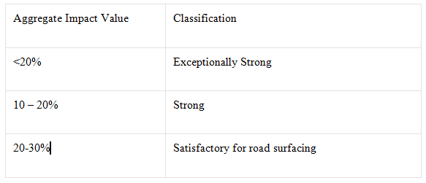

**5.2.5 TO DETERMINE THE AGGREGATE CRUSHING VALUE OF COARSE AGGREGATE.**

The mix crushing cost provides a comparative strength degree for a joint crush less than the continuously applied pressure load. With a total cutting fee of 30 or more, the result may be abnormal, and in such cases, it is necessary to establish a fine fee of 10 percent.

**Apparatus**

(I) A metal cylinder of 15 cm in diameter with a plunger and a base plate.

(II) A metallic filler rod with a 16 mm diameter in length from 45 to 60 cm is rounded at one end.

(III) A legible and corrected three-kilogram scale of one gram.

(Iv) It is 12.5 mm and 10 mm sieves and a 36 mm pair.

(V) Pressure checks system.

(VI) Steel cylindrical tensile gauge is sufficient to keep it under heavy use and is 11.5 cm in diameter and 18 cm in height.

(Vii) Demand scale.

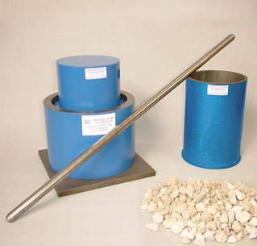

**Figure 5.3: Crushing apparatus Sampling**

The coarse mixture passes through a 12.5 mm IS sieve and is kept on a 10 mm sieve. It is sifted and heated at 100 to 110 ° C for four hours and cooled to room temperature.

The amount of aggregate should be such that the fabric's tension inside the drum after compacting, as shown below, is 10 cm.

The correct amount can easily notice by filling the cylinder.

Measure in three layers with nearly identical density, each layer 25 time stamping with the tamper bar, and finally using the tamper bar while leveling the instantaneous part, taking care in the now weaker materials break the particles. The weight of the fabric comprising the control criterion will be determined (Weight A), and the same weight of the sample will take for the repeated control.

**Procedure**

((1) Place the paper roller on the base plate and weigh it (W)

(2) Place the model on three layers, each layer subjecting to twenty-five strokes using a rammer, taking care in the case of soft materials not to break the aggregate and its weight (W1).

(3) Carefully set the floor of the mixture and insert the piston so that it rests horizontally on the surface, taking care to ensure that the piston is not stuck inside the cylinder.

(4) Place the cylinder with the piston on the pressure test loading platform.

(5) Apply the load with a uniform load to apply 40T full pack in 10 minutes.

(6) Release the weight and remove the cloth from the cylinder.

(7) Sift the materials with a 2.36 mm IS sieve, taking care to avoid a lack of fines.

(8) Weight of the portion passing through the IS sieve (W2)

**Calculations**

The ratio of weight of fines poured to the weight of the total sample in each test will be expressed as a percentage, and the result will be recorded in the initial decimal area.

**5.3CASTING OF TEST SPECIMENS**

This pilot program consists of pouring and reviewing structured pressure samples of M-40 grade concrete.

**5.3.1 MIXING**

All concrete components mixed well in a dry condition. The cement was changed to already mixed with mineral additives. The mixture is complete in the blender. Steel and polypropylene fibers are gradually released into the mix to prevent caking. The mixing water is also brought in continuously for mixing. A superior plasticizer (SP 430) was added with water to achieve the foam concrete mixture's medium workability. After incorporating well, the concrete builds up in a collective container.

**5.3.2 PLACEMENTS AND MERGER**

Standard dice molds of 150 x 150 x 150 mm were kept ready to fire. The mold was dry cleaned, the nuts and bolts tightened, and a thin layer of mold oil was applied inside the mold with a brush. The molds covered with oil, the mixture was laid in 3 layers and pressed by a table vibrator to obtain a dense mix.

**5.3.3 CURING**

The cubes, beams, and control sample cylinders were stored in a place free from vibrations in moist air at 90% relative humidity and at a temperature of 27 +/- 2 ° C for 24 half hours from the moment of adding water to drying the elements. After 24 h, the samples were removed from the mold and now submerged in a tank of clean, soft water for seven, 14, and 28 days.

5 3.4.4 Test sample preparation

Immediately after processing, all samples were cleaned and tested according to IS: 516-1969.

Five 3. Five samples of the tests

After processing the samples for the specified period, they are removed from the water tank and prepared from the global testing system test to locate mechanical homes with cubic pressure energy.

5.3.5.1 Checking for piezoelectricity

According to IS 516: 1969, samples were tested, and the test performed on a 3000 kN pressure controller. The device can handle the charging rate with a valve. The device calibrated to the required standards. Dishes are cleaned, greased, controlled, and stored all-around prepared for testing.

The sample is placed on CTM and held tightly to not move around any longer. After that, the load was changed to the cube using the push-button start. The load increases steadily until the dice cannot take any more load. Then the study is recorded.

The electrostatic pressure takes because the charge applied to the sample divided with the sample charge surface area's help(P/A).

**Testing Procedure of Compressive strength:**

**Apparatus for Concrete Cube Test**

Compression testing machine

**Preparation of Concrete Cube Specimen**

The ratio and materials needed to make these control samples are the same as the concrete used in the system.

**Mixing of Concrete for Cube Test**

• Mix concrete by hand and in a laboratory mixer

Mix cement and gentle aggregate on a non-absorbent waterproof platform until the mixture is completely incorporated and the color is uniform.

• Coarse aggregate is added and mixed with cement and fine aggregate until the rough mix is evenly distributed somewhere in the batch.

• Add water and mix until the concrete appears homogeneous and of the required consistency.

• Take a sampling bucket for testing

• Hill cleaning and oil application

Pouring concrete into the formwork in layers with a thickness of about five cm.

Compression of each layer by at least 35 strokes with at least 35 strokes consistent with the coating using a tamper bar (a metal rod of 16 mm in diameter and 60 cm in length, directing a bullet towards the bottom edge)

• Level the upper surface and smooth it with a trowel

**Curing of Cubes**

Control samples are stored in moist air for twenty-four hours, after this age, samples are marked, removed from the molds, and stored immersed in clean water until first removed for verification..

**Precautions for Tests**

The process water should be tested every 7 days and the water temperature should be -2-27 ° C.

**Procedure for Concrete Cube Test**

• Remove the water sample after careful handling time and wipe off the excess water from the surface.

Rounding the sample size to the nearest zero

• Clean the backing surface of the test machine.

• Place the sample in the device to be loaded onto the other faces of the formed cube.

• Align the model in the center of the instrument base plate.

• Gently rotate the moving component so that it touches the top floor of the model.

• Apply the load step by step without jerking and continuously at a load of 140 kg / cm2 / min until the model fails.

• Record the maximum load and write any unusual functions under the fault type

**Note:**

At least three samples should be tested at each specified age. If any piece's resistance varies with the help of more than 15 percent of the combined energy, the effects of that sample should be rejected. Models provide an average of the crush resistance of the concrete.

**5.3.5.2 FLEXURAL STRENGTH TEST OF CONCRETE (IS:516-1959)**

**OBJECTIVE**

Determine the concrete's bending strength, which takes effect when a road slab that does not have adequate support in the sub-layer is subject to wheel loads, and there are volume changes due to temperature/shrinkage.

**REFERENCE STANDARDS**

**EQUIPMENT & APPARATUS**

* **Beam mould** of size 15 x 15x 70 cm (when size of aggregate is less than 38 mm) or of size 10 x 10 x 50 cm (when size of aggregate is less than 19 mm)
* **Tamping bar** (40 cm long, weighing 2 kg and tamping section having size of 25 mm x 25 mm)
* **Flexural test machine**– The validation device's bed will provide with metal reels with a diameter of 38 mm on which the sample will place, and these cylinders must be connected so that the center area to the center is 60 cm for 15 cm samples or 40 cm for 10 cm 0 samples. The load will be carried out through two identical rollers placed in the third factor of the aid section, i.e., spaced 20 or thirteen, 3 cm from center to center. The load will similarly divide between two bearing rollers. All cylinders will install so that the load is applied axially without subjecting the sample to any tension or torsion restriction.

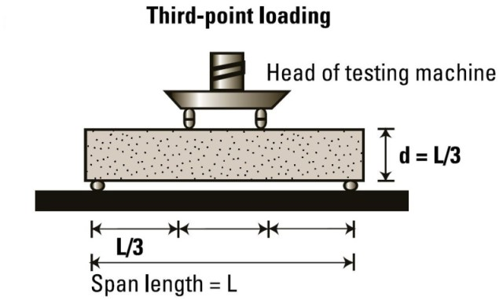

**Figure 5.4: Flexural Strength Test Arrangement**

**PROCEDURE**

1. Prepare the test sample using concrete filler in the mold with three layers of approximately the same thickness. Each layer is compacted with 35 cases of packing tape, as specified above. The filler shall be distributed evenly over the entire front section of the beam template and each layer's intensity.

2. Clean the support surfaces of the utility rollers and the bearing rollers and remove any traces of sand or various tissues from the sample surfaces that may be on to touch the rollers.

3. 38mm steel round rollers can be used to provide auxiliary and carrying points for samples. The duration of the rolls should be at least 10 mm longer than the sample width. A total of 4 rollers will use, 3 of which should rotate along their respective axes. The distance between the outer cylinders (i.e., Span) will be 3D, and the distance between the inner cylinders will be d. The inner cylinders should be evenly spaced between the outer cylinders so that the entire equipment is uniform

4. The sample stored in water should check immediately after removing the water while still wet. The control sample will be placed inside the system correctly, with the sample's longitudinal axis centered at right angles to the rollers. For molded samples, the die packing path will be normal in the loading direction.

5. Loading will carry at a rate of loading four hundred kg/min for 15.0 cm samples and at a rate of 180 kg/min for 0 cm samples..

**CALCULATION**

11.0cm for 10.0cm specimen.)

Where,

a = the distance between the fracture line and the nearest auxiliary, measured at the center line of the tensile side of the sample.

**5.3.5.3 SPLIT TENSILE STRENGTH TEST OF CONCRETE (IS:5896-1999)**

**Equipment for Splitting Tensile Test of Concrete:**

Pressure testing machine, 30cm 12mm wide plywood packing strips.

**Procedure of Splitting Tensile Test:**

1. Remove the wet sample from the water after 7 days of treatment.

2. Clean soil water from the sample.

3. Draw diagonal strokes on both ends of the sample to ensure that they can be in the same focal location.

4. Consider the sample size and shipment.

5. Set the pressure test device to the desired range.

6. Keep the plywood tape on the bottom plate and the sample area.

7. Align the sample so that the distinct lines at the ends are perpendicular and centered on the bottom plate.

8. Place alternate plywood tape over the sample.

9. Lower the top panel to touch the plywood tape.

10. Apply the load continuously without jerking at a rate of 14-21 kg / cm2 / min (which corresponds to a total load of 9900 kg / min to 14,850 kg / min)

11. Fracture load log (P)

**CALCULATIONS:**

**Range Calculation**

The splitting tensile strength is calculated using the formula

L = length of the specimen

**SPLIT TENSILE STRENGTH**

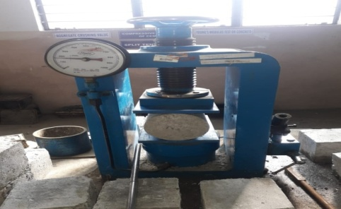

Fig.5.5.split tensile strength test

**5.4 Experimental Study of Fresh SCC**

Characteristic properties of fresh SCC are determined for passing ability by J-ring test, segregation resistance by V-funnel T5 min test and filling ability by slump flow test, T50 slump test and V-funnel test. Characteristic properties of fresh SCC are tabulated below

|  |  |  |  |  |  |
| --- | --- | --- | --- | --- | --- |
| Table: 5.7 Properties of Fresh SCC1 | | | | | |
| GGBS  % | J-ring in mm | V-Funnel T5 min sec | Slump-flow  Mm | T50 slump sec | V-Funnel  Sec | |
| 0 | 8 | 14.93 | 658 | 5.12 | 11.89 | |
| 20 | 8 | 14.8 | 662 | 4.3 | 11.9 | |
| 40 | 7 | 14.2 | 672 | 3.3 | 11.27 | |
| 60 | 7 | 10.27 | 675 | 3.1 | 9 | |
| 80 | 9 | 13 | 684 | 3.1 | 11.08 | |

**Passing Ability**

Fig. 5.2: Passing Ability of SCC

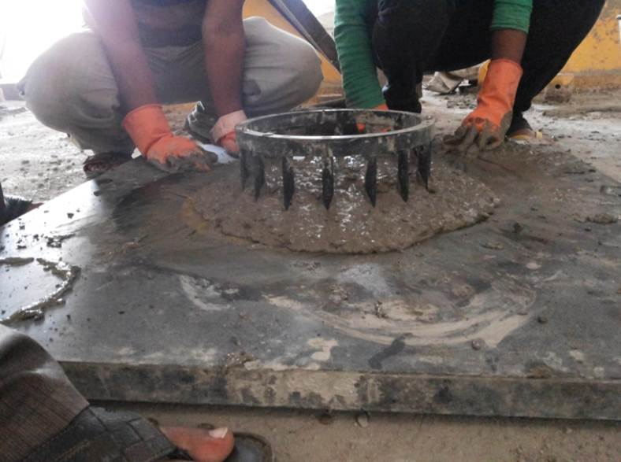

Fig. 5.6: Passing Ability test of SCC

Passing ability of SCC determined by j-ring test is represented by the figure 5.2. From the figure 5.2 it is observed that for varying proportions of GGBS the passing ability of SCC satisfies the EFNARC specifications

**Segregation Resistance**

Fig. 5.3: Segregation Resistance of SCC1

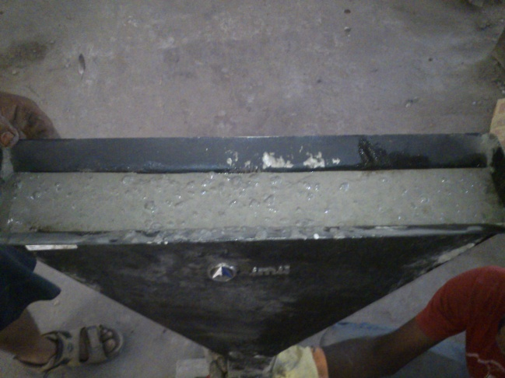

Fig. 5.7: Segregation Resistance test of SCC

Segregation resistance of SCC determined by V-funnel T5 min test is represented by the figure 5.4. From the figure 5.4 it is observed that for varying proportions of GGBS the segregation resistance of SCC satisfies the EFNARC specifications.

**Filling Ability**

Fig. 5.4: Filling Ability of SCC1

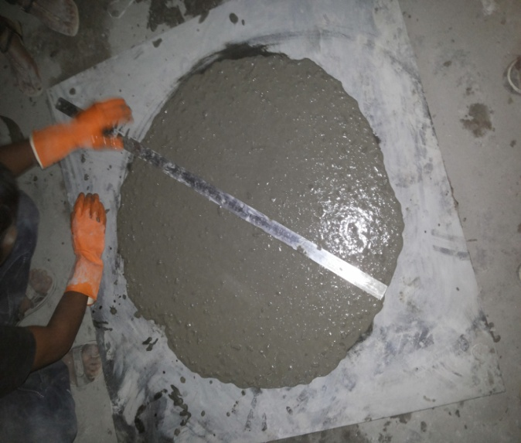

Fig. 5.8: Filling Ability Test of SCC1

Filling ability of SCC determined by V-funnel test, Slump flow test and T50 slump test are represented by the fig. 5.6. From the fig. 5.6 it is observed that for varying proportions of GGBS the filling ability of SCC1 satisfies the EFNARC specifications

### **SCC with UFNSP**

The trail mix proportion of SCC is determined by Nan su method. Several alterations were made to this trail mix to obtain the final mix proportion of SCC. The final mix proportion of SCC with UFNSP is mentioned in table. 5.9

Characteristic properties of fresh SCC are determined for passing ability by J-ring test, segregation resistance by V-funnel T5 min test and filling ability by slump flow test, T50 slump test and V-funnel test. Characteristic properties of fresh SCC2 are tabulated in table. 5.10

|  |  |  |  |  |  |
| --- | --- | --- | --- | --- | --- |
| Table: 5.8 Properties of Fresh SCC2 | | | | | |
| UFNSP % | J-ring  mm | V-Funnel T5 min sec | Slump-flow mm | T50 slump sec | V-Funnel  Sec |
| 0 | 6 | 12.1 | 686 | 3.7 | 9.7 |
| 5 | 6 | 12.6 | 705 | 3.5 | 9.9 |
| 10 | 6 | 12.5 | 710 | 3.5 | 9.6 |
| 15 | 6 | 12.9 | 700 | 3.6 | 9.95 |
| 20 | 6 | 13.2 | 710 | 3.6 | 9.7 |

**Passing Ability**

Fig. 5.5: Passing Ability of SCC2

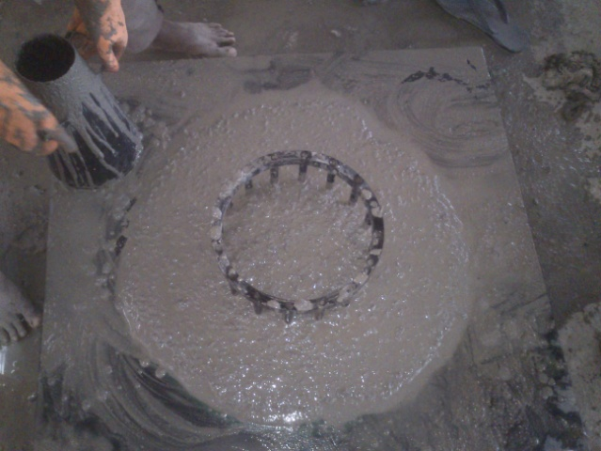

Fig. 5.9: Passing Ability Test of SCC2

Passing ability of SCC2 determined by j-ring test is represented by the fig. 5.8. From

the fig. 5.8 it is observed that for varying proportions of UFNSP the passing ability of SCC2 satisfies the EFNARC specifications

**Segregation Resistance**

Fig. 5.6: Segregation Resistance of SCC2



Fig. 5.10: Segregation Resistance Test of SCC2

Segregation resistance of SCC2 determined by V-funnel T5 min test is represented by the figure 5.10. From the figure 5.10 it is observed that for varying proportions of UFNSP the segregation resistance of SCC2 satisfies the EFNARC specifications.

**Filling Ability**

Fig. 5.7: Filling Ability of SCC2

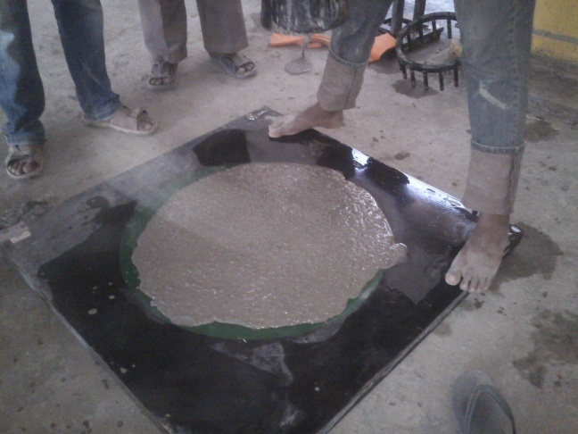

Fig. 5.11: Filling Ability Test of SCC2

Filling ability of SCC2 determined by V-funnel test, Slump flow test and T50 slump test are represented by the fig. 5.12. From the fig. 5.12 it is observed that for varying proportions of UFNSP the filling ability of SCC2 satisfies the EFNARC specifications.From the above graphs we can conclude that the amount of SP required for attaining the acceptance criteria for SCC is decreasing with the increase of UFNSP

**6.MIX DESGIN**

**6.1 MIX DESIGN PROCEDURE FOR M40 OPC**

**6.1.1 STIPULATIONS FOR PROPORTIONING**

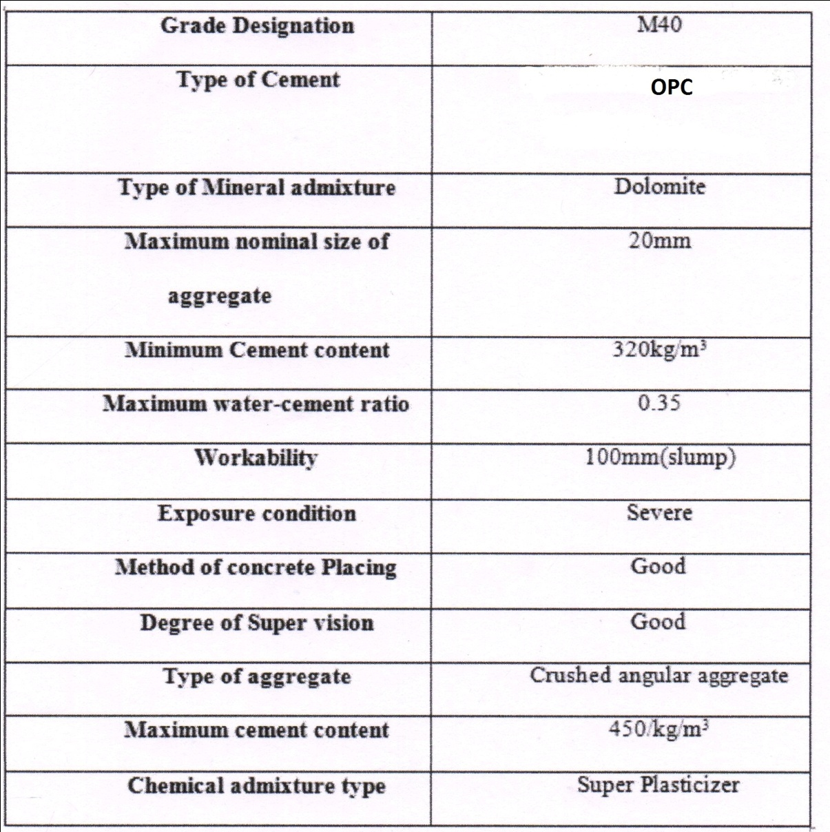

**6.1.2 TEST DATA FOR MATERIALS**

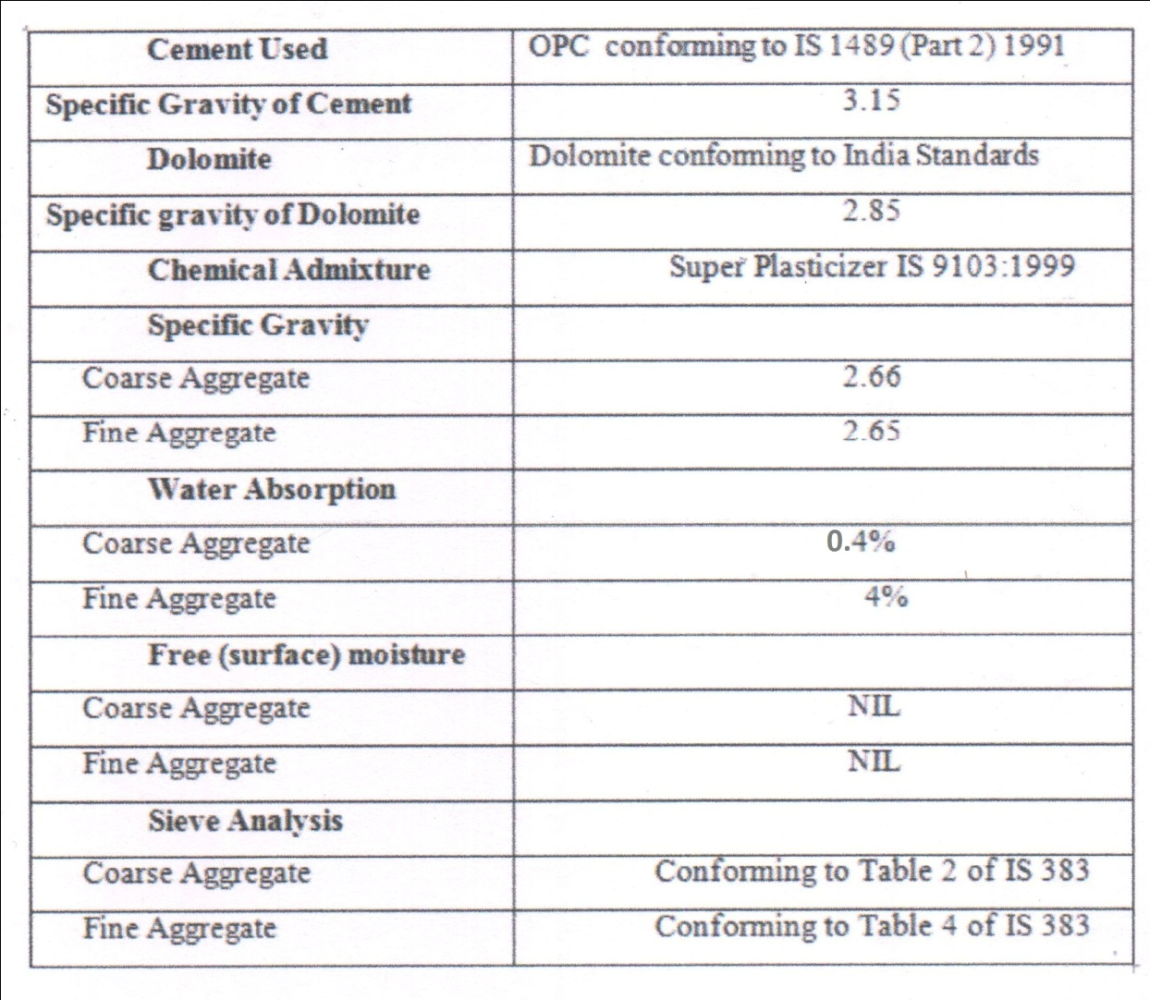

**6.1.3TARGET STRENGTH FOR MIX PROPORTIONING**

where

.

.

**6.1.4 SELECTION OF WATER·CEMENT RATIO**

.

Based on experience, take the ratio of water to cement 0.35.

.

**6.1.5 SELECTION OF WATER CONTENT**

From Table 2, maximum aggregate water content of 20 mm = 186 L (for a precipitation range of 25 to 50 mm)

Estimated water content of leveling 100 mm = 186+ (6/100) * 186 = 197.16 liters

When using a super plasticizer, the water content can be reduced by up to 30 percent.

Based on the super plasticizer pathways, a 25% reduction in water content was achieved. Therefore, the water content reached = 197 * 0.75 = 148 liters.

**6.1.6 CALCULATION OF CEMENT, AND GGBS CONTENT**

Water-cement ratio (see note under 4.1) = 0.35

Cementitious material

(cement +GGBS) content = (148/0.35) = 422.85kg/m3

From Table 5 of IS 456, minimum cement

content for 'severe' exposure conditions

338.29 kg/m3> 320 kg/m3, hence. O.K.

GGBS replacement @ 20 % =422.85*0.2= 84.57 kg/m3

Therefore,

**Cement content = 338.29 kg/m3**

**GGBS content = 84.57 kg/m3**

We adopt super plasticizer content as 0.45 % of total cementitious material based on the experience.

Super Plasticizer = 422.85 *0.45%

422.85*(0.45/100) = 1.9 kg/m3

**6.1.7 PROPORTION OF VOLUME OF COARSE AGGREGATE AND FINE AGGREGATE CONTENT**

Schedule III [IS 10262; 2009], The amount of coarse mixture corresponding to the size mix 20 mm and the best aggregate (second region) for the ratio of water to cement is 0.50 = zero. 62. In the current case, the ratio of water to cement is zero. 35. Therefore, it is required to increase the amount of coarse mixture to reduce first-class gravel content. Since the ratio of water to cement is less than zero .07, the percentage of the coarse mix's quantity expands by zero .02 (above the price of - / + 0.01 for every ± 0.05 change in the water ratio). Builds). The volume correction ratio of the coarse mixture to the ratio of water to cement is zero. 35 = 0. 62

**Note** - if the rough mixture is not angular. Then the quantity too: Coarse aggregate might be loud for sure, depending on the enjoyment.

.

**6.1.8 MIX CALCULATIONS**

The mix calculations for each unit volume of concrete will be as follows:

b) Volume of cement = Mass of cement__ __ X 1___

Specific gravity of cement 1000

= 338.29 X 1_

3.15 1000

= **0.10739m3**

c) Volume of GGBS = Mass of GGBS____ X 1___

Specific gravity of GGBS 1000

= 84.57X _1__

2.85 1000

= **0.02967m3**

d) Volume of water = Mass of water X _1__

Specific gravity of water 1000

= 148 X _1__

1 1000

= **0.148 m3**

e) Volume of = Mass of super plasticiser ____ X 1___

super plasticiser Specific gravity super plasticiser 1000

= 1.9 X _ 1 __

1.13 1000

= **0.00168 m3**

f) Volume of all in aggregate = [ a-(b+c+d+e+f)]

= **0.71325 m3**

h) Mass of coarse aggregate = g x volume of coarse aggregate x

Specific gravity of coarse aggregate x 1000

= 1062.46 kg

h) Mass of fine aggregate = g x volume of fine aggregate x Specific gravity of fine aggregate x 1000

= 831.65 kg

**6.1.9 Corrections for water absorption**

Since excellent and coarse water absorption of aggregates is recognized, we must deduct the large and coarse composition according to their water absorption ratios and the distinction must be entered into the total water required.

Fine aggregate [4%] = 831.65 x 0.04=33.27

= **798.38 kg/m3**

Coarse aggregate [0.4%] = 1062.46x 0.004 = 4.25

= **1058.21kg/m3**

Therefore, total water = 148 + 33.27+4.25

= **185.52 lit/m3**

**6.1.10 MIX PROPORTIONS FOR 1m3**

**Table.6.1: M40 OPC OF CONTROL MIX**

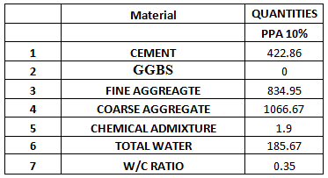

**Table.6.2: M40 OPC OF 20% GGBS**

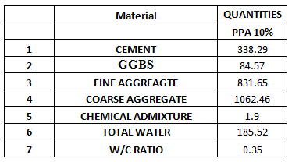

**Table.6.3: M40 OPC OF 40% GGBS**

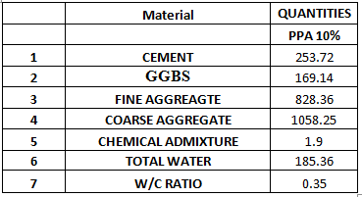

**Table.6.4: M40 OPC OF 60% GGBS**

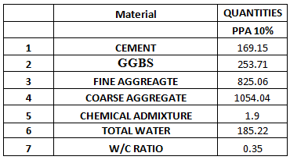

**Table.6.5: M40 OPC OF 80% GGBS**

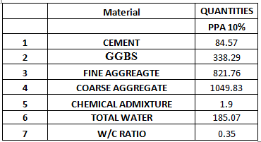

**Table.6.6: M40 OPC OF 5% UFNSP**

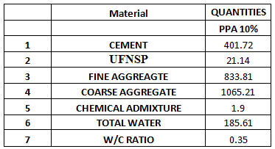

**Table.6.7: M40 OPC OF 10% UFNSP**

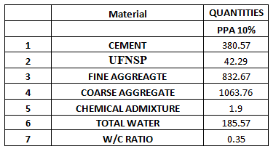

**Table.6.8: M40 OPC OF 15% UFNSP**

|  |  |  |
| --- | --- | --- |
|  | **Material** | **QUANTITIES** |
|  |  | **PPA 10%** |
| **1** | **CEMENT** | 359.43 |
| **2** | **UFNSP** | 63.43 |
| **3** | **FINE AGGREAGTE** | 831.53 |
| **4** | **COARSE AGGREGATE** | 1062.31 |
| **5** | **CHEMICAL ADMIXTURE** | 1.9 |
| **6** | **TOTAL WATER** | 185.51 |
| **7** | **W/C RATIO** | 0.35 |

**Table.6.9: M40 OPC OF 20% UFNSP**

|  |  |  |
| --- | --- | --- |
|  | **Material** | **QUANTITIES** |
|  |  | **PPA 10%** |
| **1** | **CEMENT** | 338.29 |
| **2** | **UFNSP** | 84.57 |
| **3** | **FINE AGGREAGTE** | 830.39 |
| **4** | **COARSE AGGREGATE** | 1060.85 |
| **5** | **CHEMICAL ADMIXTURE** | 1.9 |
| **6** | **TOTAL WATER** | 185.46 |
| **7** | **W/C RATIO** | 0.35 |

**7.TEST DATA AND RESULTS**

**7.1 Test Data**

**7.1.1 GGBS ADDITION**

**7.1.1.1 Compressive Strength test**

**Table 7.1: Compressive Strength Test Data for 3 days**

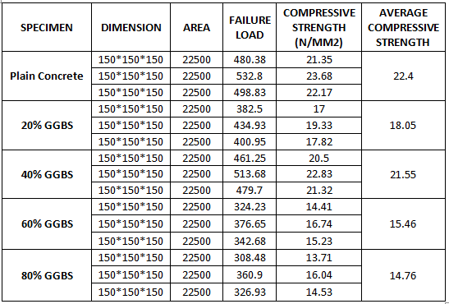

**Table 7.2: Compressive Strength Test Data for 7 days**

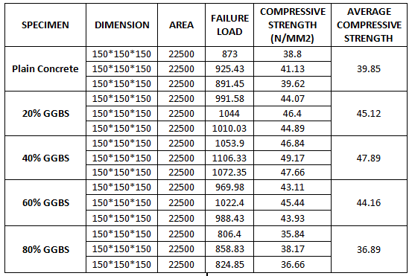

**Table 7.3: Compressive Strength Test Data for 28 days**

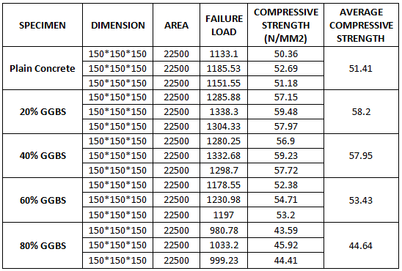

**7.1.1.2 Flexural Strength test**

**Table 7.4: Flexural Strength Test Data for 3 days**

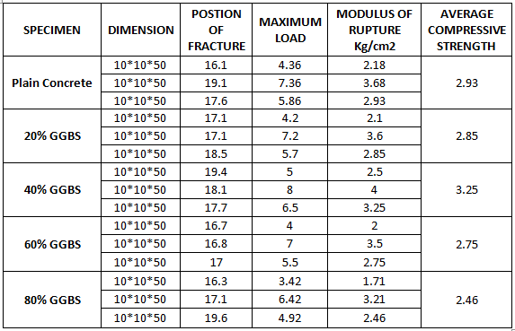

**Table 7.5: Flexural Strength Test Data for 7 days**

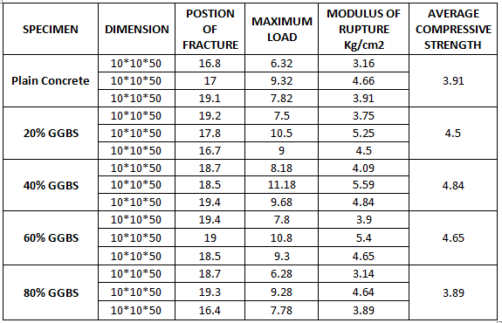

**Table 7.6: Flexural Strength Test Data for 28 days**

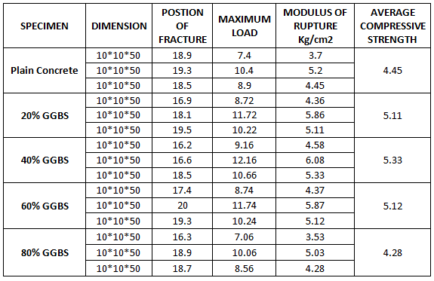

**7.1.1.3Split Tensile Strength test**

**Table 7.7: Split Tensile Strength Test Data for 3 days**

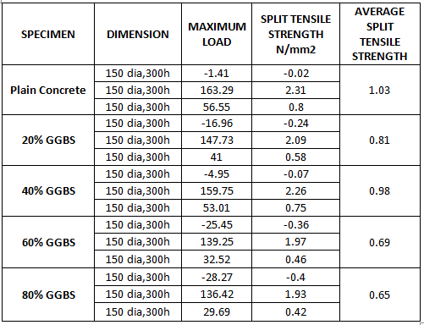

**Table 7.8: Split Tensile Strength Test Data for 7 days**

|  |  |  |  |  |
| --- | --- | --- | --- | --- |
| **SPECIMEN** | **DIMENSION** | **MAXIMUM LOAD** | **SPLIT TENSILE STRENGTH N/mm2** | **AVERAGE SPLIT TENSILE STRENGTH** |
| **Plain Concrete** | 150 dia,300h | 157.63 | 2.23 | 1.91 |
| 150 dia,300h | 171.77 | 2.43 |
| 150 dia,300h | 170.35 | 2.41 |
| **20% GGBS** | 150 dia,300h | 80.58 | 1.14 | 2.19 |
| 150 dia,300h | 245.28 | 3.47 |
| 150 dia,300h | 138.55 | 1.96 |
| **40% GGBS** | 150 dia,300h | 90.48 | 1.28 | 2.33 |
| 150 dia,300h | 255.18 | 3.61 |
| 150 dia,300h | 148.44 | 2.1 |
| **60% GGBS** | 150 dia,300h | 77.05 | 1.09 | 2.14 |
| 150 dia,300h | 241.75 | 3.42 |
| 150 dia,300h | 135.01 | 1.91 |
| **80% GGBS** | 150 dia,300h | 50.19 | 0.71 | 1.76 |
| 150 dia,300h | 214.89 | 3.04 |
| 150 dia,300h | 108.15 | 1.53 |

**Table 7.9: Split Tensile Strength Test Data for 28 days**

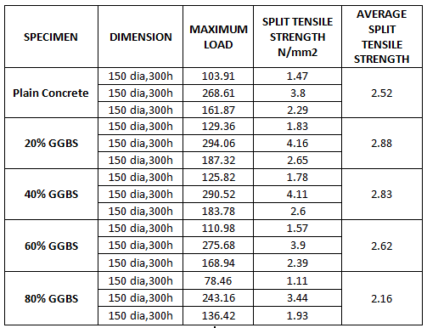

**7.1.2UFNSP ADDITION**

**7.1.2.1 Compressive Strength test**

**Table 7.10: Compressive Strength Test Data for 3 days**

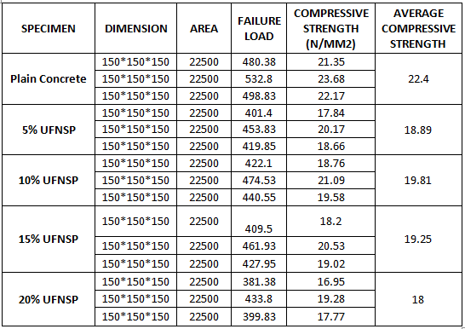

**Table 7.11: Compressive Strength Test Data for 7 days**

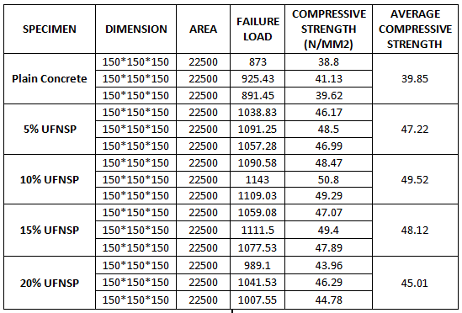

**Table 7.12: Compressive Strength Test Data for 28 days**

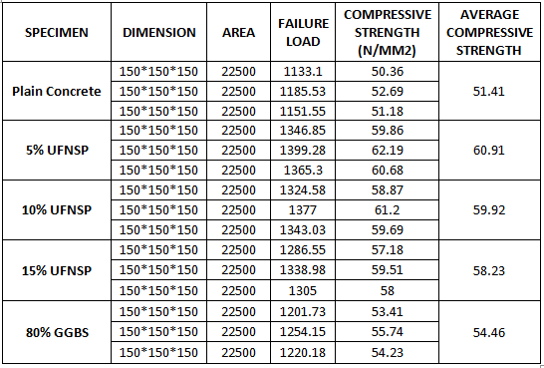

**7.1.2.2 Flexural Strength test**

**Table 7.13: Flexural Strength Test Data for 3 days**

|  |  |  |  |  |  |
| --- | --- | --- | --- | --- | --- |
| **SPECIMEN** | **DIMENSION** | **POSTION OF FRACTURE** | **MAXIMUM LOAD** | **MODULUS OF RUPTURE Kg/cm2** | **AVERAGE COMPRESSIVE STRENGTH** |
| **Plain Concrete** | 10*10*50 | 19.8 | 4.36 | 2.18 | 2.93 |
| 10*10*50 | 19.9 | 7.36 | 3.68 |
| 10*10*50 | 19.5 | 5.86 | 2.93 |
| **5% UFNSP** | 10*10*50 | 17.2 | 4.32 | 2.16 | 2.91 |
| 10*10*50 | 17.1 | 7.32 | 3.66 |
| 10*10*50 | 18.7 | 5.82 | 2.91 |
| **10% UFNSP** | 10*10*50 | 19.9 | 4.74 | 2.37 | 3.12 |
| 10*10*50 | 19 | 7.74 | 3.87 |
| 10*10*50 | 20 | 6.24 | 3.12 |
| **15% UFNSP** | 10*10*50 | 16.1 | 4.64 | 2.32 | 3.07 |
| 10*10*50 | 18.9 | 7.64 | 3.82 |
| 10*10*50 | 18.5 | 6.14 | 3.07 |
| **20% UFNSP** | 10*10*50 | 16.3 | 3.94 | 1.97 | 2.72 |
| 10*10*50 | 20 | 6.94 | 3.47 |
| 10*10*50 | 18.1 | 5.44 | 2.72 |

**Table 7.14: Flexural Strength Test Data for 7 days**

|  |  |  |  |  |  |
| --- | --- | --- | --- | --- | --- |
| **SPECIMEN** | **DIMENSION** | **POSTION OF FRACTURE** | **MAXIMUM LOAD** | **MODULUS OF RUPTURE Kg/cm2** | **AVERAGE COMPRESSIVE STRENGTH** |
| **Plain Concrete** | 10*10*50 | 16.2 | 6.32 | 3.16 | 3.91 |
| 10*10*50 | 19.3 | 9.32 | 4.66 |
| 10*10*50 | 16.3 | 7.82 | 3.91 |
| **5% UFNSP** | 10*10*50 | 16.1 | 7.7 | 3.85 | 4.6 |
| 10*10*50 | 18 | 10.7 | 5.35 |
| 10*10*50 | 19.1 | 9.2 | 4.6 |
| **10% UFNSP** | 10*10*50 | 19.7 | 8.36 | 4.18 | 4.93 |
| 10*10*50 | 18.7 | 11.36 | 5.68 |
| 10*10*50 | 17.7 | 9.86 | 4.93 |
| **15% UFNSP** | 10*10*50 | 18.6 | 8.22 | 4.11 | 4.86 |
| 10*10*50 | 16.3 | 11.22 | 5.61 |
| 10*10*50 | 19.6 | 9.72 | 4.86 |
| **20% UFNSP** | 10*10*50 | 16.2 | 7.08 | 3.54 | 4.29 |
| 10*10*50 | 17.3 | 10.08 | 5.04 |
| 10*10*50 | 17.4 | 8.58 | 4.29 |

**Table 7.15: Flexural Strength Test Data for 28 days**

|  |  |  |  |  |  |
| --- | --- | --- | --- | --- | --- |
| **SPECIMEN** | **DIMENSION** | **POSTION OF FRACTURE** | **MAXIMUM LOAD** | **MODULUS OF RUPTURE Kg/cm2** | **AVERAGE COMPRESSIVE STRENGTH** |
| **Plain Concrete** | 10*10*50 | 17.2 | 7.4 | 3.7 | 4.45 |
| 10*10*50 | 17.6 | 10.4 | 5.2 |
| 10*10*50 | 17.1 | 8.9 | 4.45 |
| **5% UFNSP** | 10*10*50 | 17.9 | 8.96 | 4.48 | 5.23 |
| 10*10*50 | 18.5 | 11.96 | 5.98 |
| 10*10*50 | 17.4 | 10.46 | 5.23 |
| **10% UFNSP** | 10*10*50 | 17.7 | 9.34 | 4.67 | 5.42 |
| 10*10*50 | 17.9 | 12.34 | 6.17 |
| 10*10*50 | 18.2 | 10.84 | 5.42 |
| **15% UFNSP** | 10*10*50 | 19.8 | 9.18 | 4.59 | 5.34 |
| 10*10*50 | 17.2 | 12.18 | 6.09 |
| 10*10*50 | 16.9 | 10.68 | 5.34 |
| **20% UFNSP** | 10*10*50 | 17.9 | 7.94 | 3.97 | 4.72 |
| 10*10*50 | 18.9 | 10.94 | 5.47 |
| 10*10*50 | 16.3 | 9.44 | 4.72 |

**7.1.2.3Split Tensile Strength test**

**Table 7.16: Split Tensile Strength Test Data for 3 days**

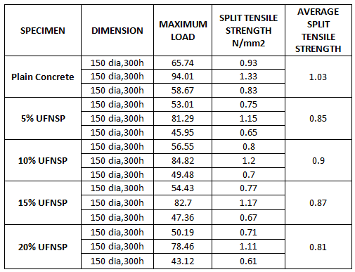

**Table 7.17: Split Tensile Strength Test Data for 7 days**

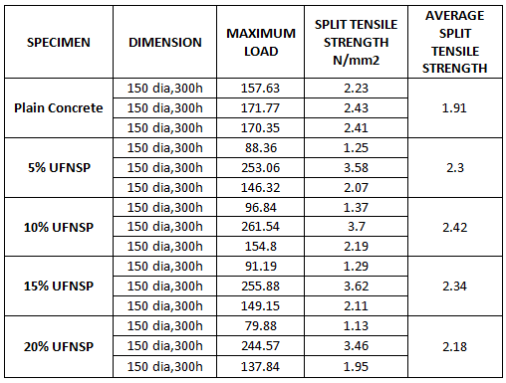

**Table 7.18: Split Tensile Strength Test Data for 28 days**

|  |  |  |  |  |
| --- | --- | --- | --- | --- |
| **SPECIMEN** | **DIMENSION** | **MAXIMUM LOAD** | **SPLIT TENSILE STRENGTH N/mm2** | **AVERAGE SPLIT TENSILE STRENGTH** |
| **Plain Concrete** | 150 dia,300h | 103.91 | 1.47 | 2.52 |
| 150 dia,300h | 268.61 | 3.8 |
| 150 dia,300h | 161.87 | 2.29 |
| **5% UFNSP** | 150 dia,300h | 139.25 | 1.97 | 3.02 |
| 150 dia,300h | 303.95 | 4.3 |
| 150 dia,300h | 197.21 | 2.79 |
| **10% UFNSP** | 150 dia,300h | 135.72 | 1.92 | 2.97 |
| 150 dia,300h | 300.42 | 4.25 |
| 150 dia,300h | 193.68 | 2.74 |
| **15% UFNSP** | 150 dia,300h | 129.36 | 1.83 | 2.88 |
| 150 dia,300h | 294.06 | 4.16 |
| 150 dia,300h | 187.32 | 2.65 |
| **20% UFNSP** | 150 dia,300h | 115.22 | 1.63 | 2.68 |
| 150 dia,300h | 279.92 | 3.96 |
| 150 dia,300h | 173.18 | 2.45 |

**7.2 TEST RESULTS**

**7.2.1 With GGBS Content**

**7.2.1.1 Compressive Strength test results**

**Table 7.19: Compressive Strength Test Results**

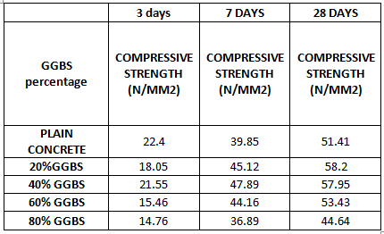

**Figure 7.1 : Compressive Strength Test Results**

**7.2.1.2 Flexural Strength test**

**Table 7.20: Flexural Strength Test Results**

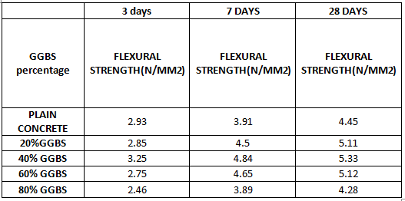

**Figure 7.2: Flexural Strength Test Results**

**7.2.1.3Split Tensile Strength test**

**Table 7.21: Split Tensile Strength Test Results**

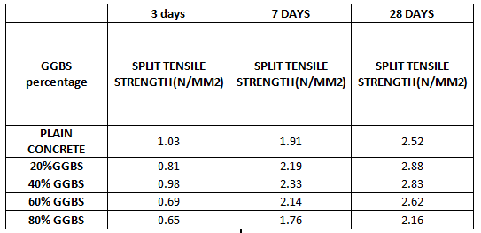

**Figure 7.3: Split Tensile Strength Test Results**

**7.2.2With UFNSP Content**

**7.2.2.1 Compressive Strength test**

**Table7. 22: Compressive Strength Test Results**

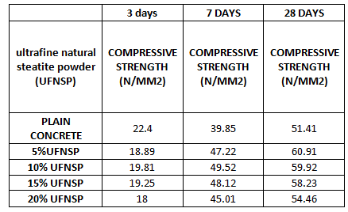

**Figure 7.4: Compressive test results**

**7.2.2.2 Flexural Strength test**

**Table 7.23: Flexural Strength Test Results**

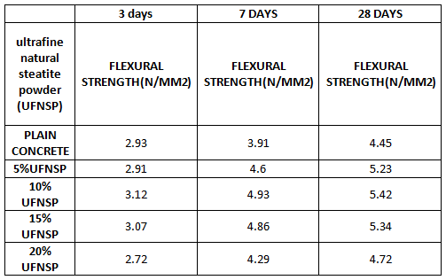

**Figure 7.5: Flexural test results**

**7.2.2.3Split Tensile Strength test**

**Table 7.24: Split Tensile Strength Test Results**

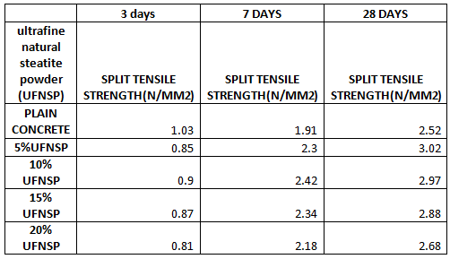

**Figure 7.6: Split Tensile test results**

**8.CONCLUSIONS**

* When looking at experimental effects, 20 to 40% of the alternative is the best value.
* More than 40% of cement substitute with GBBS, compressive strength is greatly reduced.
* Maximum compressive strength of 58.2 N / mm2 at 20% GGBS, bending energy of 5.33 N / mm2 at 40% GGBS and cut tensile energy of 2.88 N / mm2 at 20% GGBS alternative.
* The maximum compression electrolyte was determined to be 60.91 N / mm2 at 5% UFNSP, bending electricity of 5.42 N / mm2 at 10% UFNSP, and shear tensile strength of 3.02 N / mm2 when substituting 5% of UFNSP.
* From the results, the pressure is reduced after a rapid addition of 15% UFNSP.
* The maximum bending electrolyte is 10%, while most of the discrete tensile and electric stresses are 5p.
* You receive less energy while increasing the magnesium content in UFNSP.

**REFERENCES**

1. M.T.Nageswararao, A.V.S.Saikumar. “Experimental study on use of crushed stone dust and marble sludge powder as replacement to natural sand in self compacting concrete”. International Journal of Engineering Sciences and Research Technology (ISSN: 2277-9655) 4(8): august, 2015 pg: 40-47.
2. Prof. ShriramH.Mahure, Dr.V.M.Mohitkar, 2013, “Effect of mineral admixture on fresh and hardened properties of self-compacting concrete” . International Journal of Innovative Research in Science, Engineering and Technology (ISSN: 2319-8753) pg: 5585-5592.
3. “An Investigation on Self-Compacting Concrete Using Ultrafine Natural Steatite Powder as Replacement to Cement. Available from:”
4. S. Harini, J. P, Dinesh,. 2017, “Experimental study on self-compacting concrete”, IJESRT, vol. 6, 2017, pp. 42-50.
5. K. Yilmaz, M. Uysal, 2011, “Effect of mineral admixtures on properties of self-compacting concrete”, Cement and Concrete Composites, vol. 33, 2011, pp. 771–776.
6. S. Türke, B. Felekoğlu, l, 2007, “Effect of water/cement ratio on the fresh and hardened properties of self-compacting concrete”, pp. 1795–1802,
7. B. Persson, 2001, “A comparison between mechanical properties of self-compacting concrete and the corresponding properties of normal concrete”, pp. 193198,
8. Rafat Siddique, Divyachopra, kunal, 2015 “Strength, permeability and microstructure of self-compacting concrete containing rice husk ash” Biosystem engineering 130 (2015) 72-80.
9. Vandana C.J, Edwin Fernando,2014, “Experimental investigation of self-compacting concrete with copper slag. IJERA (ISSN:2248-9622) 2014 pg:92-97
10. Kosmas K. AlexandrosChatzopoulos, 2015, “Production of durable self-compacting concrete using ladle furnace slag (LFS) as filler material”. Procedia engineering 108, 592-597.
11. Nileena M S, Praveen Mathew, 2014, “Effect of GGBS and GBS on the properties of self-compacting concrete. IJIRAE, page no: 211-216.
12. P. Aggarwal, Y. Aggarwal, S.M. Gupta, R. Siddique, “Properties of self-compacting concrete – an overview”, 30th Conference on OUR WORLD IN CONCRETE & STRUCTURES, Aug. 2005, pp. 23-24, http://cipremier.com/100030011. [10] P. L. Domone, “A review of the hardened mechanical properties of self-compacting concrete. Cement and Concrete Composites”, Cement & Concrete Composites, vol. 29, 2007, pp. 1–12, doi: 10.1016/j.cemconcomp.2006.07.010.
13. M. Şahmaran, İ.Ö. Yaman, M. Tokyay, “Transport and mechanical properties of self-consolidating concrete with high volume fly ash”, Cement and Concrete Composites, vol. 31, 2009, 99–106, doi:10.1016/j.cemconcomp.2008.12.003.
14. B. Persson, “A comparison between mechanical properties of self-compacting concrete and the corresponding properties of normal concrete”, Cement and Concrete Research, vol. 31, 2001, pp. 193-198, doi:10.1016/S0008-8846(00)00497-X
15. M. Mazloom, A. Ranjbar, “Relation between the workability and strength of self-compacting concrete”, 35th Our World in Concrete and Structures (OWICs) – 2010, <http://www.cipremier.com/page.php?162>.
16. Vandana C.J, D. Singh, 2013, “Workability of Self Compacting Concrete Containing Rice Husk Ash” ,pp.196-200.
17. <https://www.scribd.com/document/162458543/WORKABILITY-OF-SELF-COMPACTING-CONCRETE-CONTAINING-RICE-HUSK-ASH>.
18. S. Türkel, B, B. Felekoğlu, 2006, “Effect of water/cement ratio on the fresh and hardened properties of self-compacting concrete”, pp. 1795–1802.
19. S. Harini, J, A. Dinesh, 2017, “Experimental study on self-compacting concrete”, IJESRT, pp. 42-50.
20. J. Daczko, CF. Ferraris, 2000, “Workability of self-compacting concrete”, ISHPC, pp. 25-27, <http://ws680.nist.gov/publication/get_pdf.cfm?pub_id=860252>.
21. K. Yilmaz,, M. Uysal, 2011, “Effect of mineral admixtures on properties of self-compacting concrete”, pp. 771–776.
22. P. Painuly, I. Uniyal, 2016, “Literature review on self-compacting concrete”, IJTRA, vol. 4, 2016, pp. 178-180,