Structural Tags
<!DOCTYPE html>
<html>
<head>
<title>Ticket Booking System</title>
</head>
<body>
<header>
<h1>Ticket Booking System</h1>
<p>One platform for booking travel tickets</p>
<nav>
<a href="#">Home</a> |
<a href="#">Tickets</a> |
<a href="#">Bookings</a> |
<a href="#">Support</a>
</nav>
</header>
<main>
<section>
<h2>Available Ticket Categories</h2>
<article>
<h3>Bus Tickets</h3>
<p>Book intercity and intracity bus tickets.</p>
</article>
<article>
<h3>Train Tickets</h3>
<>Reserve seats on express and local trains.</p>
</article>
<article>
<h3>Flight Tickets</h3>
<p>Domestic and international flight bookings.</p>
</article>
</section>
<aside>
<h3>Announcements</h3>
<p>Festival season discounts available now!</p>
</aside>
</main>
<footer>
<p> 2026 Ticket Booking System</p>
<p>Contact: support@ticketbooking.com</p>
</footer>
</body>
</html>

Output:-

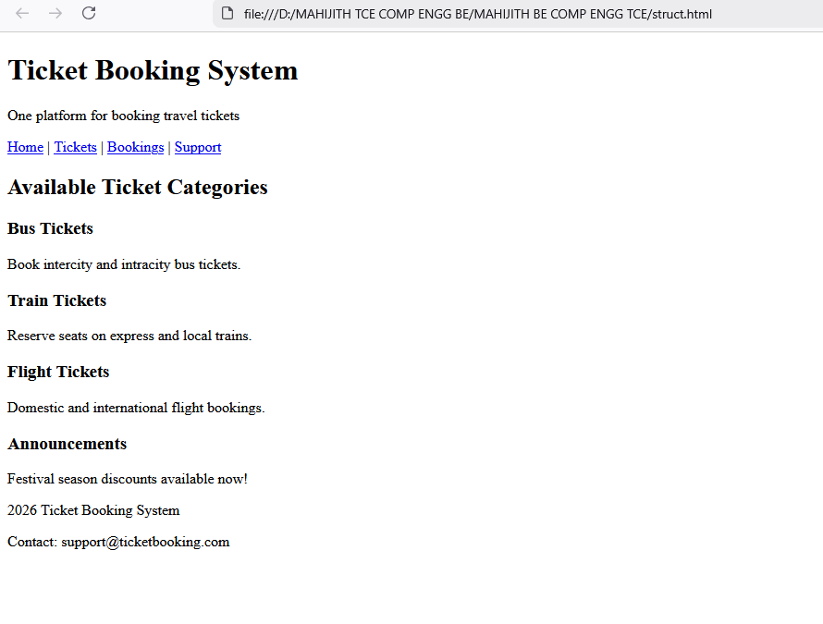

Image tags
<!DOCTYPE html>
<html lang="en">
<head>
<title>Image Tag Demonstration</title>
</head>
<body>
<h1>Ticket Booking System</h1>
<h2>Basic Image</h2>
<img src="https://www.shutterstock.com/image-illustration/image-bus-on-road-600nw-2568680639.jpg" alt="Bus Image" width="300" height="200">
<br><br>
<h2>Clickable Image</h2>
<a href="#">
<img src="https://encrypted-tbn0.gstatic.com/images?q=tbn:ANd9GcTJvdNNTB4fnrdNT0kaky-lSBuYoKmeUHvoYg&s" alt="Flight Booking">
<br>Click me
</a>
<br><br>
</body>
</html>

Output:-

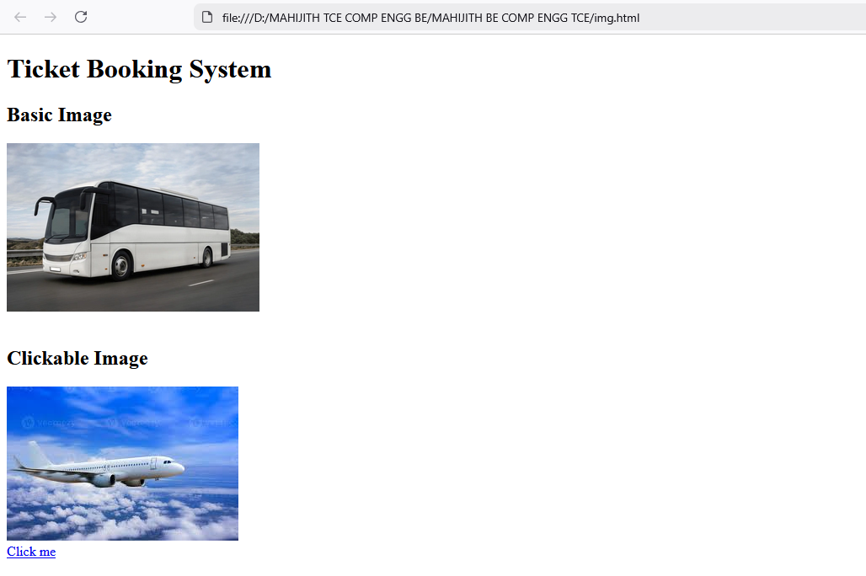

Form Elements
<!DOCTYPE html>
<html lang="en">
<head>
<title>Form Tag Demonstration</title>
</head>
<body>
<h1>Ticket Booking Form</h1>
<form>
<label>Full Name:</label><br>
<input type="text" name="name" required>
<br><br>
<label>Email Address:</label><br>
<input type="email" name="email" required>
<br><br>
<label>Mobile Number:</label><br>
<input type="tel" name="phone"
pattern="[0-9]{10}"
placeholder="10-digit number" required>
<br><br>
<label>Journey Date:</label><br>
<input type="date" name="date" required>
<br><br>
<label>Number of Tickets:</label><br>
<input type="number" name="tickets" min="1" max="6" required>
<br><br>
<label>Ticket Type:</label><br>
<select name="type" required>
<option>Bus</option>
<option>Train</option>
<option>Flight</option>
</select>
<br><br>
<label>Seat Preference:</label><br>
<input type="radio" name="seat" required> Window </input>
<input type="radio" name="seat"> Aisle
<br><br>
<input type="checkbox" required> I agree to the terms and conditions</input>
<br><br>
<button type="submit">Book Ticket</button>
<button type="reset">Reset</button>
</form>
</body>
</html>

Output:-

