MVC Experiment: Java JSP & XML Travel Booking
Subject/Course: Web Technologies / Advanced Java Lab
Topic: Implementation of MVC Architecture Using Java Servlets, JSP, and XML

1. Objective
To design and develop a dynamic web application applying the Model-View-Controller (MVC) architecture. The application should demonstrate data parsing mechanisms by utilizing Java Servlets as the controller, JSP for presentation views, and XML functioning as the lightweight database model.

2. Architecture & Design
The Wanderlust Escapes application integrates the following:
- Model (XML & Handler): destinations.xml holds data (image, price, strings), and XMLHandler.java dynamically parses it using built-in standard org.w3c.dom libraries into collections.
- View (JSP & CSS): index.jsp creates a landing page with a modern Glassmorphism visual design. destinations.jsp processes the Java Lists and maps card interfaces iteratively.
- Controller (Servlet): DestinationServlet.java handles GET /destinations mappings, initializes the Model logic, creates Request Attributes, and strictly dispatches forwarding to the view.

3. Project Configuration

Application Deployment Descriptor (web.xml)
The web.xml controls the initialization context and servlet map pointing strings to the Java Controller classes.
<?xml version="1.0" encoding="UTF-8"?>
<web-app xmlns="http://xmlns.jcp.org/xml/ns/javaee" version="4.0">
<servlet>
<servlet-name>DestinationServlet</servlet-name>
<servlet-class>com.travel.DestinationServlet</servlet-class>
</servlet>
<servlet-mapping>
<servlet-name>DestinationServlet</servlet-name>
<url-pattern>/destinations</url-pattern>
</servlet-mapping>
</web-app>

Data Layer (destinations.xml)
A structured XML format that eliminates the need for heavyweight relational databases for simple configurations.
<?xml version="1.0" encoding="UTF-8"?>
<destinations>
<destination>
<id>1</id>
<name>Paris, France</name>
<description>Experience the romance of the Eiffel Tower.</description>
<price>1200.00</price>
<duration>5 Days, 4 Nights</duration>
</destination>
</destinations>

4. Backend Source Code

The Backend Controller (DestinationServlet.java)
package com.travel;
import java.io.IOException;
import java.util.List;
import java.util.Map;
import javax.servlet.ServletException;
import javax.servlet.http.HttpServlet;
import javax.servlet.http.HttpServletRequest;
import javax.servlet.http.HttpServletResponse;
public class DestinationServlet extends HttpServlet {
protected void doGet(HttpServletRequest request, HttpServletResponse response)
throws ServletException, IOException {
String xmlFilePath = getServletContext().getRealPath("/WEB-INF/data/destinations.xml");
List<Map<String, String>> destinationsList = XMLHandler.parseDestinations(xmlFilePath);
request.setAttribute("destinations", destinationsList);
request.getRequestDispatcher("/destinations.jsp").forward(request, response);
}
}

The XML Parser Logic (XMLHandler.java)
package com.travel;
import org.w3c.dom.*;
import javax.xml.parsers.*;
import java.io.File;
import java.util.*;
public class XMLHandler {
public static List<Map<String, String>> parseDestinations(String filePath) {
List<Map<String, String>> destList = new ArrayList<>();
try {
File xmlFile = new File(filePath);
Document doc = DocumentBuilderFactory.newInstance().newDocumentBuilder().parse(xmlFile);
doc.getDocumentElement().normalize();
NodeList nList = doc.getElementsByTagName("destination");
for (int i = 0; i < nList.getLength(); i++) {
Node nNode = nList.item(i);
if (nNode.getNodeType() == Node.ELEMENT_NODE) {
Element eElement = (Element) nNode;
Map<String, String> destMap = new HashMap<>();
destMap.put("name", eElement.getElementsByTagName("name").item(0).getTextContent());
destList.add(destMap);
}
}
} catch (Exception e) {}
return destList;
}
}

5. Output Results
The system outputs the highly appealing user interface constructed completely via Java/JSP dynamic injection.

Landing / Index Page Output

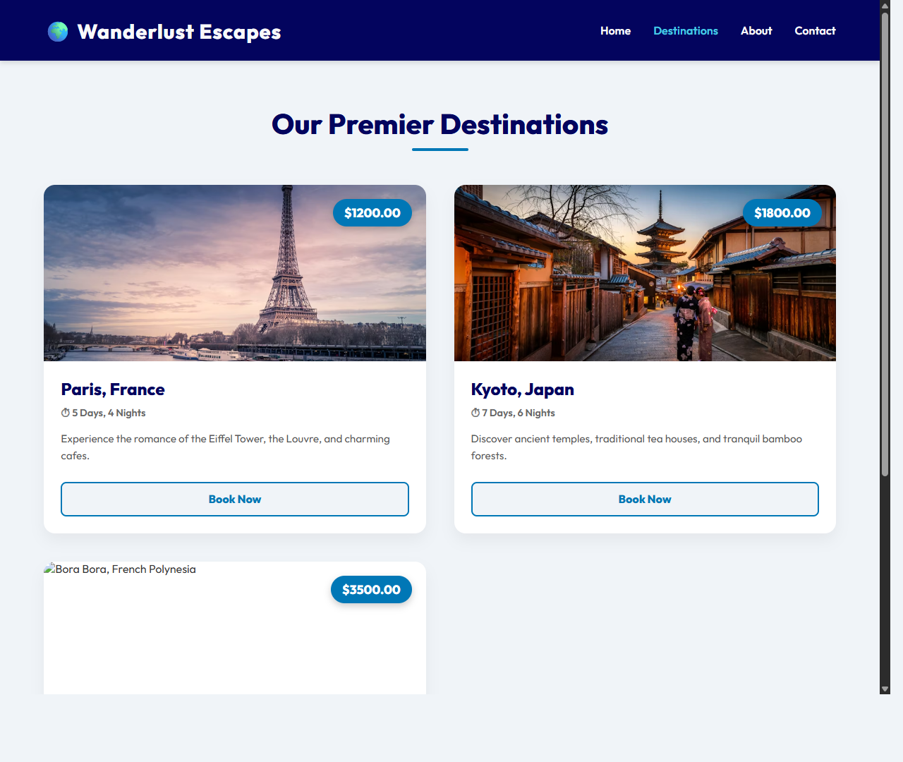

Destinations Route Controller Output

