PRACTICAL – 1
Write the queries for Data Definition (DDL) in RDBMS
- Create COMMAND
As the name suggest, it is used to create objects like databases and tables as shown below:
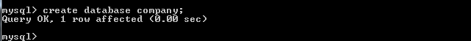
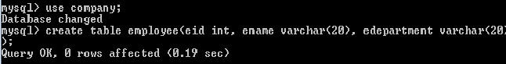

- Desc COMMAND
Desc command is used to show the schema of a table.
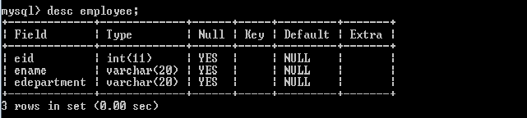

- Alter COMMAND
Alter command is used to add or delete attributes from existing schema.
- Add or delete column from table. 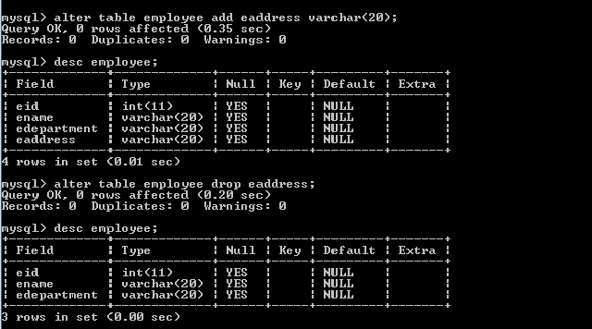

- Change the data type of the specified column. 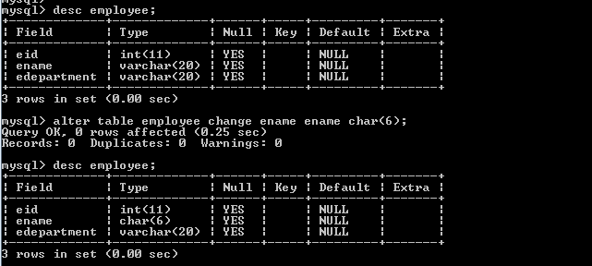

- Rename the specified attribute.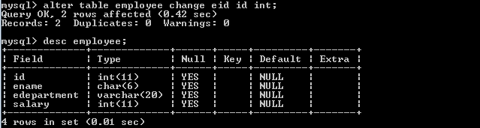

- Rename COMMAND
This command is used to change the name of table.
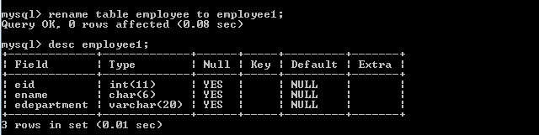

- Drop COMMAND
It is used to deletes objects from the databases like tables.

PRACTICAL – 2
Write the queries for Data Manipulation Language (DML) in RDBMS
- Insert COMMAND
Insert command is used to insert values to tables. In other words inserting values in tuples.
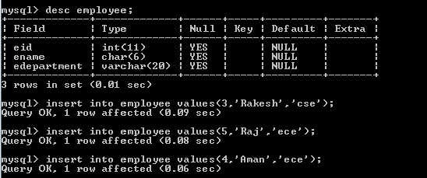
- Select COMMAND
Select command is used to select a table. It can be achieved by selecting the name of table.
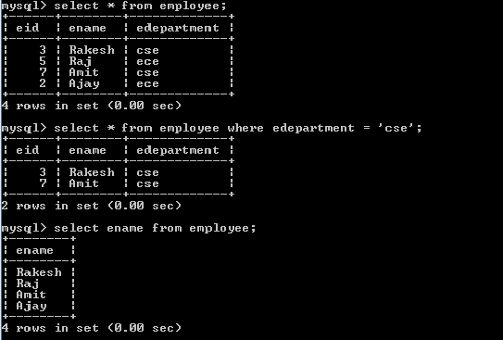
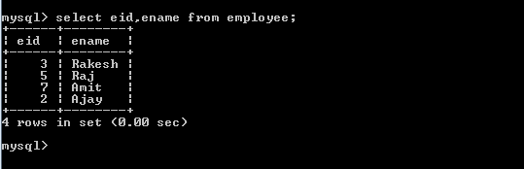

- Update COMMAND
Update command is used to make changes in any tuple. It is achieved by using field value of any other attribute of that particular tuple.
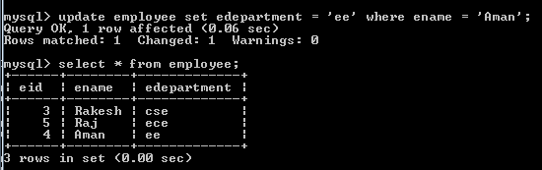
- Delete COMMAND
Delete command is used to delete any tuple from table.
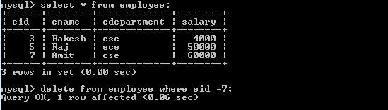
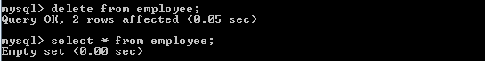

PRACTICAL – 3
Write SQL queries using Logical operations

- AND Operator
This operator is used to temporarily show rows only when two or more than two conditions are true.
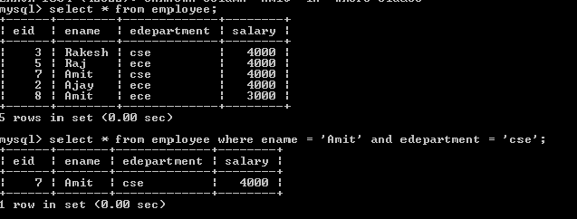
- OR Operator
This operator is used to temporarily show rows when either any one of the given conditions are true or all the conditions are true.

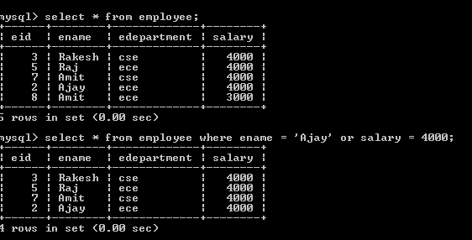

- NOT Operator
Not operator is used to temporarily show all the rows having all the conditions False.
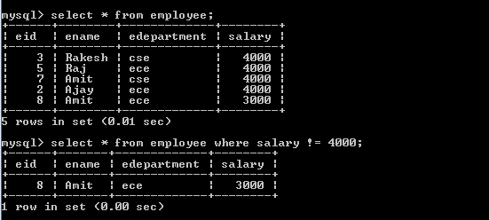

- IN Operator
When this operator is used then it just shows all the rows having same values given in bracket.
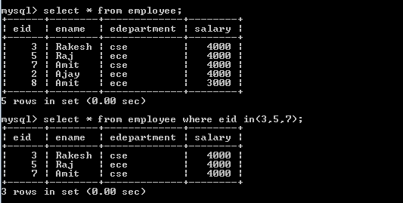

- BETWEEN Operator
It temporarily shows all the rows which lies between the two values given (including the two values).
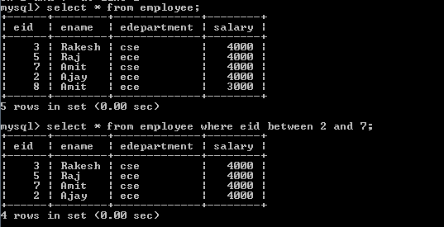

- LIKE Operator
Like operator is used to temporarily show all the rows having same alphanumeric in given attribute. Examples are given in command prompt. Below.
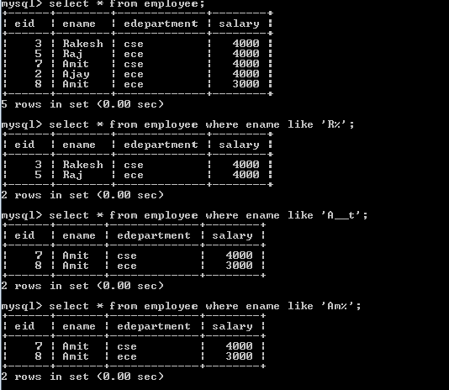
PRACTICAL – 4
Write SQL queries using SQL operators

- AIRTHMETIC OPERATORS

- SQL plus (+) operator: This operator is used to add two or more expressions or numbers.
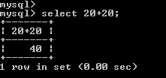
- SQL minus (-) operator: This operator is used to subtract one expression or number from another expression or number.
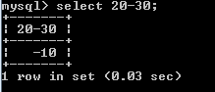
- SQL multiply (*) operator: This operator is used to multiply two or more expressions or numbers.
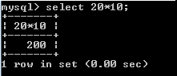

- SQL divide (/) operator: This operator is used to divide one expressions or numbers by another.
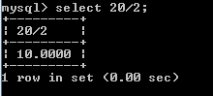

- SQL modulo (%) operator: This operator returns the remainder (an integer) of the division.
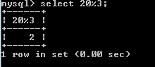

- COMPARISONS OPERATORS

EQUALITY OPERATOR
This operator is used to test equality in the query.
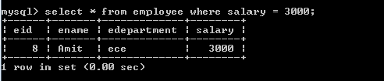

INEQUALITY OPERATOR
In SQL, there are two ways to test for inequality in a query. Either by using < > or! = operator.
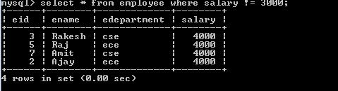

GREATER THAN OPERATOR

We can use the > operator in SQL to test for an expression greater than.
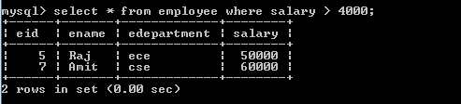

GREATER THAN OR EQUAL OPERATOR
In SQL, you can use the >= operator to test for an expression greater than or equal to.
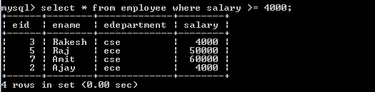

  - lESS THAN OPERATOR
We can use the < operator in SQL to test for an expression less than.
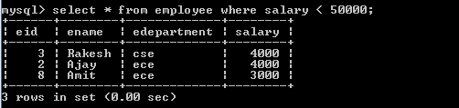

  - LESS THAN OR EQUAL OPERATOR
In SQL, you can use the <= operator to test for an expression less than or equal to.
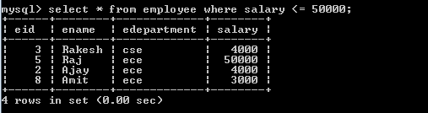

PRACTICAL – 5
Write SQL query using character, number, date and group functions
- AGGREGATE OPERATORS

- AVERAGE OPERATOR
It returns average of the values in the selected columns. The result can then be assigned to an alias using the AS clause.
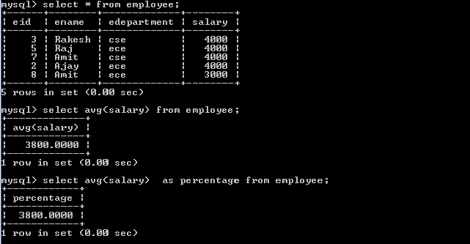

- MIN Operator
It returns the data from the row in which the specified column contains the lowest value.
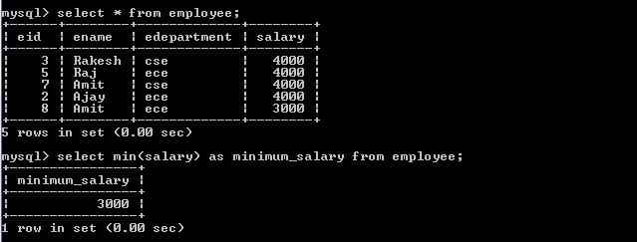

- MAX Operator
It returns the data from the row in which the specified column contains the highest value.

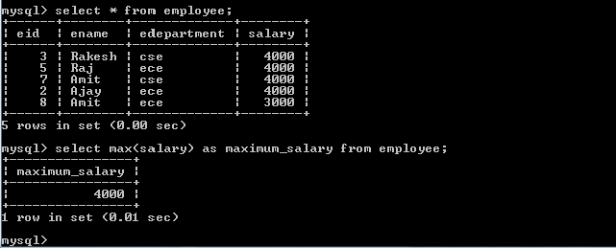

- SUM Operator
The sum () function returns the total of all the values in a specified column.

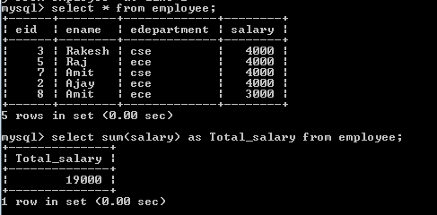

- COUNT Operator
The MySQL count () function adds the number of rows that match the filter criteria specified in a Select statement.
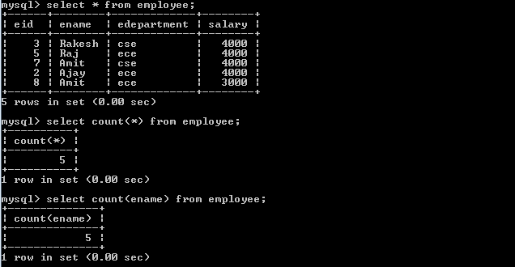

- CURRENT DATE AND TIME:

- Now( ): This function returns the current date and time of the system.

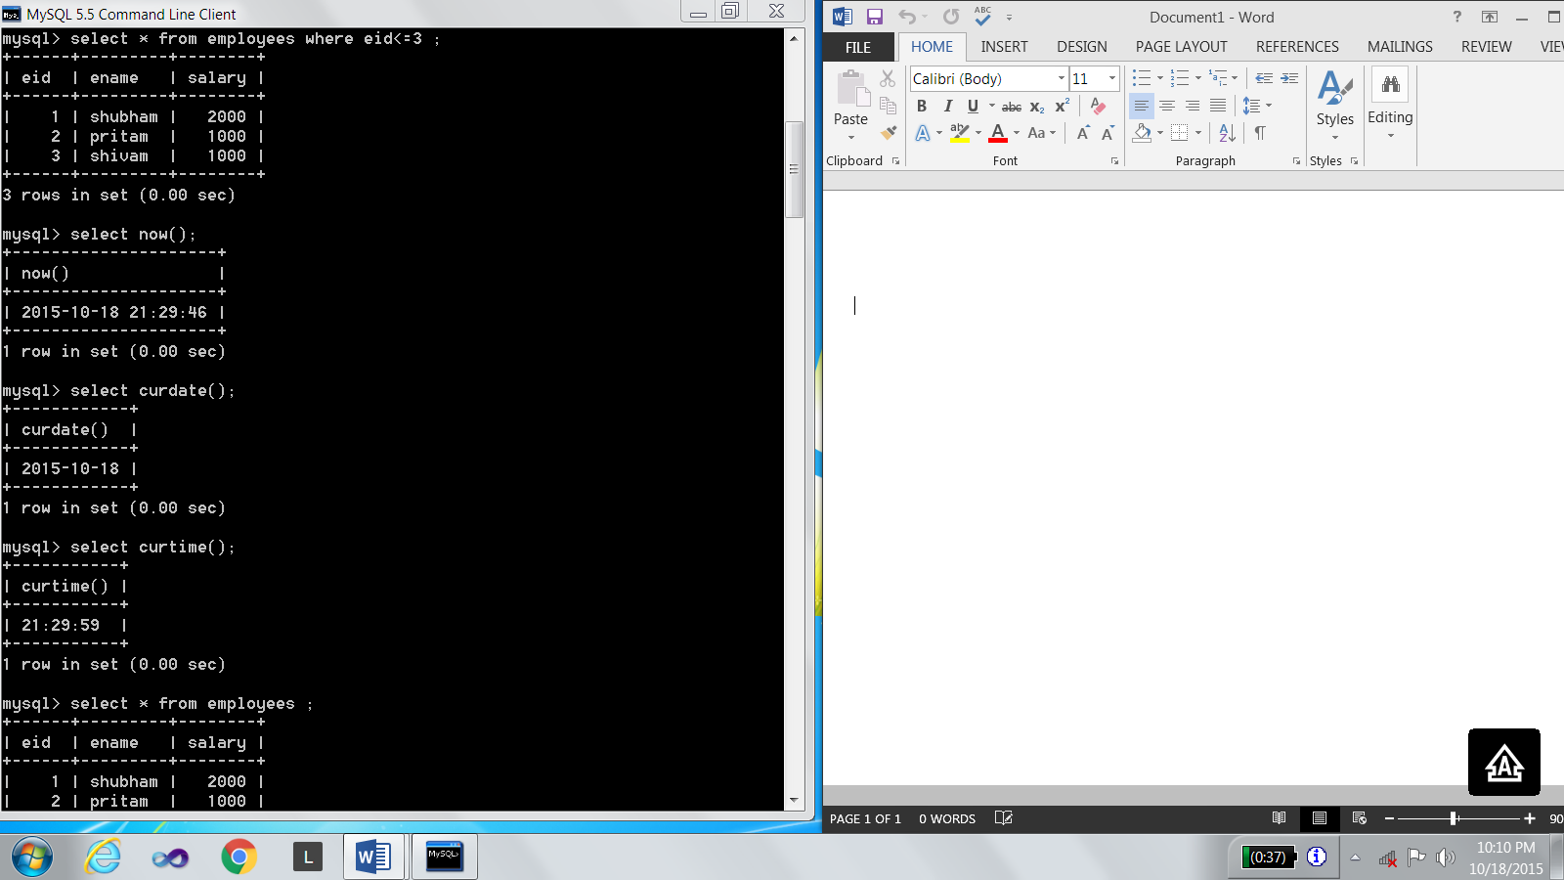

- Curdate(): This function returns the current date of the system.

- Curtime(): This function returns the current time of the system.

- Last_Day(): This function returns the corresponding value for the last day of the month.
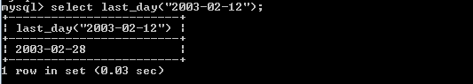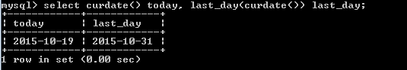

- Date_format(): This function format the date value according to format string. The ‘%’ character is required before format specifier characters.
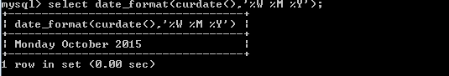

- CHARACTER FUNCTIONS:

- ASCII: This function returns the ASCII code of the leftmost character of the string str.

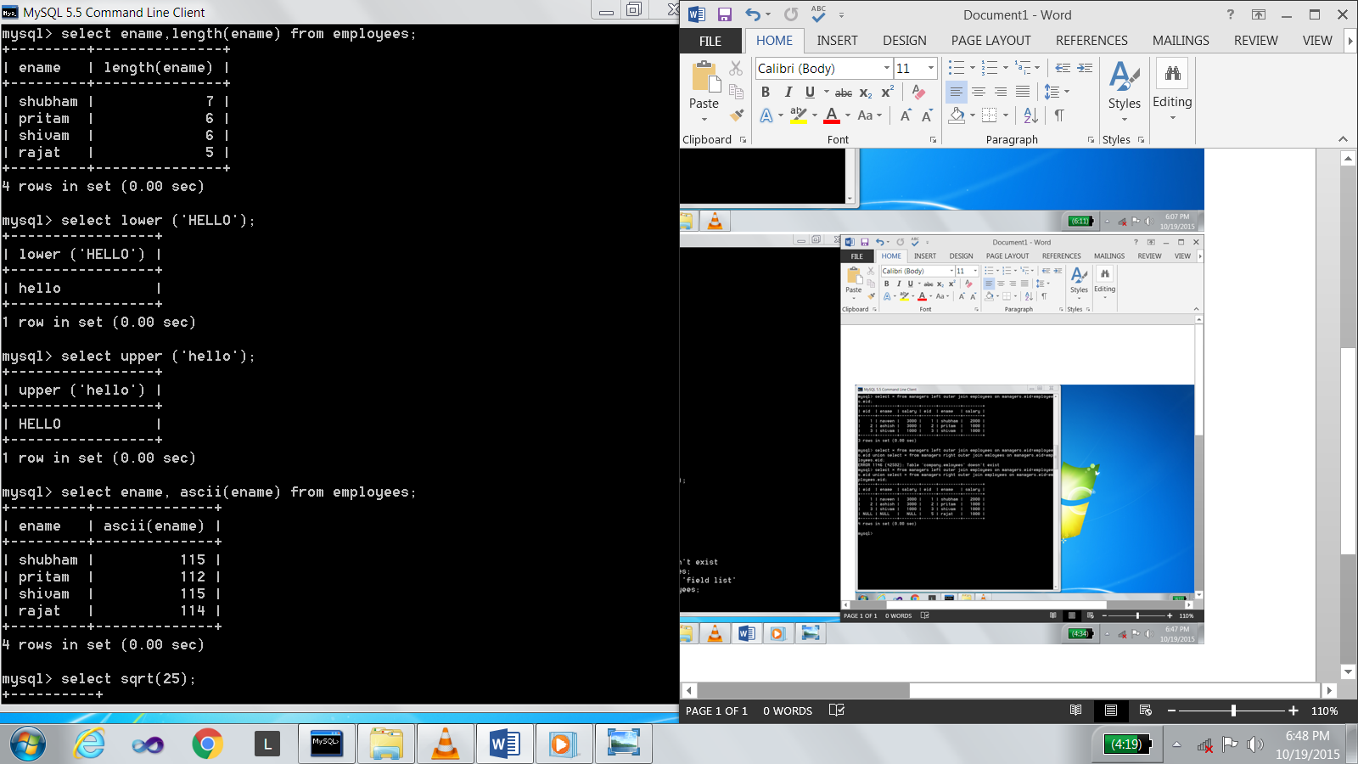

- CHAR: This function returns the character for each integer.

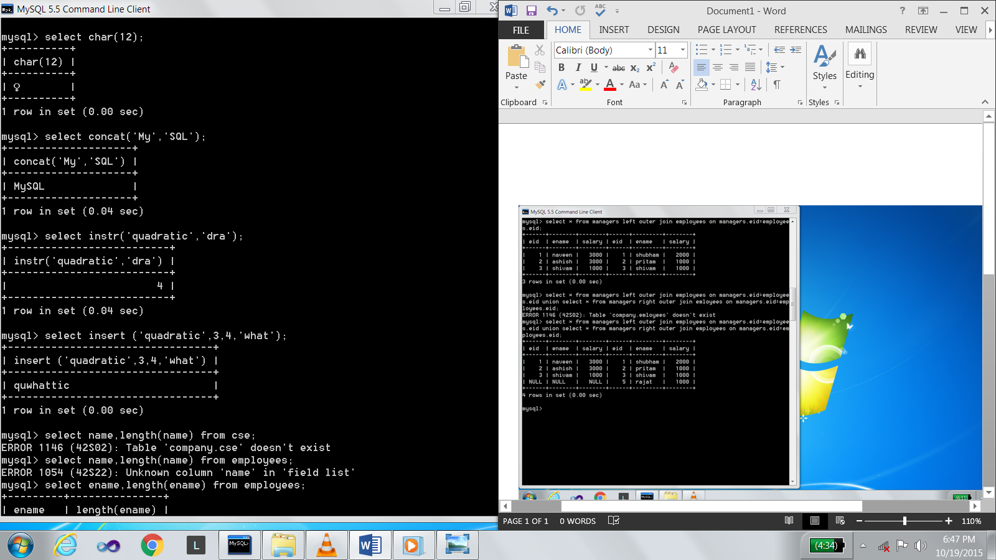

- CONCAT: This function returns the string that results from concatenating the arguments.

- INSTR: This function return the location in a string of the specified substring.

- INSERT: This function insert a substring into a string.

- LENGTH: this function returns the length of the string.

- LOWER: This function converts all the letter to lower case.

- UPPER: This function converts all the letter to lower case.

- NUMBER FUNCTIONS

- POWER (X,Y): These function return the value of X raised to power of Y.

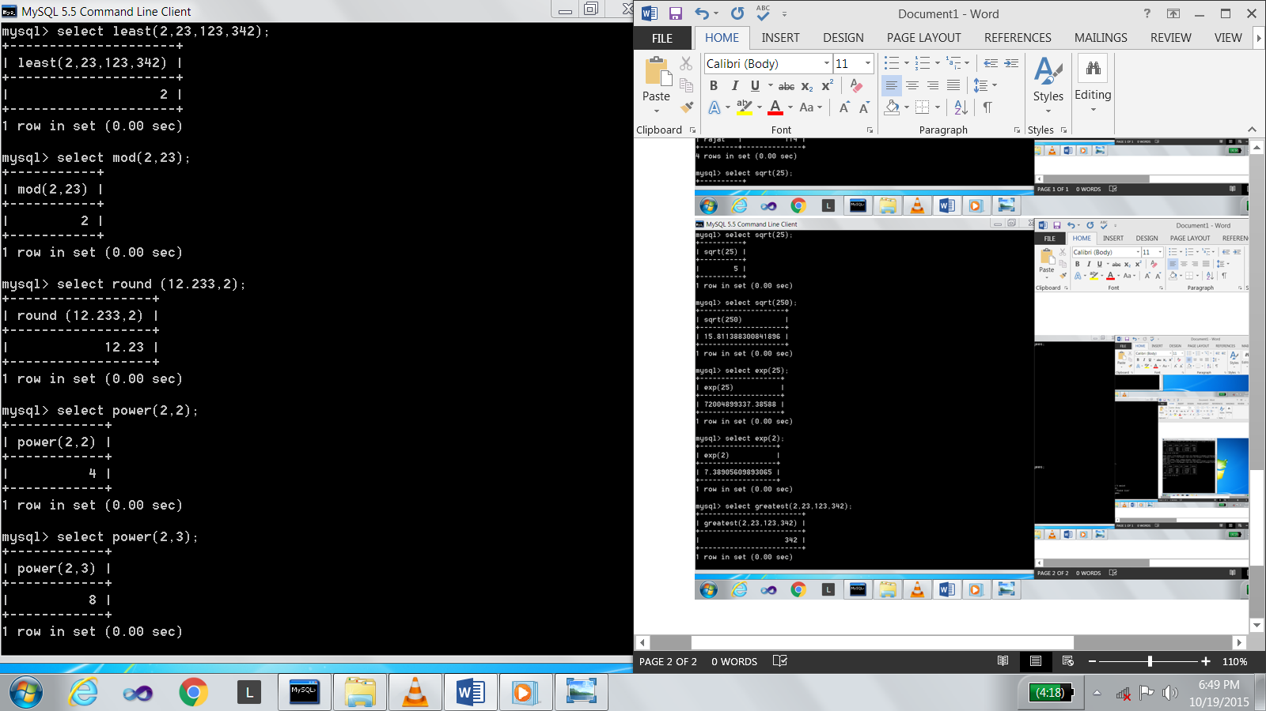

- ROUND (M,N): This function returns M round to N places to right of a decimal point.

- SQRT (N): This function returns the square root of N.

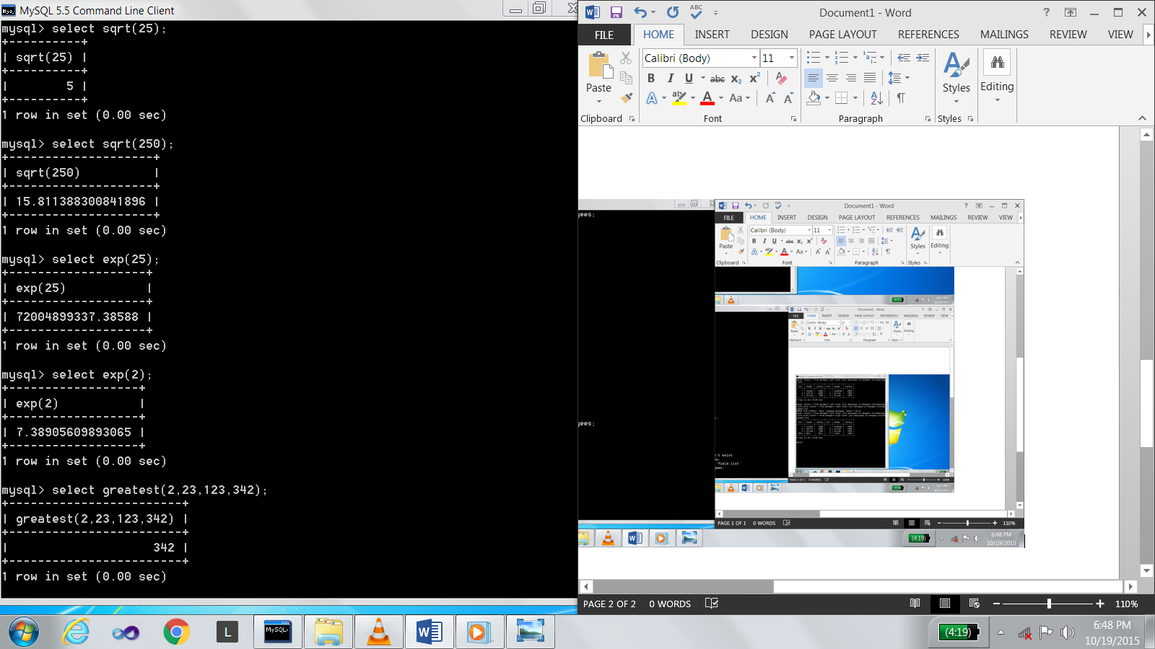

- EXP (N): This function returns ‘e’ raised to N^{th} power where
e = 2.71828183.

- GREATEST: This function returns the greatest value in a list of expression.

- LEAST: This function returns the least value in a list of expression.

- MOD (N,M): This function returns the remainder of the first number divided by the second number.

- FLOOR: This function returns largest integer value that is equal to or less than a number.

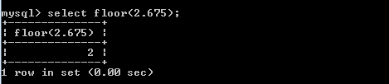

- CEIL: This function returns the smallest integer value that is equal to or greater than a number.

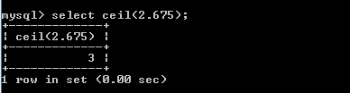

PRACTICAL – 6
Write SQL queries for relational algebra
- SELECT
It is used to select the subset of the tuples of a relation that satisfies the selection condition.
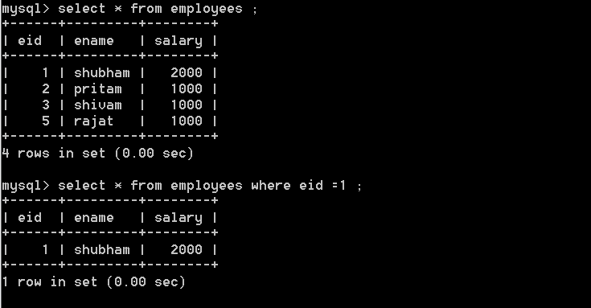

- PROJECT
It selects only those columns or attributes in which the user is interested and discards other.
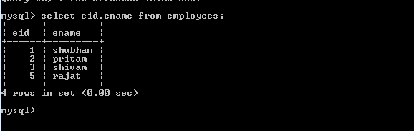

- SET OPERATIONS
- UNION OPERATOR
It is used to combine the results of two or more Select statements. However it will eliminate duplicate rows from its result set. In case of union, number of columns and data type must be same in both the tables.
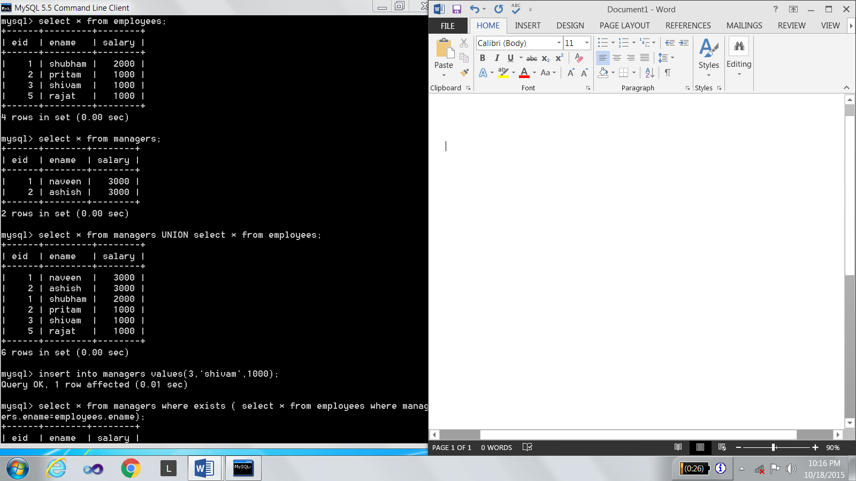
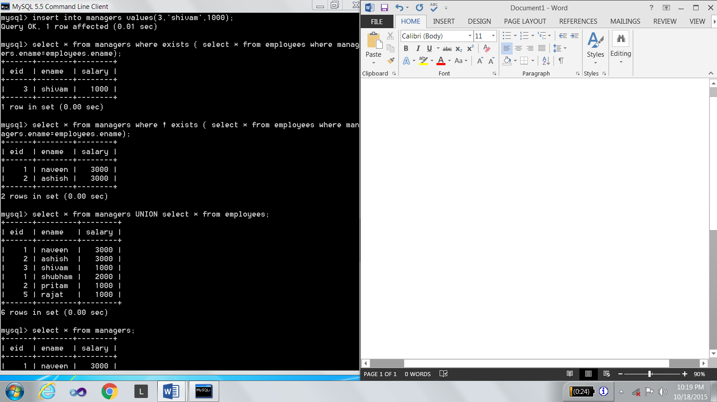

- INTERSECTION OPERATOR
It is used to combine two SELECT statements, but it only returns the records which are common from both SELECT statements. In case of Intersect the number of columns and data type must be same.

- DIFFERENCE OPERATOR
This operation combines result of two Select statements and return only those result which belongs to first set of result.

PRACTICAL – 7
Write SQL queries for extracting data from more than one table
- JOINS
Database on which all the join operations are applied is as follows:-

- INNER JOIN
Inner join creates a new result table by combining column values of two tables (A and B) based upon the join-predicate. It is similar to cross join or Cartesian product.
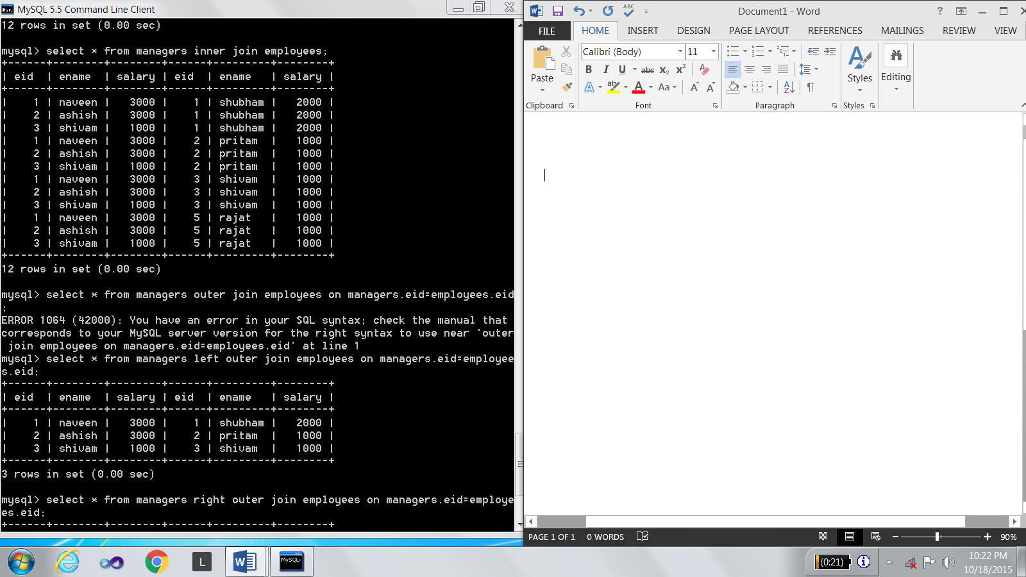

- OUTER JOIN

  - LEFT OUTER JOIN
The result of a left outer join for tables A and B always contains all records of the "left" table (A), even if the join-condition does not find any matching record in the "right" table (B).

  - RIGHT OUTER JOIN
Every row from the "right" table (B) will appear in the joined table at least once. If no matching row from the "left" table (A) exists, NULL will appear in columns from A for those records that have no match in B.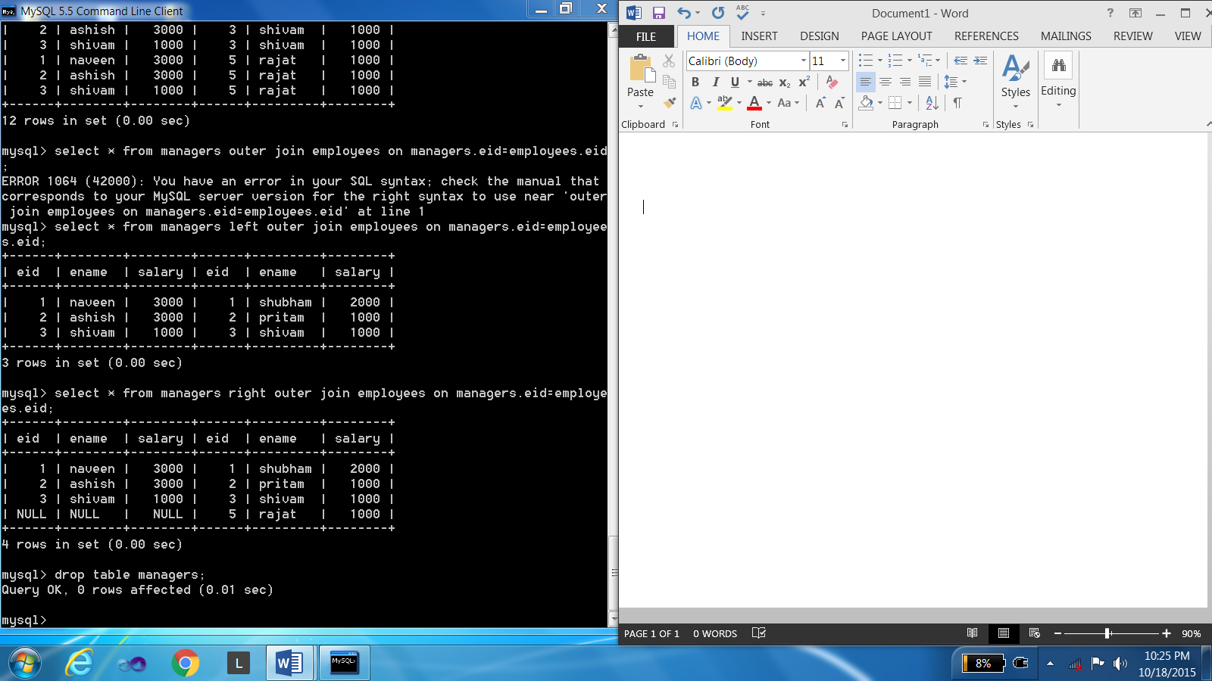

  - FULL OUTER JOIN : In the SQl the full outer join combines the result of both left and right outer join and return all rows from the tables on both sides of the join clause

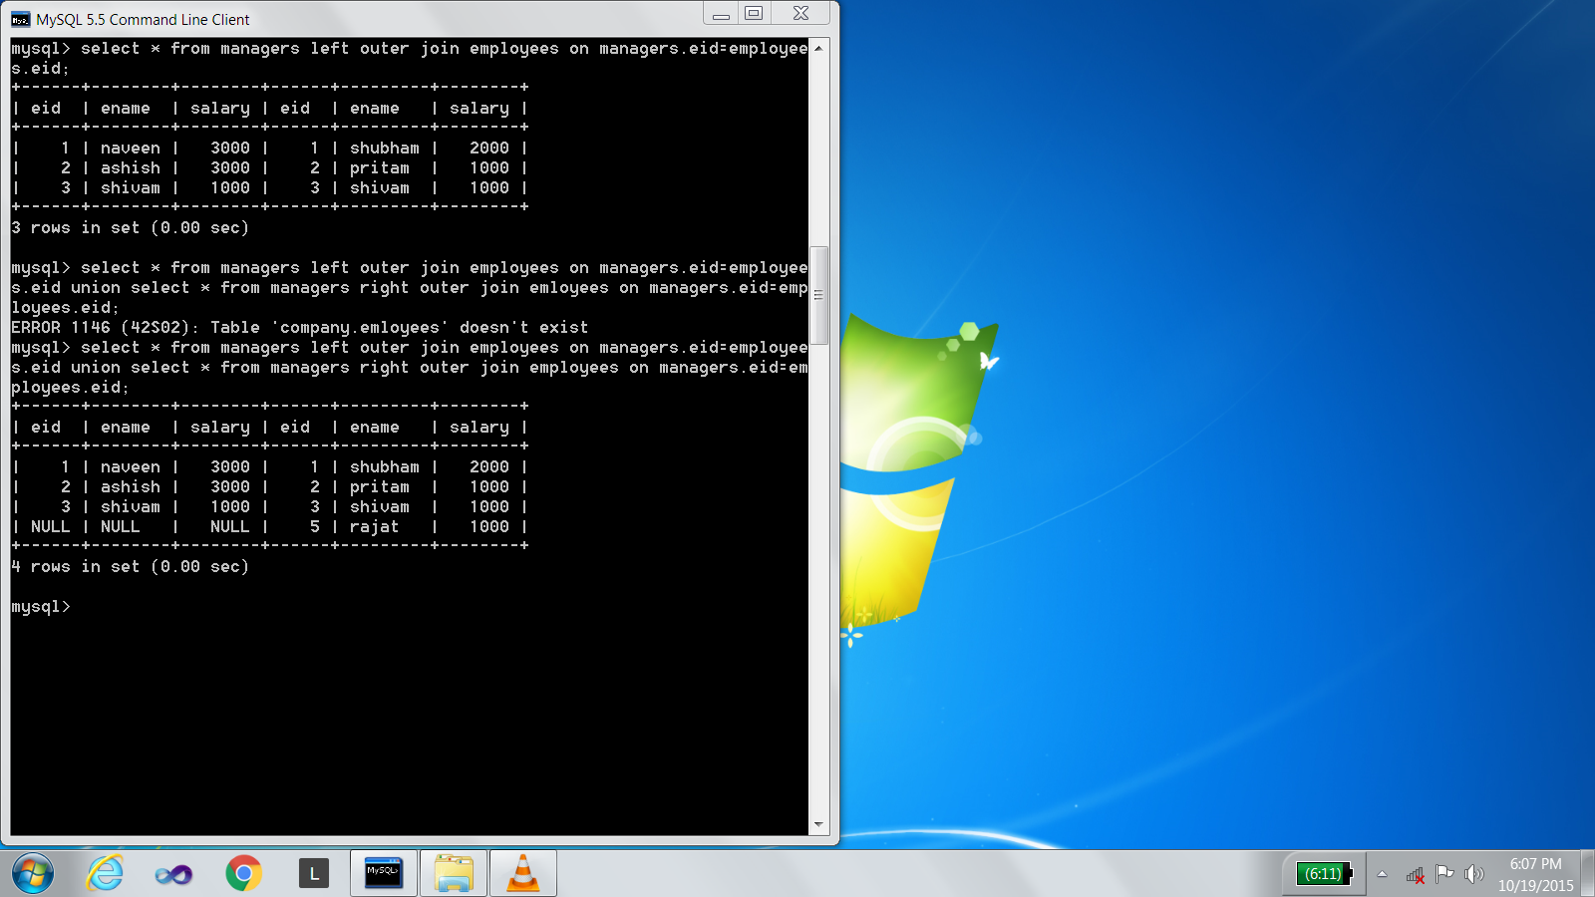

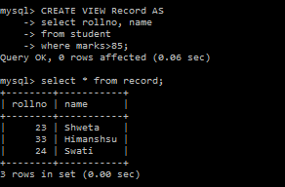
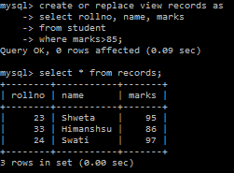
PRACTICAL – 8
Write SQL queries to create, update and delete the VIEWs.

View: A view is a virtual table. A view contains rows and columns, just like a
Real table. The fields in a view are fields from one or more real tables in the database. You can add SQL functions, WHERE, and JOIN statements to a view
And present the data as if the data were coming from one single table .

Updating the view as if we want to add another column in the existing view.

DROPPING A VIEW: We can delete a view in database using drop view
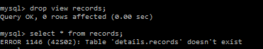
command.
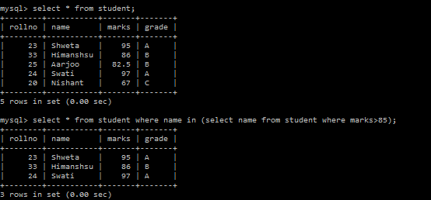
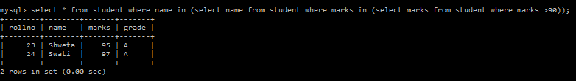
PRACTICAL-9
Write SQL queries for sub queries and nested queries.
A Subquery or Inner query or Nested query is a query within another SQL
query and embedded within the WHERE clause. A subquery is used to return
data that will be used in the main query as a condition to further restrict the data to be retrieved.

Cascading of queries: Query within query is called cascading.

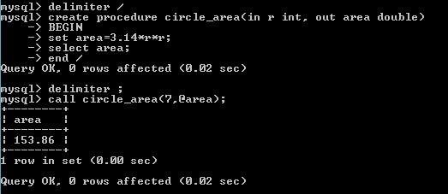
PRACTICAL 10
To study the concept of the procedures.
PROCEDURE: A procedure (often called a stored procedure) is a subroutine
Like a subprogram in a regular computing language, stored in database. A procedure has a name, a parameter list, and SQL statement(s).
Syntax in SQL

Execution of procedure using loop in my SQL
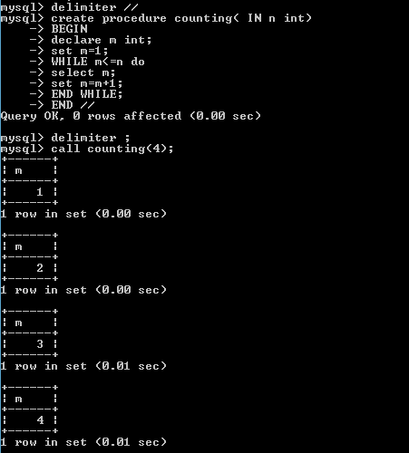

PROGRAM -11
To study the concept of the trigger.
TRIGGER: A trigger is a set of actions that are run automatically when a
specified change operation (SQL INSERT, UPDATE, or DELETE statement) is performed on a specified table. Triggers are useful for tasks such as enforcing business rules, validating input data, and keeping an audit trail.
CREATE Trigger: This statement is used to create a trigger.

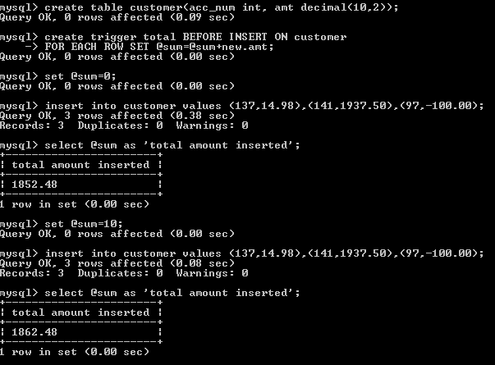

DROP Trigger: This command is used to delete the trigger.


