This is one of the most important topics in modern VLSI Physical Design. Since you are learning power planning in Innovus, understanding UPF/CPF will help you understand why we create multiple power nets, power rings, power straps, isolation cells, etc.
I'll explain it from the beginning.

Why do we need UPF/CPF?
Earlier chips had only one power supply.
Entire Chip
---------------------
VDD = 1.0V
VSS = GND
---------------------
Everything always remained ON.
Power consumption was high.
Today's SoCs (mobile processors, AI chips, automotive chips) contain many blocks.
Example : CPU, GPU, USB, Bluetooth, DDR, Camera, Display
Not every block is required all the time.
Example
You are only listening to music.
Bluetooth -> ON

CPU -> ON

GPU -> OFF

Camera -> OFF

Video Codec -> OFF
Why keep GPU powered if it is unused?
Answer: We shut off its power. This is called Power Gating

What is UPF?
UPF = Unified Power Format
It is an IEEE standard.
A UPF file tells the EDA tools
"This block belongs to this power domain."
"This block uses this voltage."
"Insert isolation cells here."
"Insert retention registers here."
"Use these sleep transistors."
Instead of manually inserting these cells into RTL, we describe the power intent in a UPF file.

CPF CPF = Common Power Format, Created by Cadence.
Purpose is almost identical to UPF.
Nowadays UPF is much more widely used.

What is Power Intent?
Power intent means : How power should behave in the chip.
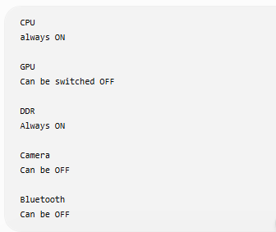
This information is stored inside UPF.

Main Concepts in UPF
Let's go one by one.
1. Power Domain
A power domain is A group of cells that share the same ON/OFF behavior.
Example
-----------------------
Chip
-----------------------

CPU , GPU, Bluetooth and Camera
Suppose
CPU should never shut down.
GPU should sleep.
Bluetooth should sleep.
Camera should sleep.
Then
Power Domain 1 : CPU :Always ON
Power Domain 2 : GPU : Can OFF
Power Domain 3 : Bluetooth : Can OFF
Power Domain 4 : Camera : Can OFF
Each is a different power domain.

Important Point
Power Domain is about : ON/OFF control , NOT voltage.

2. Voltage Domain
Voltage domain means : Cells working at the same voltage.
Example
CPU : 1.0V
GPU : 0.8V
DDR : 1.2V
Each becomes a different voltage domain.

Difference
Power Domain: ON/OFF behavior
Voltage Domain : Operating voltage
Example : CPU ; Always ON : 1.0V
GPU : Sleep Mode : 1.0V
same voltage but Different power domains
Another example
GPU : 0.8V
DSP : 1.0V
Always ON , Different voltage domains and Same power domain possible.

One voltage domain can contain multiple power domains
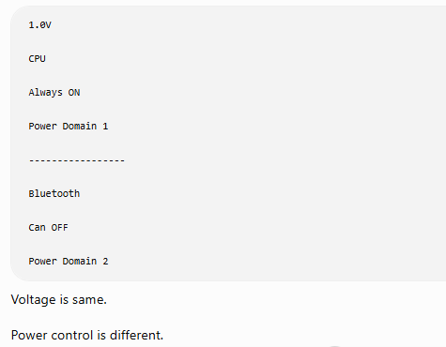

One power domain can also contain multiple voltage domains
Possible in some advanced designs.
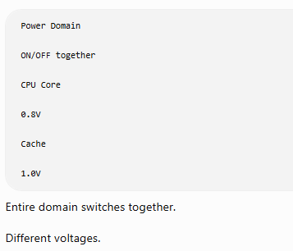

3. Supply Net
Example
VDD_CPU

VDD_GPU

VDD_IO

VSS
UPF defines these supply nets.

4. Supply Set
A pair of power and ground.
Example
Power : VDD_GPU

Ground : VSS
Together Supply Set

5. Power Switch
This is a transistor.
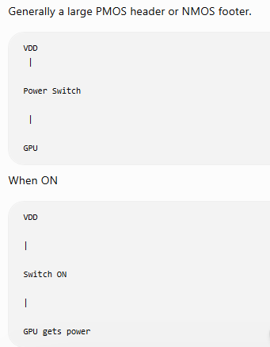
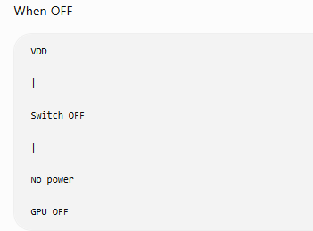

Sleep Transistor
Power switch = Sleep transistor.
Usually a very large transistor.
Placed near the power grid.
VDD

|

Sleep Transistor

|

Power Domain

Why called Sleep Transistor?
Because it disconnects power during sleep mode.

6. Power Gating
Entire concept.
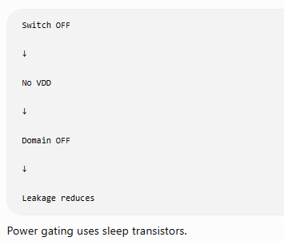.

7. Isolation Cell
Very important interview question.
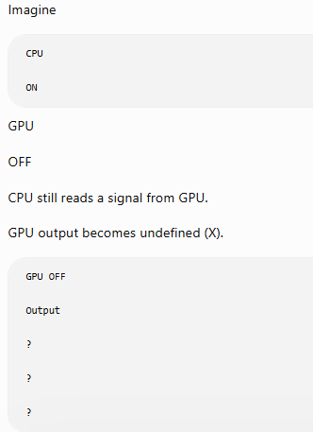
CPU receives garbage.
Isolation cell solves this.
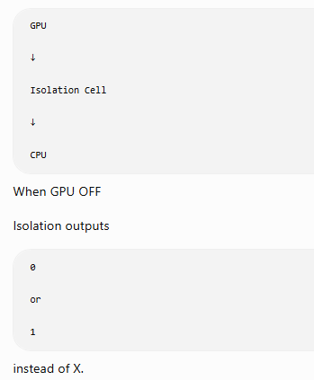
Without isolation
GPU OFF

Output = X

CPU

Error
With isolation
GPU OFF

Output = 0
CPU continues safely.

Where is Isolation Cell placed?
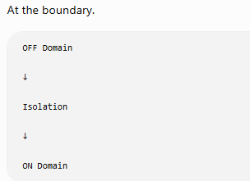

8. Retention Register
Suppose
GPU has Counter = 250
GPU turns OFF.
Power removed. Counter becomes 0
Information lost.
Retention Register keeps important values.
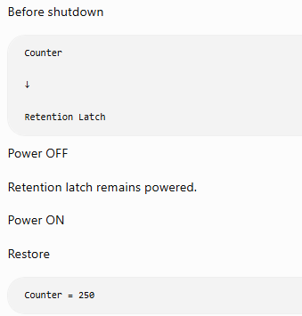

9. Always ON Cells
Some logic must remain ON.
Examples
Power controller
Reset controller
Clock controller
Wake-up logic
These cells belong to the Always-On power domain.

10. Level Shifter
Suppose
CPU : 1.2V
GPU : 0.8V
Signal
CPU
↓
GPU
Voltage mismatch.
Need
CPU

↓

Level Shifter

↓

GPU
Two cases
High → Low
Low → High
Different level shifters may be used depending on the direction and library.

Relation between Isolation and Level Shifter
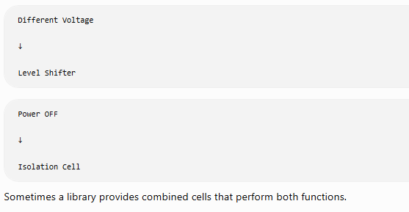

Role of UPF During the Design Flow
RTL

↓

Read UPF

↓

Synthesis
The synthesis tool inserts:
- Isolation cells
- Retention cells
- Level shifters
- Power switches (depending on methodology)
Then : Netlist -> Floorplan -> Power Planning -> Placement -> CTS -> Routing
The implementation tool uses the UPF information throughout the flow.

In Physical Design (Innovus), what do PD engineers do?
Once the synthesized netlist (with UPF intent) reaches Physical Design, you typically:
- Create separate power grids (rings, straps, rails) for each power domain.
- Connect the correct supply nets (for example, VDD_CPU, VDD_GPU, VDD_IO).
- Ensure isolation cells, level shifters, retention cells, and always-on cells are placed in legal locations.
- Route always-on power separately where required.
- Verify power-domain connectivity and power intent.
- Check that power switches and switched power nets are connected correctly.
- Run low-power checks (LP verification) to ensure the implementation matches the UPF intent.
Complete Example
CHIP
-------------------------------------------------

CPU Domain
1.0V
Always ON
|
|
Isolation Cell
|
-------------------
| |
GPU Domain Camera Domain
0.8V 1.0V
Sleep Switch Sleep Switch
| |
Retention Reg Retention Reg

-------------------------------------------------
Here:
- Power Domain: CPU, GPU, Camera (different ON/OFF behavior)
- Voltage Domain: CPU = 1.0V, GPU = 0.8V, Camera = 1.0V
- Sleep Transistor: Disconnects power to GPU and Camera
- Isolation Cell: Protects the CPU from invalid signals when another domain is OFF
- Retention Register: Saves important state before power is removed
- Level Shifter: Needed between CPU (1.0V) and GPU (0.8V) if signals cross voltage domains
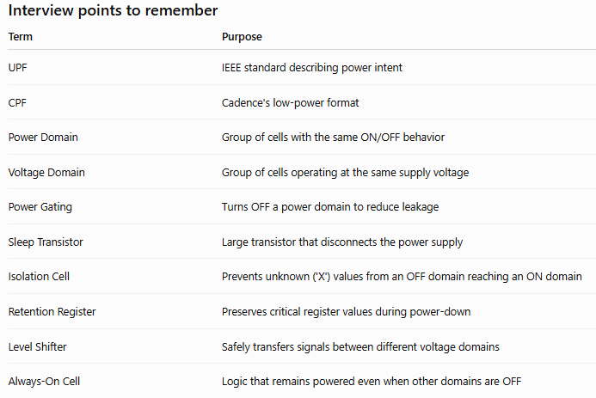
Since you're currently studying power planning in Innovus, the next logical topic is how a UPF file is written (commands such as create_power_domain, create_supply_port, create_supply_net, set_domain_supply_net, create_power_switch, set_isolation, set_retention, and set_level_shifter) and how these commands map to what you see during floorplanning and placement. That connection makes the concepts much easier to understand.

