Complete VLSI STA and Physical Design Notes

ASIC Flow
Complete ASIC Flow:
1. Specification
2. RTL Design
3. Functional Verification
4. Synthesis
5. DFT (Design for Test)
6. Physical Design
7. STA & Signoff
8. Fabrication
9. Packaging
10. Testing & Validation
ASIC means Application-Specific Integrated Circuit.

Physical Design (PD) Flow
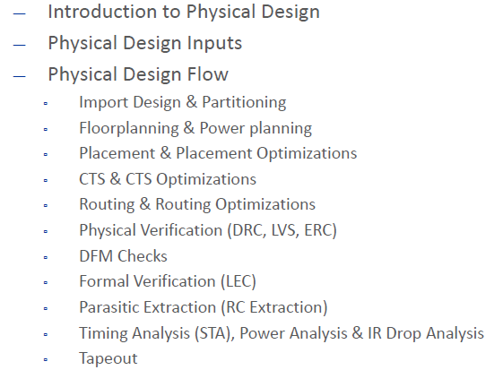
Goal:
Convert logical netlist into manufacturable chip layout.

Timing Paths
A timing path is the complete path through which data travels from one point to another point in the chip.
Basic Timing Path:
Launch Flip-Flop → Combinational Logic → Capture Flip-Flop
Main Components:
1. Launch Flip-Flop
2. Combinational Logic
3. Capture Flip-Flop
Types of Timing Paths:
- Register to Register
- Input to Register
- Register to Output
- Input to Output
Critical Path:
The path having maximum delay is called critical timing path.

1. Net Delay and Cell Delay
Cell Delay:
Cell delay is the delay produced inside a logic gate or standard cell.
Example: inverter delay, NAND gate delay.
Net Delay:
Net delay is the delay caused by interconnect wires between cells.
It depends on:
- Wire resistance (R)
- Wire capacitance (C)
- Wire length
Total Path Delay Formula:
Total Delay = Cell Delay + Net Delay
Important Points:
- In modern technologies, net delay is often larger than cell delay.
- Placement and routing strongly affect net delay.

2. Setup Time and Hold Time
Setup Time:
Minimum time before clock edge during which data must remain stable.
Hold Time:
Minimum time after clock edge during which data must remain stable.
Setup Check Formula:
Clock Period >= Clock-to-Q + Combinational Delay + Setup Time + Skew
Hold Check Formula:
Clock-to-Q + Minimum Delay >= Hold Time + Skew
Violations:
- Large delay causes setup violation.
- Very small delay causes hold violation.

3. Clock Skew
Clock skew means difference in arrival time of clock signal between launch and capture flip-flops.
Positive Skew:
Capture clock arrives later.
Negative Skew:
Capture clock arrives earlier.
Causes of Skew:
- Unequal wire lengths
- Buffer delays
- Clock tree imbalance
Skew Formula:
Skew = Capture Clock Arrival - Launch Clock Arrival

4. Impact of Clock Skew
Positive Skew:
- Improves setup timing
- Worsens hold timing
Negative Skew:
- Worsens setup timing
- Improves hold timing
Important Understanding:
Setup and hold timing are always affected opposite to each other by skew.

Timing Arcs
Timing arc means relationship between input transition and output transition inside a standard cell.
Examples:
- Inverter: A → Y
- NAND Gate: A → Y, B → Y
Types of Timing Arcs:
- Combinational Timing Arc
- Sequential Timing Arc

Unateness
Unateness describes output behavior with respect to input transition.
Types:
1. Positive Unate:
Input and output move in same direction.
Example: Buffer
2. Negative Unate:
Input and output move in opposite direction.
Example: Inverter
3. Non-Unate:
Output direction cannot be predicted.
Example: XOR, MUX
Unateness is important for STA delay calculation and transition propagation.

6. False Paths
False path is a logically impossible or unused timing path.
STA ignores these paths because data never propagates in real operation.
Examples:
- MUX mutually exclusive paths
- Debug logic inactive during normal mode
Importance:
Reduces unnecessary timing violations.

7. Half Cycle Paths
Half-cycle path uses opposite clock edges.
Example:
- Launch on positive edge
- Capture on negative edge
Available timing becomes half clock period.
Formula:
Available Time = Clock Period / 2

8. Multi-Cycle Paths (MCP)
Multi-cycle path is a path allowed to take more than one clock cycle.
Example:
A complex arithmetic block may need 2 or 3 cycles.
MCP Setup Formula:
Required Time = N × Clock Period
Where N = number of cycles.
Importance:
Prevents unnecessary setup violations on slow functional paths.

9. Timing Arcs and Unateness
Timing Arc:
Relationship between input pin transition and output pin transition.
Unateness Types:
1. Positive Unate
Input ↑ → Output ↑
2. Negative Unate
Input ↑ → Output ↓
3. Non-Unate
Output transition unpredictable.
Examples:
- Buffer → Positive Unate
- Inverter → Negative Unate
- XOR → Non-Unate

Important STA Concepts Summary Table
Concept | Improves | Worsens
Positive Skew | Setup | Hold
Negative Skew | Hold | Setup
Large Delay | Hold | Setup
Small Delay | Setup | Hold

Basic Timing Diagram
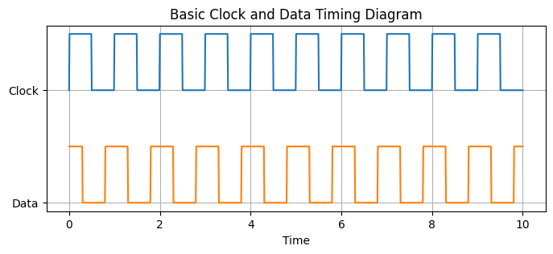
The timing diagram above shows clock and data relationship used for setup and hold analysis.

