Timing :
In real chip design flow:
1️ Setup violations are prioritized first
2️ Hold violations are fixed later
Reason:
- Setup depends on clock frequency
- Hold does not depend on clock period
- Fixing hold early can break setup badly.
Typical flow in tools from Cadence Design Systems or Synopsys:
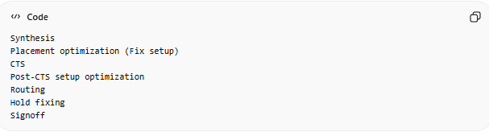

Why Setup First?
Setup check
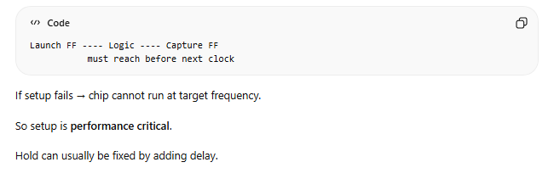
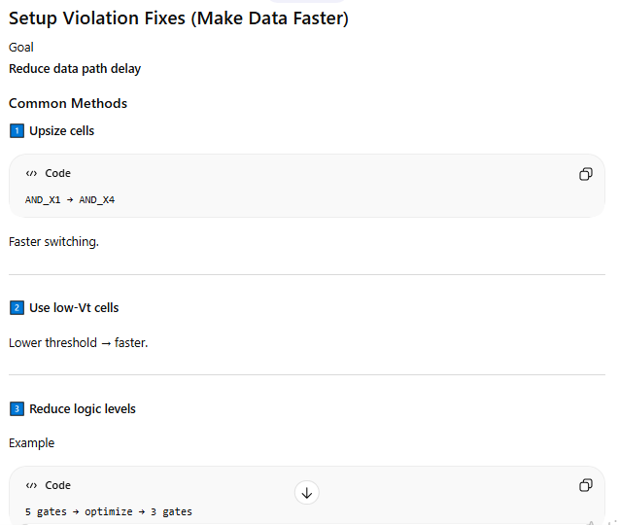
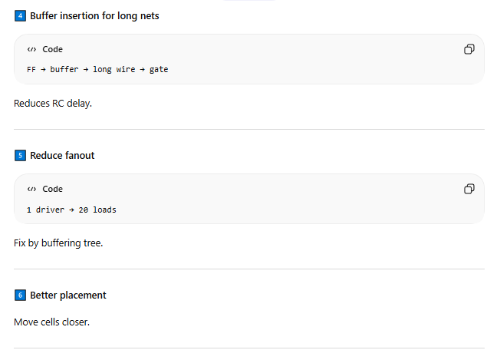
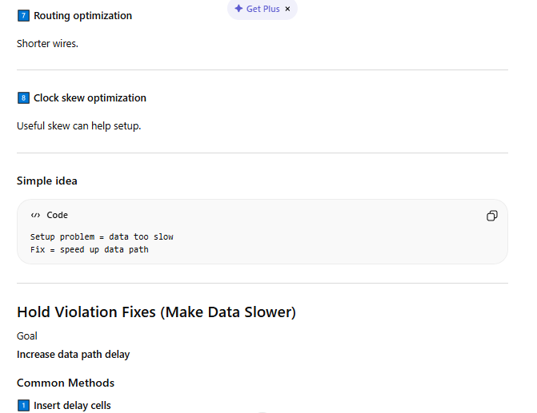
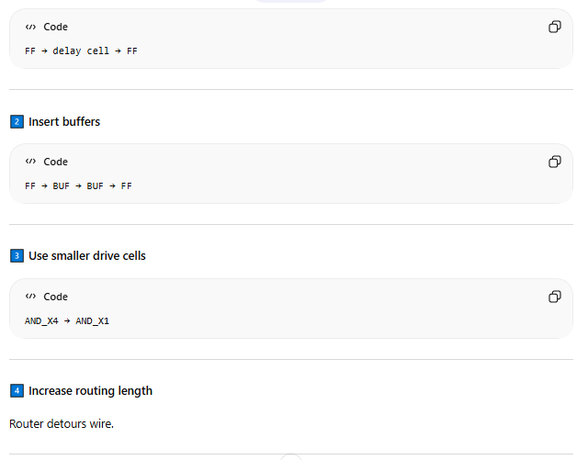
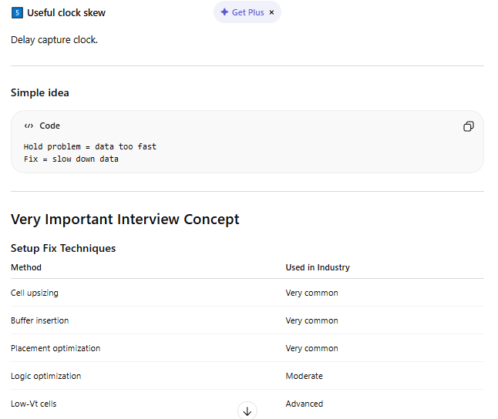
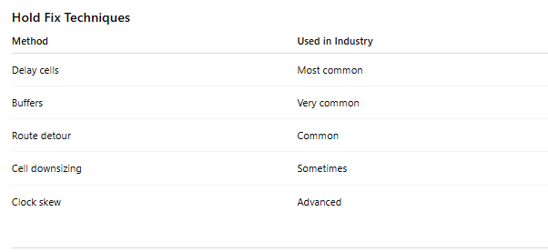
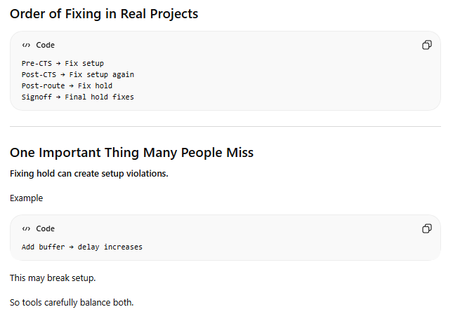
Which violation is fixed first?
Setup violations are fixed first because they determine the maximum operating frequency. Hold violations are fixed later by inserting delay cells or buffers.
Buffers :
A buffer is a simple logic cell that:
- Takes input
- Gives same output
- But with stronger drive strength
Function:
Y=A
Y = A
Y=A
It does NOT change logic.
It only improves signal strength or adds delay.
Buffers are essential for hold fixing, fanout control, and clock tree building, but excessive buffering increases area, power, congestion, and may degrade setup timing
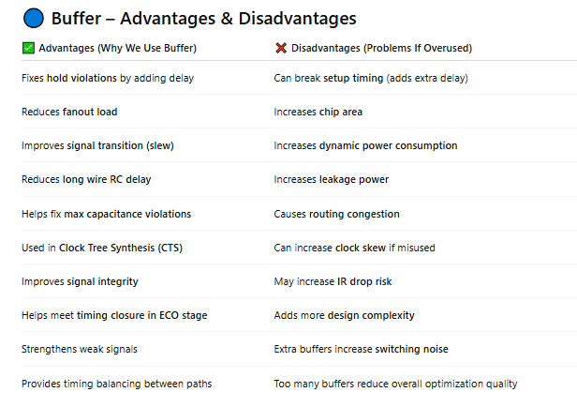

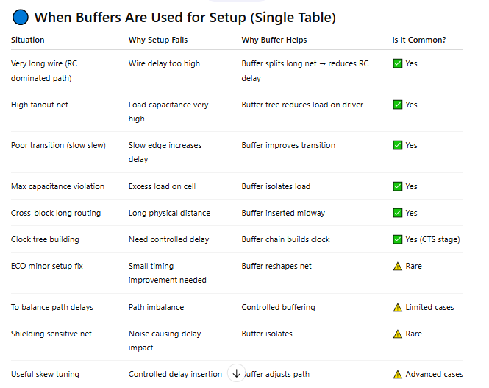
Buffers are NOT primary tool for setup fixing.
Primary tools for setup:
- Cell upsizing
- Low Vt swap
- Logic restructuring
- Placement improvement
- Useful skew
Buffer helps setup only when:
- Delay is dominated by wire RC
- Or fanout problem

Buffers are not the primary solution for setup violations. They are used for setup improvement mainly in RC-dominated long nets or high fanout cases where splitting the load reduces overall delay.
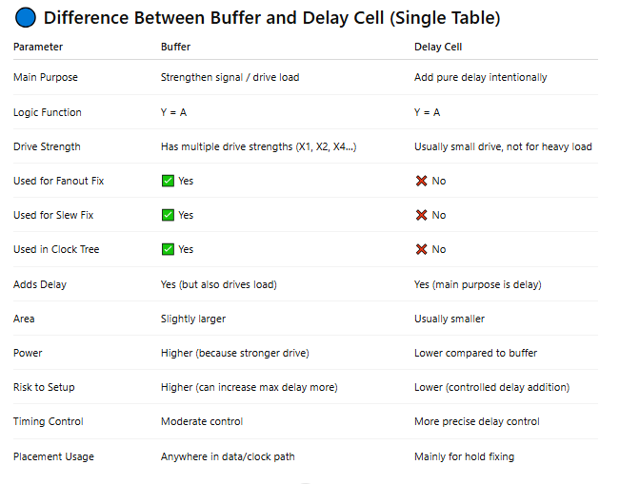
Fanout :
✅ 1 What is Fanout?
Fanout = Number of input pins driven by one output pin.
If one gate output connects to 5 gates →
👉 Fanout = 5

✅ 2 Why Fanout Matters?
Each input pin adds capacitance (load).
More fanout → More capacitance → More delay
Timing delay formula:
Delay=R×CDelay = R \times CDelay=R×C
- R = Driver resistance
- C = Load capacitance
If C increases → Delay increases

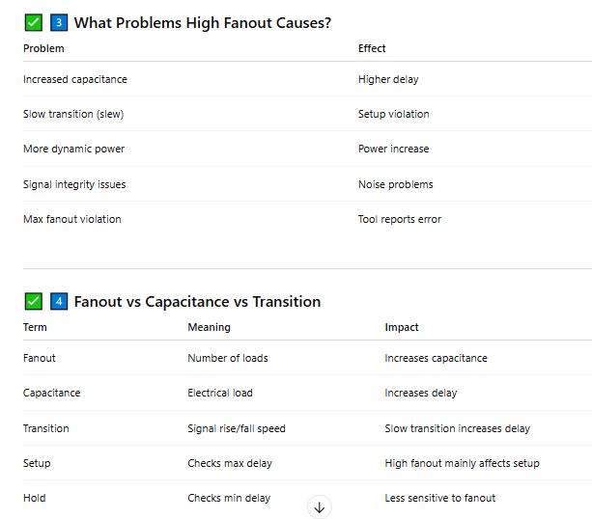

✅ 5 Why Setup Is More Affected?
Setup checks maximum delay.
High fanout → More load → Data arrives late → Setup violation.
Hold checks minimum delay, so usually less affected.
6 How We Fix High Fanout?

🔹 Method 1: Buffer Insertion (Physical Solution)
Split load using buffer tree.
Used commonly in:
- Clock tree
- Data nets

🔹 Method 2: Cell Upsizing
Use stronger driver.
Risk:
- Can create hold violation.

🔹 Method 3: Logic Replication (Cloning)
Duplicate driver cell and divide loads.
Best for:
- Very high fanout nets
- Setup critical paths

🔹 Method 4: Better Placement
Reduce wire length → Reduce effective capacitance.
7 Clock Network and Fanout
Clock drives thousands of flip-flops.
So we use:
Clock Tree Synthesis (CTS)
Built mainly using buffers.
Clock always has very high fanout.
8 Interview Important Points
✔ Fanout increases load capacitance
✔ Load capacitance increases delay
✔ High fanout mainly affects setup timing
✔ Buffer insertion and logic replication are common fixes
✔ Clock nets require buffer trees due to huge fanout
Final Concept in One Line
More fanout → More capacitance → More delay → Setup risk

