Timing report calculation:
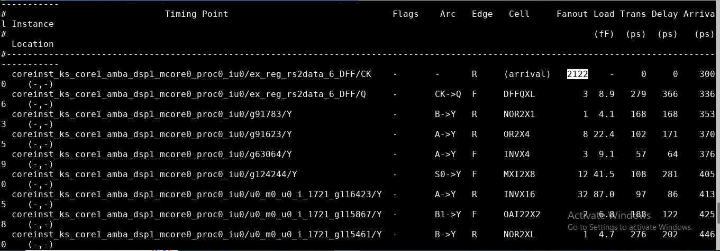
the arrival time
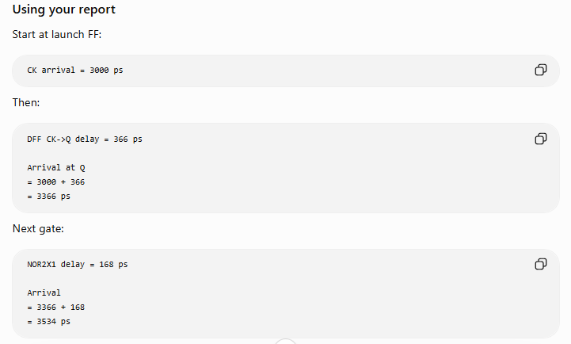
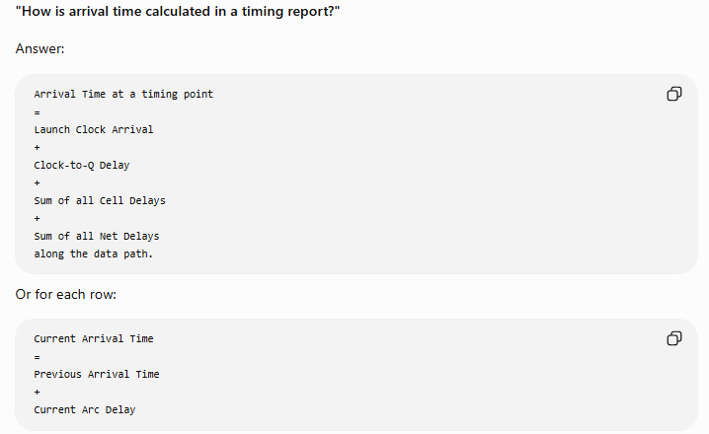

STA reports the timing arc through which the analyzed signal propagates. Although the NOR gate has both A→Y and B→Y timing arcs, only the arc corresponding to the actual timing path is shown in the report.
Timing Report & STA Concepts – Quick Reference

1. Arrival Time Calculation
Arrival Time is calculated as:
Arrival Time = Previous Arrival Time + Current Arc Delay
Example:
Launch Clock Arrival = 3000 ps
DFF CK→Q Delay = 366 ps
Arrival at Q = 3000 + 366 = 3366 ps
Next Gate Delay (NOR2X1) = 168 ps
Arrival = 3366 + 168 = 3534 ps
Next Gate Delay (OR2X4) = 171 ps
Arrival = 3534 + 171 = 3705 ps
Thus, the arrival column is obtained by continuously adding delays along the path.

2. Timing Report Columns

Arc
Timing relationship used by STA.
Examples:
CK→Q
A→Y
B→Y

Fanout
Number of loads driven by the output pin.
Higher fanout generally increases load and delay.

Load (Capacitance)
Total capacitance driven by the cell output.
Higher load increases delay.

Transition (Slew)
Rise/Fall edge speed at the pin.
Large transition causes larger delays.

Delay
Delay contributed by the current cell/net.

Arrival
Cumulative delay from launch point up to the current point.

3. Relationship Between Columns
Fanout ↑
↓
Load ↑
↓
Delay ↑
↓
Arrival ↑
Transition ↑
↓
Delay ↑
↓
Arrival ↑
STA computes delay using Liberty (.lib) tables:
Cell Delay = f(Input Slew, Output Load)

4. NOR Gate Timing Arc
For a NOR2 gate:
A
\
NOR ---> Y
/
B
The library contains separate arcs:
A→Y
B→Y
A timing report may show:
NOR2X1 B→Y
This means the analyzed path propagated through pin B.
It does NOT mean pin A is ignored.

5. If A Arrives Later Than B
Example:
A arrival = 5 ns
B arrival = 3 ns
A→Y delay = 0.15 ns
B→Y delay = 0.20 ns
Output contributions:
A path = 5.15 ns
B path = 3.20 ns
Output Arrival = MAX(5.15, 3.20)
Output Arrival = 5.15 ns
For setup analysis, STA propagates the worst-case (latest) arrival.

6. Why Timing Report Shows Only One Arc
STA evaluates all relevant inputs internally.
The report displays only the arc that belongs to the reported timing path.
Example:
FF → B → NOR → Y
Report shows:
B→Y
Even though STA has already evaluated A→Y internally.

7. Setup Timing Equation
Setup Slack = Required Time − Arrival Time
Where:
Arrival Time = Launch Clock Arrival + Clock-to-Q Delay + Cell Delays + Net Delays
Required Time = Capture Clock Arrival + Clock Period − Setup Time − Uncertainty
If Slack > 0 → Timing Met
If Slack < 0 → Setup Violation

8. Common Delay Contributors
Large Fanout -> Large Capacitance - > Poor Transition (High Slew)
Complex Logic Gates (MUX, AOI, OAI, NOR)
Long Nets -> Weak Drive Strength Cells

9. Interview Answers
Q: How is arrival time calculated?
A: Current Arrival = Previous Arrival + Current Arc Delay.
Q: Why does the report show B→Y and not A→Y?
A: Because the reported timing path propagates through pin B. The NOR gate contains both A→Y and B→Y timing arcs.
Q: If A arrives later than B, will timing be impacted?
A: Yes. STA evaluates all relevant inputs and propagates the worst-case arrival to the output.
Q: What determines cell delay?
A: Input slew and output load from Liberty timing tables.

STA Fundamentals: DAT, DRT, Setup, Hold, Slack

1. DAT (Data Arrival Time)
DAT is the time at which data reaches the capture flip-flop D pin.
Formula:
DAT = Launch Clock Arrival + Clock-to-Q Delay + Data Path Delay
Where:
Data Path Delay = Cell Delays + Net Delays
Example:
Launch Clock Arrival = 3.0 ns
Clock-to-Q = 0.3 ns
Combinational Delay = 1.5 ns
DAT = 3.0 + 0.3 + 1.5
DAT = 4.8 ns

2. DRT (Data Required Time)
DRT is the latest time by which data must arrive at the capture flip-flop D pin.
Formula:
DRT = Capture Clock Arrival + Clock Period - Setup Time - Clock Uncertainty
Example:
Capture Clock Arrival = 3.1 ns
Clock Period = 5 ns
Setup Time = 0.1 ns
Uncertainty = 0.1 ns
DRT = 3.1 + 5 - 0.1 - 0.1 = 7.9

3. Setup Check
Setup check ensures data reaches the destination flip-flop before the next active clock edge.
Condition:
DAT < DRT
If data arrives too late, setup violation occurs.
Example:
DAT = 7.5 ns
DRT = 7.9 ns
Timing Met
Example:
DAT = 8.2 ns
DRT = 7.9 ns
Setup Violation

4. Setup Slack
Formula:
Setup Slack = DRT - DAT
Example:
DRT = 7.9 ns
DAT = 7.5 ns
Setup Slack = 7.9 - 7.5
Setup Slack = +0.4 ns
Positive Slack → Timing Met
Negative Slack → Setup Violation

5. Hold Check
Hold check ensures data does NOT reach the destination flip-flop too early after the same clock edge.
Condition:
DAT > Hold Requirement

6. Hold Required Time
For hold analysis:
Hold Required Time = Capture Clock Arrival + Hold Time + Clock Uncertainty
Example:
Capture Clock Arrival = 0.1 ns
Hold Time = 0.05 ns
Uncertainty = 0.05 ns
Hold Required Time = 0.2 ns

7. Hold Slack
Formula:
Hold Slack = DAT - Hold Required Time
Example: DAT = 0.4 ns
Hold Required Time = 0.2 ns
Hold Slack = 0.4 - 0.2
Hold Slack = +0.2 ns
Timing Met
Example:
DAT = 0.1 ns
Hold Required Time = 0.2 ns
Hold Slack = 0.1 - 0.2
Hold Slack = -0.1 ns
Hold Violation

8. Quick Comparison
Setup Analysis
Purpose: Checks data is not late.
Formula: Setup Slack = DRT – DAT
Requirement: DAT < DRT
Violation: Negative Setup Slack
Hold Analysis
Purpose: Checks data is not early.
Formula: Hold Slack = DAT - Hold Required Time
Requirement: DAT > Hold Required Time
Violation: Negative Hold Slack

9. Easy Way to Remember
Setup: "Data must arrive BEFORE required time."
Setup Slack = Required - Arrival
Hold: "Data must remain stable AFTER clock edge."
Hold Slack = Arrival - Required

10. Interview Answer
DAT (Data Arrival Time): Actual time data reaches destination D pin.
DRT (Data Required Time): Latest allowable arrival time for setup analysis.
Setup Slack: DRT - DAT
Hold Slack: DAT - Hold Required Time
Positive Slack:Timing Met
Negative Slack:Timing Violation

