1. What is Floor planning?
Floor planning is the process of deciding:
- Chip size (Core Area)
- Macro placement (SRAMs, Memories, IPs)
- IO placement
- Power structure planning
- Routing space reservation
- Utilization setting

Goal : Create a layout structure that can achieve:
- Better timing
- Lower congestion
- Lower power
- Easier routing
- Better IR Drop performance

2. PD Flow Overview
RTL
↓
Synthesis
↓
Floorplanning
↓
Power Planning
↓
Placement
↓
CTS
↓
Routing
↓
STA & Signoff
↓
GDSII

Previous Stage Input
Synthesis provides: Netlist (.v) , SDC (.sdc) , MMMC views and Timing reports.

Next Stage
Placement stage.

3. Inputs Required for Floorplan

Logical Inputs

Netlist : design.v
contains: Cells , Connections and Hierarchy

Constraints : design.sdc
Contains: Clocks, Input delays, Output delays, False paths and Multicycle paths

Physical Inputs

LEF Files : tech.lef, stdcell.lef, and macro.lef.
Contain: Cell dimensions, Pin locations and Routing layers.

Technology Files : tf, ict, tlu+ and captable.
Contain RC information.
Timing Libraries : .lib
Contain: Setup, Hold, Cell delays and Power data.

MMMC File
Contains: Corners, Modes and RC corners

4. Outputs of Floorplanning
Typically:
design_floorplan.enc
design_floorplan.def
Contains:
- Core size
- Macro locations
- IO locations
- Blockages
- Power structure
Given to placement team/stage.

5. Main Activities Done by PD Engineer

Activity 1: Decide Core Area
Formula: Core Area = Netlist Area ÷ Utilization
Example: Netlist Area = 1,000,000 µm²
Utilization = 70%
Core Area =1,000,000/0.7
=1,428,571 µm²

Activity 2: Decide Aspect Ratio
Aspect Ratio: Height / Width
Examples: 1.0 → Square
0.5 → Wide
2.0 → Tall
Typical: 0.8 to 1.2
Activity 3: Macro Placement
Place:
- SRAM
- ROM
- Analog IP
- PLL
- DSP blocks
Rules:
- Near related logic
- Avoid center blockage
- Leave routing channels
Example:
Bad:

MEM1 MEM2 MEM3
MEM4 MEM5 MEM6

Huge congestion
Good:

MEM1 MEM2

Channel

MEM3 MEM4

Activity 4: IO Placement
Place: Inputs, Outputs and Clock pins.
Example: Clock input near PLL

Activity 5: Create Blockages
Prevent placement.
Types: Hard Blockage, Soft Blockage and Partial Blockage.
Used to reduce congestion.
Activity 6: Power Planning
Create: Power Ring
VDD
VSS
Create: Power Stripes
Purpose: Reduce IR Drop and Reduce EM violations

Activity 7: Pin Assignment
For hierarchical blocks: Place pins strategically.
Bad pin placement causes: Congestion, Long routes and Timing issues.
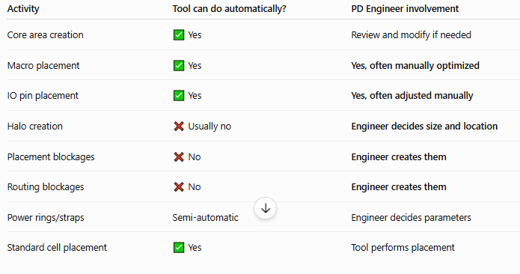

6. Optimization Techniques Used During Floorplan

Macro Clustering : Place communicating macros together.
Benefit: Short wire length and Better timing
Channel Spacing : Reserve routing space.
Benefit: Less congestion

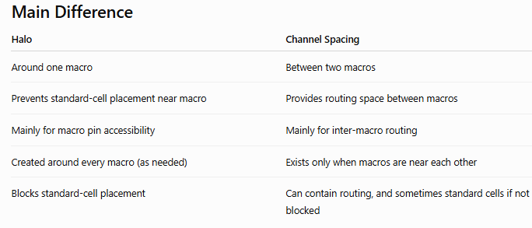
Utilization Optimization : Typical: 65% - 75%
Too High: Congestion
Too Low: Larger chip area

Macro Orientation : Rotate: R0, R90, MX and MY
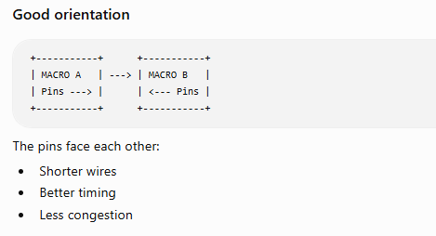
To reduce wirelength.

Feed through Planning
Reserve path for signals crossing macros.

Power Optimization
Increase power stripes.
Benefit: Lower IR Drop

7. Checks Done in Floorplan

Floorplan Review
Check: Core size, Aspect ratio and Macro placement.

Congestion Check
Identify: Routing hotspots

Timing Estimation
Check: Long paths
Power Check
Check: IR Drop

DRC Check
Check: Spacing and Overlap

8. Common Floorplan Commands (Innovus)
floorPlan : Create floorplan.

addRing : Create power ring.

addStripe : Create power stripes.

placeInstance : Place macros.

createRouteBlk : Create blockage.

reportCongestion : Check congestion.

9. Important Interview Questions

Q1. What is floorplanning?
Floorplanning is deciding core area, aspect ratio, macro placement, IO placement and power planning before placement.

Q2. What are floorplan inputs?
- Netlist, SDC, LEF, LIB, Technology files and MMMC

Q3. What is utilization?
Cell Area/Core Area ×100

Q4. What happens if utilization is 90%?
- Congestion increases, Timing degrades and Routing becomes difficult

Q5. What is aspect ratio?
Height / Width

Q6. Why are channels required between macros?
To provide routing resources.

Q7. What is a hard blockage?
No cells can be placed.

Q8. What is a soft blockage?
Placement discouraged but allowed.

Q9. What is a power ring?
Metal ring around core carrying VDD and VSS.

Q10. Why is floorplanning important?
About 70% of timing, congestion, power and routability success depends on floorplan quality.

One-Line Interview Summary
Floorplanning is the stage where a PD engineer defines core size, utilization, aspect ratio, macro placement, IO placement, blockages, and power structure using inputs such as Netlist, SDC, LEF, LIB, MMMC, and technology files, and generates a DEF/database that is used by the Placement stage.
For interviews, after floorplanning, the next topic you should learn is Placement stage (global placement, legalization, congestion optimization, timing optimization, HFN buffering, scan chain reordering, etc.), because interviewers usually ask the complete flow from Floorplan → Placement → CTS.

