CoachDesk — Complete Software Requirements & Technical Specification
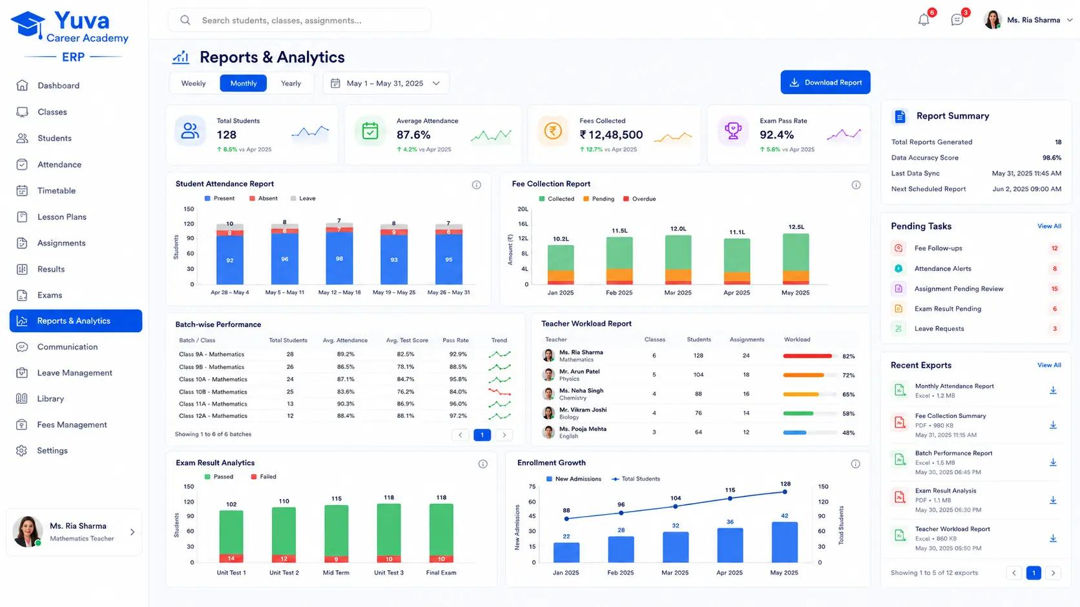

CoachDesk
Project specification finalized
Multi-Tenant Coaching Institute Management SaaS
A centralized platform for coaching centres, tuition classes, competitive exam institutes, computer training centres, and educational organizations.
This document defines the product scope, functional requirements, database design, API architecture, frontend/backend structure, security standards, and phased development roadmap.
The architecture is designed so CoachDesk can start with a small coaching centre and scale to large institutes operating multiple branches.

1. Project overview

1.1 Product vision
CoachDesk will provide a complete digital management platform for coaching institutes.
An institute owner should be able to manage:
- Students and admissions
- Courses, subjects, and batches
- Teachers and employees
- Student attendance
- Fee structures and payments
- Examinations and results
- Timetables and classrooms
- Homework and study materials
- Parent/student communication
- Reports and analytics
- Multiple branches
The platform will operate as a subscription-based SaaS product.

1.2 Project decisions
Requirement | Final decision
Product name | CoachDesk
Product type | Education Management SaaS
Target audience | All types of coaching institutes
Architecture | Multi-tenant SaaS
Frontend | React + Vite + TypeScript
Backend | Node.js + NestJS
Database | MySQL 8
ORM | Prisma
UI framework | Tailwind CSS + shadcn/ui
API | REST API
Authentication | JWT + refresh tokens
Development | Phased implementation
Deployment | Separate frontend, backend and database

1.3 Target customers
CoachDesk should support these institute types:
- School tuition centres
- Competitive examination institutes
- IIT-JEE / NEET coaching centres
- SSC / Banking / Government exam institutes
- Computer training institutes
- English-speaking institutes
- Skill development centres
- Professional training institutes
- Private tutors and small academies
The system should not hardcode any specific educational category. Institutes should be able to configure their own courses, subjects, batches, fee structures, and academic sessions.

2. Application architecture
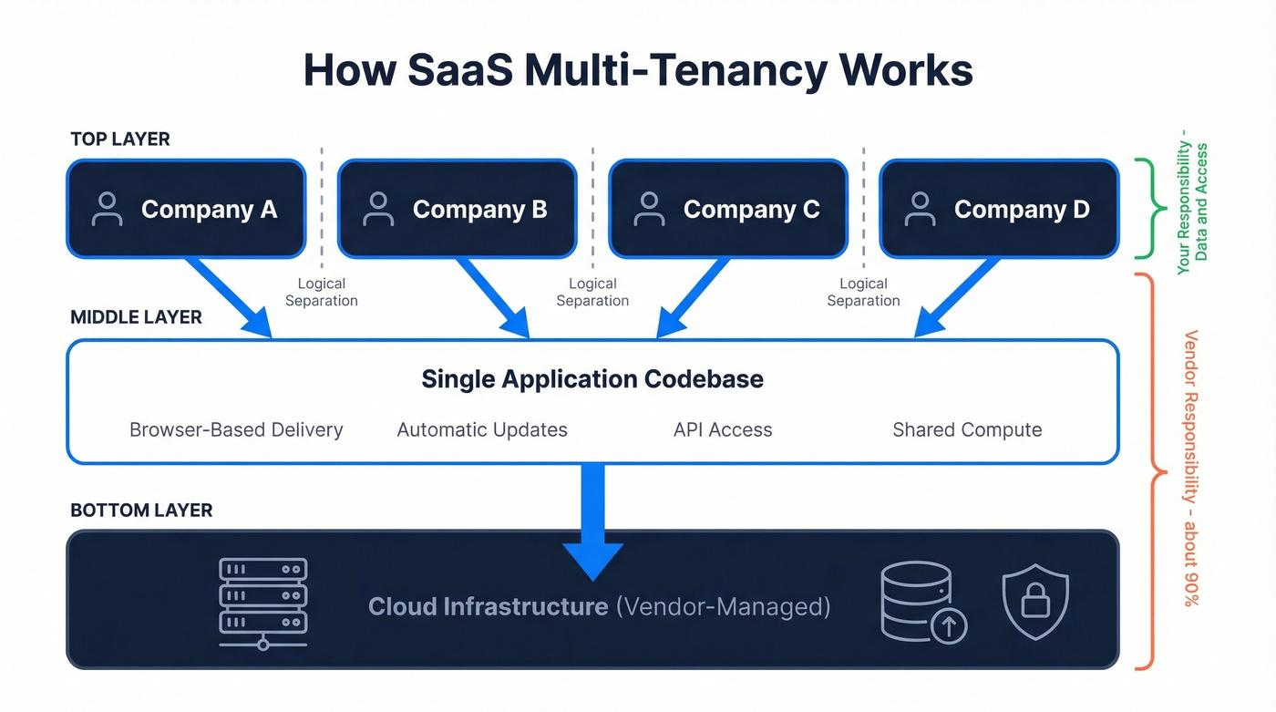CoachDesk will have three primary application areas.
Application | Purpose
Super Admin Panel | Manage the entire SaaS platform
Institute Admin Panel | Manage individual institutes and branches
Student / Parent Portal | Access academic and payment information
Teacher and staff access will be provided through role-specific dashboards.

2.1 Multi-tenant architecture
Multiple institutes will use the same application and database infrastructure.
Example:
CoachDesk SaaS Platform
Shared application infrastructure
Institute A  Greater Noida  Tenant A | Institute B  Delhi  Tenant B | Institute C  Noida  Tenant C
Shared MySQL Database
Tenant-scoped records and access control

Important security requirement:
Every institute-owned record must be associated with an institute_id.
The backend must automatically identify the logged-in user's institute and restrict database queries to that tenant.
For example:
- Institute A must never see Institute B students.
- Institute A must never access Institute B fee records.
- A teacher must only access assigned batches.
- A parent must only access linked students.
Do not rely on frontend filtering for tenant security. Enforce it at the API/service/database query level.

3. Application modules
I recommend the following complete module structure.

3.1 Super Admin Panel
Platform administration
The Super Admin controls the entire CoachDesk SaaS platform.
Module | Features
Dashboard | Total institutes, users, students, revenue
Institutes | Add, edit, activate, suspend institutes
Subscriptions | Plans, renewals, expiry, cancellations
Payments | Subscription payments and transaction history
Plans | Configure subscription packages
Users | View platform and institute users
Support | Manage tickets and customer requests
Notifications | Global announcements
Settings | Platform configuration
Activity Logs | Track administrative activities
Super Admin dashboard statistics:
- Total institutes
- Active institutes
- Trial institutes
- Expired subscriptions
- Total registered students
- Monthly recurring revenue
- Subscription renewal report
- New institute registrations

3.2 Institute Management
Each institute gets its own workspace.
Features:
- Institute registration
- Institute profile
- Logo and branding
- Contact details
- Address and location
- Academic session configuration
- Branch management
- Institute-specific settings
- Custom receipt format
- Institute-specific notification templates
One institute may have multiple branches.
For example:
ABC Coaching Institute
│
├── Greater Noida Branch
├── Delhi Branch
└── Noida Branch
Users can be assigned to one or more branches depending on permissions.

3.3 Student Management
Core module
Features:
- Student registration
- Student admission
- Unique student ID
- Profile management
- Student photograph
- Parent/guardian information
- Document uploads
- Course enrollment
- Batch enrollment
- Student status management
- Admission cancellation
- Student transfer
- Student ID card
- Student history
- Excel import/export
Suggested student ID format:
CD-GN-2026-00001
CD-GN-2026-00002
CD-DL-2026-00001
The ID generation pattern should be configurable by institute.

3.4 Course & Subject Management
Features:
- Create courses
- Create subjects
- Assign subjects to courses
- Course duration
- Course fees
- Course descriptions
- Course syllabus
- Course status
- Academic session mapping
Example:
Course | Subjects | Duration
Class 10 | Maths, Science, English | 12 months
IIT-JEE | Physics, Chemistry, Maths | 12 months
SSC | Reasoning, Maths, English | 6 months
Computer Basics | MS Office, Internet | 3 months

3.5 Batch Management
Features:
- Create batches
- Batch code
- Batch capacity
- Course assignment
- Subject assignment
- Teacher assignment
- Classroom assignment
- Start and end date
- Batch timing
- Student enrollment
- Batch transfer
- Batch status
A student can have multiple historical enrollments, but active enrollments should be controlled according to the institute's rules.

3.6 Attendance Management
Core module
Features:
- Daily attendance
- Batch-wise attendance
- Date-wise attendance
- Bulk present/absent marking
- Late attendance
- Half-day attendance
- Leave management
- Attendance correction requests
- Attendance reports
- Monthly attendance summary
- Parent absence notifications
Attendance statuses:
PRESENT
ABSENT
LATE
HALF_DAY
ON_LEAVE
Important business rule: prevent duplicate attendance records for the same student, batch, and attendance session.

3.7 Fee & Payment Management
Core financial module
Features:
- Fee structures
- Admission fee
- Monthly fee
- Quarterly fee
- Annual fee
- Examination fee
- Installments
- Partial payments
- Discounts
- Scholarships
- Late fees
- Fee due dates
- Payment history
- Payment receipts
- Refunds
- Outstanding fee reports
- Daily collection reports
Payment methods:
- Cash
- UPI
- Bank transfer
- Cheque
- Online payment gateway
Critical financial rule: Never update or delete historical payment records to correct an error. Use refund, reversal, or adjustment transactions with a full audit trail.

3.8 Examination & Results
Features:
- Create examinations
- Assign exams to batches
- Add examination subjects
- Define maximum marks
- Enter student marks
- Calculate percentage
- Calculate grades
- Generate merit lists
- Subject-wise performance
- Generate report cards
- Exam history
Future enhancements:
- Online MCQ examination
- Question bank
- Negative marking
- Automatic result evaluation
- Time-limited tests

3.9 Teacher & Staff Management
Features:
- Teacher registration
- Employee profiles
- Qualifications
- Experience
- Subject assignment
- Batch allocation
- Teacher timetable
- Attendance
- Leave requests
- Salary records
- Staff permissions

3.10 Timetable & Classroom
Features:
- Weekly timetable
- Batch schedules
- Teacher availability
- Classroom allocation
- Lecture scheduling
- Holiday management
- Class cancellation
- Substitute teacher assignment
Conflict checking must prevent overlapping teacher or classroom bookings.

3.11 Student & Parent Portal
Students and parents should have separate login access.
Student portal:
- Profile
- Course and batch details
- Attendance
- Fee status
- Payment receipts
- Examination results
- Timetable
- Homework
- Study materials
- Notices
Parent portal:
- Linked student profiles
- Attendance information
- Fee status
- Payment history
- Academic results
- Notifications
- Announcements
A parent account can be linked to multiple children.

3.12 Homework & Study Material
Features:
- Upload notes
- Upload PDFs
- Add video links
- Assign homework
- Homework submission
- Submission deadlines
- Teacher comments
- Batch-wise materials
- Subject-wise materials

3.13 Notifications & Communication
Supported notification channels:
- In-app notifications
- Email
- SMS
- WhatsApp
Notification triggers:
- Student admission
- Fee payment received
- Fee due reminder
- Student absent
- Examination announcement
- Result published
- Homework assigned
- Holiday announcement
Integrations should be configurable per institute.

3.14 Reports & Analytics
Recommended reports:
Report | Details
Student Admission | New admissions by date
Active Students | Current student strength
Attendance | Daily/monthly attendance
Fee Collection | Date-wise collections
Fee Defaulters | Pending fee amounts
Payment History | All payment transactions
Course Performance | Course-wise student performance
Batch Strength | Batch-wise enrollment
Teacher Workload | Teacher-wise batch allocation
Examination | Marks, percentage and rank
Expenses | Institute operating expenses
Profit & Loss | Income versus expenses

4. Role-based access control
CoachDesk must use a flexible RBAC permission system.

4.1 Default roles
Role | Main permissions
Super Admin | Entire SaaS platform
Institute Owner | Full institute management
Branch Admin | Assigned branch management
Accountant | Fees, payments, finance reports
Teacher | Assigned batches, attendance, exams
Receptionist | Admissions, student profiles, fee collection
Student | Own academic records
Parent | Linked children's records

4.2 Permission format
Example permissions:
students.view
students.create
students.edit
students.delete

attendance.view
attendance.mark
attendance.edit

fees.view
fees.collect
fees.refund
fees.reports

exams.create
exams.edit
exams.enter_marks
exams.publish_results
Permissions should be configurable from the administration panel.

5. Complete database schema design
Use MySQL 8 with Prisma.
The following is the recommended logical schema. It defines the important tables, fields, and relationships. Exact Prisma models and indexes should be finalized during database implementation.

5.1 Common database conventions
Recommended common fields:
Field | Type | Purpose
id | BIGINT | Internal primary key
public_id | CHAR(36) | UUID exposed in APIs
institute_id | BIGINT | Tenant ownership
branch_id | BIGINT NULL | Branch ownership where applicable
created_at | DATETIME | Creation timestamp
updated_at | DATETIME | Last update timestamp
created_by | BIGINT NULL | Creator
updated_by | BIGINT NULL | Last editor
deleted_at | DATETIME NULL | Soft deletion
Do not add institute_id to global tables such as platform-wide subscription plans or global permissions. Tenant ownership should be applied where relevant.
Use:
- DECIMAL(12,2) for financial amounts.
- DATETIME stored consistently in UTC.
- DATE for calendar-only dates such as date of birth.
- Foreign keys for relational integrity.
- Unique constraints that include tenant identity where necessary.

5.2 SaaS & tenant tables
Table | Important fields
institutes | id, public_id, name, code, email, phone, logo, status
branches | id, institute_id, name, branch_code, address, status
subscription_plans | id, name, price, billing_cycle, limits, features
institute_subscriptions | id, institute_id, plan_id, start_date, end_date, status
subscription_payments | id, institute_id, subscription_id, amount, transaction_id, status
platform_settings | id, setting_key, setting_value
Subscription limits should support:
- Maximum students
- Maximum staff
- Maximum branches
- Maximum storage
- Enabled modules

5.3 Authentication & access tables
Table | Important fields
users | id, institute_id, name, email, phone, password_hash, status
roles | id, institute_id, name, is_system
permissions | id, permission_key, module
role_permissions | id, role_id, permission_id
user_roles | id, user_id, role_id, branch_id
user_permissions | id, user_id, permission_id, effect
refresh_tokens | id, user_id, token_hash, expires_at, revoked_at
password_resets | id, user_id, token_hash, expires_at
Super Admin users can be platform-level users without an institute ID. Institute users must have tenant ownership.

5.4 Academic tables
Table | Important fields
academic_sessions | id, institute_id, name, start_date, end_date, status
courses | id, institute_id, course_name, course_code, duration, fees
subjects | id, institute_id, subject_name, subject_code
course_subjects | id, course_id, subject_id
teachers | id, institute_id, user_id, qualification, joining_date
classrooms | id, institute_id, branch_id, room_name, capacity
batches | id, institute_id, branch_id, course_id, academic_session_id, batch_name, capacity, status
batch_subjects | id, batch_id, subject_id, teacher_id
batch_students | id, institute_id, batch_id, student_id, start_date, end_date, status
timetable | id, institute_id, batch_id, teacher_id, classroom_id, day_of_week, start_time, end_time

5.5 Student tables
Table | Important fields
students | id, institute_id, student_code, name, dob, gender, phone, email, address, status
student_guardians | id, institute_id, student_id, name, relationship, phone, email
student_documents | id, institute_id, student_id, document_type, file_path
student_admissions | id, institute_id, student_id, course_id, admission_date, admission_number, status
student_notes | id, institute_id, student_id, note, created_by
Student profile and enrollment should be separate. A student can change batches or courses without losing historical information.

5.6 Attendance tables
Table | Important fields
attendance_sessions | id, institute_id, branch_id, batch_id, attendance_date, status
attendance_records | id, institute_id, session_id, student_id, attendance_status, remarks
student_leave_requests | id, institute_id, student_id, start_date, end_date, reason, status
Add a unique constraint on (session_id, student_id).

5.7 Fee & payment tables
Table | Important fields
fee_structures | id, institute_id, course_id, name, total_amount
fee_structure_items | id, fee_structure_id, fee_type, amount
student_fee_accounts | id, institute_id, student_id, total_amount, discount_amount, status
fee_installments | id, institute_id, fee_account_id, installment_name, amount, due_date
payments | id, institute_id, student_id, receipt_number, payment_date, amount, method, status
payment_allocations | id, institute_id, payment_id, installment_id, allocated_amount
payment_refunds | id, institute_id, payment_id, amount, reason, status
fee_adjustments | id, institute_id, fee_account_id, amount, adjustment_type, reason
Use a separate payment allocation table so partial payments and payments covering multiple installments can be handled correctly.

5.8 Examination tables
Table | Important fields
exams | id, institute_id, batch_id, exam_name, exam_date, status
exam_subjects | id, exam_id, subject_id, maximum_marks, passing_marks
exam_questions | id, exam_subject_id, question_text, marks, question_type
exam_results | id, institute_id, exam_id, student_id, total_marks, percentage, grade
exam_result_details | id, exam_result_id, subject_id, obtained_marks

5.9 Homework & communication tables
Table | Important fields
homework | id, institute_id, batch_id, subject_id, title, description, due_date
homework_submissions | id, homework_id, student_id, file_path, submitted_at, marks
study_materials | id, institute_id, subject_id, batch_id, title, file_path
announcements | id, institute_id, title, description, target_type, status
notifications | id, institute_id, user_id, title, message, read_at
notification_templates | id, institute_id, channel, template_key, content
notification_logs | id, institute_id, channel, recipient, status, response

5.10 Audit & system tables
Table | Important fields
activity_logs | id, institute_id, user_id, action, module, record_id, metadata
expenses | id, institute_id, branch_id, category, amount, expense_date
support_tickets | id, institute_id, user_id, subject, status
file_uploads | id, institute_id, uploaded_by, file_path, mime_type, file_size
settings | id, institute_id, setting_key, setting_value

5.11 Important database rules
These should be treated as non-negotiable implementation requirements:
- Use foreign keys and indexes for relational consistency.
- Use tenant-scoped unique constraints, for example (institute_id, student_code).
- Use database transactions for fee collection, refunds, and attendance submission.
- Use soft deletion for records that have business history.
- Never hard-delete a payment or published examination result.
- Store uploaded documents outside the public web root or in private cloud storage.
- Maintain audit logs for sensitive changes.
- Validate all tenant and branch relationships on the server.
- Use pagination for large data lists.
- Store money in decimal fields, never floating-point types.

6. REST API architecture
Use a versioned REST API.
Base URL:
https://api.coachdesk.in/api/v1

6.1 Authentication APIs
Method | Endpoint | Purpose
POST | /auth/login | User login
POST | /auth/logout | Logout
POST | /auth/refresh | Refresh access token
POST | /auth/forgot-password | Password recovery
POST | /auth/reset-password | Reset password
GET | /auth/me | Current user profile

6.2 Institute APIs
GET /institutes
POST /institutes
GET /institutes/:id
PUT /institutes/:id
PATCH /institutes/:id/status

GET /branches
POST /branches
PUT /branches/:id
DELETE /branches/:id
Institute creation and subscription activation should be handled through controlled onboarding workflows.

6.3 Student APIs
GET /students
POST /students
GET /students/:id
PUT /students/:id
DELETE /students/:id

GET /students/:id/profile
GET /students/:id/fees
GET /students/:id/attendance
GET /students/:id/results

POST /students/import
GET /students/export
POST /students/:id/documents
Example filters:
GET /students?search=rahul&batch_id=10&status=active&page=1&limit=20

6.4 Course & batch APIs
GET /courses
POST /courses
PUT /courses/:id
DELETE /courses/:id

GET /subjects
POST /subjects

GET /batches
POST /batches
PUT /batches/:id

POST /batches/:id/students
DELETE /batches/:id/students/:studentId

GET /batches/:id/students
GET /batches/:id/timetable

6.5 Attendance APIs
GET /attendance/sessions
POST /attendance/sessions

GET /attendance/sessions/:id
POST /attendance/sessions/:id/records

PUT /attendance/records/:id
GET /attendance/reports/daily
GET /attendance/reports/monthly
GET /attendance/students/:studentId
Attendance submission should be atomic: either all validated records are saved successfully, or the operation fails without partially updating the session.

6.6 Fee APIs
GET /fee-structures
POST /fee-structures

GET /student-fees
POST /student-fees

GET /fee-installments
POST /fee-installments

GET /payments
POST /payments
GET /payments/:id
POST /payments/:id/refund

GET /fees/defaulters
GET /fees/reports/collection
GET /payments/:id/receipt

6.7 Examination APIs
GET /exams
POST /exams
PUT /exams/:id

POST /exams/:id/subjects
POST /exams/:id/results

GET /exams/:id/results
GET /students/:id/results
GET /exams/:id/merit-list

POST /exams/:id/publish-results
Published results should be protected from unauthorized modification.

6.8 API response standard
Successful response:
{
"success": true,
"message": "Student created successfully",
"data": {
"id": "student-public-uuid",
"student_code": "CD-GN-2026-00001",
"name": "Rahul Sharma"
}
}
Paginated response:
{
"success": true,
"data": [],
"pagination": {
"page": 1,
"limit": 20,
"total": 150,
"totalPages": 8
}
}
Error response:
{
"success": false,
"message": "Validation failed",
"errors": [
{
"field": "phone",
"message": "Phone number is required"
}
]
}
Use consistent HTTP status codes:
- 200 — successful request
- 201 — resource created
- 400 — invalid request
- 401 — authentication required
- 403 — permission denied
- 404 — resource not found
- 409 — duplicate/conflicting request
- 422 — validation error
- 500 — internal server error

7. Frontend folder structure
Use React, Vite, TypeScript, Tailwind CSS, and shadcn/ui.
Recommended structure:
coachdesk-frontend/
│
├── public/
│ ├── logo.svg
│ └── images/
│
├── src/
│ ├── assets/
│ │
│ ├── components/
│ │ ├── common/
│ │ ├── forms/
│ │ ├── tables/
│ │ ├── charts/
│ │ ├── dialogs/
│ │ └── ui/
│ │
│ ├── layouts/
│ │ ├── AuthLayout.tsx
│ │ ├── AdminLayout.tsx
│ │ ├── TeacherLayout.tsx
│ │ ├── StudentLayout.tsx
│ │ └── ParentLayout.tsx
│ │
│ ├── pages/
│ │ ├── auth/
│ │ ├── dashboard/
│ │ ├── institutes/
│ │ ├── branches/
│ │ ├── students/
│ │ ├── courses/
│ │ ├── subjects/
│ │ ├── batches/
│ │ ├── teachers/
│ │ ├── attendance/
│ │ ├── fees/
│ │ ├── payments/
│ │ ├── examinations/
│ │ ├── timetable/
│ │ ├── homework/
│ │ ├── materials/
│ │ ├── notifications/
│ │ ├── reports/
│ │ ├── subscriptions/
│ │ └── settings/
│ │
│ ├── services/
│ │ ├── api.ts
│ │ ├── auth.service.ts
│ │ ├── student.service.ts
│ │ ├── attendance.service.ts
│ │ ├── fee.service.ts
│ │ └── exam.service.ts
│ │
│ ├── hooks/
│ ├── contexts/
│ ├── routes/
│ ├── permissions/
│ ├── types/
│ ├── utils/
│ ├── constants/
│ ├── App.tsx
│ └── main.tsx
│
├── .env.example
├── package.json
├── tsconfig.json
└── vite.config.ts

Frontend design requirements
The UI should have:
- Professional SaaS dashboard
- Responsive sidebar
- Top navigation
- Search functionality
- Breadcrumb navigation
- Light and dark themes
- Consistent tables and filters
- Reusable modal dialogs
- Confirmation dialogs
- Loading indicators
- Empty states
- Error handling
- Toast notifications
- Mobile-responsive layouts
Use a clean white/light interface with a restrained accent color. Avoid oversized cards, excessive gradients, and unnecessarily complicated dashboards.

8. Backend folder structure
I recommend NestJS with a modular architecture.
coachdesk-backend/
│
├── prisma/
│ ├── schema.prisma
│ ├── migrations/
│ └── seed.ts
│
├── src/
│ ├── main.ts
│ ├── app.module.ts
│ │
│ ├── common/
│ │ ├── decorators/
│ │ ├── guards/
│ │ ├── interceptors/
│ │ ├── filters/
│ │ ├── middleware/
│ │ ├── validators/
│ │ └── utils/
│ │
│ ├── config/
│ │
│ ├── database/
│ │
│ ├── modules/
│ │ ├── auth/
│ │ ├── users/
│ │ ├── roles/
│ │ ├── permissions/
│ │ ├── institutes/
│ │ ├── branches/
│ │ ├── subscriptions/
│ │ ├── students/
│ │ ├── courses/
│ │ ├── subjects/
│ │ ├── batches/
│ │ ├── teachers/
│ │ ├── classrooms/
│ │ ├── timetable/
│ │ ├── attendance/
│ │ ├── fees/
│ │ ├── payments/
│ │ ├── examinations/
│ │ ├── homework/
│ │ ├── materials/
│ │ ├── notifications/
│ │ ├── reports/
│ │ ├── expenses/
│ │ └── support/
│ │
│ └── integrations/
│ ├── email/
│ ├── sms/
│ ├── whatsapp/
│ ├── payments/
│ └── storage/
│
├── test/
├── .env.example
├── nest-cli.json
├── package.json
└── tsconfig.json
Each module should follow a consistent pattern:
students/
│
├── students.module.ts
├── students.controller.ts
├── students.service.ts
├── students.repository.ts
├── dto/
│ ├── create-student.dto.ts
│ ├── update-student.dto.ts
│ └── filter-student.dto.ts
└── entities/
Responsibilities:
- Controller: HTTP endpoints.
- Service: Business logic.
- Repository: Database operations.
- DTO: Request validation.
- Guard: Authentication and permissions.
Keep business logic out of controllers.

9. Security and reliability requirements
Security is particularly important because CoachDesk will contain student personal information and financial records.

Authentication
- Password hashing using Argon2id or bcrypt.
- Short-lived access tokens.
- Rotating refresh tokens.
- Secure logout and token revocation.
- Password reset with expiring tokens.
- Login rate limiting.
- Optional OTP/MFA for administrative accounts.

Tenant security
- Derive tenant identity from the authenticated session.
- Never trust a client-supplied institute_id.
- Validate tenant ownership for every related record.
- Validate branch-level access.
- Protect all exports and file downloads.
- Include automated cross-tenant access tests.

Data security
- HTTPS everywhere.
- Validate and sanitize user input.
- Restrict file upload types and sizes.
- Store private files securely.
- Use environment variables for secrets.
- Maintain regular database backups.
- Audit financial and administrative actions.

Reliability
- Database transactions for financial operations.
- Idempotency keys for payment callbacks.
- Background jobs for notifications.
- Retry failed external integrations safely.
- Centralized application logging.
- Error monitoring.
- Automated database backups and recovery testing.

Privacy
Design for applicable Indian data protection requirements, including appropriate notices, access controls, retention policies, and consent where required.

10. Business workflows
These workflows should be implemented before adding advanced features.

Workflow A — Institute registration 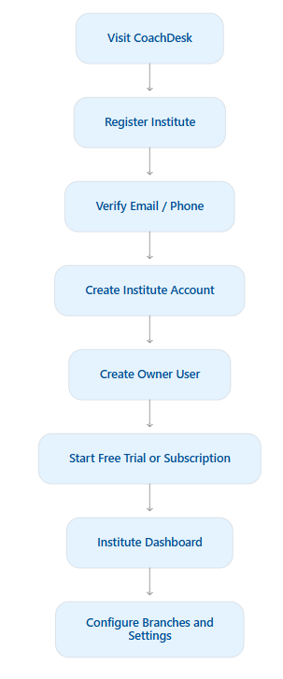

Workflow B — Student admission
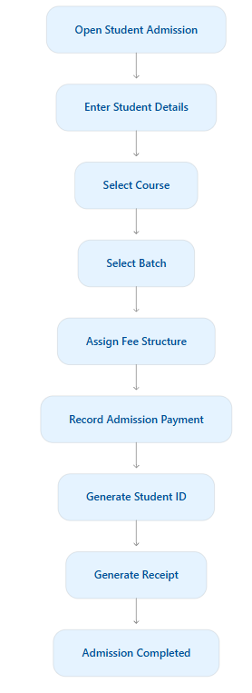

Workflow C — Fee collection
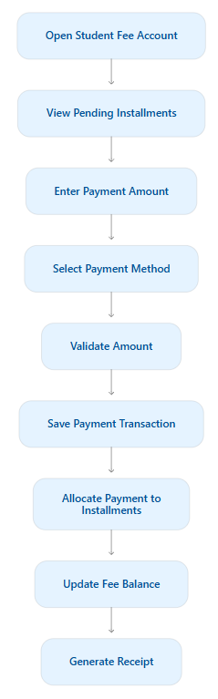
Important: Steps F–H must be performed in a single database transaction.

Workflow D — Attendance
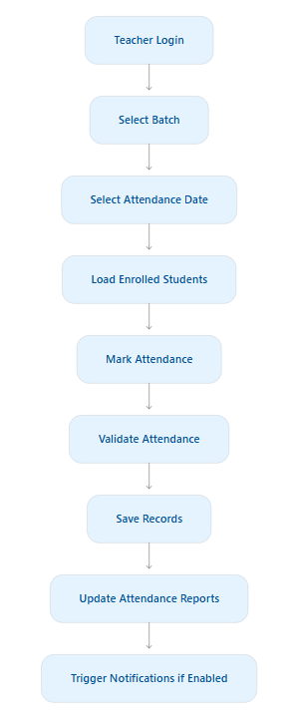

11. Development roadmap
I recommend implementing CoachDesk over six development phases.
The following are planning estimates for one developer or a small development team, not guaranteed delivery dates.
Phase | Scope | Estimated duration
1 | Foundation and SaaS architecture | 1–2 weeks
2 | Students and academic management | 2–3 weeks
3 | Attendance and fees | 2–3 weeks
4 | Examinations and reports | 2–3 weeks
5 | Portals and communication | 2–3 weeks
6 | SaaS billing, testing and launch | 2–3 weeks
Phase 1 — Foundation
First development milestone
- React project setup
- NestJS project setup
- MySQL and Prisma configuration
- Database migrations
- Authentication
- Institute registration
- Multi-tenant middleware
- Roles and permissions
- Branch management
- Dashboard layout
- Super Admin basic panel
Deliverable: A working SaaS foundation with isolated institute accounts.
Phase 2 — Academic Management
- Student management
- Student admission
- Courses
- Subjects
- Teachers
- Batches
- Enrollment
- Timetable
- Student document management
Deliverable: Institutes can manage their complete academic structure.
Phase 3 — Daily Operations
- Attendance
- Leave management
- Fee structures
- Student fee accounts
- Installments
- Payment collection
- Payment receipts
- Outstanding fee reports
Deliverable: Institutes can run daily operations and collect fees.
Phase 4 — Examination & Reporting
- Exam creation
- Subject-wise marks
- Results
- Report cards
- Merit lists
- Dashboard analytics
- Excel and PDF exports
Deliverable: Complete academic performance management.
Phase 5 — Portals & Communication
- Student portal
- Parent portal
- Homework
- Study materials
- Announcements
- Email integration
- SMS/WhatsApp integration
Deliverable: A connected institute, teacher, student, and parent experience.
Phase 6 — SaaS Launch
- Subscription plans
- Free trial
- Subscription payment gateway
- Usage limits
- Automated renewals
- Super Admin reports
- Security testing
- Performance testing
- Backup and recovery testing
- Production deployment
Deliverable: CoachDesk ready for commercial use.

12. Suggested SaaS subscription plans
Keep plans configurable from the Super Admin panel instead of hardcoding them.
Feature | Starter | Basic | Professional
Monthly price | ₹499 | ₹999 | ₹1,999
Students | 100 | 300 | 1,000
Staff accounts | 3 | 10 | 30
Branches | 1 | 1 | 3
Attendance | Yes | Yes | Yes
Fee management | Yes | Yes | Yes
Examinations | Basic | Yes | Advanced
Parent portal | No | Yes | Yes
Reports | Basic | Standard | Advanced
Support | Standard | Priority | Priority
These are proposed launch prices. Validate them with actual coaching institute owners before fixing the commercial plans.
Additional revenue opportunities:
- Additional student capacity
- Additional branches
- SMS and WhatsApp credits
- Extra file storage
- Custom branding
- Premium analytics
- White-label deployments

13. UI/UX design requirements
CoachDesk should look like a modern professional SaaS application, not an old-fashioned school ERP.
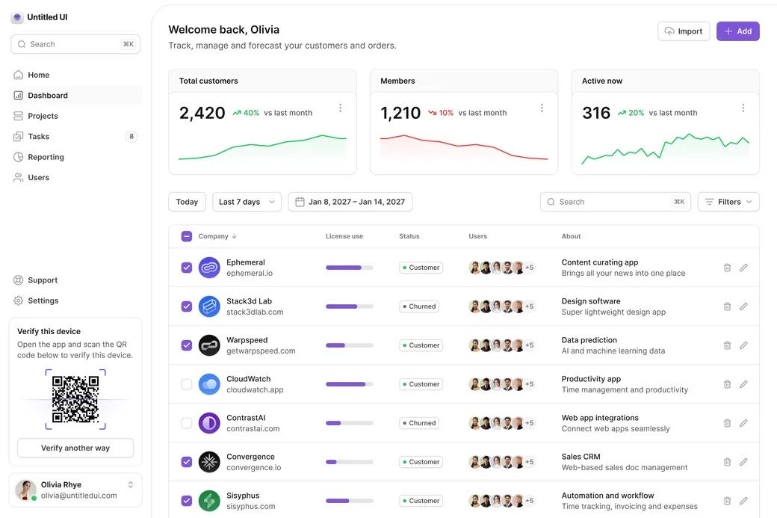Light Dashboard
Primary theme
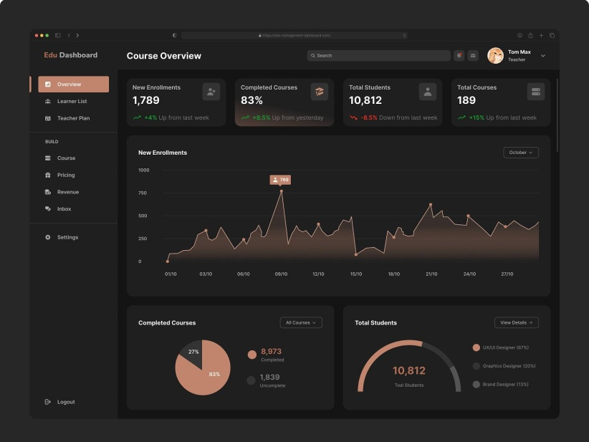
Dark Dashboard
Optional theme
Data Tables
Search, sorting and filters
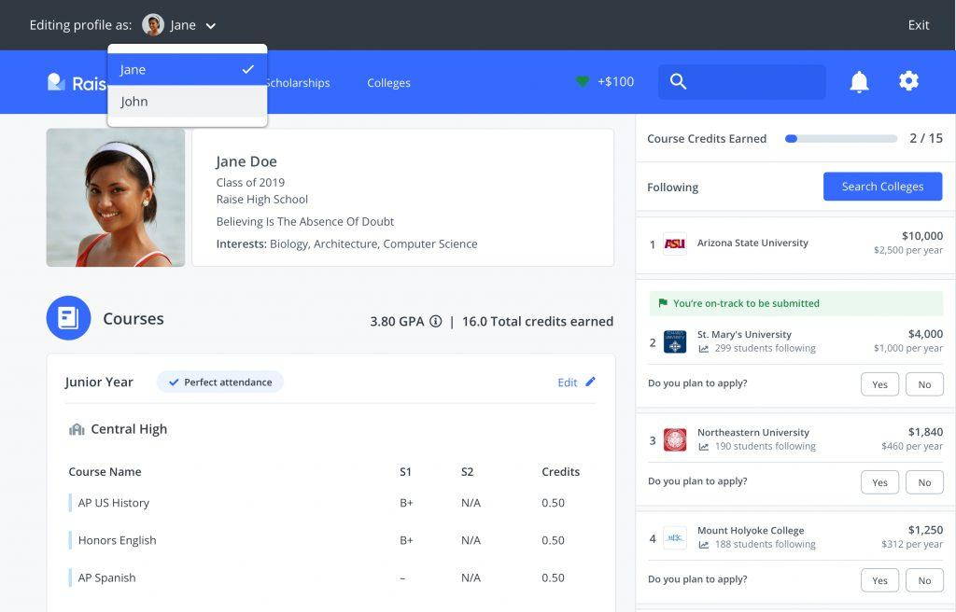
Student Profiles
Tabs and detailed records
Suggested design system:
Element | Recommendation
Primary color | Indigo / Violet
Background | #F8FAFC
Cards | White
Text | #1E293B
Success | Green
Warning | Amber
Danger | Red
Border radius | 8–12px
Typography | Inter
Layout | Sidebar + Topbar
Design rules:
- Consistent page spacing.
- Compact professional tables.
- Clear form validation.
- Reusable components.
- Avoid excessive gradients.
- Responsive on mobile, tablet, and desktop.
- Proper empty/loading/error states.

14. Testing and acceptance criteria
Before releasing any phase, verify the following.
Area | Acceptance criteria
Authentication | Only authorized users can access protected pages
Tenant isolation | One institute cannot access another's records
Permissions | Users only access permitted features
Students | Admission, editing and enrollment work correctly
Batches | Enrollment and capacity validation work correctly
Attendance | Duplicate student/session entries are prevented
Fees | Partial payments and installments calculate correctly
Payments | Duplicate payment callbacks cannot create duplicate transactions
Examinations | Marks, grades and percentages calculate correctly
Reports | Reports match underlying database records
Exports | Excel/PDF exports respect tenant permissions
Security | File uploads and API requests are validated
Recommended automated tests:
- Unit tests for business logic.
- Integration tests for database operations.
- API tests for each module.
- Tenant isolation tests.
- Permission tests.
- Payment idempotency tests.
- End-to-end tests for admission, attendance, and fee collection.

15. Production deployment architecture
Recommended deployment:
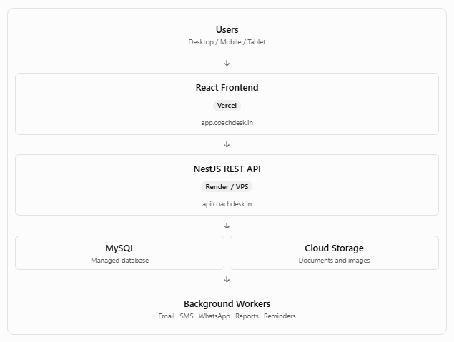
Important deployment requirements:
- Use separate production and staging environments.
- Run database migrations during controlled deployment.
- Never expose database credentials in frontend code.
- Use private cloud storage for student documents.
- Configure backups and restore testing.
- Configure API rate limits and CORS.
- Use a background job queue for scheduled notifications.
- Monitor application errors and database performance.

16. Final MVP scope
Although the complete application has many modules, I recommend launching the first usable version with only these features:

CoachDesk MVP
Recommended first release
Included modules
- Institute registration and login
- Multi-tenant architecture
- User roles and permissions
- Branch management
- Dashboard
- Student management
- Course and subject management
- Batch management
- Teacher management
- Attendance management
- Fee structures
- Payment collection
- Payment receipts
- Basic reports
- Excel import/export
Post-MVP
- Online examinations
- Parent portal
- Student portal
- Homework and study material
- WhatsApp/SMS automation
- Subscription billing
- Advanced analytics
The SaaS foundation and subscription architecture should be designed from the beginning, even if commercial billing is activated later.

17. Development rules for the project
These rules should be followed throughout development.
- Develop one module at a time.
- Complete backend APIs before integrating the frontend module.
- Keep frontend and backend in separate projects.
- Use reusable React components.
- Use DTO validation in every API endpoint.
- Use Prisma migrations; do not modify production databases manually.
- Never trust institute_id received from the frontend.
- Use transactions for all financial operations.
- Maintain activity logs for important actions.
- Implement permissions at the API level.
- Write tests for tenant isolation.
- Maintain a README and API documentation.
- Keep .env.example updated.
- Do not leave dummy buttons or non-functional UI elements.
- Test each module before starting the next phase.

18. First development milestone
I recommend starting with the project foundation rather than generating all modules in one go.
The first deliverable should contain:
Backend
- NestJS setup
- MySQL connection
- Prisma configuration
- Initial database migrations
- Institute registration
- Authentication
- JWT and refresh tokens
- Tenant middleware
- RBAC permissions
- Seed data
Frontend
- React + Vite + TypeScript
- Login page
- Institute registration page
- Admin dashboard
- Sidebar and navigation
- Protected routes
- API integration
- User profile and logout
Testing
- Register Institute A.
- Register Institute B.
- Log in to both.
- Verify that neither institute can access the other's data.
- Test role-based permissions.
This establishes the most important part of CoachDesk: its multi-tenant foundation.

19. Master development prompt
The following prompt can be used with your AI coding assistant to start implementing the project. It establishes the architecture and prevents the AI from trying to build the entire application in one step.

Project: CoachDesk — Multi-Tenant Coaching Institute Management SaaS
Act as a Senior Software Architect, Senior React Developer, Senior NestJS Developer, and MySQL Database Architect.
Build a production-oriented SaaS application named CoachDesk.

Product Objective
CoachDesk is a multi-tenant Coaching Institute Management System designed for Indian coaching centres, tuition institutes, competitive exam preparation centres, computer training institutes, and educational organizations.
Multiple institutes must be able to register and operate independently on the same platform.

Technology Stack
Frontend:
- React
- Vite
- TypeScript
- Tailwind CSS
- shadcn/ui
- TanStack Query
- React Hook Form
- Zod
Backend:
- Node.js
- NestJS
- TypeScript
- REST API
- Prisma ORM
- JWT authentication
- Role-based access control
Database:
- MySQL 8
- Prisma migrations
Other:
- Recharts for analytics
- SheetJS for Excel import/export
- PDF generation for receipts and reports
- Cloud storage for documents
- Background job processing for notifications

Architecture Requirements
- Maintain separate frontend and backend projects.
- Use modular NestJS architecture.
- Implement multi-tenant SaaS architecture.
- Every institute-owned record must have an institute_id.
- Enforce tenant isolation in backend services and database queries.
- Do not trust institute_id supplied by frontend requests.
- Implement branch-level access where required.
- Implement configurable roles and permissions.
- Use database transactions for financial operations.
- Maintain audit logs.
- Use pagination and filtering for large datasets.
- Maintain API versioning under /api/v1.
- Use environment variables for all secrets and environment-specific configuration.

Main Modules
- Super Admin
- Institute Management
- Branch Management
- User Management
- Role & Permission Management
- Student Management
- Student Admission
- Course Management
- Subject Management
- Batch Management
- Teacher Management
- Classroom Management
- Timetable Management
- Attendance Management
- Fee Structure Management
- Student Fee Accounts
- Payment Collection
- Payment Receipts
- Refund Management
- Examination Management
- Results and Report Cards
- Homework Management
- Study Material
- Student Portal
- Parent Portal
- Notifications
- Reports and Analytics
- Subscription Management
- Support Management
- System Settings

User Roles
- Super Admin
- Institute Owner
- Branch Admin
- Accountant
- Teacher
- Receptionist
- Student
- Parent
Implement configurable permissions rather than hardcoding module access.

Database Requirements
Create normalized MySQL tables for:
- Institutes
- Branches
- Users
- Roles
- Permissions
- Role Permissions
- User Roles
- Academic Sessions
- Students
- Student Guardians
- Student Documents
- Courses
- Subjects
- Course Subjects
- Teachers
- Classrooms
- Batches
- Batch Students
- Batch Subjects
- Timetable
- Attendance Sessions
- Attendance Records
- Fee Structures
- Fee Structure Items
- Student Fee Accounts
- Fee Installments
- Payments
- Payment Allocations
- Payment Refunds
- Fee Adjustments
- Exams
- Exam Subjects
- Exam Results
- Exam Result Details
- Homework
- Homework Submissions
- Study Materials
- Announcements
- Notifications
- Notification Logs
- Subscription Plans
- Institute Subscriptions
- Subscription Payments
- Expenses
- Activity Logs
- Settings
Add appropriate foreign keys, indexes, tenant-scoped unique constraints, and timestamps.

UI/UX Requirements
Build a professional modern SaaS interface.
- Responsive sidebar
- Top navigation
- Breadcrumbs
- Dashboard statistics
- Searchable data tables
- Filters and pagination
- Create/edit forms
- Reusable modal dialogs
- Confirmation dialogs
- Toast notifications
- Light and dark themes
- Mobile responsiveness
- Loading and empty states
- Proper form validation
Use a clean, modern design with a white/light background, restrained indigo accent, professional typography, and compact layouts.

Development Approach
Implement the project in phases.

Phase 1 — Foundation
- Frontend/backend setup
- Database and Prisma
- Institute registration
- Authentication
- Tenant isolation
- Roles and permissions
- Branch management
- Dashboard layout

Phase 2 — Academic Management
- Students
- Admissions
- Courses
- Subjects
- Teachers
- Batches
- Enrollment
- Timetable

Phase 3 — Daily Operations
- Attendance
- Fee structures
- Fee collection
- Installments
- Receipts
- Refunds
- Fee reports

Phase 4 — Examinations
- Exams
- Marks entry
- Results
- Report cards
- Merit lists
- Analytics

Phase 5 — Portals and Communication
- Student portal
- Parent portal
- Homework
- Study material
- Email/SMS/WhatsApp notifications

Phase 6 — SaaS Commercial Launch
- Subscription plans
- Free trials
- Payment gateway
- Usage limits
- Subscription renewal
- Super Admin reports
- Production readiness

Important Development Instructions
- Do not generate the entire application in a single step.
- Start with Phase 1 only.
- Before coding, inspect and document the project architecture.
- Create a detailed implementation checklist.
- Implement database migrations before dependent API functionality.
- Complete backend APIs and test them before frontend integration.
- Use reusable components and services.
- Do not duplicate code.
- Do not leave placeholder pages or non-functional buttons.
- Do not hardcode business rules that should be configurable.
- Maintain README.md, .env.example, and API documentation.
- Write automated tests for authentication, permissions, tenant isolation, and financial operations.
- After completing each module, provide a summary of files created, APIs implemented, database changes, and tests performed.
- Wait for approval before moving to the next development phase.
First task: Create the CoachDesk Phase 1 architecture, folder structure, database schema, Prisma setup, authentication, multi-tenant security, RBAC, and basic dashboard. Ensure the application can run locally using documented commands.

