Coaching Institute Management System has good potential as a practical SaaS product, particularly in India.
Rather than building just a student attendance application, I recommend creating a complete platform where coaching institutes can manage their daily operations from one dashboard.
Let's plan it as a product that can be used by small coaching centres initially and expanded to larger institutes later.

1. Product concept

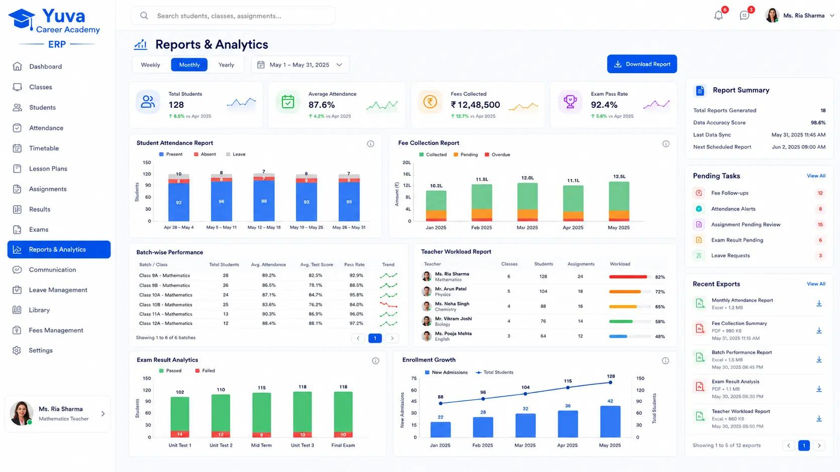

CoachDesk
Proposed product name
Coaching Institute Management Platform
Manage students, teachers, batches, attendance, fees, examinations, results, and parent communication in one place.
Target customers:
- Small coaching centres
- Competitive exam preparation institutes
- Computer training institutes
- Tuition centres
- English-speaking institutes
- Skill development and vocational training centres
- Multi-branch educational institutes
The platform should support both offline and online classroom operations.

2. Main application modules
I would divide the application into 12 major modules.

Module 1: Dashboard
The dashboard should give the institute owner a complete overview of daily operations.
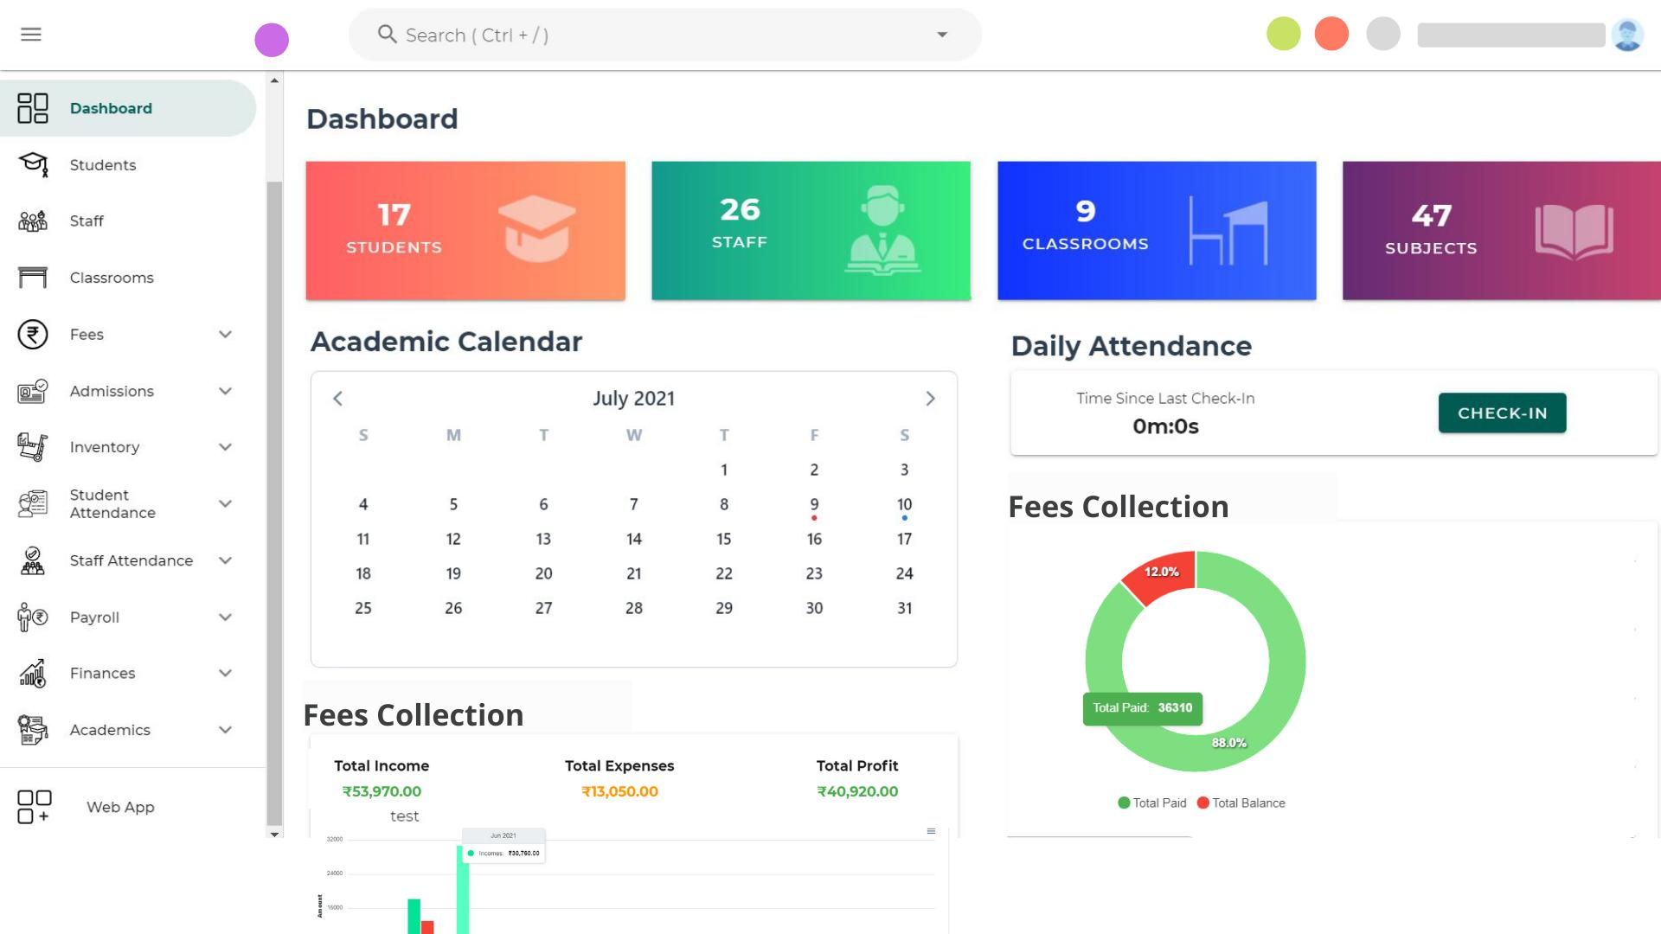
Dashboard widgets:
Widget | Information
Total Students | Active, inactive, and completed
Total Teachers | Active teaching staff
Total Batches | Running batches
Today's Attendance | Present, absent, late
Today's Collection | Fees collected today
Pending Fees | Total outstanding amount
Upcoming Exams | Next scheduled examinations
Recent Activities | Admissions, payments, attendance
Additional dashboard features:
- Monthly fee collection chart
- Student admission chart
- Batch-wise student strength
- Attendance percentage
- Top-performing students
- Fee defaulter list

Module 2: Student Management
This will be one of the most important modules.
Student registration fields:
Field | Example
Student ID | STU-00001
Full Name | Rahul Sharma
Father's Name | Amit Sharma
Mobile Number | 9876543210
Email | rahul@gmail.com
Date of Birth | 15-05-2008
Gender | Male
Address | Greater Noida
Course | Mathematics
Batch | MATH-2026-A
Admission Date | 04-11-2026
Admission Fee | ₹1,000
Monthly Fee | ₹1,500
Status | Active
Features:
- New student admission
- Student profile
- Upload photograph and documents
- Assign course and batch
- Admission history
- Student ID card generation
- Transfer between batches
- Student promotion
- Student leaving/cancellation
- Search and filters
- Excel import/export

Module 3: Course & Batch Management
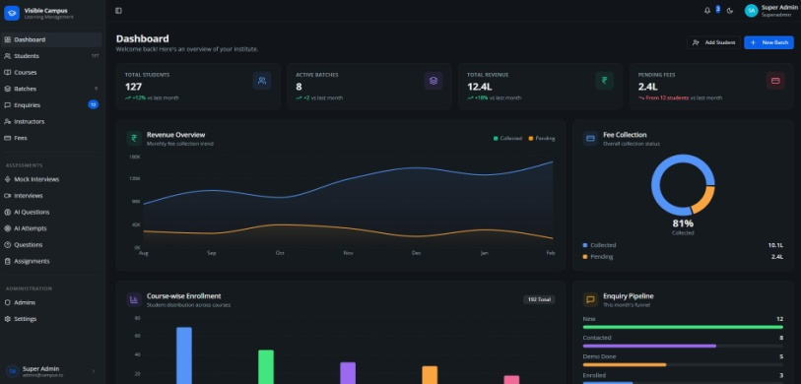
This module manages the academic structure.
Course management:
- Course name
- Course code
- Duration
- Course fees
- Subjects
- Description
- Course status
Examples:
Course | Duration | Fees
Class 10 Mathematics | 12 Months | ₹12,000
Class 12 Physics | 12 Months | ₹18,000
SSC Preparation | 6 Months | ₹15,000
Spoken English | 3 Months | ₹5,000
Computer Basics | 3 Months | ₹4,500
Batch management:
One course can have multiple batches.
Example:
Batch | Course | Timing | Teacher
MATH-A | Class 10 Maths | 8–9 AM | Amit
MATH-B | Class 10 Maths | 10–11 AM | Rahul
SSC-EVE | SSC Preparation | 5–7 PM | Suresh
Features:
- Create batches
- Assign teachers
- Assign classrooms
- Batch capacity
- Batch start/end date
- Student enrollment
- Batch timetable
- Batch transfer

Module 4: Attendance Management
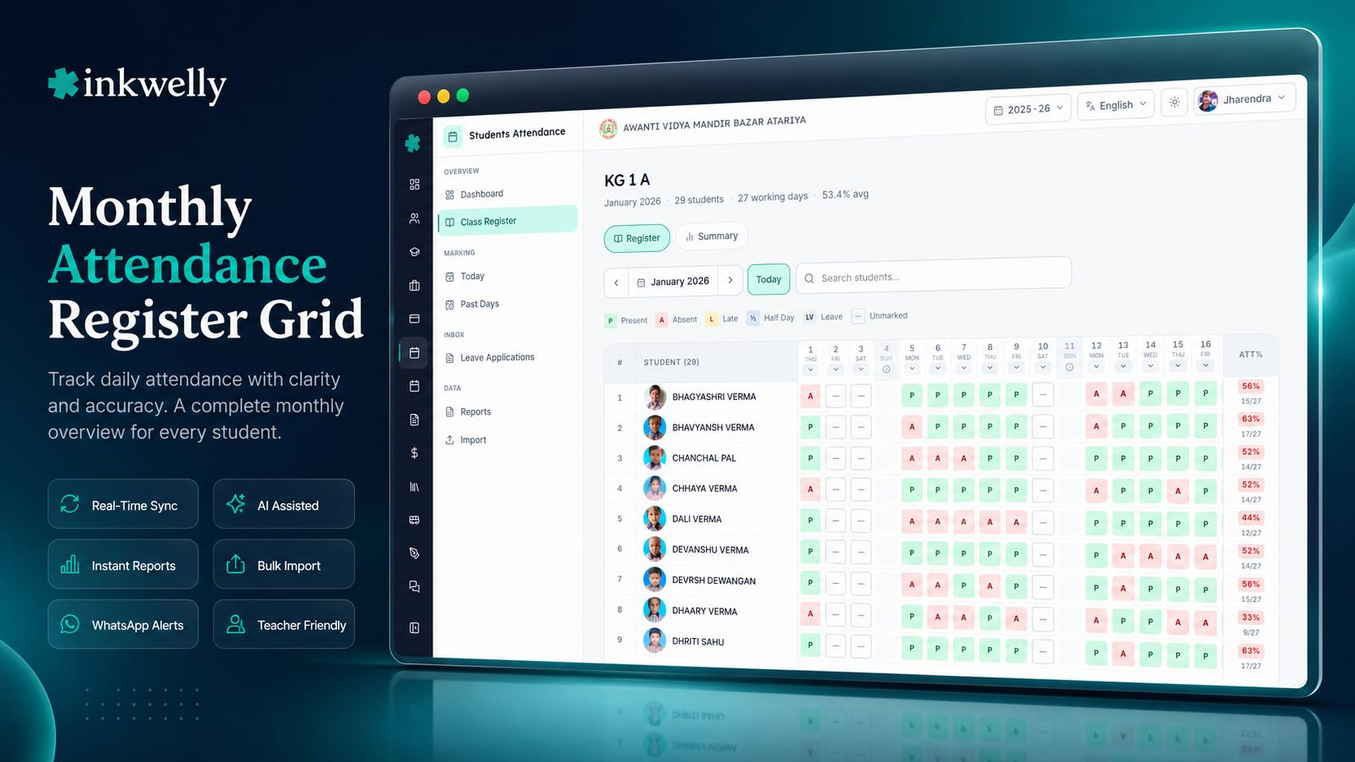
Teachers should be able to mark attendance quickly.
Attendance statuses:
- Present
- Absent
- Late
- Half Day
- Leave
Attendance workflow:
- Teacher logs in.
- Selects course and batch.
- Selects date.
- Student list appears.
- Marks attendance.
- Saves attendance.
- System updates attendance reports.
Advanced features:
- QR-based attendance
- Student attendance percentage
- Monthly attendance reports
- Absent student alerts
- Parent SMS/WhatsApp notifications
- Bulk attendance marking
For the first version, I recommend manual attendance with bulk actions. Add QR attendance later.

Module 5: Fees & Payment Management
FeeTracker
feetracker.in
This is a critical business module.
Fee types:
- Admission fee
- Monthly fee
- Quarterly fee
- Annual fee
- Examination fee
- Registration fee
- Other charges
Example student fee account:
Rahul Sharma
STU-00001 · Class 10 Mathematics
Total Fees

₹12,000
Paid Amount

₹8,000
Pending Amount

₹4,000
Next Due Date
10 Dec 2026
Payment History
Date | Amount | Mode
04 Nov | ₹3,000 | UPI
04 Oct | ₹2,500 | Cash
04 Sep | ₹2,500 | UPI
Features:
- Create fee structures
- Assign fees to students
- Installment management
- Partial payments
- Discounts and scholarships
- Late payment penalties
- Due date tracking
- Payment receipts (PDF)
- Cash, UPI, bank transfer and online payment
- Refund management
- Daily collection reports
- Defaulter reports
I would also integrate Razorpay or another payment gateway in a later phase, allowing parents to pay online.

Module 6: Examination & Results
School Result Management System India | Marksheets & Report Cards | Apna School
apnaschool.site
This module allows institutes to conduct tests and manage student performance.
Features:
- Create examinations
- Assign exams to batches
- Add subjects
- Define maximum marks
- Enter obtained marks
- Calculate percentages
- Generate rank lists
- Generate report cards
- Subject-wise performance
- Student progress reports
Example:
Student | Maths | Science | English | Total
Rahul | 85 | 78 | 90 | 253
Amit | 75 | 88 | 80 | 243
Priya | 92 | 95 | 88 | 275
Additional features can include online MCQ examinations, automatic evaluation, question banks, and negative marking.

Module 7: Teacher & Staff Management
Features:
- Teacher registration
- Staff profiles
- Qualification and experience
- Subject allocation
- Batch allocation
- Teacher attendance
- Leave management
- Salary records
- Teacher timetable
- Performance reports

Module 8: Timetable & Classroom Management
Features:
- Weekly timetable
- Batch-wise schedule
- Teacher availability
- Classroom allocation
- Lecture scheduling
- Holiday management
- Class cancellation
- Substitute teacher assignment
Avoid allowing two batches to use the same classroom or teacher at the same time.

Module 9: Parent & Student Portal
Classe365 Reviews (Jul 2026)
techraisal.com
This can become an important differentiating feature.
Give students and parents their own login.
Student portal:
- View attendance
- View fee status
- Download receipts
- View examination results
- View timetable
- View notices
- Download study materials
Parent portal:
- Monitor child attendance
- Check pending fees
- View academic performance
- Receive announcements
- Download fee receipts

Module 10: Notifications & Communication
Features:
- SMS notifications
- WhatsApp notifications
- Email notifications
- Fee due reminders
- Payment confirmation
- Absence notifications
- Exam announcements
- Holiday announcements
- Batch change notifications
Example automated notifications:
- Your monthly fee of ₹1,500 is due on 10 December.
- Rahul was absent today.
- Your examination is scheduled for 15 December.
- Your payment of ₹1,500 was received successfully.
Use configurable templates and obtain appropriate consent for messaging.

Module 11: Study Material & Homework
Features:
- Upload PDF notes
- Upload assignments
- Subject-wise material
- Batch-wise material
- Homework submission
- Assignment deadlines
- Teacher feedback
- Video lecture links

Module 12: Reports & Analytics
Reports should help institute owners understand business and academic performance.
Report | Information
Admission Report | New student admissions
Student Report | Active and inactive students
Attendance Report | Daily and monthly attendance
Fee Collection | Daily, monthly, yearly
Fee Defaulter | Pending student fees
Examination Report | Marks, grades, rankings
Teacher Report | Teacher workload
Batch Report | Student strength and performance
Expense Report | Institute operating expenses
Profit/Loss Report | Revenue vs expenses

3. User roles and permissions
I recommend a role-based system.
Role | Access
Super Admin | Manage all institutes
Institute Owner | Full institute access
Branch Admin | Manage assigned branch
Accountant | Fees, payments and financial reports
Teacher | Attendance, exams, homework
Receptionist | Admissions, student profiles, payments
Student | Own academic information
Parent | Linked child's information
Use permission-based access rather than hardcoding every module against a role.
For example, the owner can grant a receptionist access to student admissions but not salary reports.

4. Recommended database architecture
I recommend a multi-tenant database design. This means multiple coaching institutes can use the same application, while their information remains separated.
Suggested initial MySQL tables:
Institute & users
institutes
branches
users
roles
permissions
role_permissions
user_permissions
Academic management
students
student_documents
courses
subjects
batches
batch_students
teachers
teacher_subjects
classrooms
timetable
Attendance
attendance
attendance_sessions
student_leave_requests
Fees
fee_structures
student_fees
fee_installments
payments
payment_refunds
payment_receipts
Examinations
exams
exam_subjects
exam_questions
exam_results
exam_result_details
Communication
notifications
notification_templates
announcements
homework
homework_submissions
study_materials
System
subscriptions
subscription_plans
activity_logs
settings
Important: Every institute-owned record should be associated with an institute_id. Branch-specific records should also have a branch_id where appropriate.

5. Suggested application structure
I would build the application using this stack:
Frontend
React
Vite
TypeScript
Tailwind CSS + shadcn/ui + TanStack Query
Backend
Node.js
Express / NestJS
REST API + JWT authentication + RBAC
Database
MySQL 8
Prisma ORM
Transaction-safe fee and attendance operations
Deployment
Vercel
Render / VPS
Cloud Storage
React frontend + separate API + managed database
Suggested folder structure:
coachdesk/
│
├── frontend/
│ └── src/
│ ├── components/
│ ├── layouts/
│ ├── pages/
│ │ ├── dashboard/
│ │ ├── students/
│ │ ├── courses/
│ │ ├── batches/
│ │ ├── attendance/
│ │ ├── fees/
│ │ ├── examinations/
│ │ ├── teachers/
│ │ ├── timetable/
│ │ ├── reports/
│ │ └── settings/
│ ├── services/
│ ├── hooks/
│ ├── context/
│ └── routes/
│
├── backend/
│ └── src/
│ ├── modules/
│ │ ├── auth/
│ │ ├── institutes/
│ │ ├── students/
│ │ ├── courses/
│ │ ├── batches/
│ │ ├── attendance/
│ │ ├── fees/
│ │ ├── payments/
│ │ ├── examinations/
│ │ ├── teachers/
│ │ ├── notifications/
│ │ └── reports/
│ ├── middleware/
│ ├── config/
│ └── utils/
│
└── database/
├── schema/
└── seed/

6. Development roadmap
Don't build all 12 modules together. Start with the core product.

Development phases
- Phase 1 — Foundation
Build first
  - Login and authentication
  - Institute registration
  - Branch management
  - Users and permissions
  - Dashboard
  - Basic settings
- Phase 2 — Student & Academic Management
  - Student CRUD
  - Courses and subjects
  - Batches
  - Teacher management
  - Student enrollment
  - Timetable
- Phase 3 — Daily Operations
  - Attendance
  - Fee structures
  - Fee collection
  - Payment receipts
  - Fee reminders
- Phase 4 — Examination
  - Examination creation
  - Marks entry
  - Result calculation
  - Report cards
  - Performance reports
- Phase 5 — Advanced Features
  - Parent/student portal
  - WhatsApp and SMS
  - Study material
  - Online tests
  - Mobile-friendly experience
- Phase 6 — SaaS Business
  - Subscription plans
  - Free trial
  - Online payments
  - Usage limits
  - Subscription renewal
  - Super Admin analytics

7. SaaS business model
You can offer this application to multiple coaching institutes through monthly or yearly subscriptions.
Here is an illustrative pricing structure:
Plan | Monthly Price | Suggested Limits
Starter | ₹499 | 100 students
Basic | ₹999 | 300 students
Professional | ₹1,999 | 1,000 students
Enterprise | Custom | Multiple branches
You can offer annual discounts, paid SMS/WhatsApp credits, additional storage, and premium reports.
These are suggested starting prices, not market-validated rates.

8. Important features that can make your app stand out
I would consider these after the core system works:
- WhatsApp Fee Reminders: Automatically remind parents about pending fees.
- QR Attendance: Students scan their ID QR code to mark attendance.
- Student Performance Analytics: Identify students whose marks are declining.
- Automatic Fee Receipts: Generate branded PDF receipts after payment.
- Online Examination: Conduct MCQ tests and calculate results automatically.
- Multi-Branch Management: One owner can monitor several coaching centres.
- Parent Mobile Experience: A responsive portal to check attendance, results, and fees.

