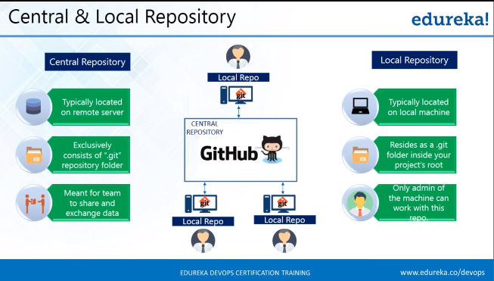

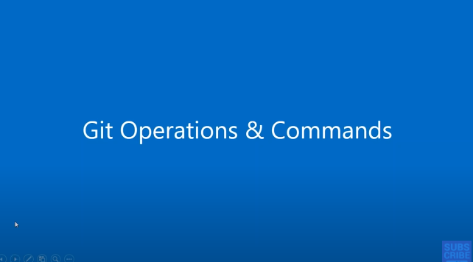

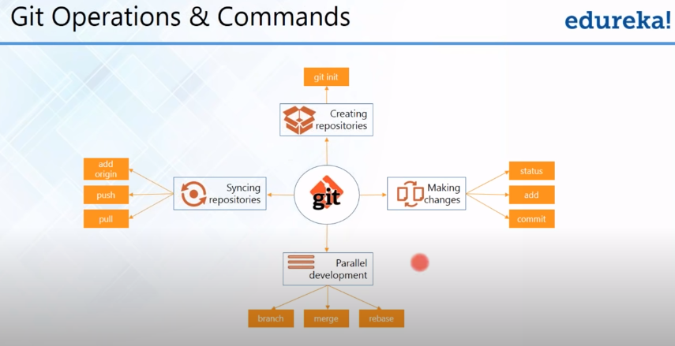

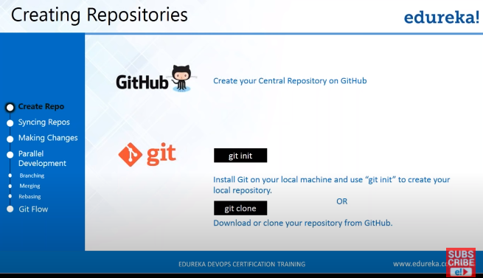

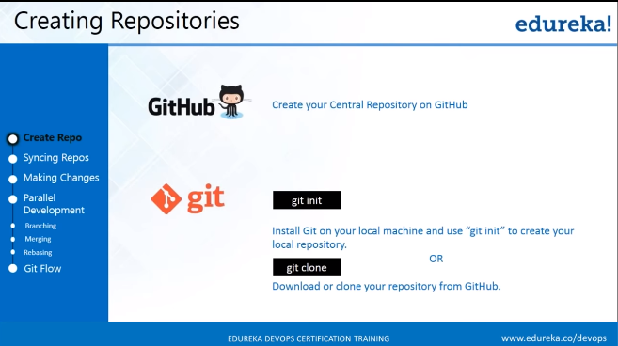

**First, we need to have Central & Local repository.**

**Create Central Repository**

1. **Create Git Hub Account (Github.com) & Sign in.**
2. **Start a Project.**
3. **Create Unique Repository Name (Public/Private)**

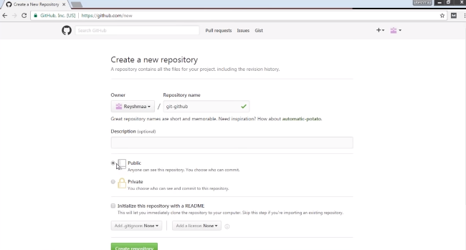

**Create Local Repository**

1. **Install Git for Windows**
2. **Create a folder in C or D drive to have Local repository inside it.**
3. **Right Click in Empty Folder & right click & select Git GUI here here or Git Besh here**

**Git base Emulator**



**Step 1: Git init (To create local repository)**

**Step 2: Link Repository with Central Repository**

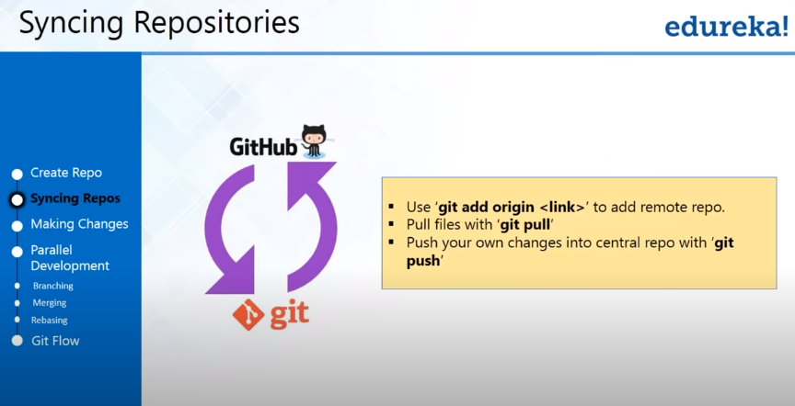

1. **Add Origin (Connecting Local repository with Central Repository)**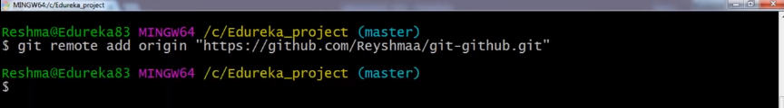
2. **Git Pull (Fetch files of Central repository into local repository)**

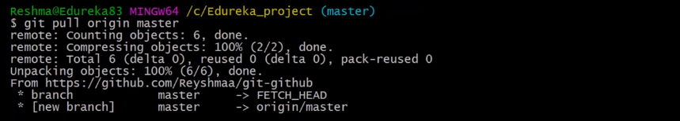

1. **Git push**

**……**

**Making changes**

**Index – a layer between work space & Local repository**

**Note: If files are not in Index, we can’t make can commit /change in local repository.**

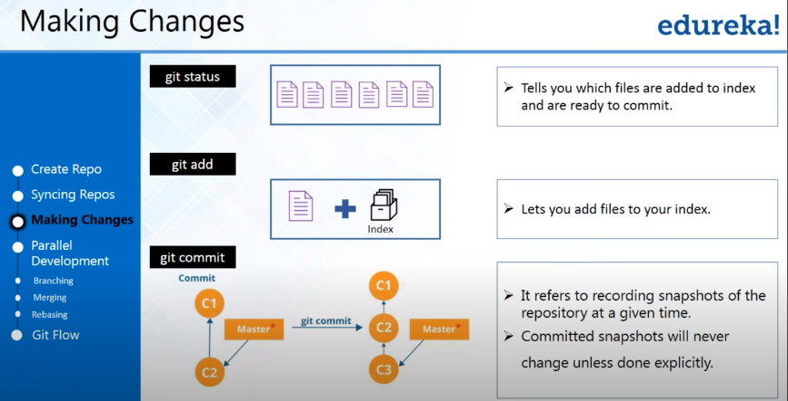

**Git status shows that which are files in index and which are not.**

**Untracked files are those files not added in Index.**

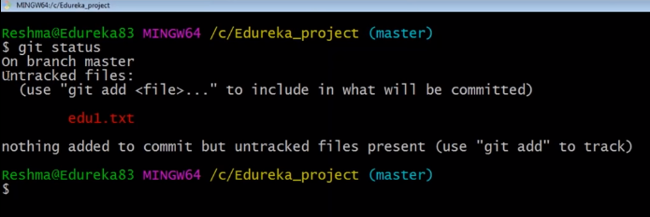

**Add file in Index**

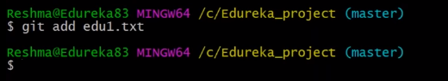

**Check Status (File added in Index, now we can make changes/ commit)**

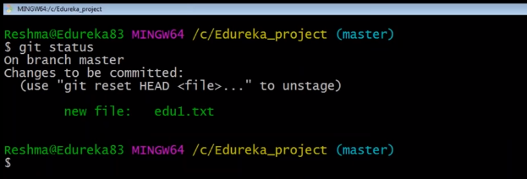

* **We can commit Multiple files / Folder.**

**Commit changes in Index file**

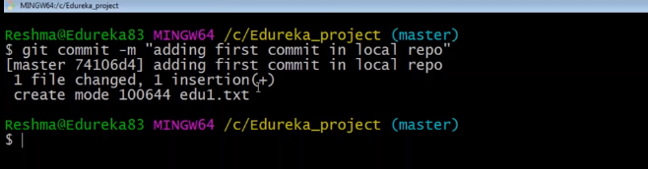

**How to add multiple files in Index**

**Git add –A**

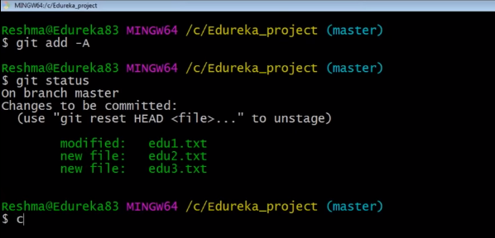

**How to add message into multiple files?**

**Git commit –a –m “message”**

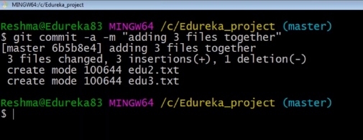

**How does git stores all these commits?**

**Git log**

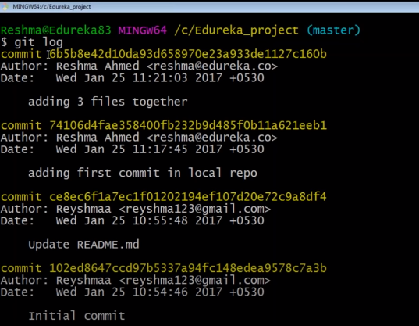

**PARALLEL DEVELOPMENT / NON-LINERAL DEVELOPMENT**

**First operation – Branching (a Pointer to specific commit)**

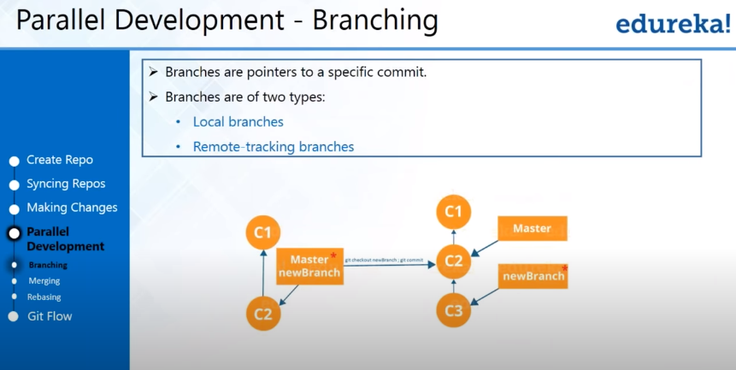

**Note: Main Branch/Master Branch shall contain all the code.**

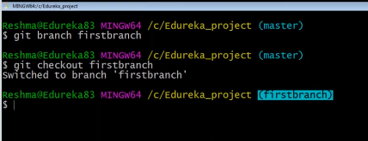

**Create edu4/txt in git folder & Add m Commit file in first branch**

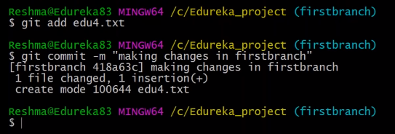

**Once we add n commit edu4 under first branch, it won’t be available in master.**

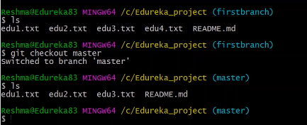

**PARALLEL DEVELOPMENT – MERGING**

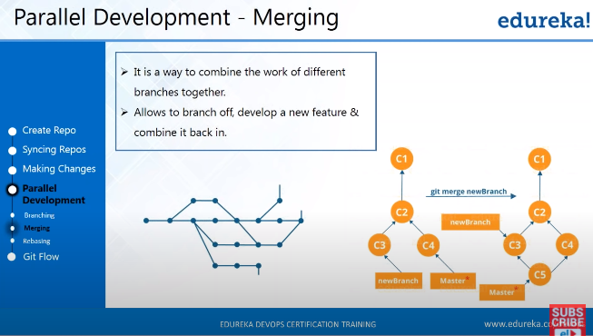

**Merge work of first branch i.e. edu4 into Master branch**

***Imp: Wherever we would like to merge any other branch work into master, the destination should be Mater. So, always checked out Master.***

